# PHASE 2 Submission Document

**PROJECT TITLE :** The Website Traffic Analysis

## Introduction:

The goal is to help website owners enhance the user experience by

understanding how visitors interact with the site. This project encompasses defining the analysis objectives, collecting website traffic data, using IBM Cognos for data visualization, and integrating Python code for advanced analysis.

## Problem statement:

The project aims to improve the user experience on a website by analyzing website traffic data. This analysis involves gaining insights into three key aspects:

**User Behavior:** Understanding how visitors interact with the website, which includes tracking actions like page views, clicks, and time spent on the site.

**Popular Pages:** Identifying the most frequently visited and engaging pages on the website.

**Traffic Sources**: Analyzing where website visitors are coming from, including sources like organic search, social media, and referrals.

The project's primary goal is to help website owners make informed decisions to enhance the user experience based on a deep understanding of user

behavior, popular content, and traffic sources. The project includes defining analysis objectives, collecting website traffic data, using IBM Cognos for data visualization, and integrating Python for advanced analysis.

## Problem Definition:

The project involves analyzing website traffic data to gain insights into user

behavior, popular pages, and traffic sources. The goal is to help website owners enhance the user experience by understanding how visitors interact with the site. This project encompasses defining the analysis objectives, collecting

website traffic data, using IBM Cognos for data visualization, and integrating Python code for advanced analysis

**Daily website visitors Excel Data:**



# Graphs Generated using IBM COGNOS ANALYTICS:

**First time visits,unique Visits,page loads:**

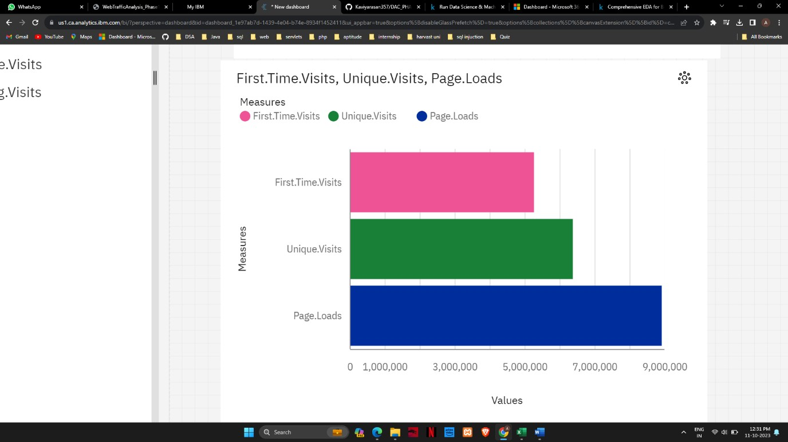

# First time visits,Returning.Visits:

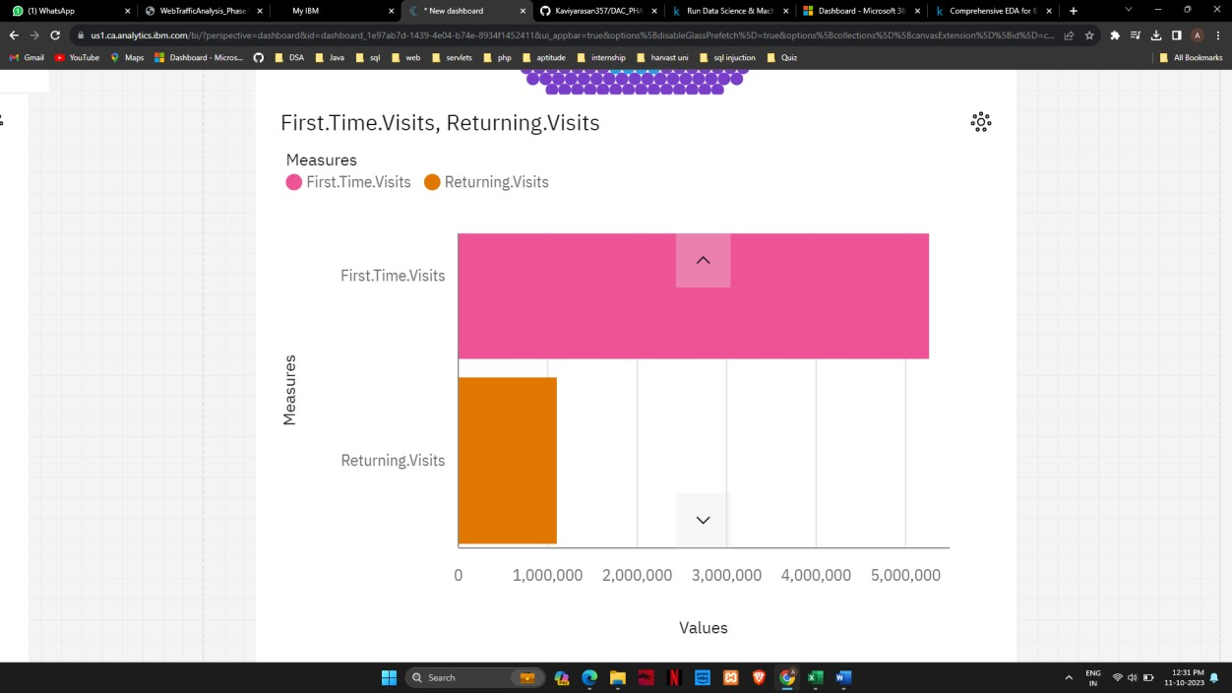

**Full Graph :**

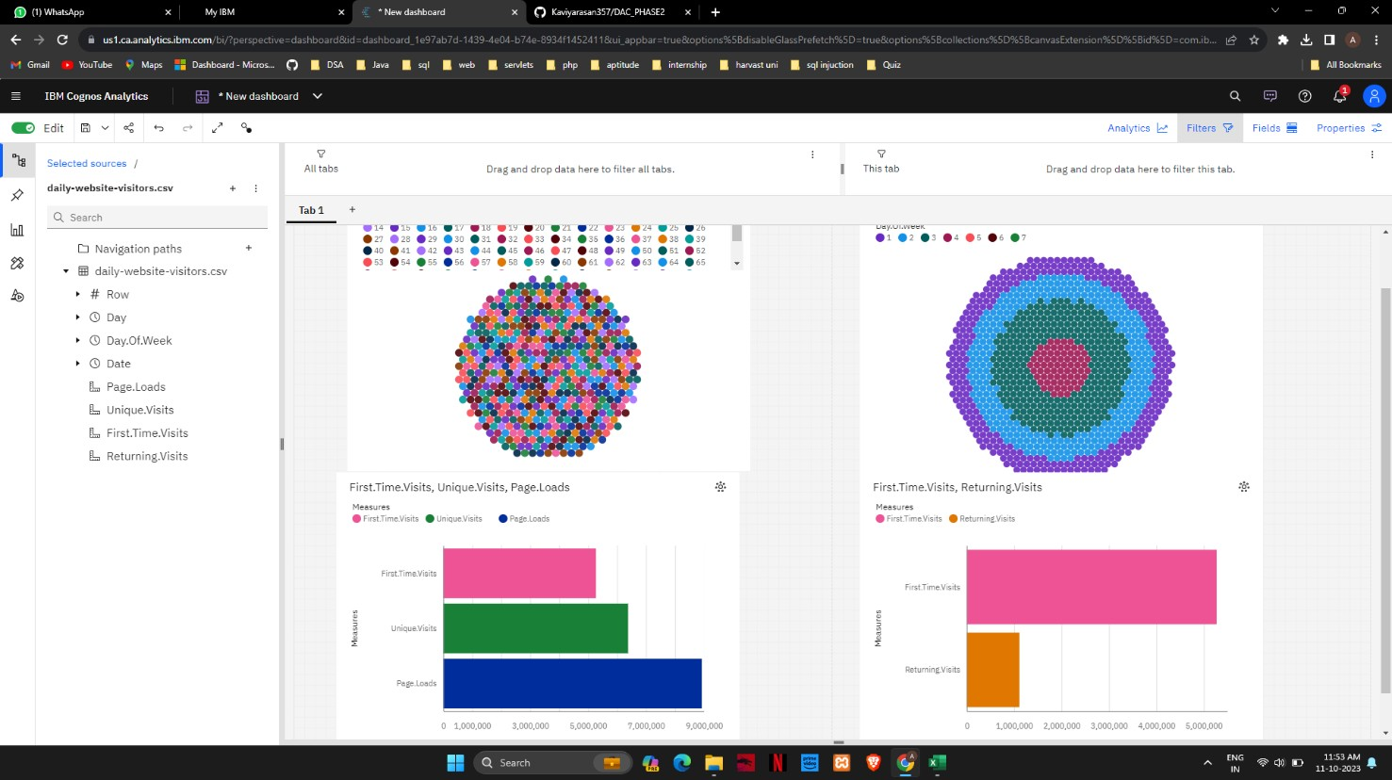

# Conclusion:

This analysis revealed crucial insights into user behavior, popular content, and traffic sources. These findings will inform targeted strategies, enhancing user experience and maximizing online engagement. Data-driven decisions will be pivotal in optimizing the website's performance and achieving business objectives efficiently.