**PROJECT TITLE :** The Website Traffic Analysis

**Project Definition:** The project involves analyzing website traffic data to gain insights into user behavior, popular pages, and traffic sources. The goal is to help website owners enhance the user experience by understanding how visitors interact with the site. This project encompasses defining the analysis objectives, collecting website traffic data, using IBM Cognos for data visualization, and integrating Python code for advanced analysis.

**1.Project Objective:**

Start by discussing the project objectives with the website owners or stakeholders. Understand their specific goals and expectations from the analysis. Clearly define what insights you want to extract from the website traffic data. For example, you may want to understand user demographics, behavior patterns, or conversion rates.

**Data Collection:** Identify the data sources for website traffic data. Common sources include Google Analytics, server logs, or other web analytics tools. Set up data collection mechanisms to gather relevant data, ensuring that you capture the necessary metrics (e.g., page views, sessions, bounce rates, referral URLs, user agents).

**Data Preparation**: Clean and preprocess the collected data to ensure it is accurate and consistent. This may involve handling missing values, removing duplicates, and transforming data as needed.

**Data Visualization with IBM Cognos:** Use IBM Cognos or a similar data visualization tool to create visualizations and dashboards that provide insights into user behavior, popular pages, and traffic sources. Generate charts, graphs, and reports that make it easy for stakeholders to interpret and derive insights from the data.

**Advanced Analysis with Python:** Integrate Python into your analysis process to perform more advanced tasks, such as: Clustering users based on behavior. Predicting user conversions. Analyzing traffic trends over time. Write Python code to extract data from your data storage, perform analysis, and generate additional insights beyond what can be achieved with IBM Cognos alone. **Insights and Recommendations:** Analyze the results from both the data visualization tool and your Python-based analysis to derive actionable insights

Based on these insights, provide recommendations to the website owners for improving the user experience. These recommendations should be data-driven and tailored to the specific findings.

**Implementation and Monitoring:** Work with website owners to implement the recommended changes or enhancements to the website. Continuously monitor the impact of these changes on user behavior and website performance.

**Documentation and Reporting:** Document your analysis process, findings, and recommendations in a clear and concise manner. Create reports and presentations that can be shared with stakeholders.

**Iterate and Improve:** Website analytics is an ongoing process. Regularly update your analysis as new data becomes available and refine your recommendations based on evolving user behavior and trends.

Throughout the project, it's essential to maintain data privacy and security, adhere to relevant regulations , and ensure that sensitive user information is handled responsibly. Additionally, effective communication with stakeholders is critical to ensure that the analysis results in meaningful improvements to the website's user experience

**Data Source:**

https://www.kaggle.com/datasets/bobnau/daily-website-visitors

**VISUALATION IS USING IBM COGNOS ANALYTICS :**

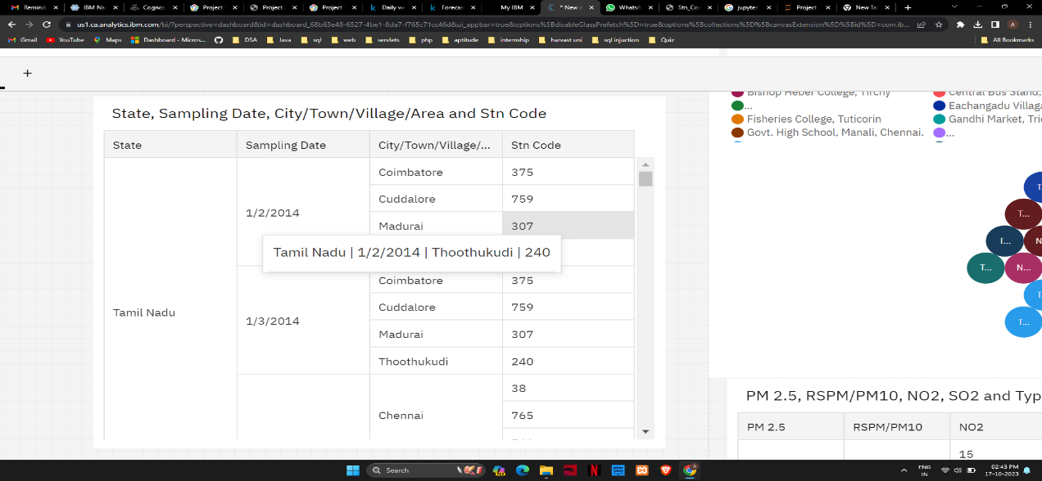

**1.Agenct colored by Location of Monitoring Station**

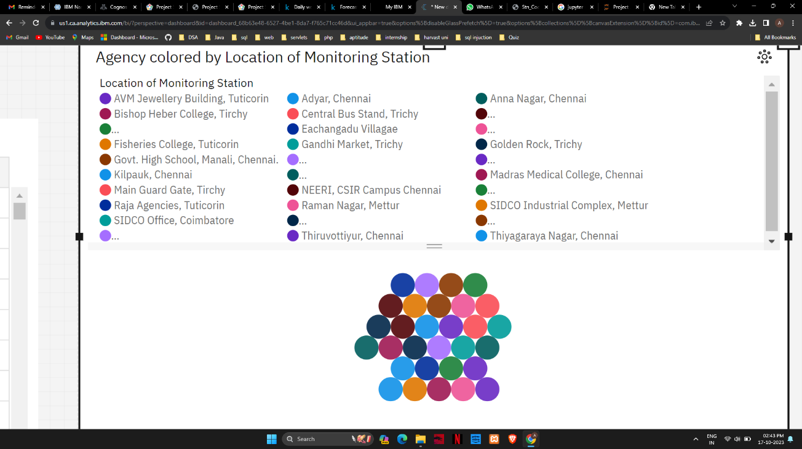

**2.PM2.5,RSPM/PM10,NO2,SP2 and Types of Location:**

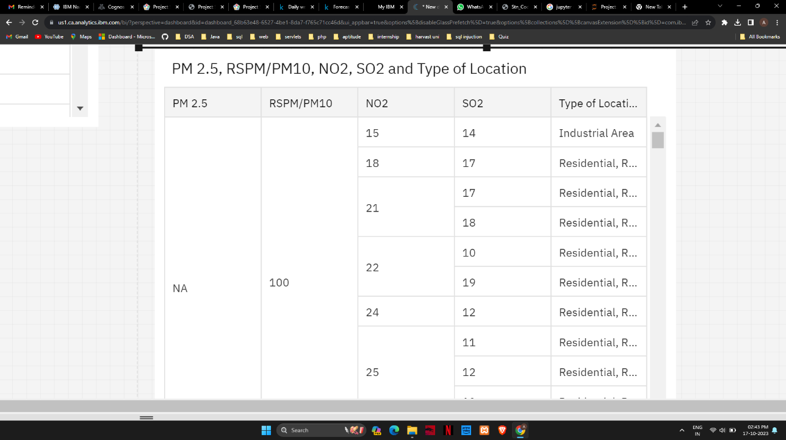

**3.Day of Week,Day and Row:**

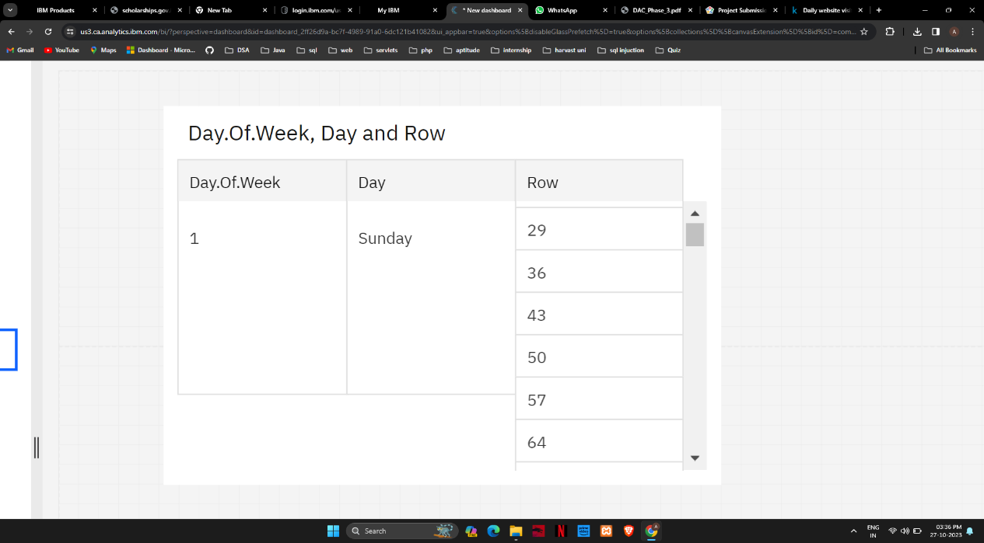

**4.Page Load Colored by returning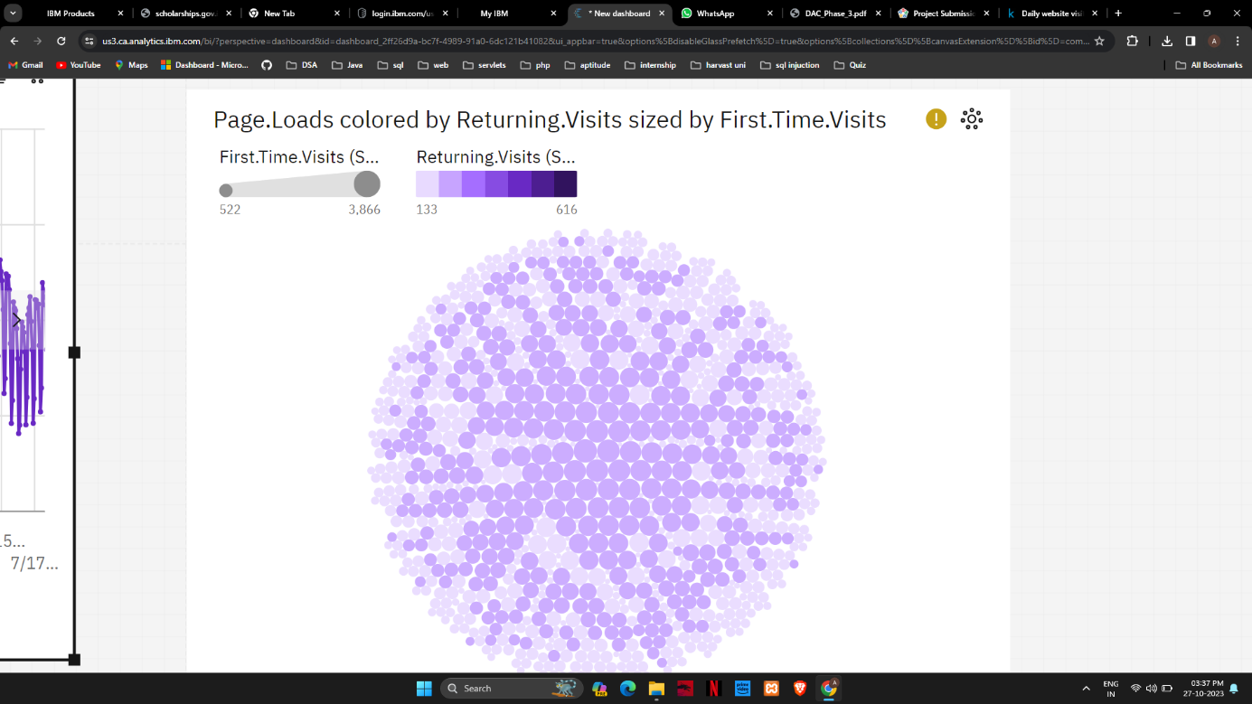5.First Time visits,Unique Visits:**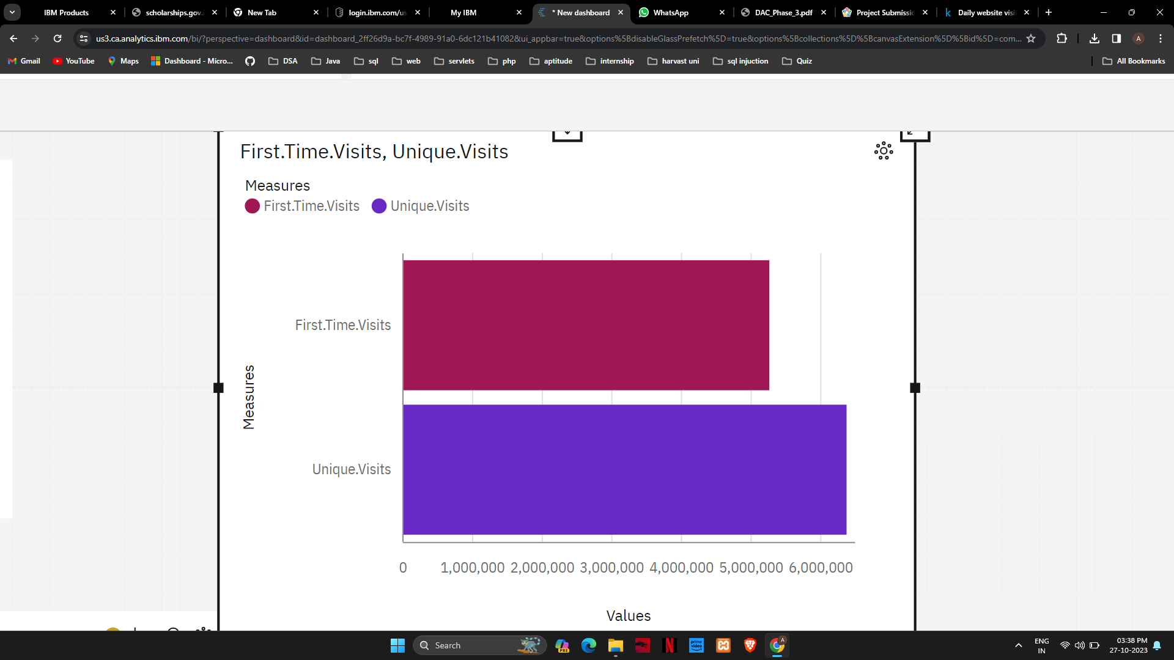

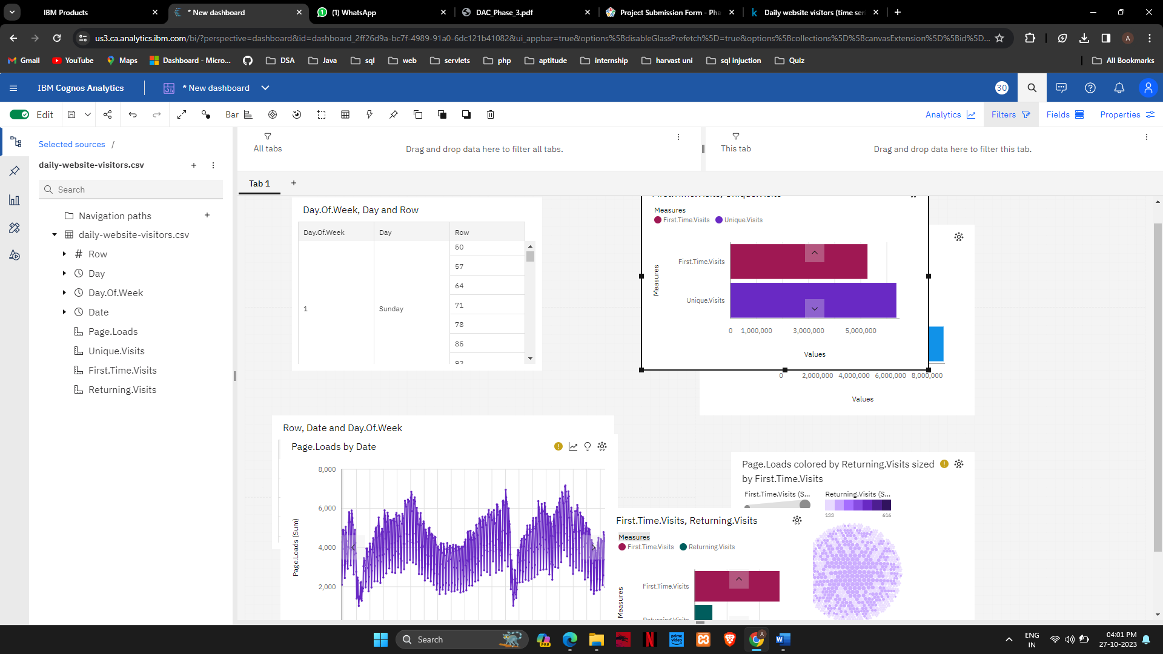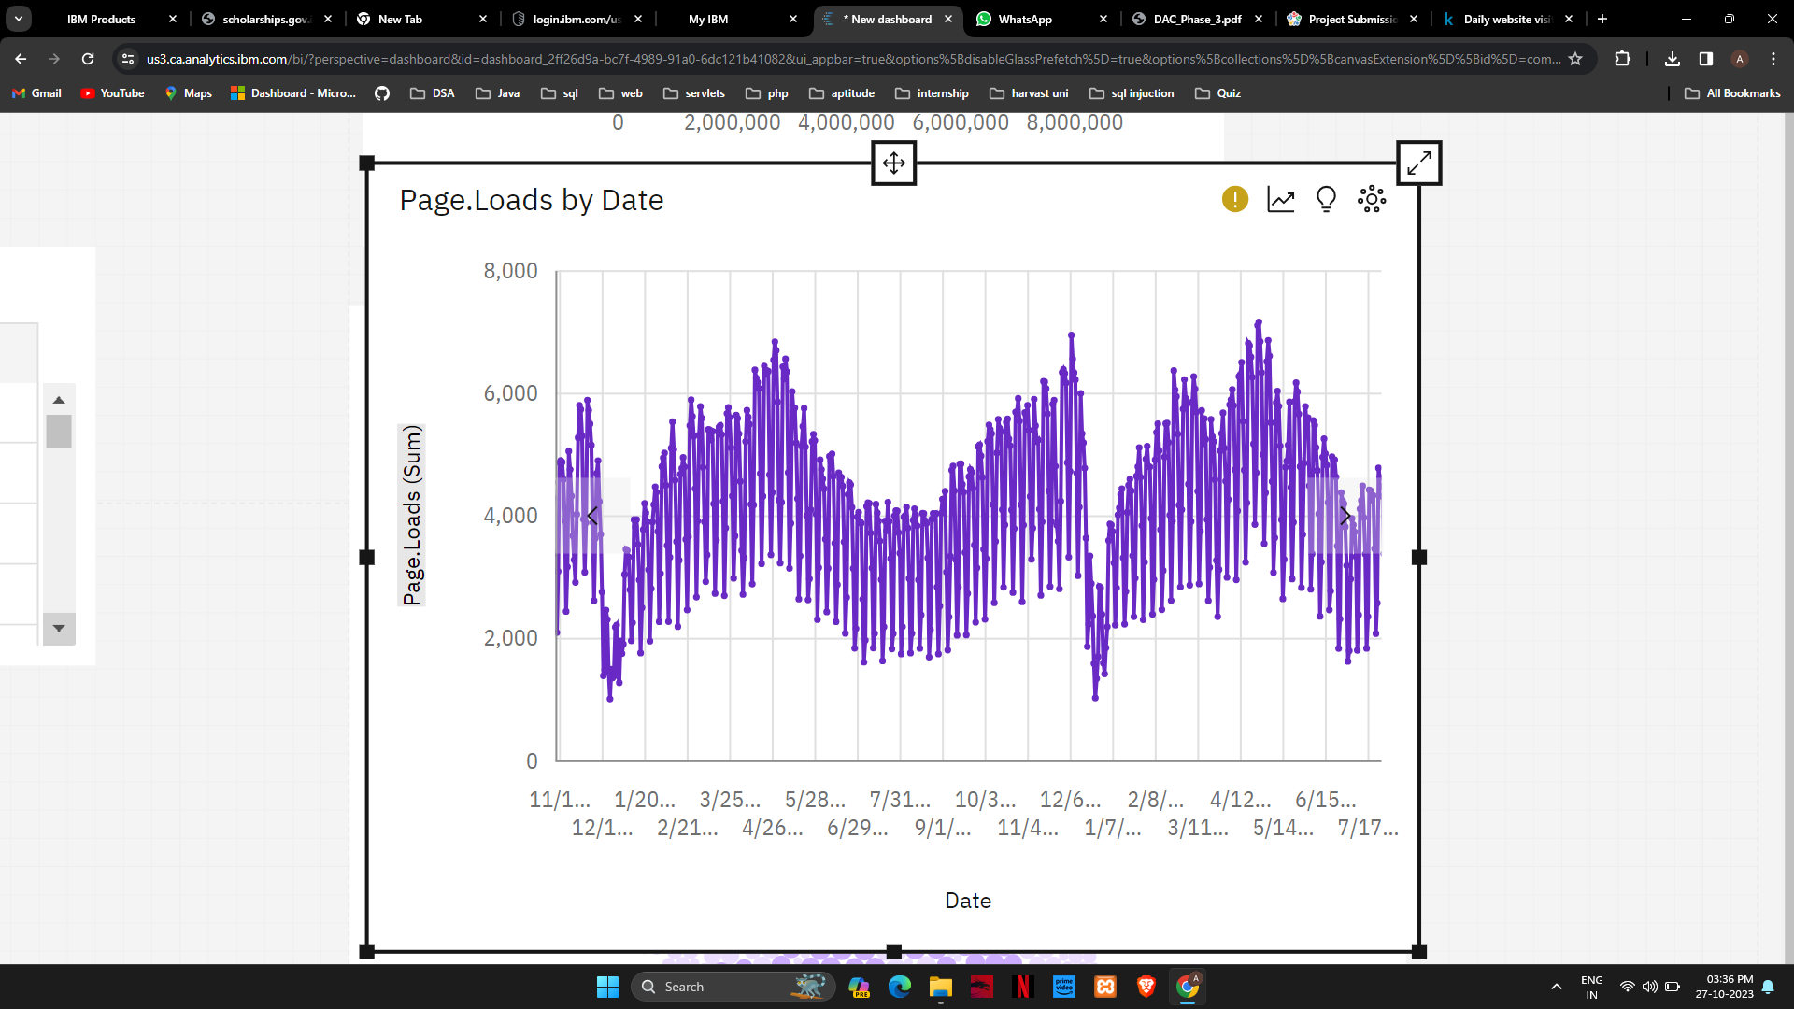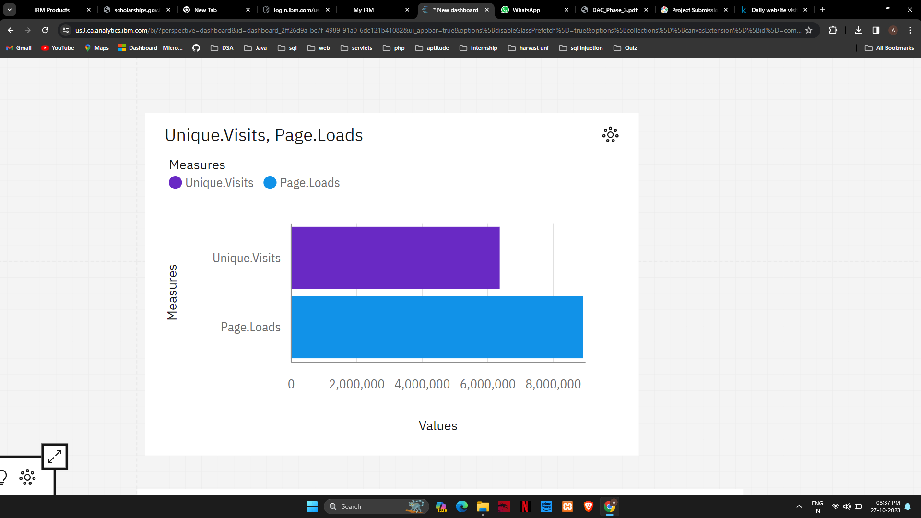

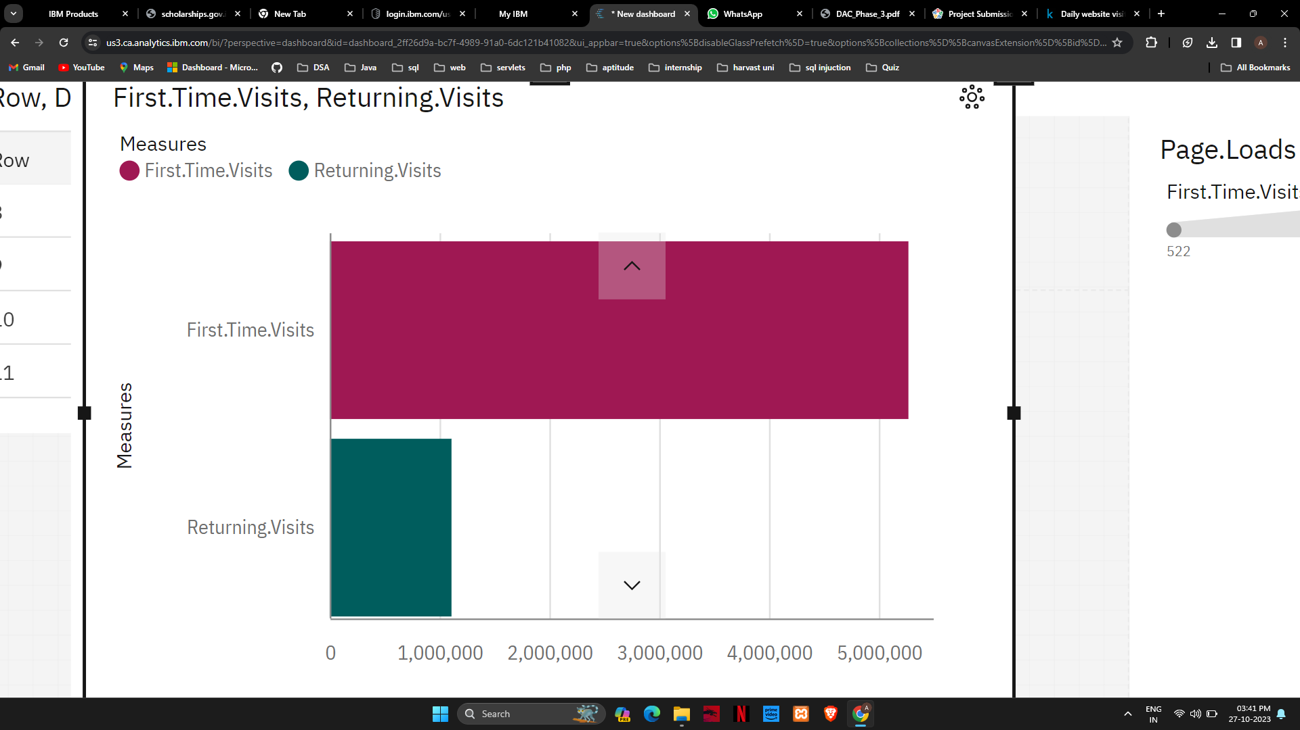

# CONCLUSION

In conclusion, leveraging IBM Cognos Analytics for website traffic analysis involves meticulous data preprocessing and insightful visualization techniques. By ensuring data accuracy and employing compelling visualizations, businesses can extract meaningful insights, enabling informed decision-making and optimizing online performance.