Using sentiment analysis for image captions enhances emotional context.

**SENTIMENT ANALYSIS:**

Sentiment analysis is the process of analyzing digital text to determine if the emotional tone of the message is positive, negative, or neutral. Today, companies have large volumes of text data like emails, customer support chat transcripts, social media comments, and reviews.

**STEP 1**:Data Collection

Gather the text data that you want to analyze for sentiment. This data can come from various sources, such as social media, customer reviews, or surveys.

**STEP 2**:Preprocessing

Clean and preprocess the text data. This may involve tasks like removing special characters, lowercasing, and tokenization (splitting the text into words or phrases).

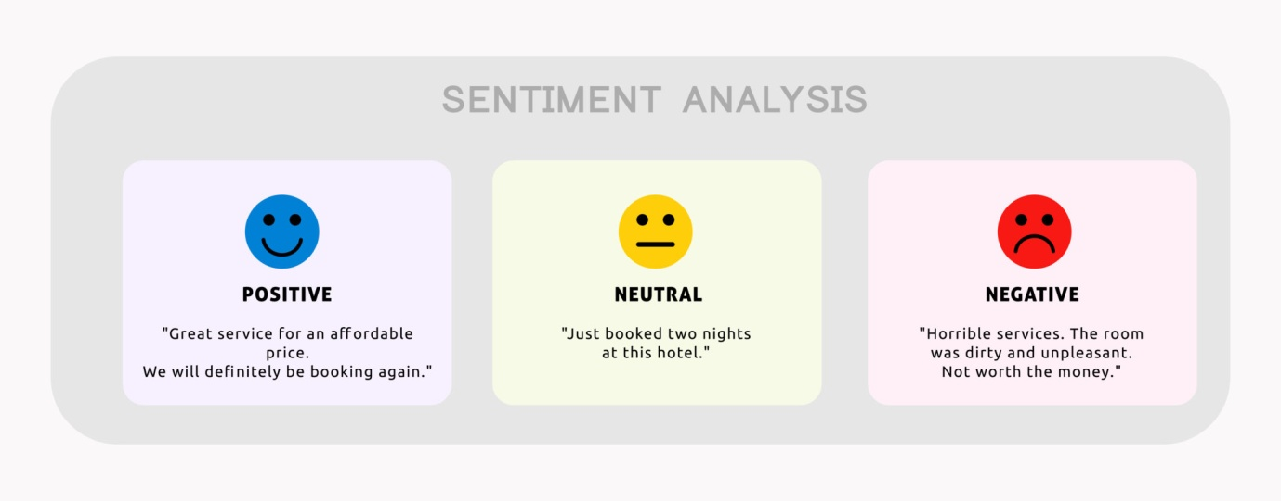

**STEP 3**:Feature Extraction

Convert the text data into numerical features that can be used for analysis. Common methods include TF-IDF (Term Frequency-Inverse Document Frequency) or word embeddings like Word2Vec or GloVe.

**STEP 4**:Sentiment Lexicon or Machine Learning Model

You can use a sentiment lexicon, which is a predefined list of words associated with sentiment scores (e.g., positive or negative). Alternatively, you can employ machine learning models like Naïve Bayes, Support Vector Machines, or deep learning models like Recurrent Neural Networks (RNNs) and Transformers (e.g., BERT) to predict sentiment.

**STEP 5**: Training (if using ML)

If you’re using a machine learning model, you’ll need a labeled dataset for training. This dataset should contain text examples with their corresponding sentiment labels (positive, negative, neutral). Sentiment

**STEP 6:**Classification

Apply the sentiment lexicon or trained model to the preprocessed text data to classify the sentiment of each text instance. Post-

**STEP 7**:processing (optional)

You may need to perform additional post-processing steps, such as aggregating sentiment scores for longer documents or applying rules for more accurate sentiment analysis.

**STEP 8**:Visualization or Decision Making

The results can be visualized in various forms, such as sentiment scores, word clouds, or emotional categories (e.g., joy, anger, sadness). These results can inform decision-making processes.

**STEP 9**:Evaluation (if using ML)

If you’re using a machine learning model, it’s important to evaluate its performance using metrics like accuracy, precision, recall, and F1 score. You may need to fine-tune the model for better results.

**STEP 10**:Application

Use the sentiment analysis results to gain insights into the emotional tone or opinions expressed in the text data. This can be applied to a wide range of applications, from customer feedback analysis to social media sentiment monitoring