OPENCV-OPEN SOURCE COMPUTER VISION FOR IMAGE PROCESSING

OpenCV (Open Source Computer Vision Library) is an open source computer vision and machine learning software library. OpenCV was built to provide a common infrastructure for computer vision applications and to accelerate the use of machine perception in the commercial products.

**STEP 1: Install OpenCV**

Begin by installing OpenCV on your system. You can do this using package managers like pip (for Python) or by building it from source.

**STEP 2: Import OpenCV**

In your code, import the OpenCV library. For example, in Python, you would use import cv2. Load an Image: Use OpenCV to load the image you want to recognize. You can do this with cv2.imread(‘image.jpg’).

**STEP 3: Preprocess the Image**

Preprocessing may involve tasks like resizing, filtering, or color conversion. This step depends on the specific requirements of your recognition task.

**STEP 4: Load a Pre-trained Model**

For many recognition tasks, you can use pre-trained models. OpenCV supports various models for tasks like face recognition, object detection, and more. Load the appropriate model using cv2.dnn.readNet().

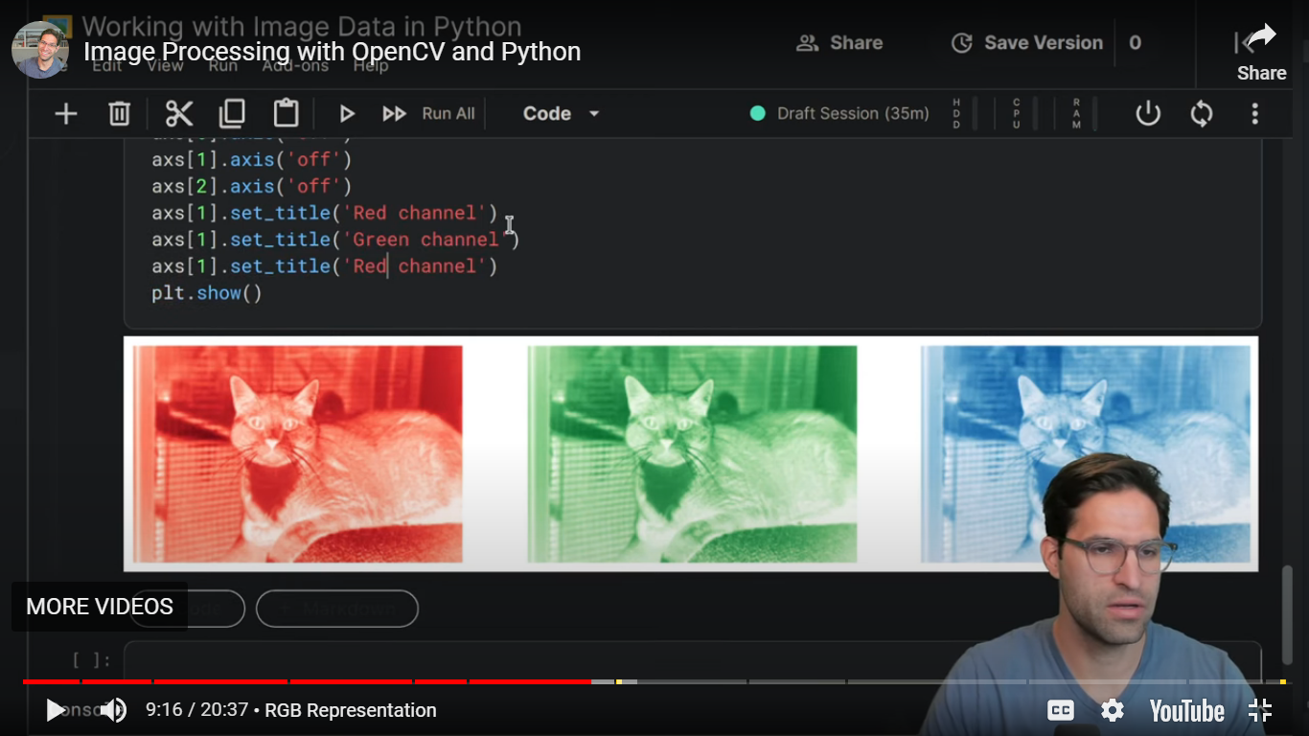

**STEP 5:Set Input:**

Prepare the image for input to the model. This often involves resizing and normalization. Use the model’s input shape and size as a guide.

**STEP 6: Perform Inference**:

Use the loaded model to perform inference on the preprocessed image. This can be done with model.forward().

**STEP 7: Post-process Results:**

The output from the model might need post-processing to extract relevant information. For example, for object detection, you’ll need to filter and interpret bounding boxes.

**STEP 8: Display or Use the Results**:

You can choose to display the results with OpenCV’s drawing functions or use the recognition results for further actions in your application.

**STEP 9: Clean Up:**

Properly release resources, like closing the image file or releasing the model when you’re done with them.

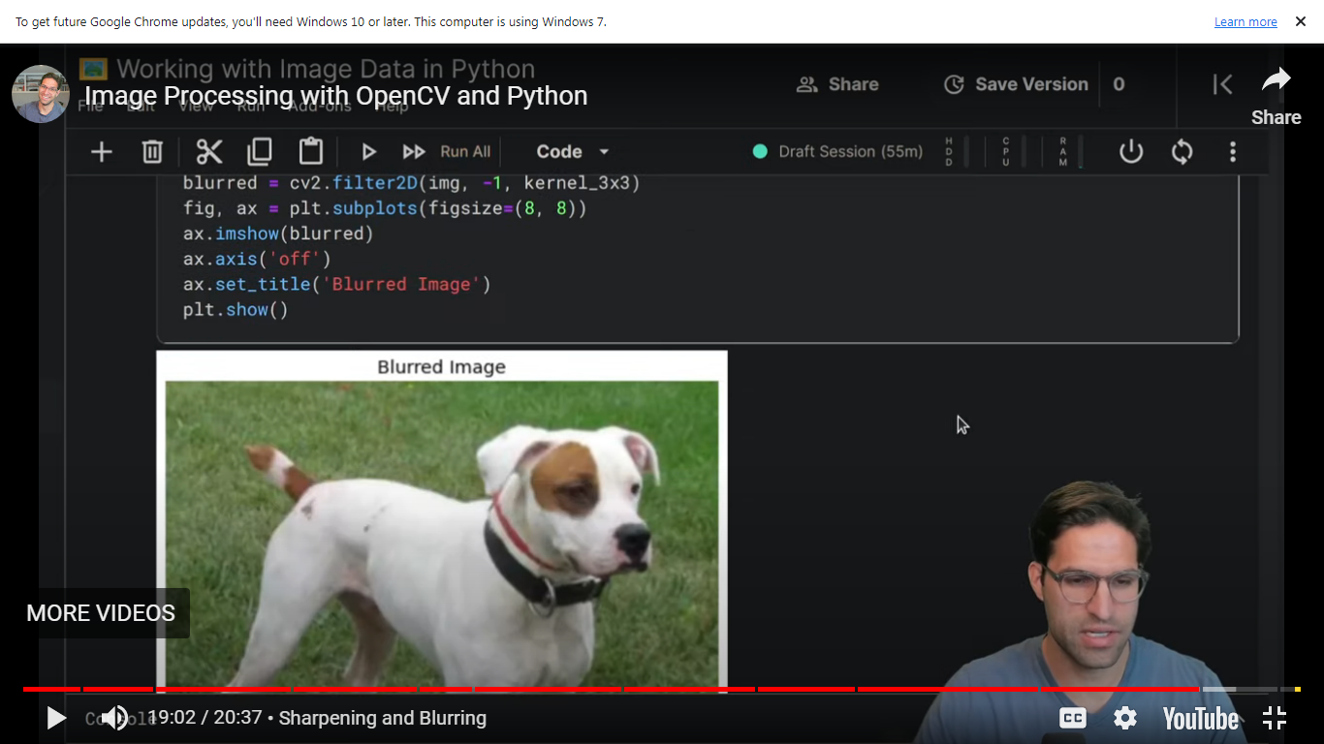

**STEP 10:Repeat (Optional)**

If you’re processing multiple images or working in a real-time environment, you can repeat the process for each new image.

**STEP 11: Handle Errors and Exceptional Cases**

Implement error handling to deal with issues like image loading failures, model loading errors, or inference problems.

**STEP 12: Optimize (Optional)**

Depending on your use case, you may want to optimize the code for better performance. OpenCV provides options for hardware acceleration and parallel processing