API Document
DevOps



Document Type | API Document
Document # | DevOps API_V1.01
Project Title | App Api workflow
Project Type | Live Deployment
Service Provider | MicroGrid Inc.
Document Date | 25 April 2023
Document Version | Version 1.02

Dharan S, Srinivas Negi
MicroGrid – Application Developer | MicroGrid – Product Owner
Prepared & Reviewed by | Approved by

Table of Contents
1. Introduction 3
2. Git workflow configuration for APP API Deployment: 3
2.1 Create a New Workflow: 4
2.2 Secret Key generation in GCP: 6
2.3 Adding Secret Key in GitHub: 6
2.4 Creating Yaml file: 7
2.5 Run workflow steps: 8
2.6 App engine version updation: 9
3. Contact Persons 9

Introduction
Git Workflow
Git: Git is a distributed revision control and source code management system with an emphasis on speed. Git was initially designed and developed by Linus Torvalds for linux kernel development. Git is a free software distributed under the terms of the GNU General Public license version 2.
- Git for Project version control in a distributed environment while working on web – based and non – web based application development.

Version Control System (VCS): VCS is a software that helps software developers to work together and maintain a complete history of their work
Functions of VCS:
- Allows developers to work simultaneously
- Does not allow overwriting each other’s changes.
- Maintain a history of every version

Types of VCS:
- Centralized version control system (CVCS)
- Distributed/Decentralized version control system (DVCS)

Advantages of Git:
- Free and open source
- Git is released under GPL’s open source license. It is available freely over the internet. You can use git to manage property projects without paying a single penny. As it is open source, you can download its source code and also perform changes according to your requirements.

Let us see the basic workflow git.
- Step 1 – modify a file from the working directory.
- Step 2 – add these files to the staging area.
- Step 3 – perform commit operation that moves the files from the staging area. After push operation, it stores the changes permanently to the git repository

Git workflow configuration for APP API Deployment:
Creating an App API workflow action in Git allows you to automate the deployment of your API application to a server or a cloud platform like Heroku, AWS, or Google Cloud. This can be particularly helpful if you have a complex deployment process, as it can save you time and reduce the risk of errors
- Continuous Integration and Delivery (CI/CD)
- Version Control
- Containerization

Create a New Workflow:

Login into the GitHub Portal: https://github.com
- Go to GitHub & click on required Source code repository

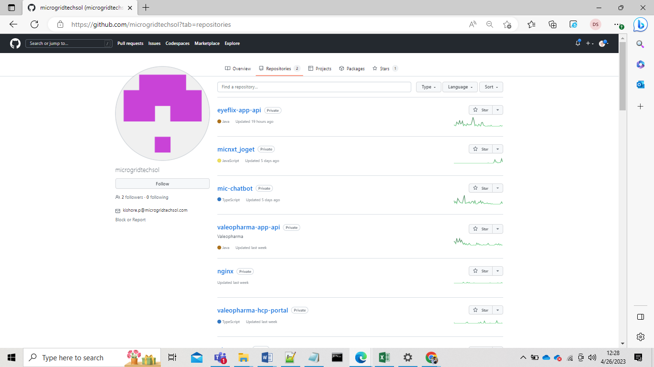

- Here we can see the source code which we need to deploy through workflow actions.

- Here we need to click on Action to configure the java with maven as per required code project
- Here we can see the yaml file creation path we can create as our required cloud setting as below screen shot step 1 & step 2.

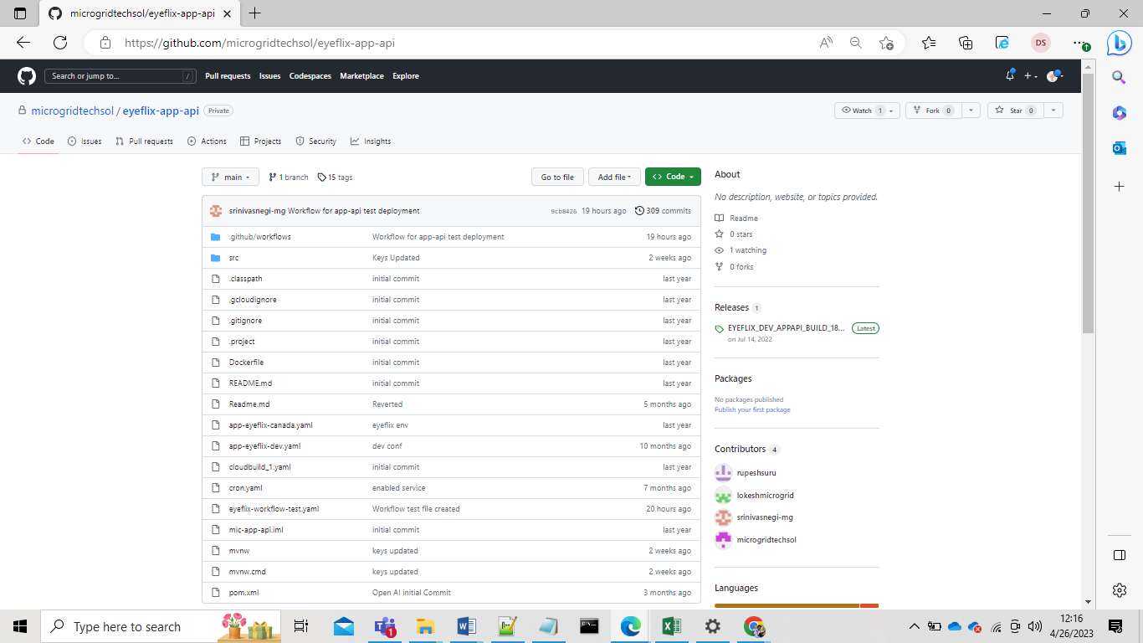

Step.1

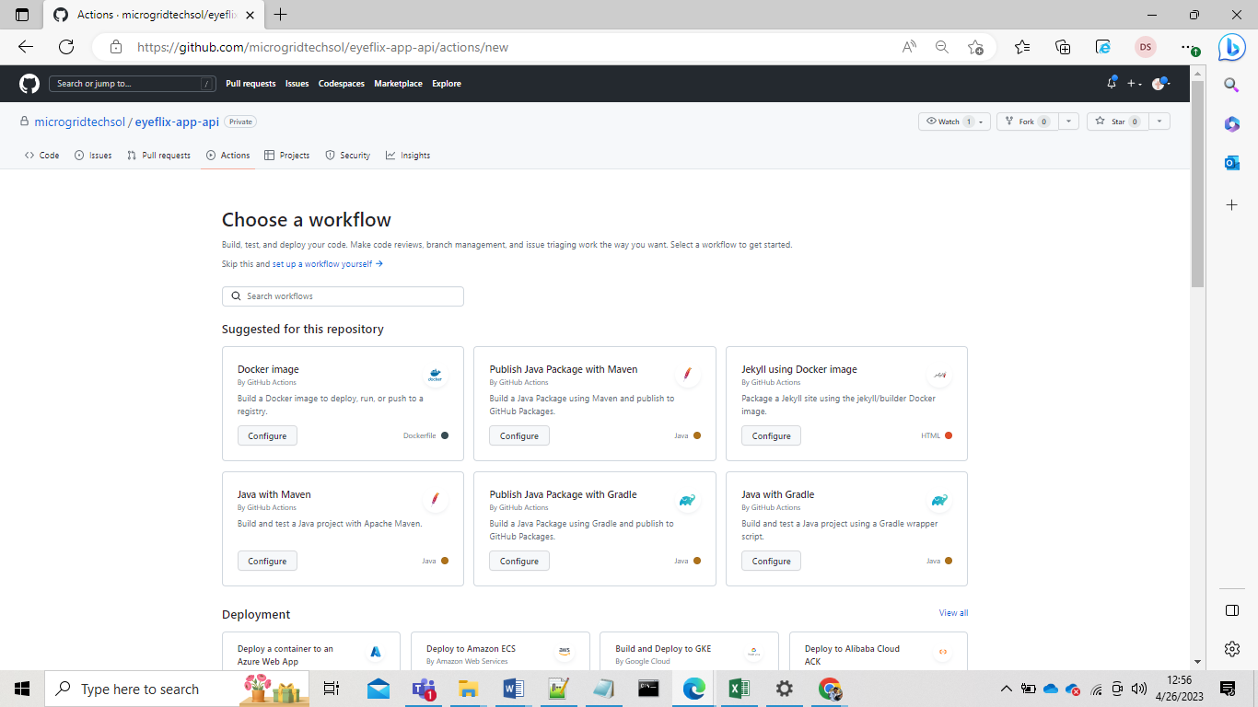

Step.2

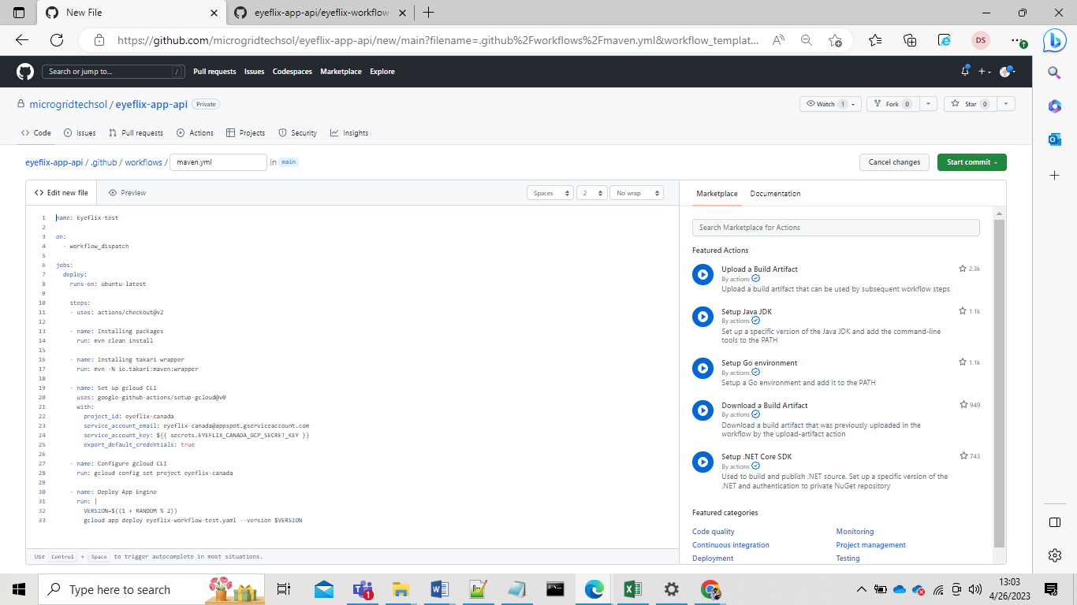

Secret Key generation in GCP:

- Open GCP console and go to IAM & ADMIN page from required project.
- Go to service account section and click on App engine default service account.
- Here go to keys option and click on Add key to create secret key for the service account.
- The Key will be generated.

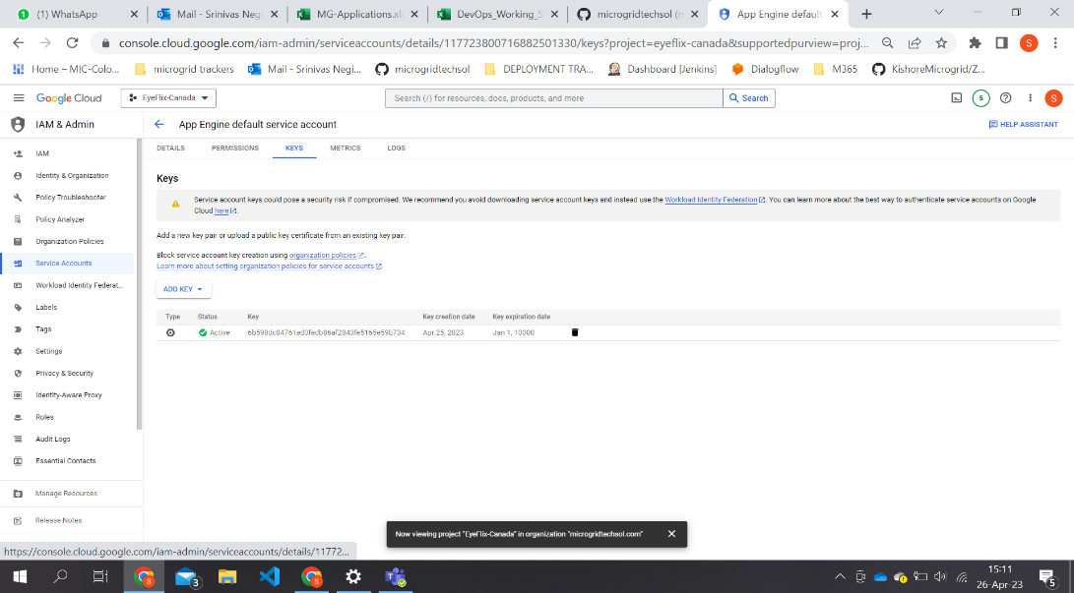

Adding Secret Key in GitHub:

- Before adding a secret key to git convert the code from Json to Base64.
- Go to GitHub repo and click on settings, go to security option to add secret key.
- Place the base64 code in the Secret section & must follow the naming convention as per project details for the secret key name.
- Now click on add secret, then

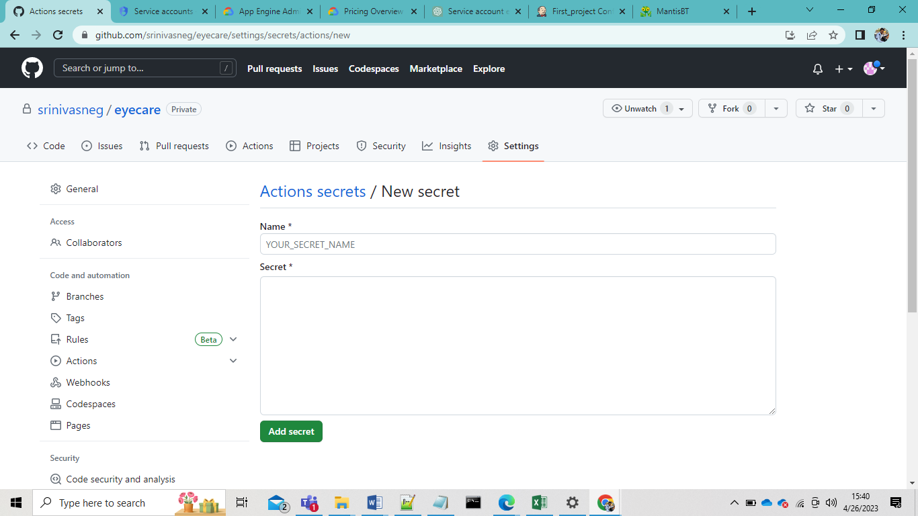

Creating Yaml file:

- The steps we have to follow to create yaml file with proper secret keys for service accounts & commands to install packages, deploy versions.

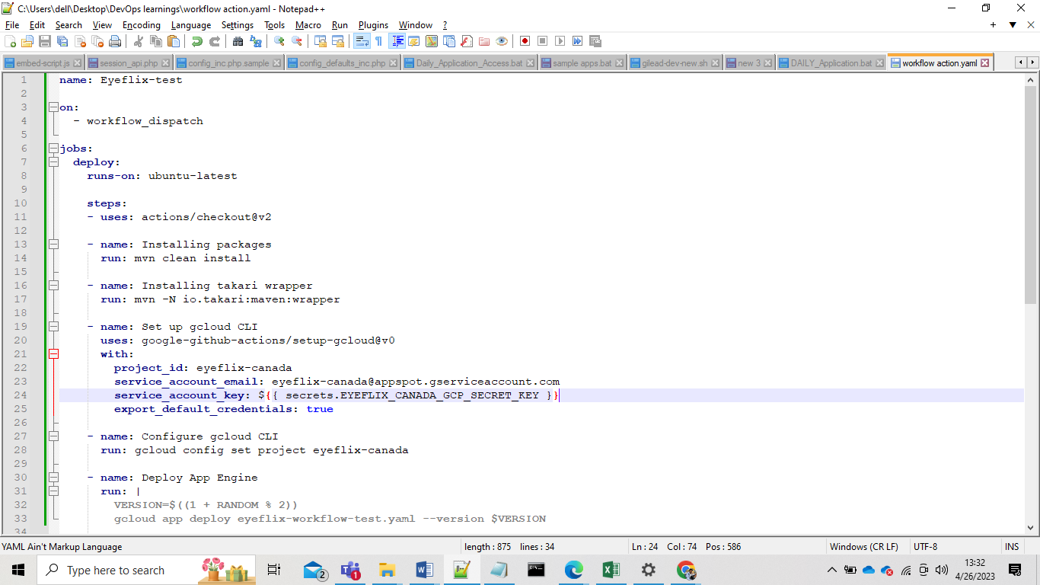

- Commands Description used in Yaml files

    - on: workflow_dispatch: This specifies that the workflow should run when manually triggered by a user, rather than being triggered automatically by a push or other event.

    - runs-on: ubuntu-latest: This sets the operating system environment for the workflow to the latest version of Ubuntu.

    - actions/checkout@v2: This action checks out the code repository for the project.

    - mvn clean install: This command runs the clean and install goals for the Maven build tool, which cleans up any existing build artifacts and then builds and installs the project's dependencies and source code.

    - mvn -N io.takari:maven:wrapper: This installs the Takari Maven wrapper, which allows the Maven build tool to be run without having to install it on the local machine.

    - google-github-actions/setup-gcloud@v0: This action sets up the Google Cloud SDK command-line interface for use in the workflow.

    - gcloud config set project eyeflix-canada: This sets the default project for the gcloud CLI to eyeflix-canada.

    - gcloud app deploy eyeflix-workflow-test.yaml --version $VERSION: This deploys the application to Google App Engine using the gcloud CLI, specifying a YAML configuration file for the deployment settings and a random version number generated by the $((1 + RANDOM % 2)) command.

Run workflow steps:

- Go to Actions, click on the App engine deployment and we can see the run workflow down bar To run the workflow deployment

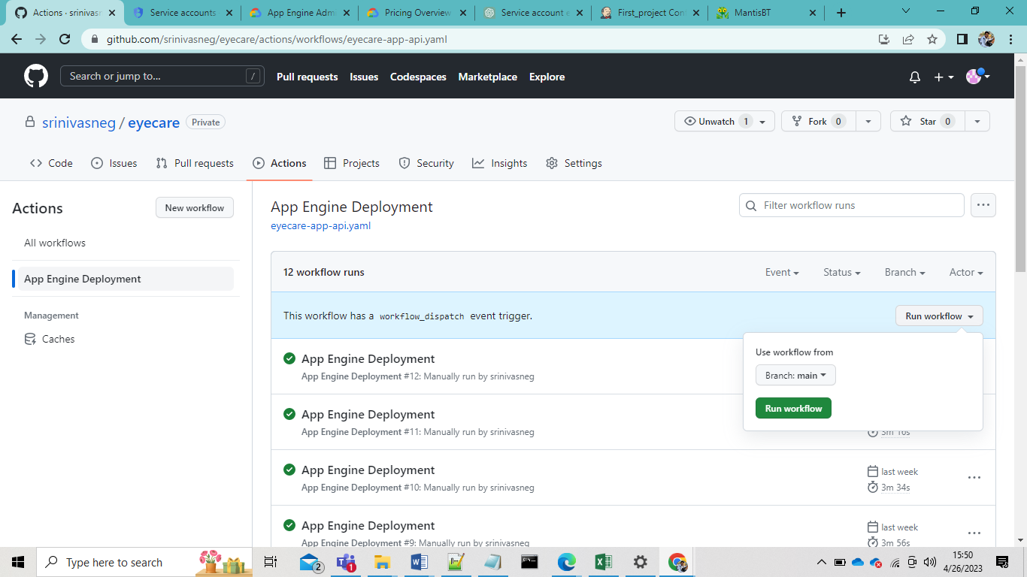

App engine version updation:

- After the deployment we can see the version update in GCP App engine in the versions

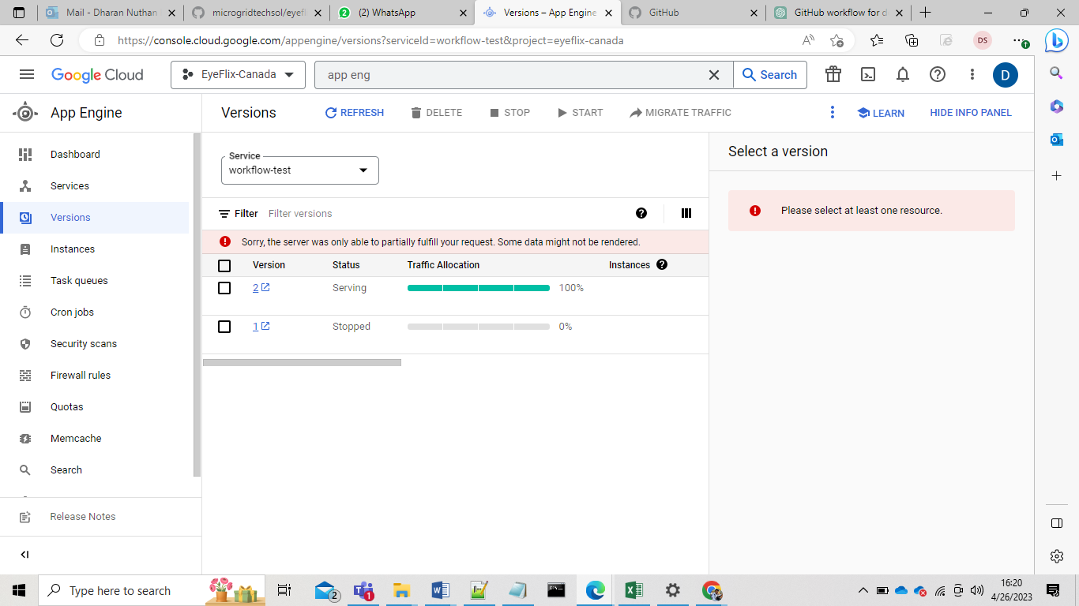

Contact Persons

Please contact for more information / clarifications / assistance:

Name | Contact
Srinivas Negi | srinivasa.n@microgridtechsol.com
Dharan. s | dharan.s@microgridtechsol.com
Kishore. b | kishore.b@microgridtechsol.com

