API Document
ZOE

 | 

Document Type | API Document
Document # | DevOps API_V1.01
Project Title | Gilead
Project Type | Live Deployment
Client | Novartis Services Inc.
Service Provider | MicroGrid Inc.
Document Date | 05 April 2023
Document Version | Version 1.01

Dharan S,Meenakshi S.
MicroGrid – Application Developer | MicroGrid – Product Owner
Prepared & Reviewed by | Approved by

Table of Contents
1. Introduction 3
2. Jenkins configuration for Chatbot Deployment: 3
2.1. Create a New Project: 4
2.2. General: 5
3. Limitations 9
4. Contact Persons 9

Introduction
Jenkins
- Jenkins is a server that encompasses various integration, testing, and deployment technologies as pre-built packages on one unified platform. As an open-source tool written in Java, Jenkins helps developers automate routine tasks and provide new builds as quickly as possible.

- Jenkins' main features are jobs and pipelines, which allow the following:
- Continuous integration pipelines for applications and Infrastructure as Code (IaC), which helps automate building and testing.
- Continuous delivery pipelines through automated delivery workflows, which achieves non-stop code deployment.
- Automation jobs and pipelines for routine tasks, such as backup management, service statistics, etc.

Jenkins configuration for Chatbot Deployment:

Jenkins can be used to deploy chatbots in several ways, depending on the chatbot platform being used and the specific deployment requirements.

- Continuous Integration and Delivery (CI/CD
- Version Control
- Containerization
- Chatbot Frameworks

Publisher | Subscriber | Mode of Operating | Service Type | Protocol
Microgrid | Third-party system | Synchronous | RESTFull | https

Create a New Project:

Login into the Jenkins Portal: https://jenkins.micnxt.com
- Click the New Item link on the left-hand side of the Jenkins dashboard.

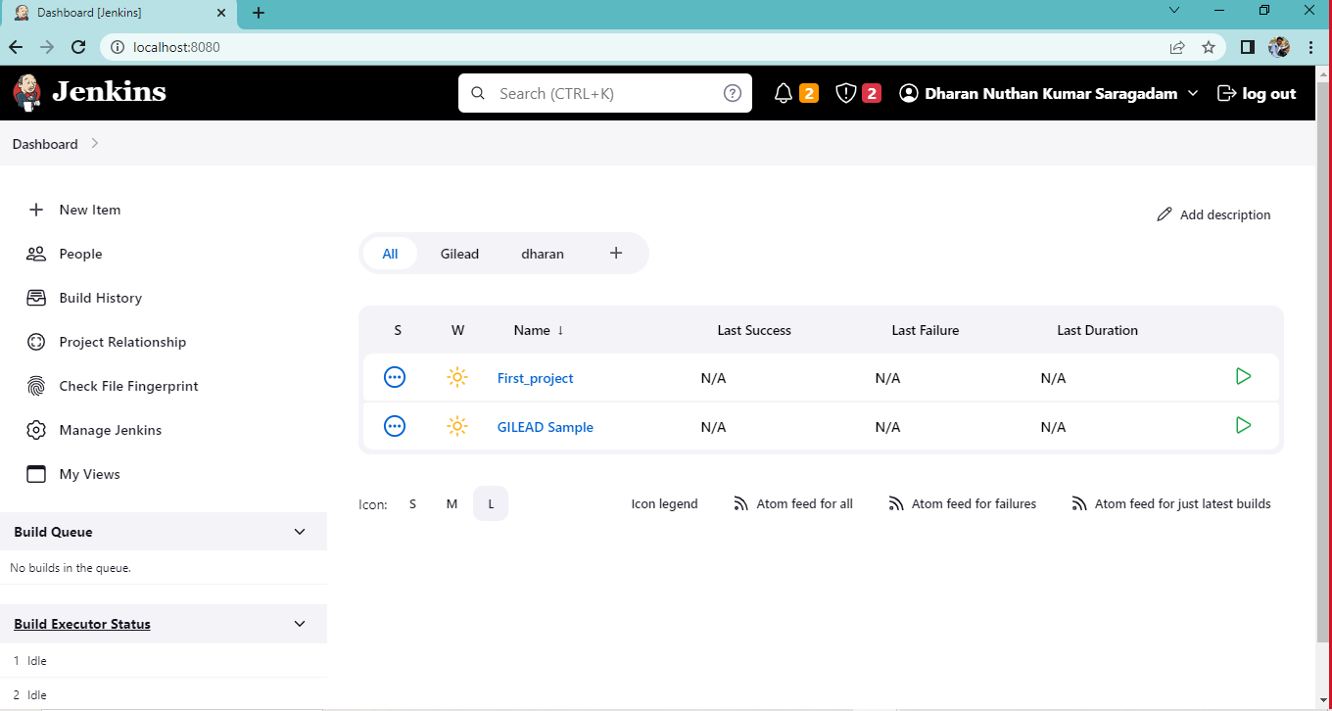

- Enter the new project's name in the Enter an item name field and select the Freestyle project type. Click OK to continue. After created we get some configurations to create a
Build.

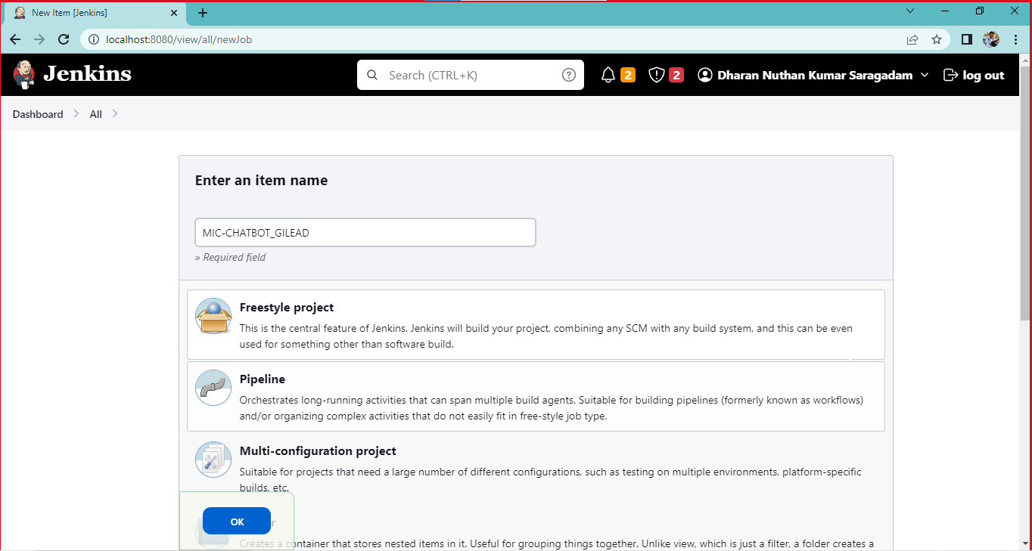

General:

- Here we can add a project description in the Description field and Here we need to select the Enable project based security and GitHub project
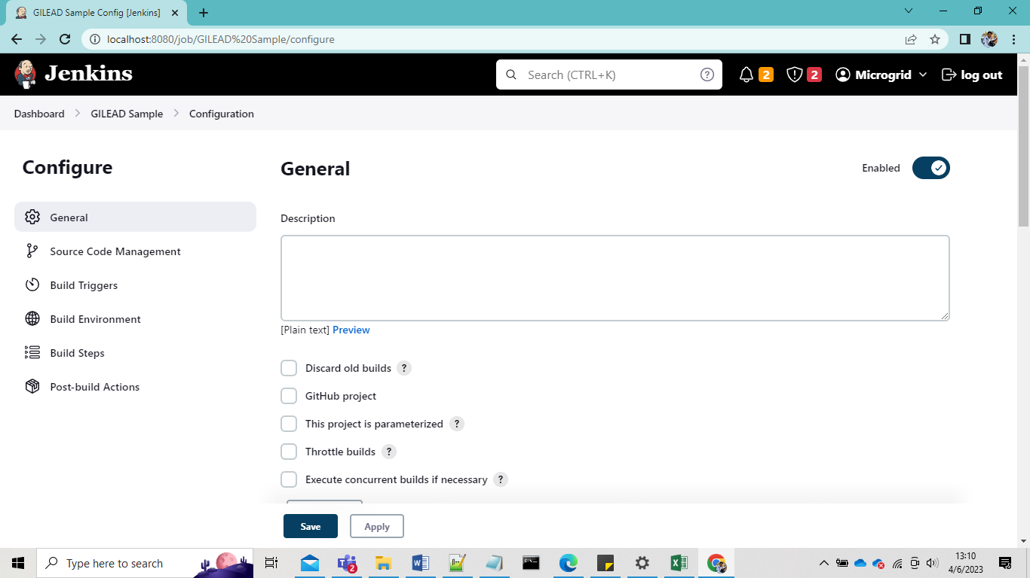

- Click on the GitHub project on the project URL we need to give our git hub repository URL as provided below evidences

Step.1
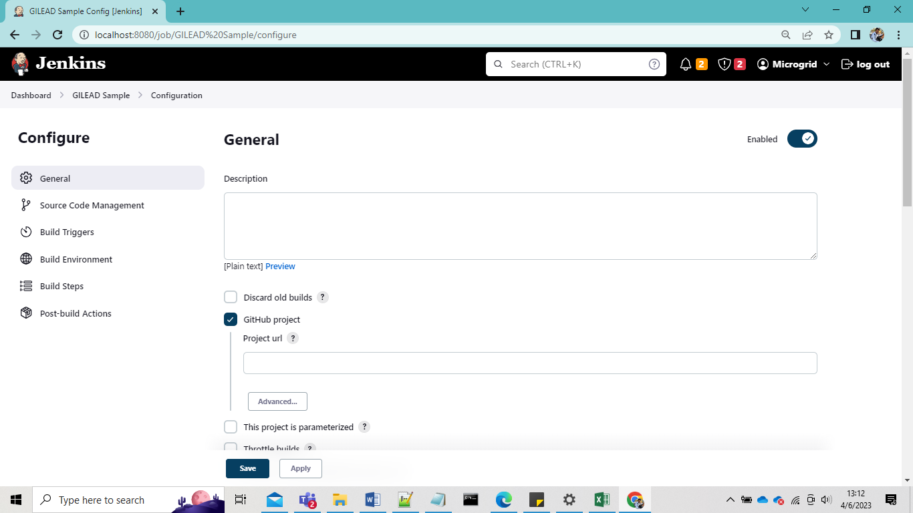

Step.2
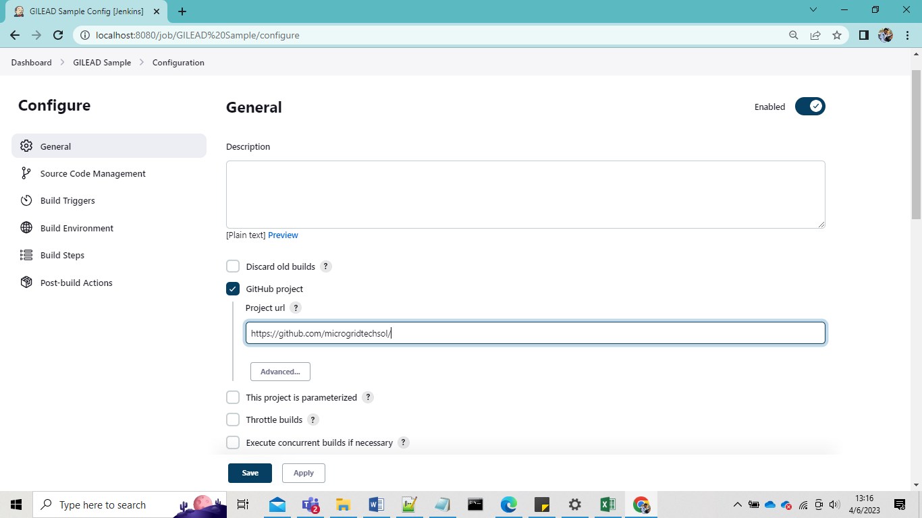

  - Source code management:

- Here we can see two option configure source code management
1. None
2. Git

- Here we selected the Git fill out the all
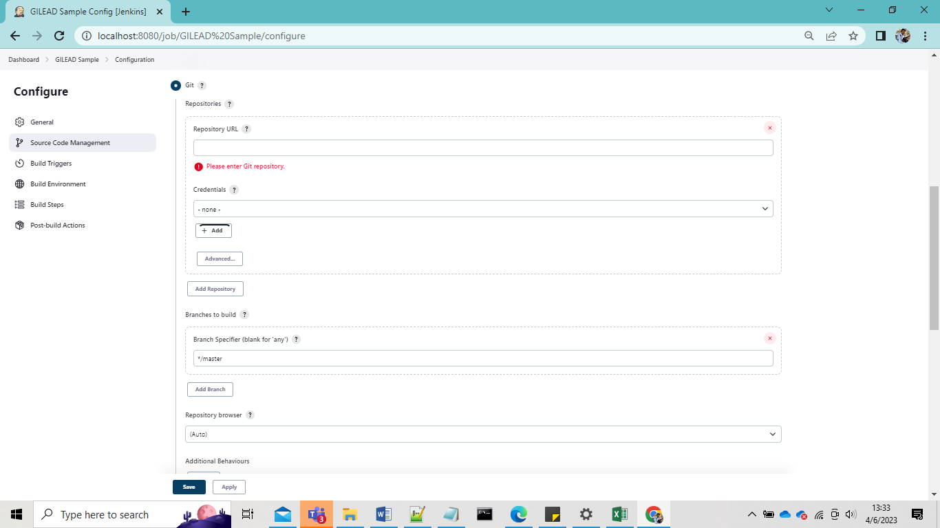

- Here we need to Paste Git repository SSH Url from git as provided below fig

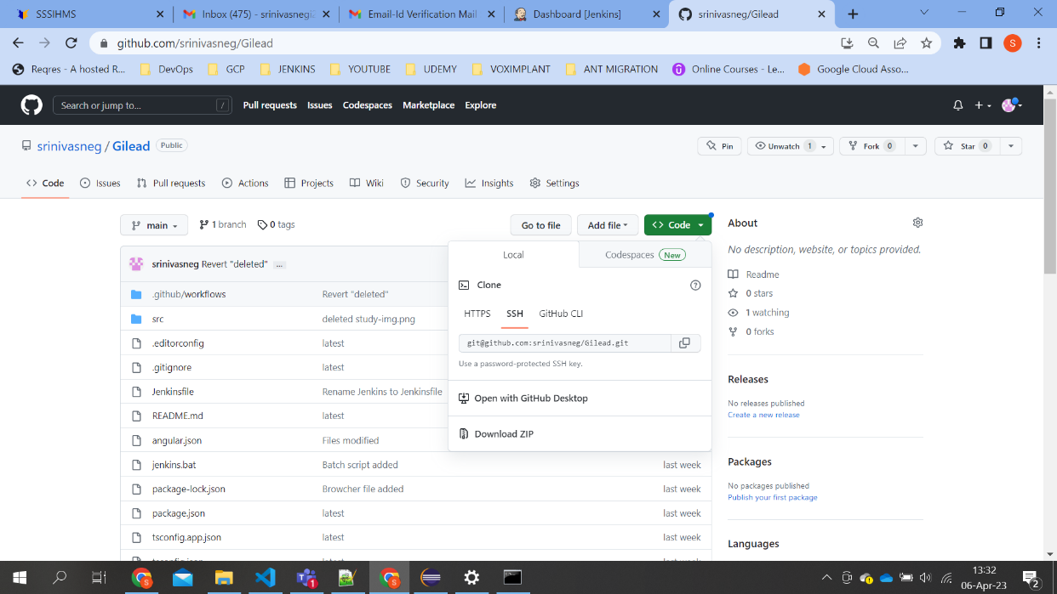

Provide credentials key for Jenkins

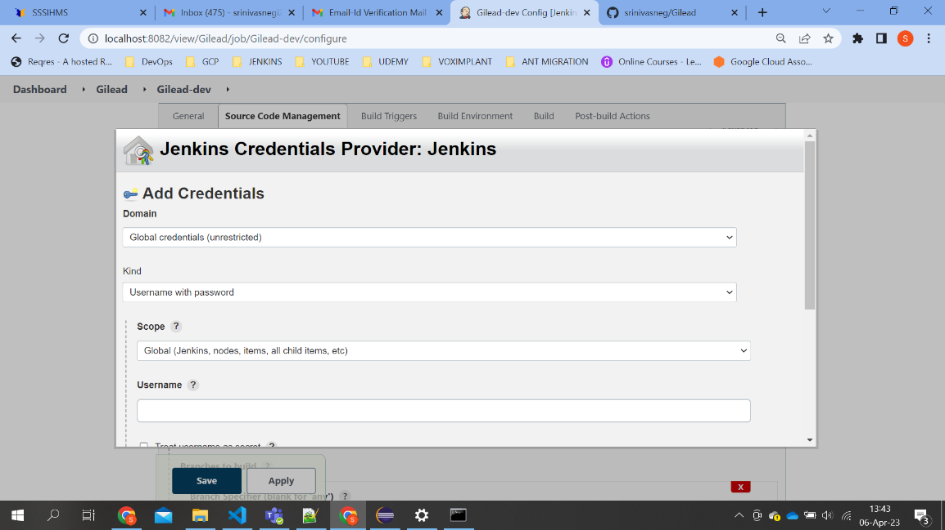

Branches build need to give main branch sub branch what we have created and Repository browser is default

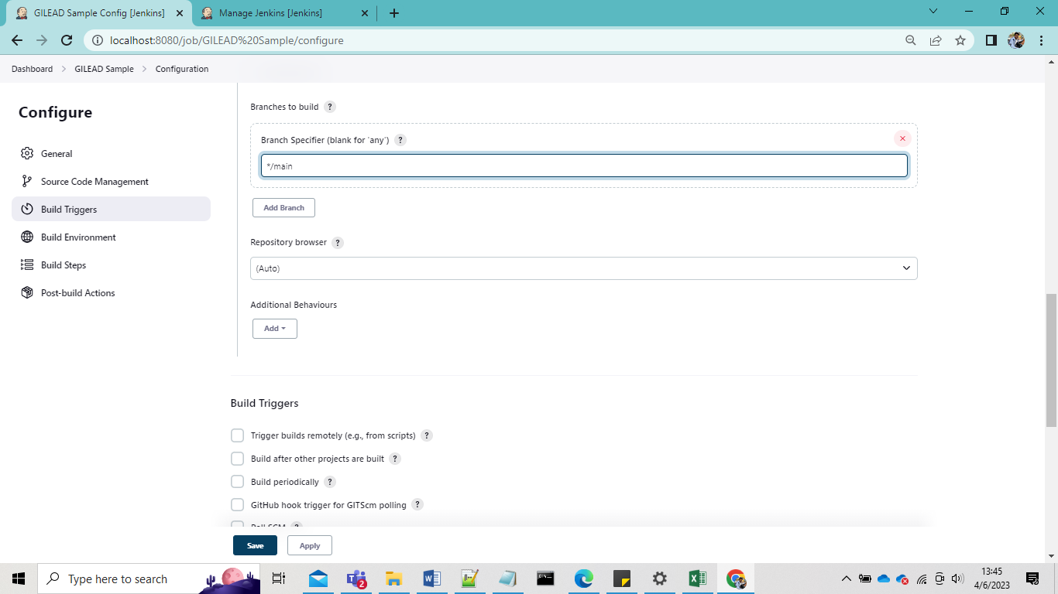

2.4. Build Triggers:

- In Jenkins, the build trigger option is used to specify the conditions that must be met to automatically trigger a new build of a job.
- As per our need we need to suggest the field not mandatory to use this option

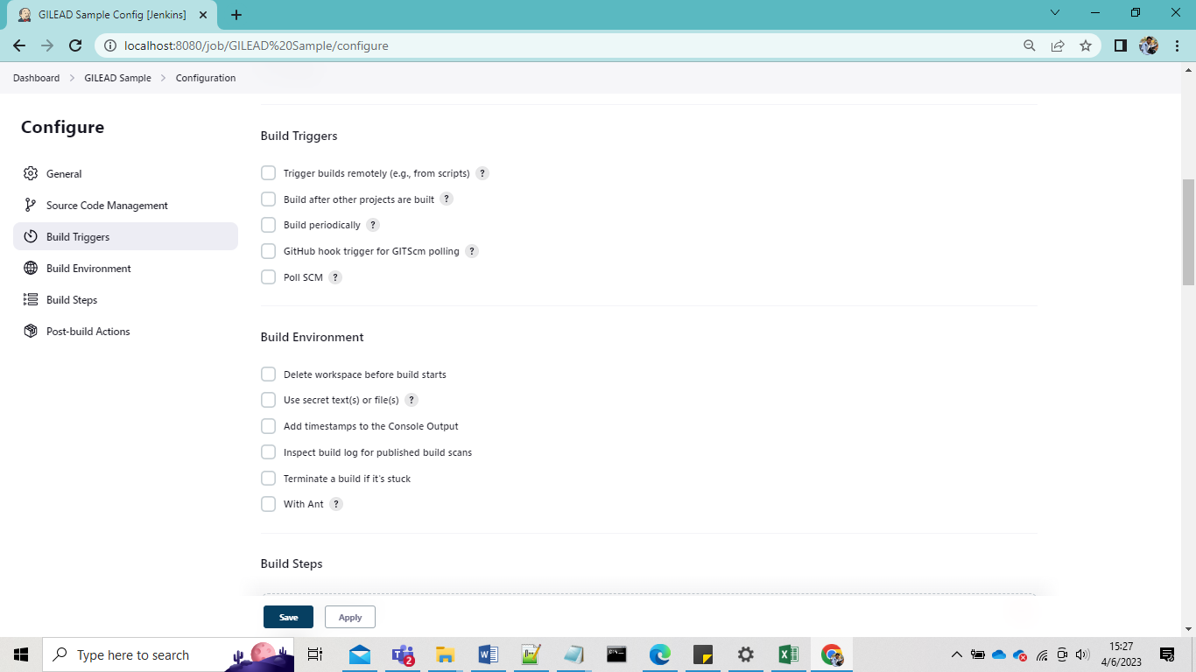

2.5. Build Environment:

- In Build environment select 3 rd option to set time stamps for the deployment steps

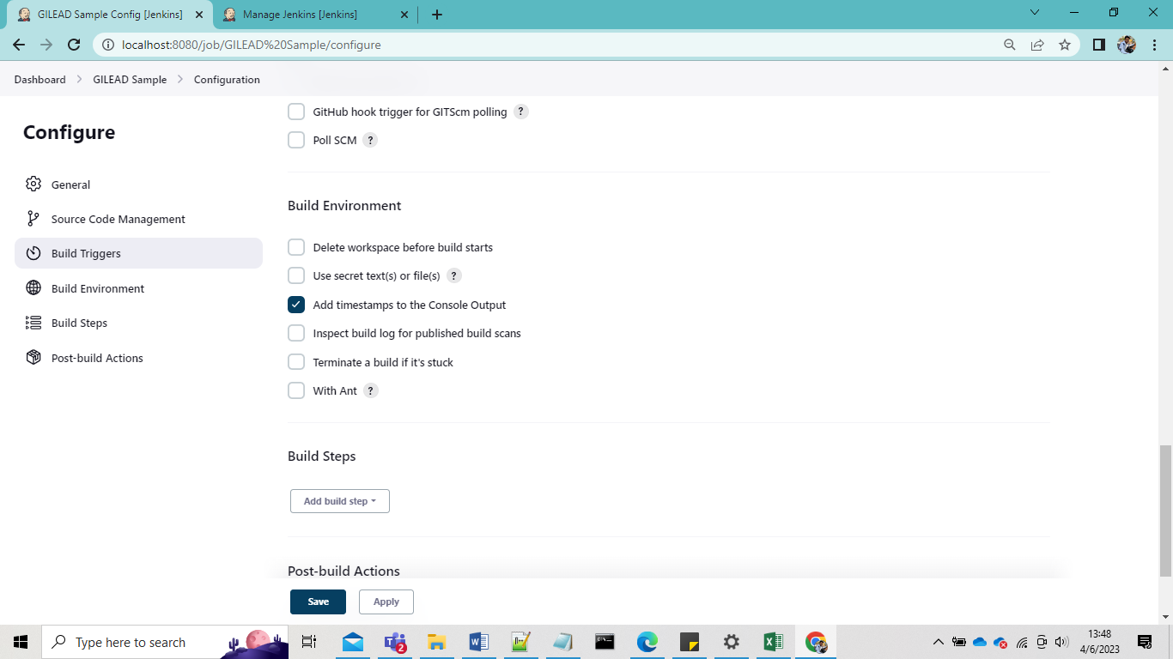

2.6.Build Steps:
- Step:1
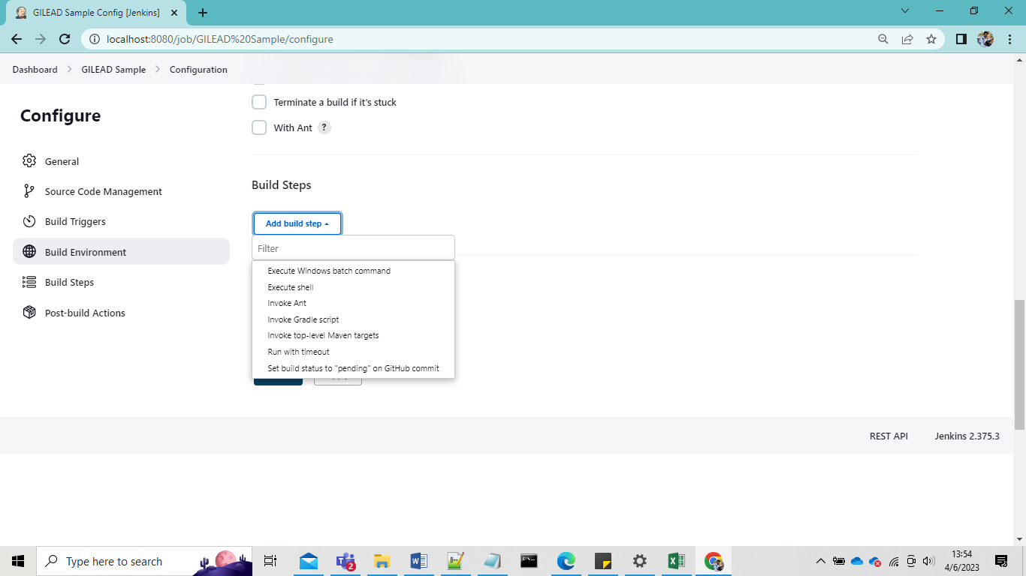

Step:2

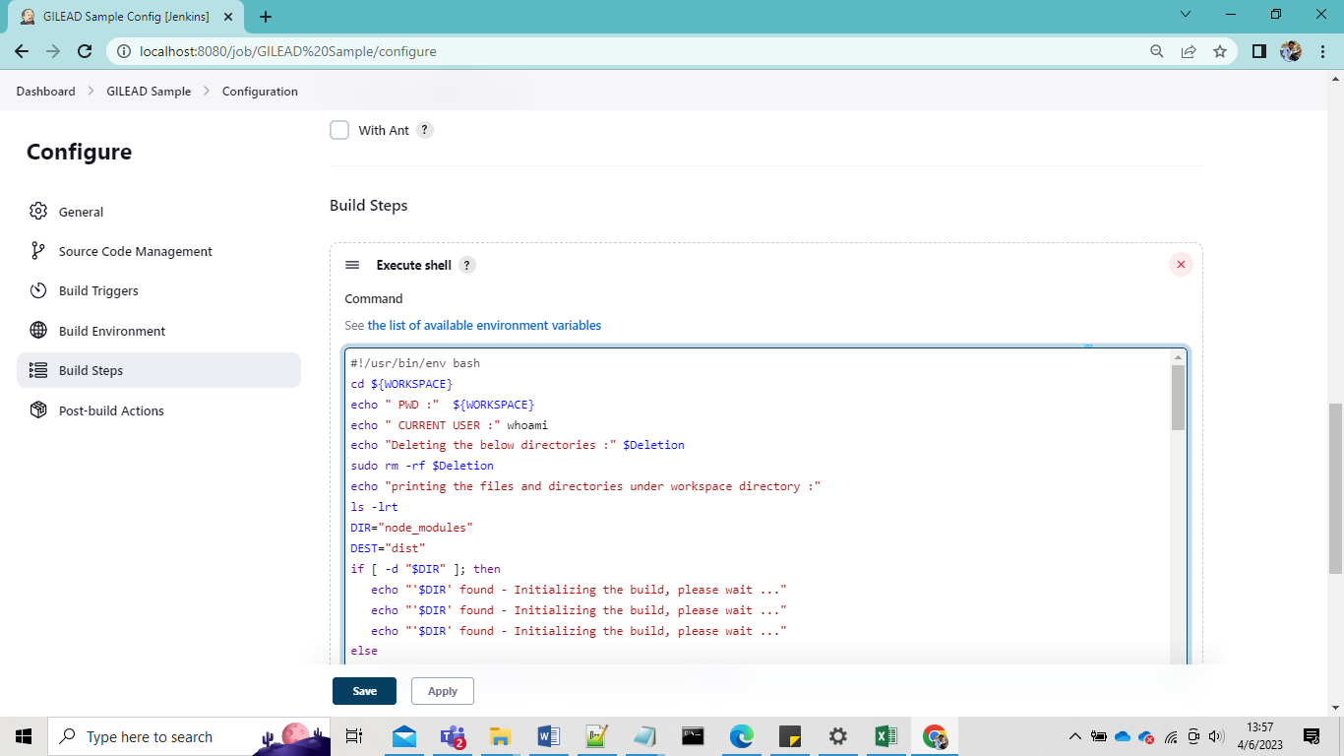

2.6.Post Build Action:
- Step:1 click on git publisher
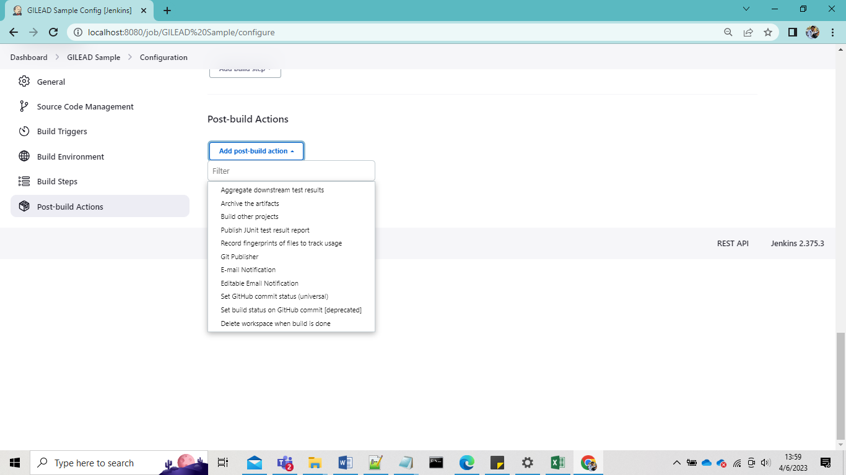

- Step:2
Push only after build success
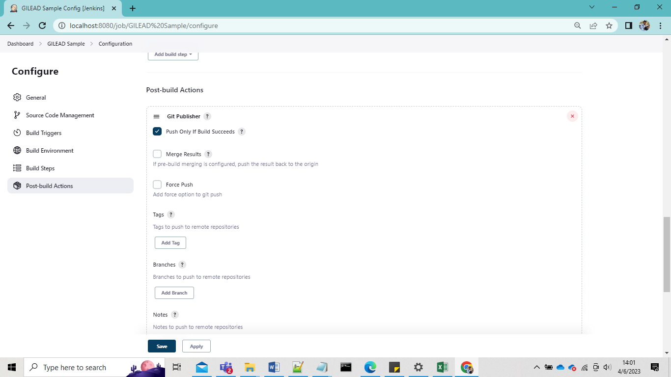

- Step:3
Creating Build tags
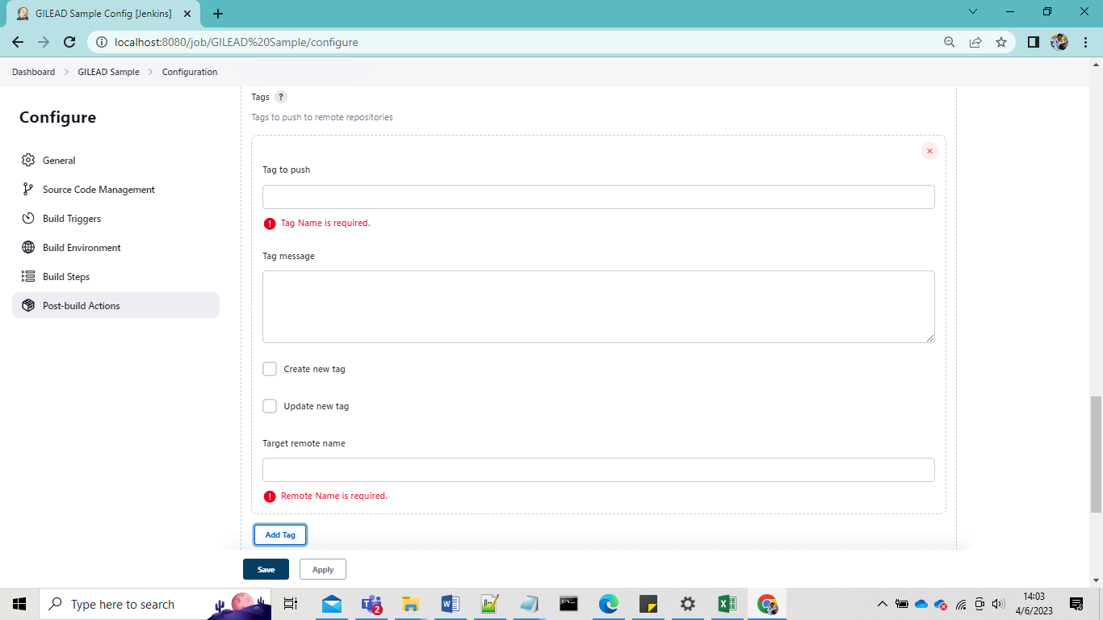

Limitations

Contact Persons
Please contact for more information / clarifications / assistance:
Name | Contact
Srinivas Negi | srinivasa.n@microgridtechsol.com
Dharan. s | dharan.s@microgridtechsol.com
Kishore. b | kishore.b@microgridtechsol.com

