* Hot Days and Cold Days for each City (Latitude & Longitude)

Mapper.py

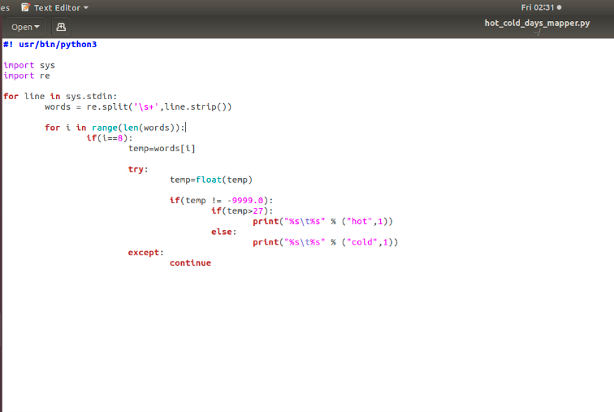

Reducer.py

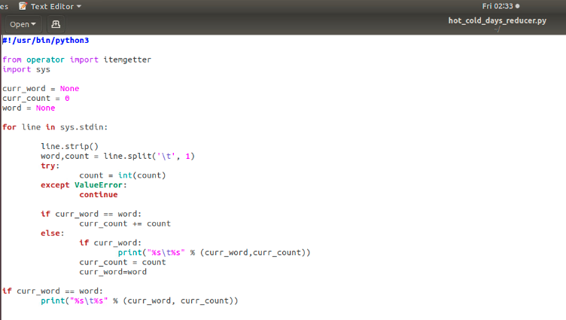

Outputs:

AustinAsheville

Baker

Fair_Banks



Holy_Springs



Ithaca

* Show Average Soil Moisture SOIL_MOISTURE_5_DAILY, SOIL_MOISTURE_10_DAILY, SOIL_MOISTURE_20_DAILY, SOIL_MOISTURE_50_DAILY

Mapper.py

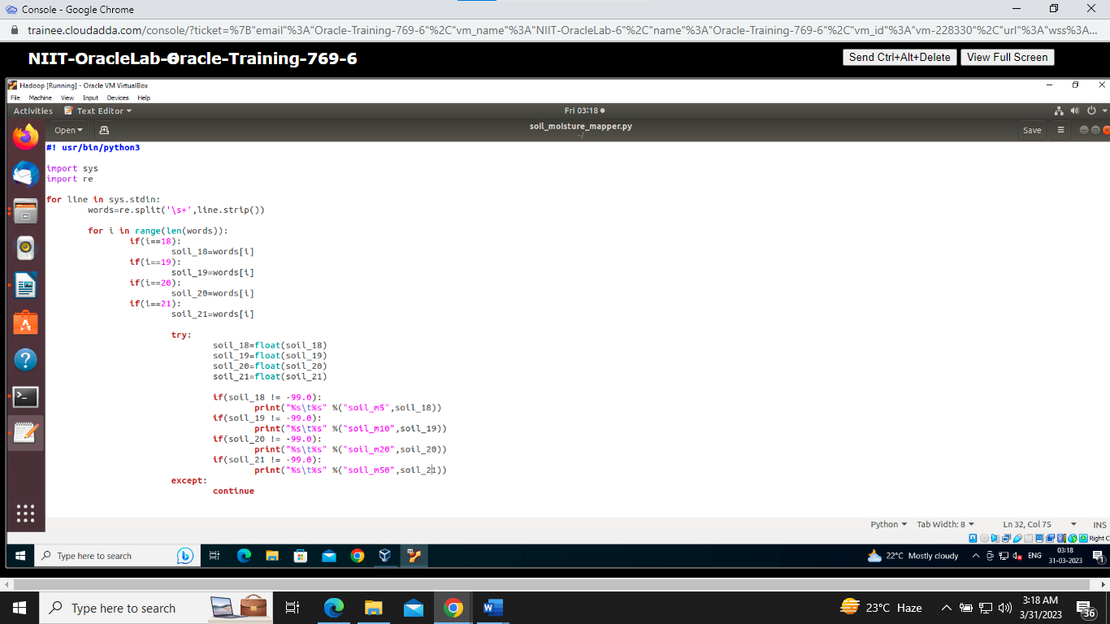

Reducer.py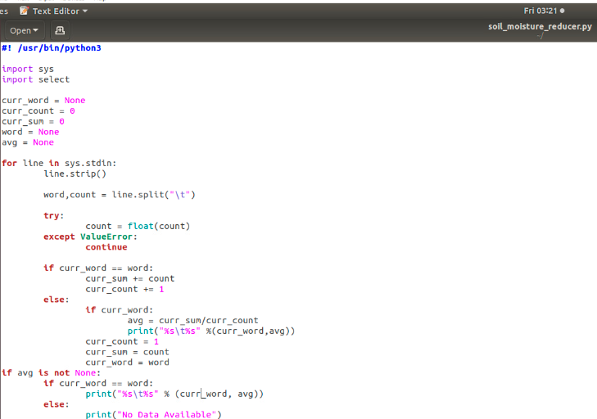

Outputs:

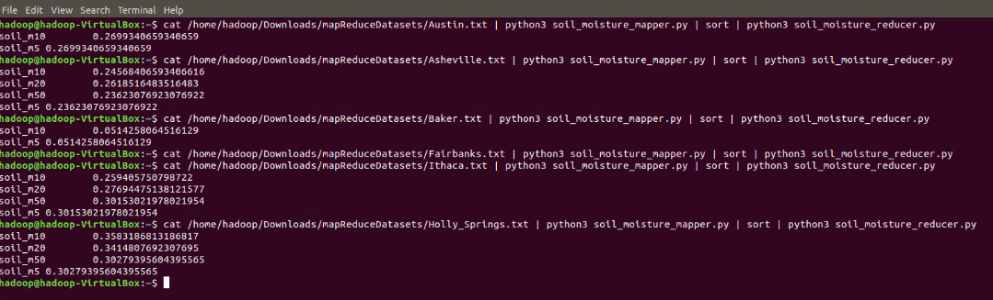

* Average Temperature for each City (Latitude and Longitude)

Mapper.py

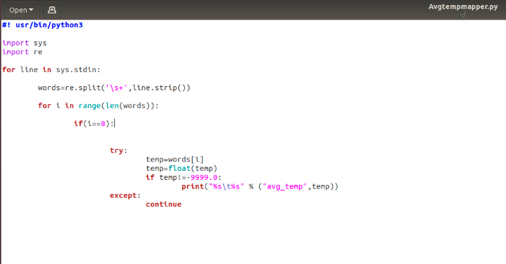

Reducer.py

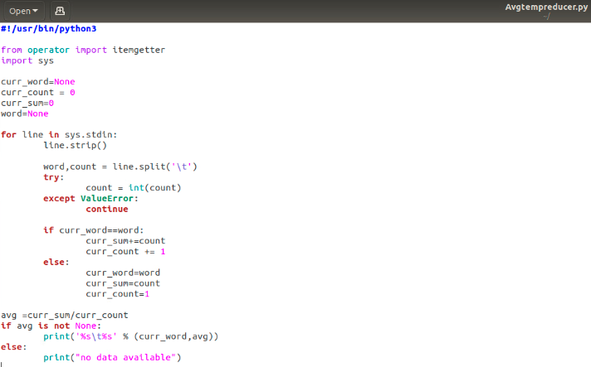

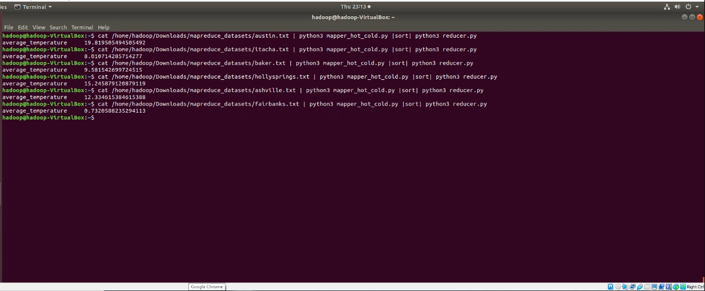Output:

Hot Days and Cold Days for all cities overall

Mapper.py

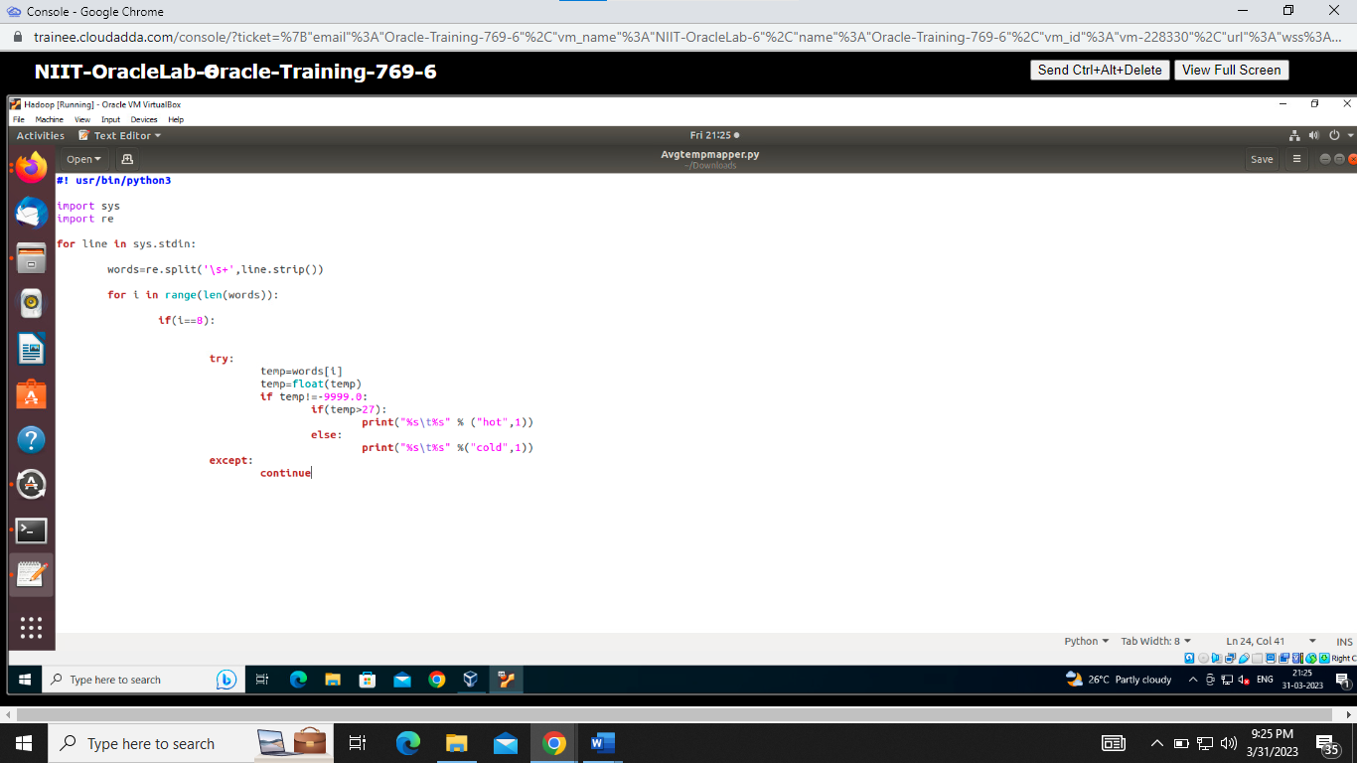

Reducer.py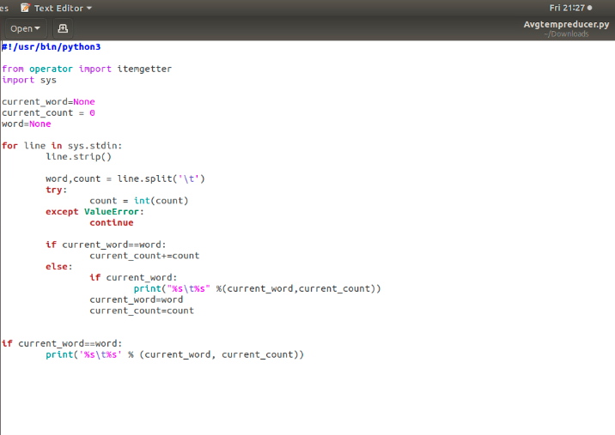Output

