MONITORING, REPORTING & PROCESS IMPROVEMENT PLAN
Customer Churn Prediction System — A Data Science Project
Prepared by: Dharanya | Role: Data Science Project Coordinator | Yuva Intern – Week 4 Task

1. Objective
This document defines the monitoring and reporting plan for the Customer Churn Prediction System, ensuring continuous evaluation of the project after execution. As Data Science Project Coordinator, this plan establishes the key performance indicators (KPIs) that define project success, the Python-based analytics tools used to track them, the reporting mechanism and stakeholder communication cadence, and the process for identifying and correcting deviations from targets.

2. Key Performance Indicators (KPIs)
The table below outlines the KPIs tracked for the churn-prediction model, their definitions, target thresholds, and the Python tool used to compute them.
KPI | Definition | Target | Python Tool Used
Accuracy | Overall proportion of correct churn/no-churn predictions | ≥ 80% | scikit-learn (accuracy_score)
Precision | Proportion of predicted churners who actually churned | ≥ 75% | scikit-learn (precision_score)
Recall | Proportion of actual churners correctly identified | ≥ 70% | scikit-learn (recall_score)
F1 Score | Harmonic mean of precision and recall | ≥ 72% | scikit-learn (f1_score)
Data Freshness | Days since the last data refresh/ingestion | ≤ 7 days | pandas (timestamp comparison)

3. Python Analytics Tools for Performance Tracking
- pandas — logs each monitoring snapshot with a timestamp into monitoring_log.csv, enabling trend analysis over time.
- scikit-learn metrics (accuracy_score, precision_score, recall_score, f1_score) — compute the core model-quality KPIs from validation predictions.
- matplotlib — generates the KPI Trend Dashboard (kpi_dashboard.png), plotting each metric against its target line for quick visual review.
- A dedicated monitoring_reporting.py module (see repository) implements KPI logging, deviation checks, dashboard generation, and weekly report text output.

4. Reporting Mechanism
Reports are generated at different cadences depending on audience and urgency, ensuring stakeholders receive timely, relevant updates without being overwhelmed by noise.
Report Type | Frequency | Stakeholders | Delivery Method
KPI Dashboard Snapshot | Weekly | Project Coordinator, Data Scientist | Auto-generated matplotlib dashboard (kpi_dashboard.png)
Performance Summary Report | Weekly | Project Coordinator, Sponsor/Evaluator | Text/CSV summary via generate_weekly_report()
Deviation Alert | As triggered | Data Scientist, Data Engineer | Flagged immediately when a KPI falls below target
Monthly Review | Monthly | All team members | Consolidated trend review from monitoring_log.csv

5. Process Improvement & Corrective Action
When a KPI falls below its target, the check_kpi_deviation() function flags it automatically. The corrective-action process follows a consistent cycle:
- Detect — weekly KPI comparison against defined targets flags any metric that has drifted below threshold.
- Diagnose — the Data Scientist and Data Engineer investigate whether the cause is data drift, stale data, or model degradation.
- Correct — depending on diagnosis, actions may include retraining the model, refreshing the data source, or adjusting feature engineering.
- Re-validate — the model is re-evaluated against KPIs before the corrective cycle is closed and reported as resolved.

6. Monitoring Cycle (Visual Overview)
The diagram below illustrates the continuous monitoring cycle applied to the churn-prediction system, from KPI tracking through to corrective action and back.
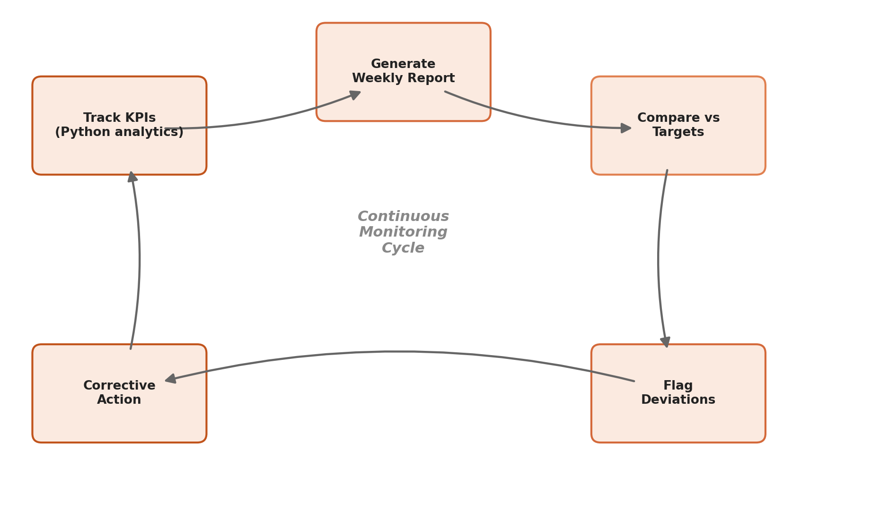

7. Conclusion
This monitoring and reporting plan ensures the Customer Churn Prediction System is not treated as a one-time deliverable but as a continuously evaluated system. By combining clearly defined KPIs, Python-based analytics tooling, a structured multi-cadence reporting mechanism, and a repeatable corrective-action cycle, the project maintains accountability and adapts quickly when performance drifts from expected targets, supporting long-term reliability of the churn-prediction solution.

