

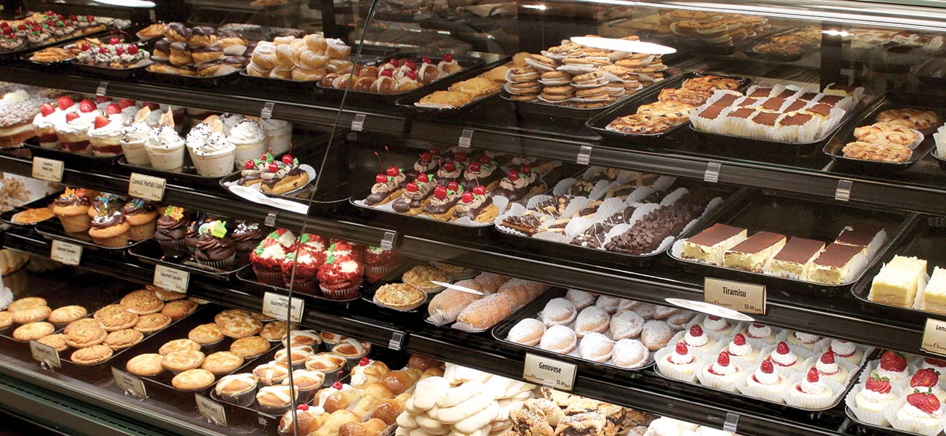**E-BAKERS**

**DHARA KUMARI RAJPUT (LEADER)**

**HAFIZ ABDUL WAHEED (MEMBER)**

**MUHAMMAD AMMAD ANSARI (MEMBER)**

**HUZAIFA ALI (MEMBER)**

**SHEHERYAR TAMIMI (MEMBER)**

**GIT-CODE:** [**https://github.com/dhararajput-official/E-bakers/tree/master/chikery-bakery-website-template/chikery-bakery-website-template**](https://github.com/dhararajput-official/E-bakers/tree/master/chikery-bakery-website-template/chikery-bakery-website-template)

**DRIVE-VIDEO:** [**https://drive.google.com/file/d/1RqiMCVZgYDzaBT_CsxUK5we4a731UMBC/view**](https://drive.google.com/file/d/1RqiMCVZgYDzaBT_CsxUK5we4a731UMBC/view)

**Project Performance Report**

**Note: Each and every member of the group will individually fill in all the phases of the assignment distributed/assigned by the group leader. If the members were not responsive or they did not complete their task Group Leader should mention their name in the report as well. Group leader should mention who has completed that (uncompleted) task?**

**Project Title: E-BAKERS (BAKERY-WEBSITE)**

|  |  |  |  |
| --- | --- | --- | --- |
| **Group Leader Name1: DHARA KUMARI RAJPUT**  Registration No: 49481  Program: Bs(CS) | | | |
| **Work Distribution** | | | |
| **Percentage:**100% | 100% | 100% | 100% |
| ASSIGNMENT#1  ( phase 1: Project Proposal) | ASSIGNMENT#2  ( phase: 2 Feasibility Report) | ASSIGNMENT#3  (phase: 3 Requirement Analysis and Usability) | ASSIGNMENT#4  ( phase: 4 System Program Design) |
| **22%** | **23%** | **20%** | **20%** |

|  |  |  |  |
| --- | --- | --- | --- |
| **Group Member Name2: HAFIZ ABDUL WAHEED**  Registration No: 41342  Program: Bs(CS) | | | |
| **Work Distribution** | | | |
| **Percentage:**100% | 100% | 100% | 100% |
| ASSIGNMENT#1  ( phase 1: Project Proposal) | ASSIGNMENT#2  ( phase: 2 Feasibility Report) | ASSIGNMENT#3  (phase: 3 Requirement Analysis and Usability) | ASSIGNMENT#4  ( phase: 4 System Program Design) |
| **23%** | **20%** | **20%** | **20%** |

|  |  |  |  |
| --- | --- | --- | --- |
| **Group Member Name3: MUHAMMAD AMMAD ANSARI**  Registration No: 41663  Program: Bs(CS) | | | |
| **Work Distribution** | | | |
| **Percentage:**100% | 100% | 100% | 100% |
| ASSIGNMENT#1  ( phase 1: Project Proposal) | ASSIGNMENT#2  ( phase: 2 Feasibility Report) | ASSIGNMENT#3  (phase: 3 Requirement Analysis and Usability) | ASSIGNMENT#4  ( phase: 4 System Program Design) |
| **20%** | **22%** | **23%** | **20%** |

|  |  |  |  |
| --- | --- | --- | --- |
| **Group Member Name4: HUZAIFA ALI**  Registration No: 41277  Program: Bs(CS) | | | |
| **Work Distribution** | | | |
| **Percentage:**100% | 100% | 100% | 100% |
| ASSIGNMENT#1  ( phase 1: Project Proposal) | ASSIGNMENT#2  ( phase: 2 Feasibility Report) | ASSIGNMENT#3  (phase: 3 Requirement Analysis and Usability) | ASSIGNMENT#4  ( phase: 4 System Program Design) |
| **17%** | **18%** | **17%** | **20%** |

|  |  |  |  |
| --- | --- | --- | --- |
| **Group Member Name5: SHEHERYAR TAMIMI**  Registration No: 49611  Program: Bs(CS) | | | |
| **Work Distribution** | | | |
| **Percentage:**100% | 100% | 100% | 100% |
| ASSIGNMENT#1  ( phase 1: Project Proposal) | ASSIGNMENT#2  ( phase: 2 Feasibility Report) | ASSIGNMENT#3  (phase: 3 Requirement Analysis and Usability) | ASSIGNMENT#4  ( phase: 4 System Program Design) |
| **18%** | **17%** | **20%** | **20%** |