FULL TECHNICAL
RESEARCH REPORT
RGB–Thermal Semantic Segmentation with CMX
Baseline reproduction, architectural ablations E0–E4, mathematical foundations,
quantitative results, research gap, and the E5 SCR-CMX architecture
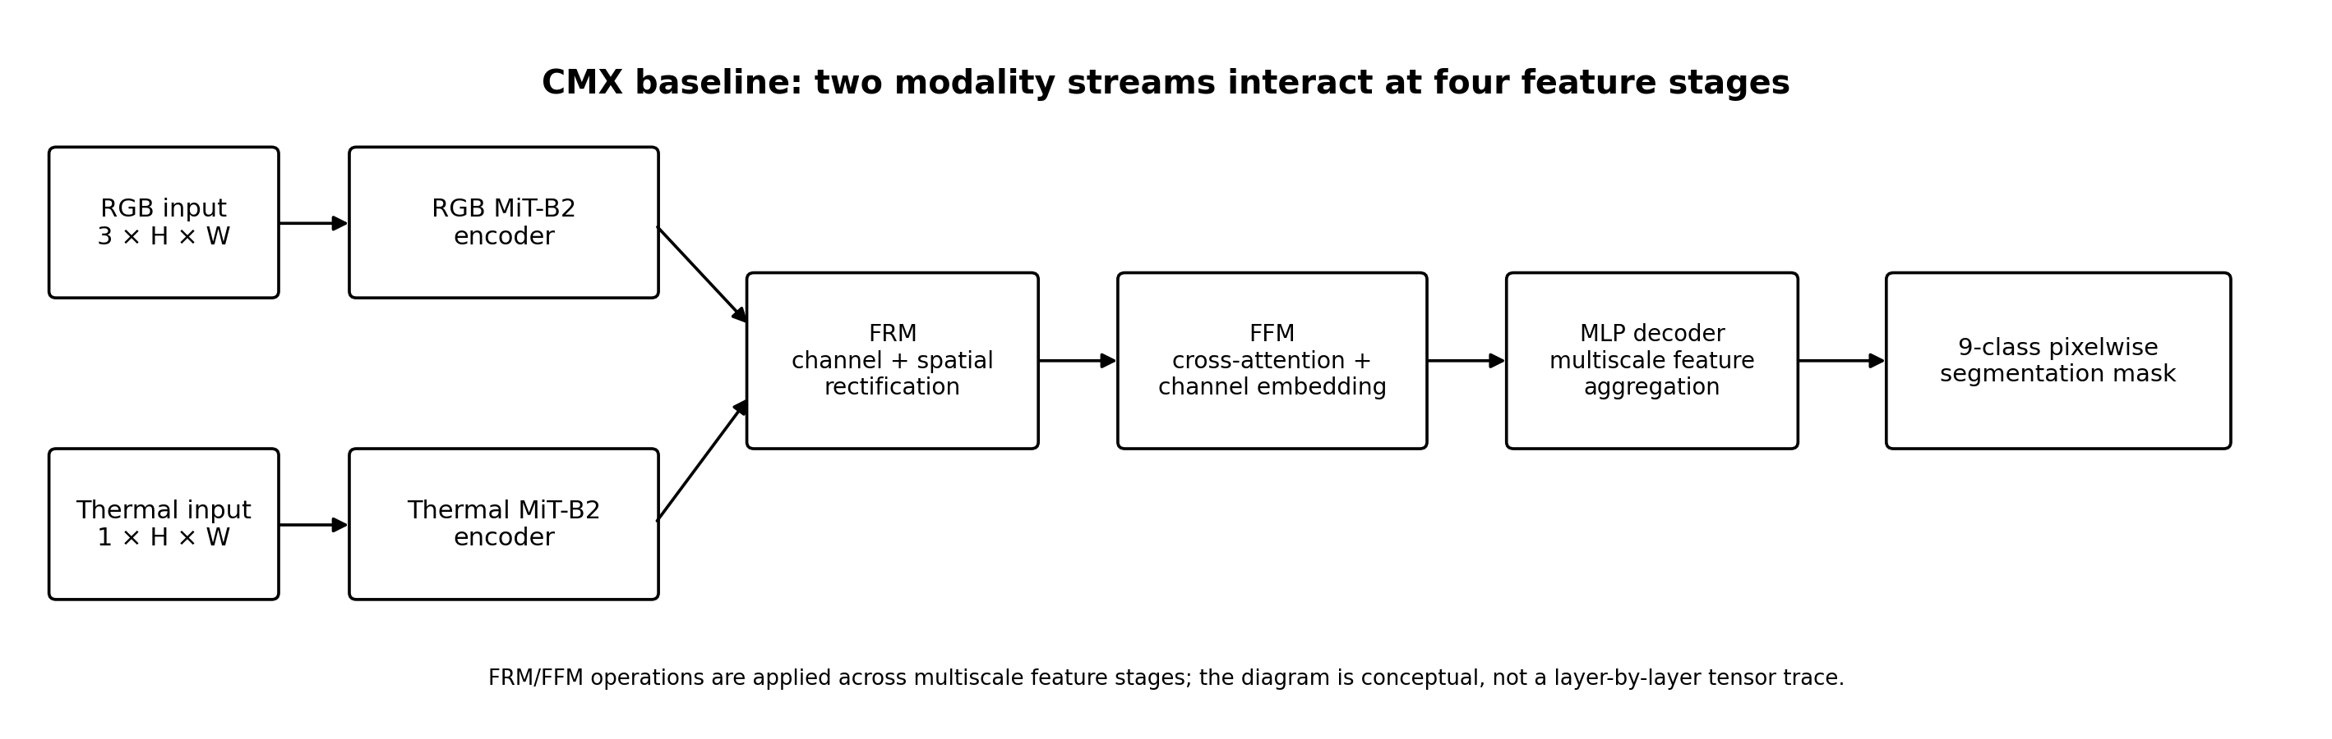
Prepared for academic review
Student / Author: [Insert name]
Department / Institute: [Insert department and institute]
Supervisor: [Insert professor name]
Report date: 16 October 2026
Evidence boundary: E0–E3 quantitative results are recorded; E4 metrics were not verifiable in the reviewed record; E5 is still running and is documented architecturally only.

Abstract
This report documents a staged study of RGB–thermal semantic segmentation built on CMX (Cross-Modal Fusion for RGB-X Semantic Segmentation with Transformers) and a dual-stream SegFormer MiT-B2 encoder. The work began by establishing an original-CMX baseline (E0), then altered cross-modal interaction in controlled variants: E1 removes the Feature Rectification Module (FRM); E2 adds learnable global modality weights to the cross-attention fusion path; E3 predicts spatially varying RGB/thermal fusion weights; and E4 adds reliability-gated rectification while retaining the E3-style reliability-guided Feature Fusion Module (FFM). E5 is the in-progress Semantic-Counterfactual Reliability-Calibrated CMX (SCR-CMX) design, which introduces class-conditioned reliability prediction, modality-specific auxiliary heads, corruption-based counterfactual targets, and reliability-calibrated rectification/fusion.
The local dataset tree is recorded as TDD and contains 2,353 paired RGB/thermal/label triplets split into 1,568 training, 392 validation, and 393 test samples. Images are 480 × 640 and the segmentation head predicts nine label IDs. On the recorded splits, E0 achieved 62.726% validation mIoU and 58.923% test mIoU. E1–E3 did not exceed E0 on either split: E1 achieved 60.944%/56.786%, E2 achieved 62.325%/57.830%, and E3 achieved 61.961%/57.894% validation/test mIoU respectively. The observed pattern suggests that simple global or self-estimated reliability weighting alone is insufficient in this setup. E5 is therefore framed as a testable hypothesis rather than a proven improvement; its final validation/test results and corruption-robustness findings are intentionally not reported while training is ongoing.
A critical dataset caveat is recorded: the local TDD directory contains 2,353 items, whereas the commonly described public MFNet benchmark contains 1,569 RGB–thermal pairs. Although the class vocabulary and image resolution align closely with MFNet, this sample-count difference prevents direct apples-to-apples comparison with published MFNet results until the local dataset provenance and protocol are documented. The report includes model diagrams, equations, training configuration, evaluation metrics, performance charts, limitations, related work, and a reproducibility checklist.
Keywords: RGB–thermal semantic segmentation; CMX; SegFormer; MiT-B2; feature rectification; cross-modal attention; reliability-aware fusion; counterfactual supervision; semantic segmentation; TDD; MFNet.

Status and evidence conventions
- Recorded result: a numeric metric available in the current project result records. These are reported with the split and metric name.
- Implemented architecture: a model variant supported by the saved configuration or source excerpt. This is not treated as evidence of performance improvement.
- Proposed/in progress: E5 architecture and design equations are documented, but no completed E5 validation or test metric is claimed.
- Not verified: E4 validation/test metrics, exact E5 loss coefficients, and any claim that the local TDD data are identical to public MFNet are not asserted.

Contents
1. Executive summary and research question
2. Introduction and motivation
3. Related work and scientific positioning
4. Dataset, labels, preprocessing, and split audit
5. Mathematical foundations and metrics
6. Backbone, pretrained weights, decoder, and software
7. Training and evaluation protocol
8. Architecture of each experiment: E0–E5
9. Quantitative results and graphs
10. Interpretation of findings and current failure modes
11. Research gap and proposed contribution
12. E5 evaluation protocol and acceptance criteria
13. Limitations, reproducibility, and reporting checklist
14. Conclusion
References
Appendix A. Configuration snapshot
Appendix B. Mathematical notation
Appendix C. Supervisor-ready summary
Navigation note: the section headings are structured Word headings. Page numbers are deliberately not hard-coded because pagination can change when the author details or institution template are added.

1. Executive summary and research question
Research question. Can cross-modal feature interaction in CMX be made more robust by estimating which modality is trustworthy at a spatial location and for a semantic class, particularly when RGB or thermal input is degraded, without sacrificing clean-data segmentation quality?
The project uses an experimental ladder instead of changing the entire network at once. E0 is the reference baseline. E1 isolates the role of FRM. E2 tests a globally learned RGB/thermal weighting after cross-modal interaction. E3 lets the relative contribution vary spatially. E4 lets predicted reliability gate the bidirectional feature-rectification step, as well as using reliability-guided fusion. E5 is designed to supervise reliability explicitly using class-local performance of RGB-only and thermal-only predictions under controlled corruption.
Experiment | Architectural change | Validation mIoU | Test mIoU | Status
E0 | Original CMX: FRM + FFM | 62.726% | 58.923% | Recorded baseline
E1 | Remove FRM; retain FFM | 60.944% | 56.786% | Recorded ablation
E2 | Learnable global modality weights in FFM | 62.325% | 57.830% | Recorded variant
E3 | Spatially varying reliability weights in FFM | 61.961% | 57.894% | Recorded variant
E4 | Reliability-gated FRM + E3-style FFM | Not verified | Not verified | Architecture inspected; metric log not available in current record
E5 | Semantic-counterfactual reliability-calibrated FRM/FFM | Pending | Pending | Training in progress; architecture only

Headline result. E0 remains the strongest of the variants with verifiable validation/test numbers. This is scientifically useful: it tells us not to claim that the initial learnable-weight or self-estimated-reliability variants improve clean-data mIoU. It also motivates why E5 must demonstrate a different learning signal, not merely a differently named attention gate.
Primary objective for E5. Learn reliability from counterfactual evidence of local semantic correctness under controlled modality degradation, then use the predicted reliability to regulate both FRM and FFM. The strongest potential contribution is the *supervision protocol and its integration into both interaction points*; generic adaptive weighting or generic reliability-aware fusion alone is not a defensible novelty claim, given prior work in this area [1,4–8].

2. Introduction and motivation
Semantic segmentation assigns a semantic class to every valid image pixel. The task is denser than image classification: it must recognize an object and localize its boundaries at the same time. In road-scene perception, small objects and thin structures can matter even when they occupy very few pixels. A model can therefore achieve high pixel accuracy by correctly labeling the dominant background while still segmenting minority classes poorly; mIoU and class-wise IoU are essential complements.
RGB images encode color, texture, edges, and appearance, but visible-spectrum evidence can deteriorate under low illumination, glare, motion blur, or occlusion. Thermal imagery can retain useful object/temperature contrast under low light, but it does not have the same texture or color detail and can itself be noisy or low contrast. RGB–thermal fusion aims to exploit complementary cues while preventing an unreliable input stream from contaminating the representation of the other stream [1,3].
CMX is a suitable starting point because it has two modality-specific transformer streams and explicitly separates feature rectification from feature fusion. Its Cross-Modal Feature Rectification Module (CM-FRM) uses spatial- and channel-wise relationships between the streams; the Feature Fusion Module (FFM) uses cross-attention for global exchange and channel embedding for the merged representation [1]. The project preserves this backbone/fusion framework and changes specific operations in each experiment.

2.1 Research goals
- Reproduce a working two-stream CMX baseline on the local TDD data and preserve the exact split/evaluation commands.
- Quantify the impact of removing FRM (E1) while retaining the rest of the pipeline.
- Test a hierarchy of fusion modifications (E2–E4) under a shared backbone and evaluation protocol.
- Investigate whether explicit, class-aware, counterfactual reliability supervision (E5) can address the weakness of unsupervised/self-estimated fusion weights.
- Assess not only clean-data mIoU but robustness under RGB-only corruption, thermal-only corruption, joint corruption, and modality dropout.
- Prepare for a separately controlled evaluation on the public MFNet benchmark without conflating it with the local TDD result.

2.2 Research hypotheses
- H1: Removing CMX FRM reduces segmentation quality because the two streams lose a direct feature-calibration step. E1 is expected to test this hypothesis.
- H2: A single pair of global modality weights is too coarse to express location-dependent reliability. E2 tests this limitation.
- H3: Spatially varying but self-estimated reliability weights can be more adaptive but may still fail to generalize if reliability is not explicitly supervised. E3 and E4 test this idea.
- H4: Counterfactual, class-conditioned reliability targets can teach the model when each stream is useful under degradation. E5 must validate this hypothesis on held-out clean and corrupted data; it is not yet established.

3. Related work and scientific positioning

3.1 CMX: Cross-modal feature rectification and fusion
CMX (Zhang et al., 2022) introduces a general RGB-X segmentation framework rather than a thermal-only design. It handles modalities such as depth, thermal, polarization, events, and LiDAR through paired streams and shared interaction logic. The main architectural principle is rectification first, fusion second: first calibrate feature streams using the other modality, then perform cross-attention and channel embedding to create fused multiscale features [1]. The current E0 implementation is based on this architecture, with SegFormer MiT-B2 as the encoder backbone.

3.2 SegFormer and MiT-B2
SegFormer uses a hierarchical Transformer encoder that outputs multiscale features and an MLP decoder that aggregates those features. Its encoder does not rely on absolute positional encodings, and its efficient self-attention includes spatial reduction. A lightweight decoder projects features from different stages into a shared embedding and combines them for dense pixel prediction [2]. The project uses MiT-B2, whose code-level output channel list is [64, 128, 320, 512], and an MLP decoder with embed dimension 512.

3.3 Prior complementarity-aware fusion
Complementarity-aware RGB-T fusion is not a new concept by itself. CCFFNet (Wu et al., 2022) explicitly models cross-modal complementarity through a Complementarity-Aware Encoder built from cascaded cross-modal fusion modules, spatial gates, channel-wise weighting, and a Three-Path Fusion and Supervision design [4]. Related work has also studied region-adaptive/context-complementary cross modulation [5], adaptive attention/gated weighting (CAFNet) [6], dynamic cross-modal rectification and bidirectional fusion (DCBF-Net, 2026) [7], scene-aware reliability estimation [8], and rectified mixture-of-experts fusion [9]. These methods overlap with broad claims such as “adaptive fusion,” “complementarity-aware fusion,” and “reliability-guided fusion.”

3.4 What this means for E5
The candidate differentiator must be defined in terms of a concrete learning signal and integration, not only the label SCR-CMX. The project’s proposed distinction is: generate class-local reliability supervision from modality-only predictions evaluated against clean ground truth under controlled corruption; predict semantic-conditioned reliability; then use that reliability in both feature rectification and final feature fusion; finally measure calibration and robustness on clean, corrupted, and dropout conditions. This is a hypothesis to be tested against the full implementation and the closest related papers, not a verified claim that no previous work has done the same thing.
Prior line of work | Core focus | Implication for this project
CMX [1] | Cross-modal FRM and cross-attention FFM | Provides the reproduced baseline and interaction points.
SegFormer [2] | Hierarchical MiT encoder + MLP decoder | Backbone/decoder foundation; not the proposed fusion novelty.
CCFFNet [4] | Explicit complementarity gates and three-path supervision | Generic “complementarity-aware fusion” is already established.
Region-adaptive / context-complementary fusion [5] | Region- and context-dependent RGB-T interaction | Spatially adaptive fusion alone is not enough to establish novelty.
CAFNet [6] | Adaptive attention and gated modality weighting | Learnable/global or dynamic gating has prior precedent.
DCBF-Net and recent reliability-aware models [7–9] | Reliability-aware rectification, bidirectional fusion, or expert weighting | E5 must demonstrate a precise supervision/integration difference and robustness gains.

4. Dataset, labels, preprocessing, and split audit

4.1 What was used locally
The project configuration labels the dataset “TDD” and points to a local directory with RGB, Thermal, and Label subfolders. The dataset inspection recorded 2,353 valid aligned triplets: 1,568 train, 392 validation, and 393 test. The audit reported no missing files and no read errors for the scanned triplets. Each RGB image, thermal image, and label mask was 640 × 480 pixels (width × height), equivalently H=480 and W=640. Thermal inputs were configured as single-channel images.
Property | Recorded setting
Dataset folder label | TDD (project-local name; provenance needs documentation)
Training list | train.txt — 1,568 entries
Validation list | val.txt — 392 entries
Test list | test.txt — 393 entries
Total aligned triplets | 2,353
Image resolution | 480 × 640 (H × W)
Modalities | RGB (3 channels) + thermal (1 channel)
Label IDs | 0–8 (nine classes); label value 255 is ignored during cross-entropy
RGB normalization | Mean [0.485, 0.456, 0.406]; standard deviation [0.229, 0.224, 0.225]
Triplet integrity check | 2,353 checked; 0 missing/read-error cases recorded

4.2 Class ontology
Label ID | Class name | Interpretation / note
0 | unlabeled | Explicit output class in the configuration; do not confuse with ignored label 255.
1 | car | Vehicles.
2 | person | Pedestrians/persons.
3 | bike | Bicycles/two-wheelers, according to label convention.
4 | curve | Road/curve-related class as defined by the dataset annotation.
5 | car_stop | Parking/vehicle-stop related class in the annotation ontology.
6 | guardrail | Roadside guardrails.
7 | color_cone | Traffic/road cones.
8 | bump | Road bumps/pothole-like annotation class; preserve the dataset’s official definition.

The class vocabulary is closely aligned with the well-known MFNet RGB-T segmentation ontology and the images are also 480 × 640. However, the standard public MFNet dataset is described as containing 1,569 RGB–thermal pairs, including 820 daytime and 749 nighttime samples [3]. This project’s local tree contains 2,353 pairs, so it must not be silently relabeled as the unmodified public MFNet benchmark. Before publication, document where the additional samples came from, whether any frames are duplicated or augmented/offline-expanded, and whether the official MFNet train/validation/test identifiers are preserved.

4.3 Split sizes and evaluation hygiene
The split counts sum exactly to the recorded local total: 1,568 + 392 + 393 = 2,353. For the reported comparisons, train.txt, val.txt, and test.txt should remain fixed and disjoint. All E0–E3 numbers should be recomputed from the archived predictions and exact list files before submission if the model files or evaluator have changed. The report treats validation and test separately; the test split is not used to choose architecture, threshold, corruption level, or checkpoint.

4.4 Planned external evaluation on public MFNet
The next cross-dataset check should begin with inference on the official MFNet data using the model trained on local TDD, without fine-tuning. This establishes a transfer/generalization result rather than a second training result. Before inference, verify RGB/thermal channel extraction, paired filenames/timestamps, label-ID mapping, ignore-label handling, normalization, and image geometry. If fine-tuning is later performed on MFNet, report it as a separate experiment with an official split; do not combine its fine-tuned metrics with the zero-shot transfer result. Published MFNet numbers can only be compared directly when the dataset version, split, class mapping, evaluation code, and protocol match.

5. Mathematical foundations and metrics

5.1 Input, labels, and feature tensors
Let the paired input be Xᵣ ∈ ℝ^(B×3×H×W) for RGB and Xₜ ∈ ℝ^(B×1×H×W) for thermal. The ground-truth label mask is Y ∈ {0,1,…,8,255}^(B×H×W), where 255 is ignored by the training criterion. For stage s∈{1,2,3,4}, the encoders produce feature maps Fᵣˢ and Fₜˢ. The streams have distinct parameters, even though both use the MiT-B2 architecture and compatible pretrained initialization.
Fᵣˢ = Eᵣˢ(Xᵣ), Fₜˢ = Eₜˢ(Xₜ), s = 1, 2, 3, 4
The project’s builder records stage channels [64, 128, 320, 512]. The spatial resolution decreases across stages while the semantic abstraction increases. Cross-modal modules operate on aligned feature tensors at each fusion stage.

5.2 Transformer attention
At a Transformer attention block, input tokens X are linearly mapped into queries, keys, and values. The standard scaled dot-product attention expression is:
Attention(Q,K,V) = softmax(QKᵀ / √dₖ) V
Here dₖ is the query/key dimension per attention head. MiT uses spatial-reduction attention to lower the cost of key/value computation for high-resolution token maps, and its Mix-FFN incorporates depthwise convolution to introduce local spatial structure. The exact shapes vary by stage and head count; this report gives the governing operation rather than claiming one fixed token count for every image.

5.3 FRM and FFM in CMX
The FRM uses the two feature maps to estimate channel-wise and spatial-wise cross-modal relationships, then rectifies each stream with evidence from the other. The FFM first performs cross-modal token interaction, then merges the interacted features through channel embedding. Abstractly, for each stage s:
(F̄ᵣˢ, F̄ₜˢ) = FRM(Fᵣˢ, Fₜˢ)
Ffˢ = FFM(F̄ᵣˢ, F̄ₜˢ)
This notation captures the functional dependencies; it is not intended to replace the original CMX paper’s detailed submodule definitions. The key design distinction is that FRM operates before fusion and changes the per-modality feature maps, whereas FFM exchanges long-range cross-modal context and creates a merged representation [1].

5.4 Decoder and pixelwise probabilities
The MLP decoder projects each fused stage into a common embedding dimension, resizes the projected maps to a shared spatial resolution, aggregates them, and predicts nine class logits per pixel. If zᵢ,c is the logit for class c at valid pixel i, then the class probability is:
pᵢ,c = exp(zᵢ,c) / Σₖ₌₀⁸ exp(zᵢ,k)
The configured training criterion is mean cross-entropy with ignore_index=255. For Ω, the set of pixels whose label is not 255, the core loss is:
Lseg = − (1 / |Ω|) Σᵢ∈Ω log pᵢ,Yᵢ
The loss averages over valid pixels, so label 255 contributes no gradient. Class ID 0 “unlabeled” remains a prediction class under the recorded configuration; it is not the same as ignore index 255.

5.5 Evaluation metrics
For class c, TPc, FPc, and FNc are true positives, false positives, and false negatives at the pixel level. Intersection over Union is:
IoU₍c₎ = TP₍c₎ / (TP₍c₎ + FP₍c₎ + FN₍c₎)
mIoU = (1 / C) Σ₍c=1₎ᶜ IoU₍c₎, C = 9
Pixel accuracy (PA) is total correctly classified valid pixels divided by all valid pixels. Mean pixel accuracy (mPA) computes the per-class pixel accuracy/recall and averages those values across classes. Frequency-weighted IoU weights each class IoU by its fraction of valid pixels. Because “unlabeled”/background-like pixels can be highly frequent, PA and frequency-weighted IoU can appear high even when some rare object classes have weak IoU; therefore mIoU and the per-class table are prioritized.

5.6 Optimization
The recorded settings use AdamW, initial learning rate η₀=6×10⁻⁵, weight decay 0.01, batch size 2, seed 12345, 100 epochs, and polynomial learning-rate power 0.9. The recorded configuration describes a 10-epoch warm-up. With T total iterations, the polynomial component is commonly represented as:
ηₜ = η₀ (1 − t/T)^0.9
The practical schedule applies warm-up to the early training phase, after which the polynomial decay is followed. The project uses 785 iterations per epoch for 1,568 training samples at batch size 2 (floor(1568/2)+1 in the current configuration), corresponding to approximately 78,500 scheduled iterations across 100 epochs. The extra iteration comes from the explicit +1 in the configuration; this should be kept consistent across all variants.

6. Backbone, pretrained weights, decoder, and software

6.1 Pretrained initialization
The saved configuration points to `pretrained/segformer/mit_b2.pth`. MiT-B2 is the shared encoder architecture; separate RGB and thermal encoder streams are used. The pretrained file is a starting point, not a complete pretrained RGB-T CMX checkpoint. CMX fusion modules, modified reliability heads, and any experiment-specific parameters must be initialized or transferred according to the chosen experiment. The original CMX paper and SegFormer paper remain the primary architectural references [1,2].
Item | Recorded value / role
Backbone family | SegFormer MiT-B2 (dual stream)
Pretrained file | pretrained/segformer/mit_b2.pth
Feature channels | [64, 128, 320, 512]
Segmentation decoder | MLPDecoder
Decoder embedding dimension | 512
Optimizer | AdamW
Criterion | CrossEntropyLoss, reduction=mean, ignore_index=255
Training seed | 12345
Batch / epochs | 2 / 100
Initial LR / weight decay | 6e−5 / 0.01
LR policy | Warm-up + polynomial decay, power 0.9
Approx. iterations | 785 per epoch; about 78,500 over 100 epochs

6.2 Implementation libraries and computing environment
The source excerpts and environment notes indicate the following implementation stack. Exact versions should be captured from the environment used for each final run, because the project environment changed during troubleshooting.
Library / component | Purpose
Python | Training scripts, configs, evaluation orchestration
PyTorch | Dual encoders, fusion modules, loss, optimizer, checkpoints
timm | Transformer utilities including DropPath, to_2tuple, truncated-normal initialization
NumPy | Array operations and metrics/data processing
Pillow / OpenCV (where used in loader) | Image reading and preprocessing
easydict | Attribute-style experiment configuration
tqdm | Training/evaluation progress bars
tensorboardX | Training scalar logging
Matplotlib | Research charts in this report

Reported later workstation environment: Python 3.12.3, PyTorch 2.14.1+cu130, CUDA 13.0, and an NVIDIA RTX 2000 Ada GPU with approximately 16 GB memory. These are environment notes, not a guarantee that every historical E0–E4 run used identical versions. Before the final paper, export a `pip freeze`/environment file, NVIDIA driver output, exact Git commit, full config, checkpoint hash, and command for each experiment.

7. Training and evaluation protocol

7.1 Controlled factors
The intended controlled factors are the same TDD split, image normalization, input geometry, MiT-B2 backbone family, decoder, number of epochs, optimizer family, base learning rate, weight decay, batch size, seed, evaluation scales, and prediction/metric script. Changes should be isolated to the designated module. The model-specific initialization path must also be reported because E3 explicitly loaded shape-compatible tensors from the E2 epoch-100 checkpoint and initialized new reliability heads separately.

7.2 Initialization trail by experiment
Experiment | Initialization/transfer trail supported by current records | Interpretation / audit note
E0 | MiT-B2 pretrained weights; original CMX modules. | Local baseline checkpoint recorded at epoch 100.
E1 | Same MiT-B2 pretraining; retrained as FRM ablation rather than merely continuing E0. | Provides the cleaner FRM-removal comparison.
E2 | MiT-B2 pretraining; learnable fusion logits initialized to [0,0], producing 0.5/0.5 softmax weights. | The learned weights are global per modality in this implementation.
E3 | Explicitly loads shape-compatible tensors from E2 epoch-100 checkpoint; initializes new reliability-head final layers to zero, yielding equal initial local weights. | Saved train.py asserts that missing keys are only reliability-head parameters.
E4 | Configuration references the same MiT-B2 pretrained path; the available excerpt shows E4 FRM + E3 FFM. | A dedicated E4 checkpoint-loading/evaluation log should be attached before claiming metrics.
E5 | Current design extends reliability-gated interaction with counterfactual supervision. | Exact starting checkpoint, class-conditioning implementation, loss coefficients, and final epoch remain to be verified from E5 config/log.

7.3 Evaluation command trail
The local baseline record includes the command `conda run -n cmx python eval.py -e 100 -d 0`; the recorded test evaluation uses an explicit `--split test` option and writes prediction masks to a split-specific directory. Because exact command-line flags changed between evaluations, archive the full command for each E0–E5 run rather than relying on this example alone.

7.4 Fairness and leakage safeguards
- Use validation results for model selection; reserve test.txt for the final one-time comparison.
- Keep all E0–E5 prediction masks, confusion matrices, class-wise IoUs, logs, configuration files, and checkpoint SHA-256 hashes.
- If E3/E4/E5 weights are initialized from a prior variant, state precisely which parameters are transferred and whether optimizer state/epoch count are reset.
- Use identical class-ID mapping, ignored label convention, resize/upsample behavior, evaluation scales, and flip settings across models.
- For robustness evaluation, never generate reliability targets from validation/test labels during model fitting; counterfactual targets may use training labels only.
- Compare published MFNet metrics only after matching the actual public dataset, official split, and evaluation convention.

8. Architecture of each experiment: E0–E5
All six configurations share a common segmentation skeleton: paired RGB/thermal inputs → two MiT-B2 encoder streams → multiscale interaction/fusion → MLP decoder → nine-class mask. The architectural question is which module modifies each stream, how fusion weights are generated, and whether reliability is explicitly supervised.
Figure 1. High-level original-CMX pipeline used as the E0 reference. The FRM/FFM pair is repeated across multiscale feature stages.
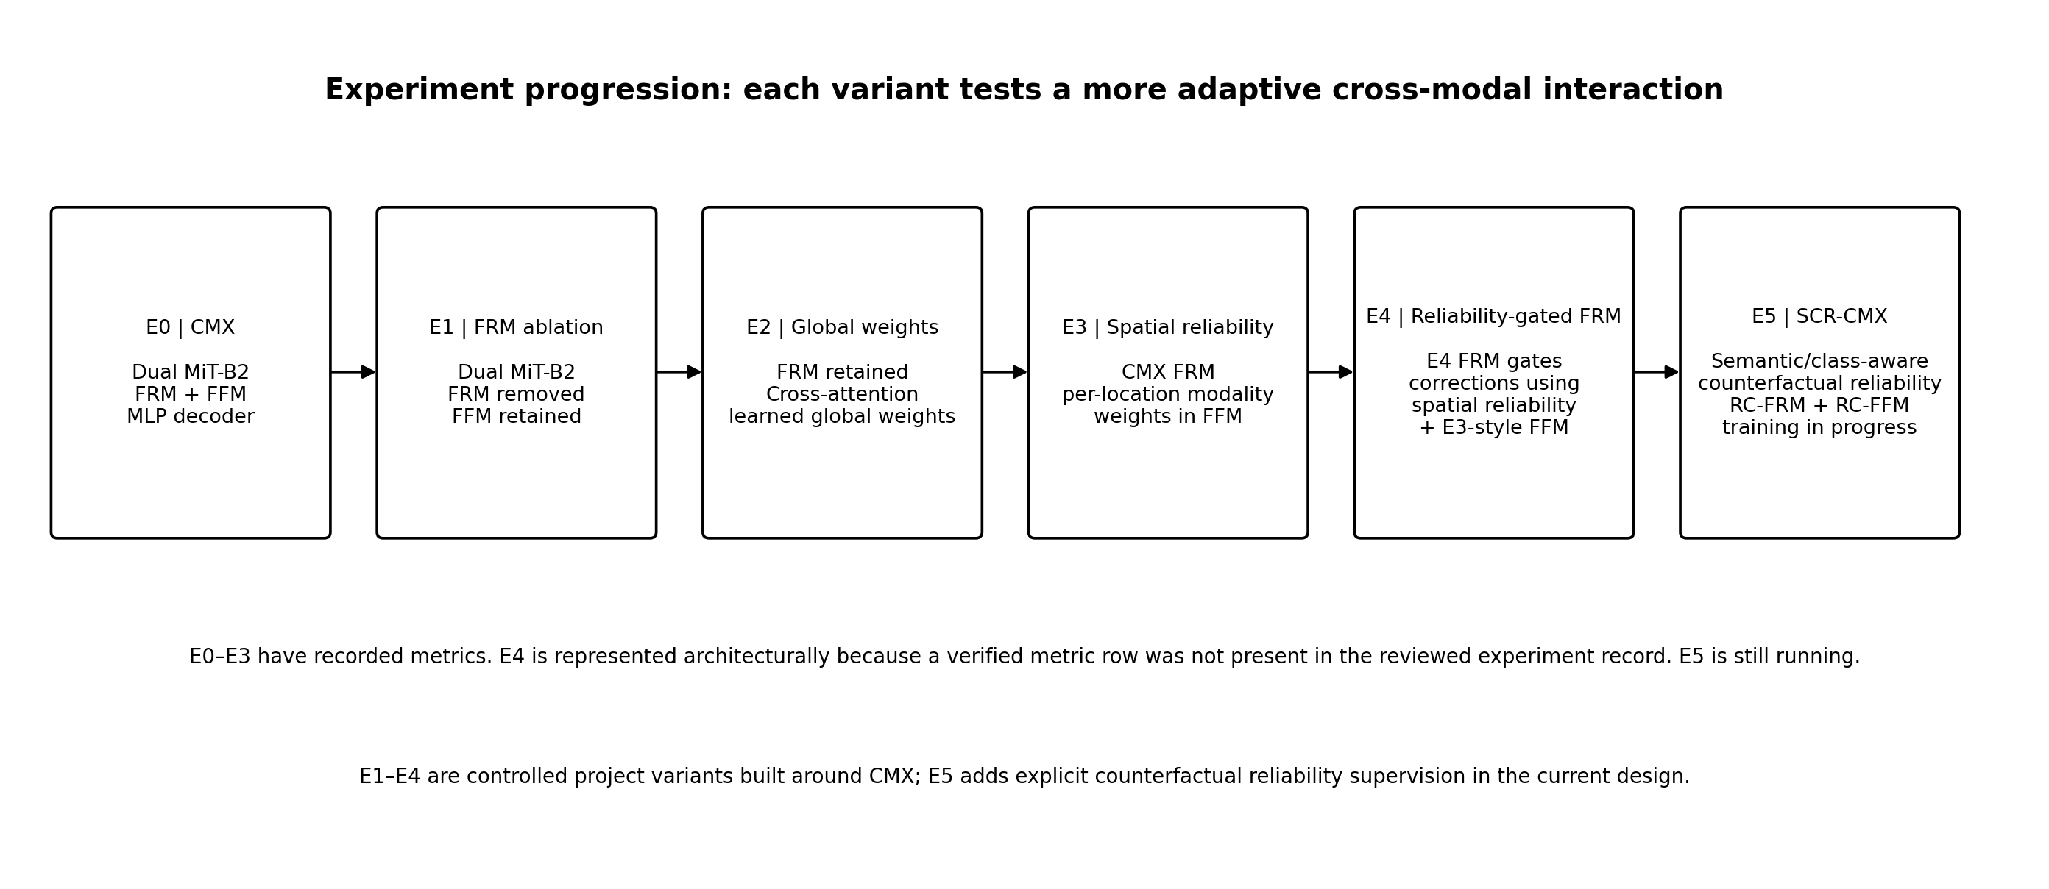
Figure 2. Evolution of project variants E0–E5. E4 metrics are not shown because no verified metric row was found in the reviewed record; E5 remains in progress.

8.1 E0 — Original CMX baseline
Purpose. Establish a working reference with the original CMX-style cross-modal rectification and fusion components. The implementation uses dual MiT-B2 streams and the MLP decoder. This is the control against which each subsequent local change is compared.
Forward path. At each stage s, RGB and thermal encoders produce Fᵣˢ and Fₜˢ. FRM uses cross-modal channel and spatial relations to produce rectified features; FFM performs cross-attention between streams and merges them through channel embedding. The decoder aggregates the outputs from all four stages and predicts nine class logits.
(F̃ᵣˢ, F̃ₜˢ) = FRM(Fᵣˢ, Fₜˢ); Ffˢ = FFM(F̃ᵣˢ, F̃ₜˢ)
Ŷ = argmax_c Decoder({Ff¹, Ff², Ff³, Ff⁴})
Why it matters. FRM and FFM handle different failure modes. FRM performs earlier bidirectional feature calibration, while FFM enables contextual feature exchange and creates a fused tensor. E0 achieved 62.726% validation mIoU and 58.923% test mIoU. The baseline is an in-project reproduction; exact numerical reproduction of the original CMX paper has not been established because local dataset/protocol identity differs from the public MFNet benchmark.

8.2 E1 — FRM-removal ablation
Purpose. Isolate the contribution of FRM. The dual MiT-B2 streams remain; the rectification step is removed, but FFM still receives and fuses the two feature streams. No additional reliability head is introduced.
Ffˢ = FFM(Fᵣˢ, Fₜˢ) (no FRM rectification before fusion)
Interpretation. E1 reduced validation mIoU from 62.726% to 60.944% (−1.782 percentage points) and test mIoU from 58.923% to 56.786% (−2.137 points). This is consistent with FRM contributing useful cross-modal calibration on this data. It is not a statistical proof: a repeated-seed ablation would be needed to estimate variance and establish significance.

8.3 E2 — Learnable global modality weighting in FFM
Purpose. Preserve the original cross-modal interaction, but let training learn the relative importance of RGB and thermal after cross-attention. The weighted module inherits the CMX FFM, retains its CrossPath and ChannelEmbed, and adds one learnable two-element parameter vector called `modality_logits`.
a = [aᵣ, aₜ]ᵀ; [wᵣ, wₜ] = softmax(a)
Ff = ChannelEmbed(concat(wᵣ · F̄ᵣ, wₜ · F̄ₜ))
At initialization, a=[0,0], so wᵣ=wₜ=0.5. The weights are global scalars per modality for a given fusion module; they do not explicitly change by pixel, local object, or corruption severity. This was a controlled way to add learnable global weighting without replacing the cross-attention path. The recorded E2 run used learning rate 6×10⁻⁵, weight decay 0.01, batch size 2, 100 epochs, seed 12345, and 78,500 scheduled iterations. A training-loop fix ensured standalone raw `nn.Parameter` fusion logits were included in the optimizer parameter list.
Result. E2 reached 62.325% validation mIoU and 57.830% test mIoU, both below E0. This suggests global weighting did not help clean-data generalization in the current setup. The result motivates location-dependent or supervised reliability, but does not by itself prove why E2 failed.

8.4 E3 — Spatially varying reliability-guided fusion
Purpose. Move from one global RGB/thermal weighting to spatially varying weights. E3 inherits original CMX cross-attention interactions, restores the two token streams to 2-D feature maps, and adds a compact reliability head at each FFM stage. The head receives the concatenated cross-attended features and outputs two logits per spatial position.
G = Conv₁×₁([F̄ᵣ ; F̄ₜ]); [wᵣ(p), wₜ(p)] = softmax₂(G(p))
Ff = ChannelEmbed(concat(wᵣ ⊙ F̄ᵣ, wₜ ⊙ F̄ₜ))
The hidden width is recorded as max(C/8, 8), followed by ReLU and a 1×1 convolution to two outputs. Softmax is applied over the two-modality dimension at each spatial location, so the pair of weights at p sums to one. The reliability head is embedded in FFM; the FRM remains the original CMX FRM. The E3 training setup explicitly initialized compatible model tensors from the E2 epoch-100 checkpoint and started new reliability heads at equal RGB/thermal weights.
Result. E3 achieved 61.961% validation mIoU and 57.894% test mIoU. It increased recorded train mIoU to 94.915%, yet did not improve validation or test results. This is consistent with a generalization problem or a train/evaluation metric mismatch. The result also exposes a design limitation: the head learns which modality to weight from feature representations, but no explicit target tells it whether RGB or thermal was actually more correct for a specific class/region under known sensor degradation.

8.5 E4 — Reliability-gated feature rectification plus E3 FFM
Purpose. E4 extends the adaptive idea earlier in the pipeline. The saved encoder excerpt imports `ReliabilityGatedFeatureRectifyModule` as FRM from `net_utils_e4.py` and retains `ReliabilityGuidedFusionModule` as FFM from `net_utils_e3.py`. Thus E4 combines reliability-gated rectification with spatially varying reliability-guided fusion. The code comment explicitly states that this E4 prototype does not yet implement counterfactual supervision.
Reliability head. At a feature stage with channel dimension C, concatenate RGB and thermal maps to obtain 2C channels. A 1×1 convolution maps 2C → max(C/8, 8), ReLU follows, and a final 1×1 convolution outputs two logits. A spatial softmax generates rᵣ(p), rₜ(p). The final convolution is initialized to zeros, so both modalities start with 0.5 reliability at every location.
[rᵣ(p), rₜ(p)] = softmax₂(gθ([Fᵣ(p), Fₜ(p)]))
The E4 rectification corrections reuse the original CMX channel-weight and spatial-weight mechanisms. With λc=λs=0.5, the implementation has the following structure:
ΔFᵣ = λc · Wcₜ→ᵣ ⊙ Fₜ + λs · Wsₜ→ᵣ ⊙ Fₜ
ΔFₜ = λc · Wcᵣ→ₜ ⊙ Fᵣ + λs · Wsᵣ→ₜ ⊙ Fᵣ
F′ᵣ = Fᵣ + rₜ ⊙ ΔFᵣ; F′ₜ = Fₜ + rᵣ ⊙ ΔFₜ
The cross-gating is intentional: thermal reliability controls the amount of thermal evidence added to RGB, and RGB reliability controls the amount of RGB evidence added to thermal. The resulting rectified streams are then passed to the E3-style FFM, which estimates local modality weights after cross-attention. This makes E4 more comprehensive than E3, but reliability remains self-estimated from the features rather than trained against explicit counterfactual correctness targets.
Metric status. The current reviewed project records include E4 code/configuration but not a verified E4 validation/test result. For that reason, this report documents its implementation and does not invent a score or include an artificial zero in charts. The final version for a supervisor should add the E4 validation/test log and checkpoint ID when available.

8.6 E5 — SCR-CMX: Semantic-Counterfactual Reliability-Calibrated CMX (in progress)
Scope of this report. E5 is included at architecture level only, as requested, because training is still running. No E5 validation mIoU, test mIoU, final checkpoint claim, or improvement percentage is presented. The design extends the E4 direction by supervising reliability using counterfactual modality-only evidence and by conditioning reliability on semantic class information.
(i) Dual encoders. RGB and thermal images are encoded by separate MiT-B2 streams, producing Fᵣ and Fₜ at multiple stages. RGB primarily supplies visible texture/color/boundary cues; thermal supplies infrared/temperature-based contrast. These roles are tendencies, not guarantees; either input can be degraded.
(ii) Semantic-conditioned reliability head. The head receives RGB features, thermal features, and semantic class information from predicted segmentation logits and/or a learnable class embedding. It outputs Rᵣ(p,c) and Rₜ(p,c), each in [0,1], interpreted as the trustworthiness of a modality at spatial location p for class c. The current architecture specification permits a lightweight two- or three-layer convolutional head with a sigmoid; the exact class-conditioning pathway must be checked against the running code before final publication.
(iii) Counterfactual supervision branch. During training, apply controlled corruption separately to RGB, thermal, or both. Add auxiliary RGB-only and thermal-only segmentation heads producing Pᵣ and Pₜ. Compare each modality-only prediction against the clean training label mask to obtain local, class-specific reliability targets R*ᵣ and R*ₜ. This provides a direct supervisory signal for when each sensor stream is actually useful, rather than asking the reliability head to infer trustworthiness only from feature magnitude.
R*ₘ(p,c) = IoUₗₒcₐₗ( Pₘ, Y ; neighbourhood W(p), class c ), m ∈ {r,t}
A concrete local target can be computed over a neighbourhood W(p): intersection of modality-only predicted class c and ground-truth class c divided by their union plus ε. The target is defined on training pairs only. It is a local statistic of modality-only correctness and should be detached from gradient flow, because it supervises rather than becomes a second trainable prediction.
R*ₘ(p,c) = TPₘ,c(W(p)) / (TPₘ,c(W(p)) + FPₘ,c(W(p)) + FNₘ,c(W(p)) + ε)
(iv) Reliability-calibrated FRM (RC-FRM). The reliability predicted for a source modality gates its contribution when rectifying the other modality:
F′ᵣ = Fᵣ + α · Rₜ ⊙ Rectify(Fᵣ, Fₜ)
F′ₜ = Fₜ + α · Rᵣ ⊙ Rectify(Fₜ, Fᵣ)
(v) Reliability-calibrated FFM (RC-FFM). The current design then combines reliability-conditioned evidence with cross-modal fusion. The evidence heads estimate eᵣ and eₜ from each rectified feature and its reliability; normalized evidence weights are used to create the fused representation:
eᵣ = EvidenceHead(F′ᵣ, Rᵣ); eₜ = EvidenceHead(F′ₜ, Rₜ)
wᵣ = eᵣ / (eᵣ + eₜ + ε); wₜ = eₜ / (eᵣ + eₜ + ε)
Ffused = wᵣ ⊙ F′ᵣ + wₜ ⊙ F′ₜ
(vi) Composite objective. The current design notes specify a five-part objective but do not yet provide the exact implemented formula for every term or the final numeric λ coefficients. Its intended structure is:
Ltotal = Lseg + λ₁Lrel + λ₂Lcalib + λ₃Lcons + λ₄Lbal
Term | Training role | Important implementation detail
Lseg | Pixelwise semantic segmentation objective on final output. | Use the valid-pixel mask and ignore label 255 exactly as in baseline.
Lrel | Supervise predicted reliability maps against counterfactual local IoU targets. | State whether BCE, Smooth-L1, MSE, or another regression loss is used in the running code.
Lcalib | Discourage overconfident reliability/evidence when observed modality correctness is lower. | Document the exact calibration metric/loss; do not infer the formula from the name.
Lcons | Encourage predictions to remain semantically stable when one modality is corrupted. | Specify clean/corrupted pairing, valid pixels, temperature, and KL/symmetric-KL formulation if used.
Lbal | Prevent collapse to relying on only RGB or only thermal in all conditions. | Define batch-level balance relative to observed target reliability, not an arbitrary 50:50 rule.

(vii) Corruption family. Proposed RGB corruptions include low illumination, motion blur, Gaussian noise, and partial blackout. Thermal corruptions include fixed-pattern noise, Gaussian noise, blur, contrast loss, gain drift, and partial blackout. Joint corruption and complete modality-dropout are also proposed. Corruption type/intensity must be logged and a portion of the corruption family held out during evaluation to test generalization rather than memorization.
Why E5 is different in principle. E3/E4 infer reliability from features but do not train against explicit counterfactual local correctness. E5 adds an external semantic signal—the relative correctness of modality-only predictions against ground truth under controlled degradations—and uses that signal to train reliability. Whether this will improve generalization remains empirical and must be measured after completion.
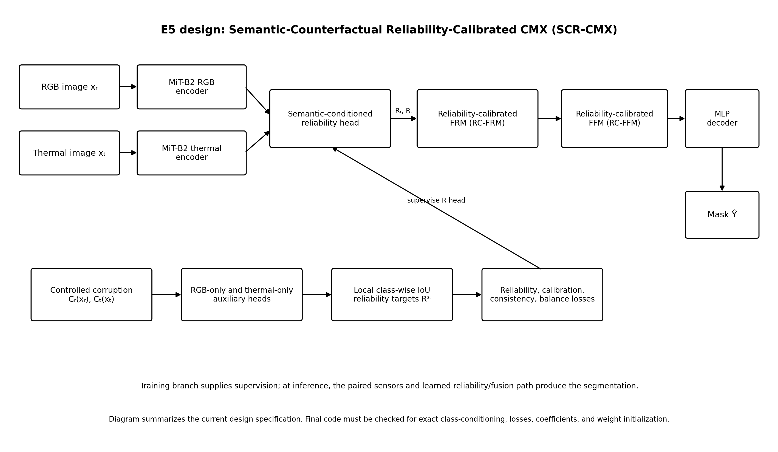
Figure 3. Current E5 SCR-CMX design. Auxiliary corruption and modality-only branches provide training targets; the inference path uses the learned reliability-calibrated FRM/FFM and decoder.

9. Quantitative results and graphs

9.1 Recorded train/validation/test mIoU
The following table consolidates the metrics in the current saved SCR-CMX progress record. “Train mIoU” is reported exactly as recorded; because the train/validation gap is large, the underlying metric implementation and timing should be audited before the results are treated as paper-ready. Validation and test metrics are not interchangeable.
Experiment | Train mIoU | Validation mIoU | Test mIoU | Δ Val vs E0 | Δ Test vs E0
E0 — Original CMX | 92.720% | 62.726% | 58.923% | — | —
E1 — FRM removed | 93.043% | 60.944% | 56.786% | −1.782 pp | −2.137 pp
E2 — Global weighting | 92.646% | 62.325% | 57.830% | −0.401 pp | −1.093 pp
E3 — Spatial reliability | 94.915% | 61.961% | 57.894% | −0.765 pp | −1.029 pp
E4 — Reliability-gated FRM | NR | NR | NR | NR | NR
E5 — SCR-CMX | Pending | Pending | Pending | Pending | Pending

pp means percentage points. NR = no verified numeric result in the reviewed record; pending = training/evaluation not completed. E4 is not assigned a score merely to make the graph complete.
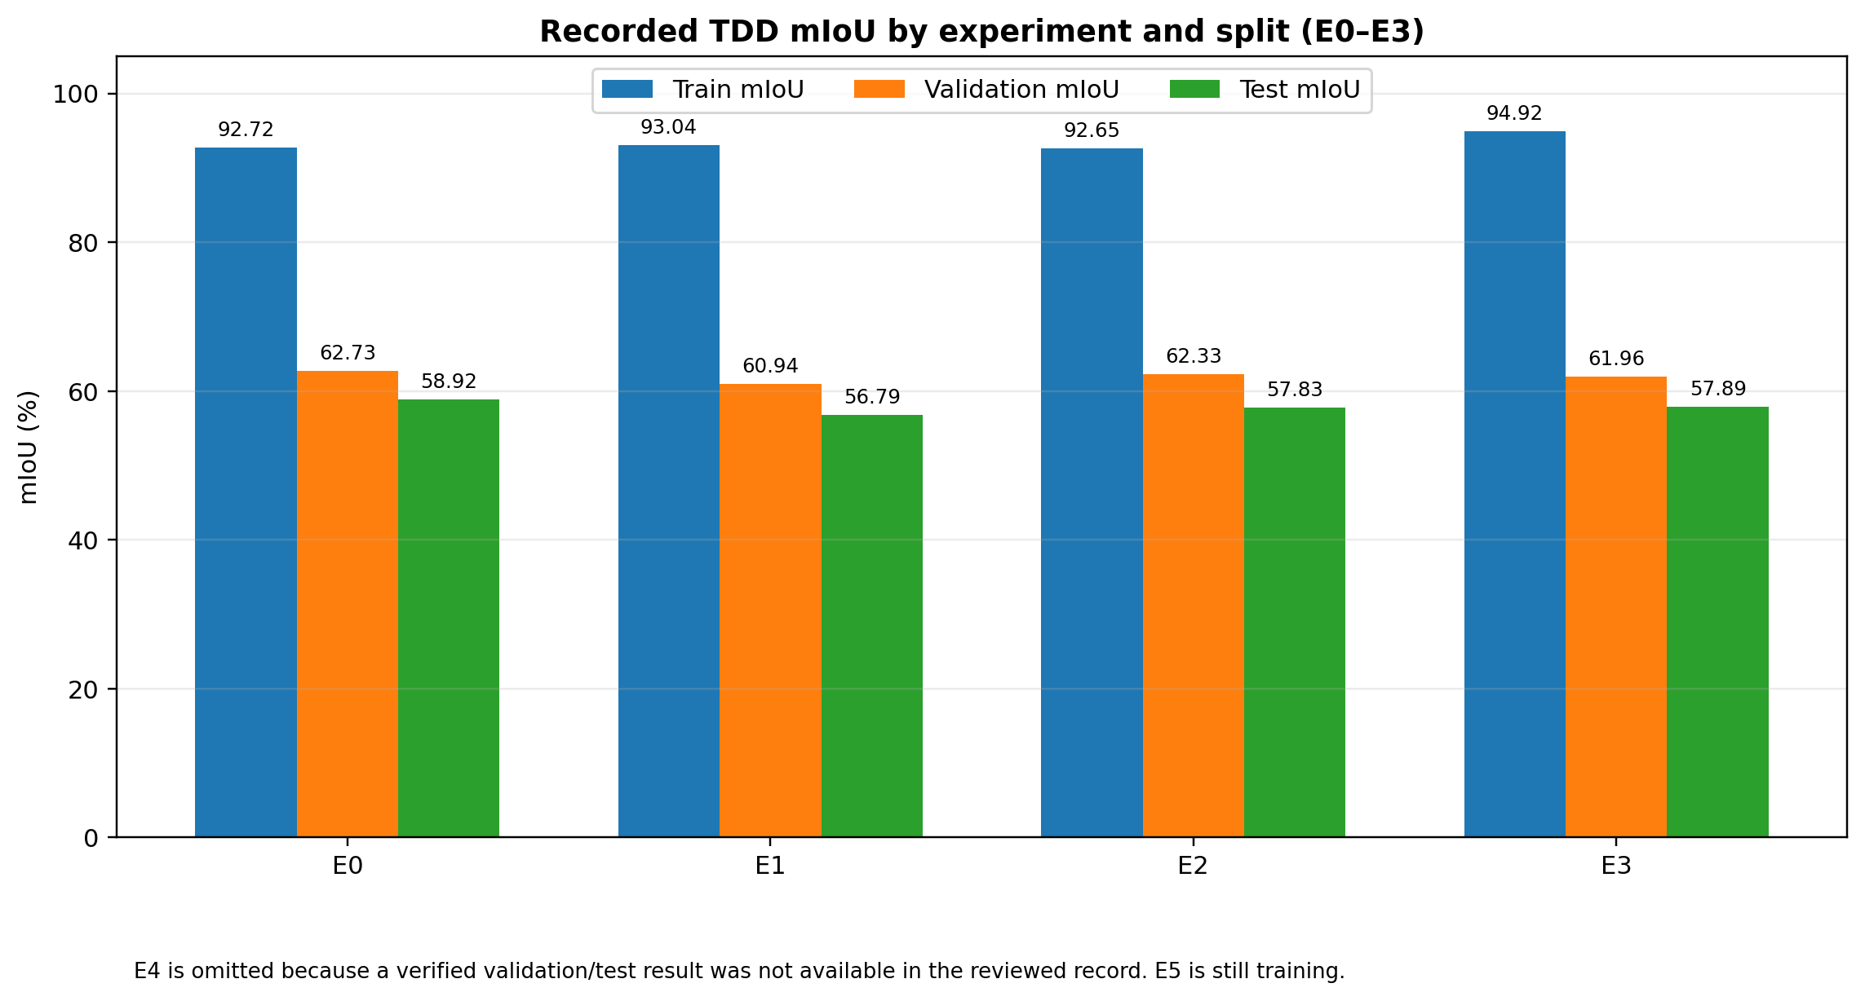
Figure 4. Recorded train, validation, and test mIoU for E0–E3. E4/E5 are intentionally absent due to missing final values.
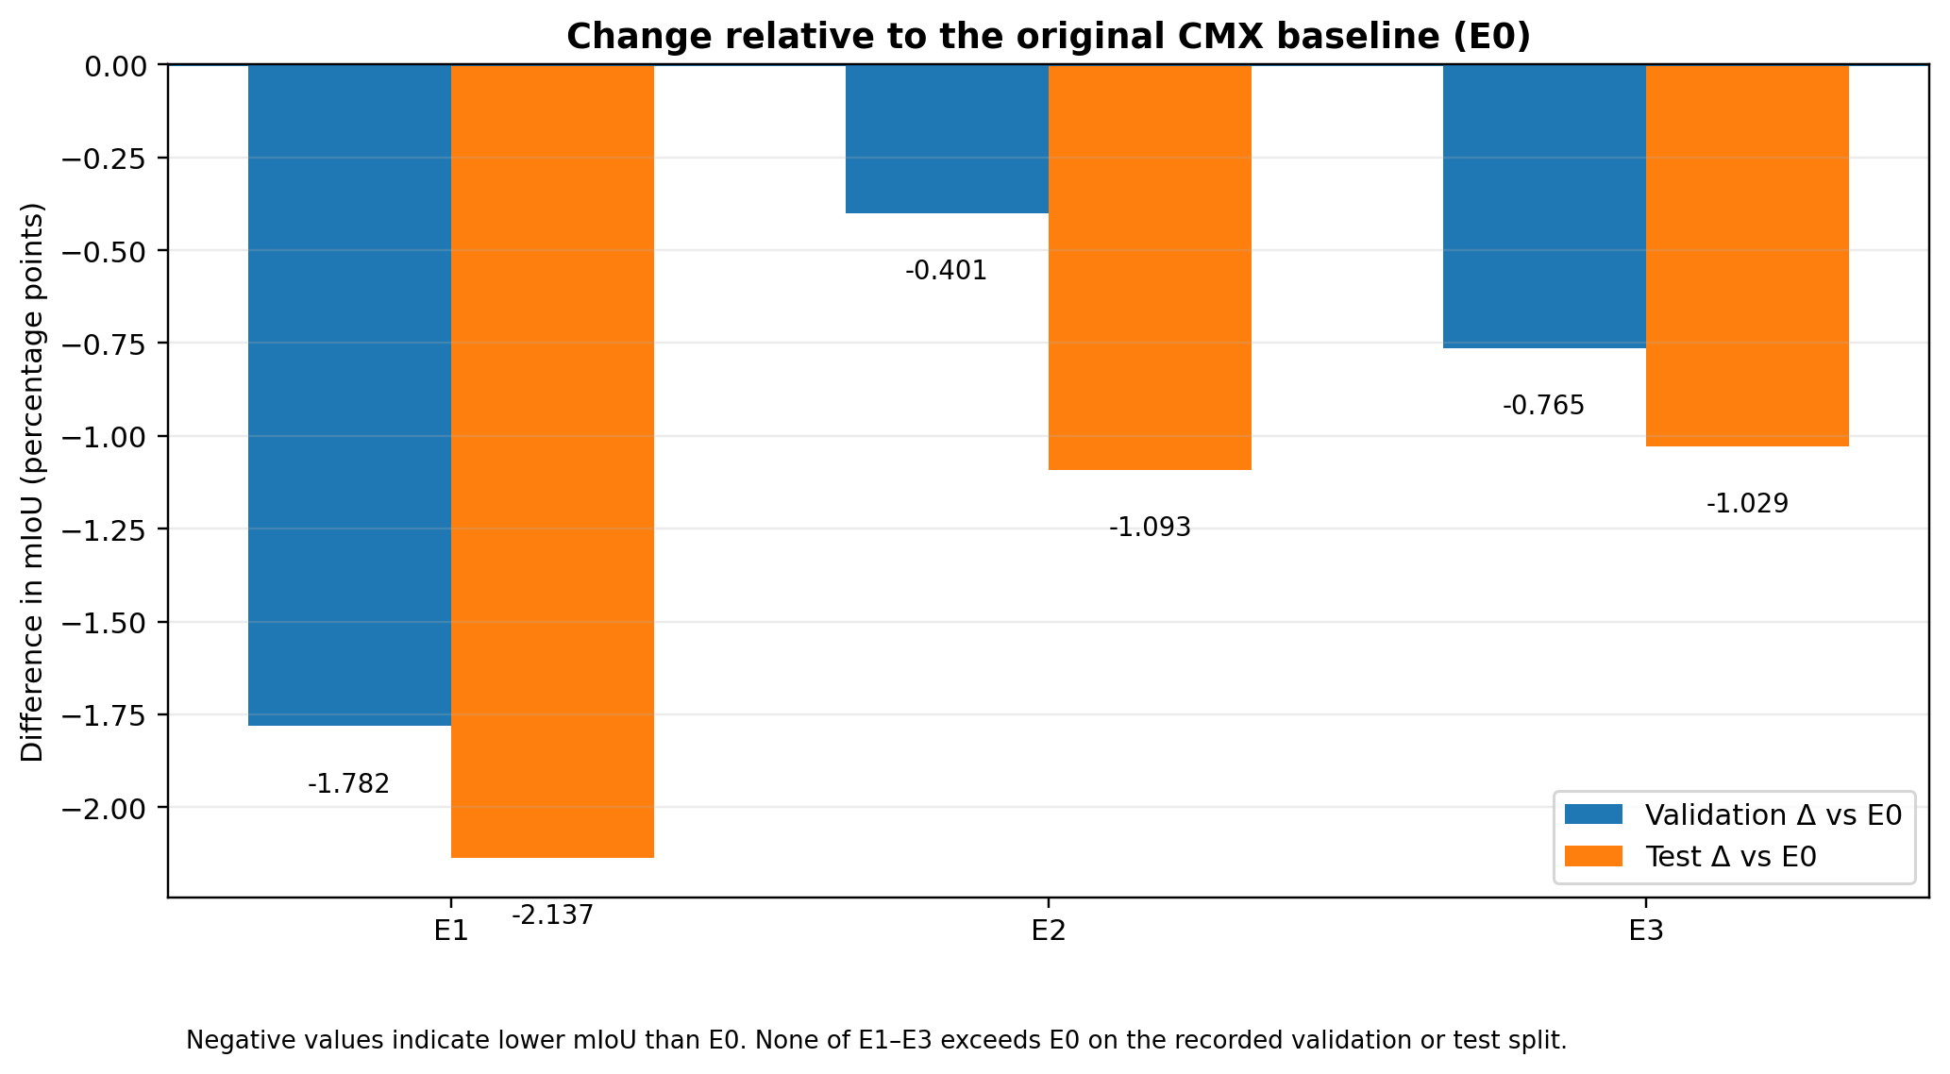
Figure 5. Validation and test mIoU differences for E1–E3 relative to E0. All recorded deltas are negative.

9.2 E0 baseline: class-wise IoU
The E0 class-wise IoUs recorded in the baseline evaluation are shown below. Their unweighted mean is 62.726%, matching the recorded mIoU (subject to rounding).
Class | E0 IoU | Interpretation
Unlabeled | 97.775% | Dominant class; very high IoU can inflate aggregate accuracy.
Car | 87.045% | Strongest foreground category.
Person | 71.804% | Moderate performance; small/occluded instances can remain difficult.
Bike | 72.866% | Moderate-to-good performance.
Curve | 38.150% | Difficult class; boundary/label ambiguity and low pixel frequency are plausible factors.
Car stop | 39.068% | Difficult class; likely sensitive to small regions and visual ambiguity.
Guardrail | 48.623% | Thin/elongated structures remain challenging.
Color cone | 58.333% | Small objects; missed pixels strongly affect class IoU.
Bump | 50.866% | Moderate IoU, with limited spatial extent potentially affecting recall.

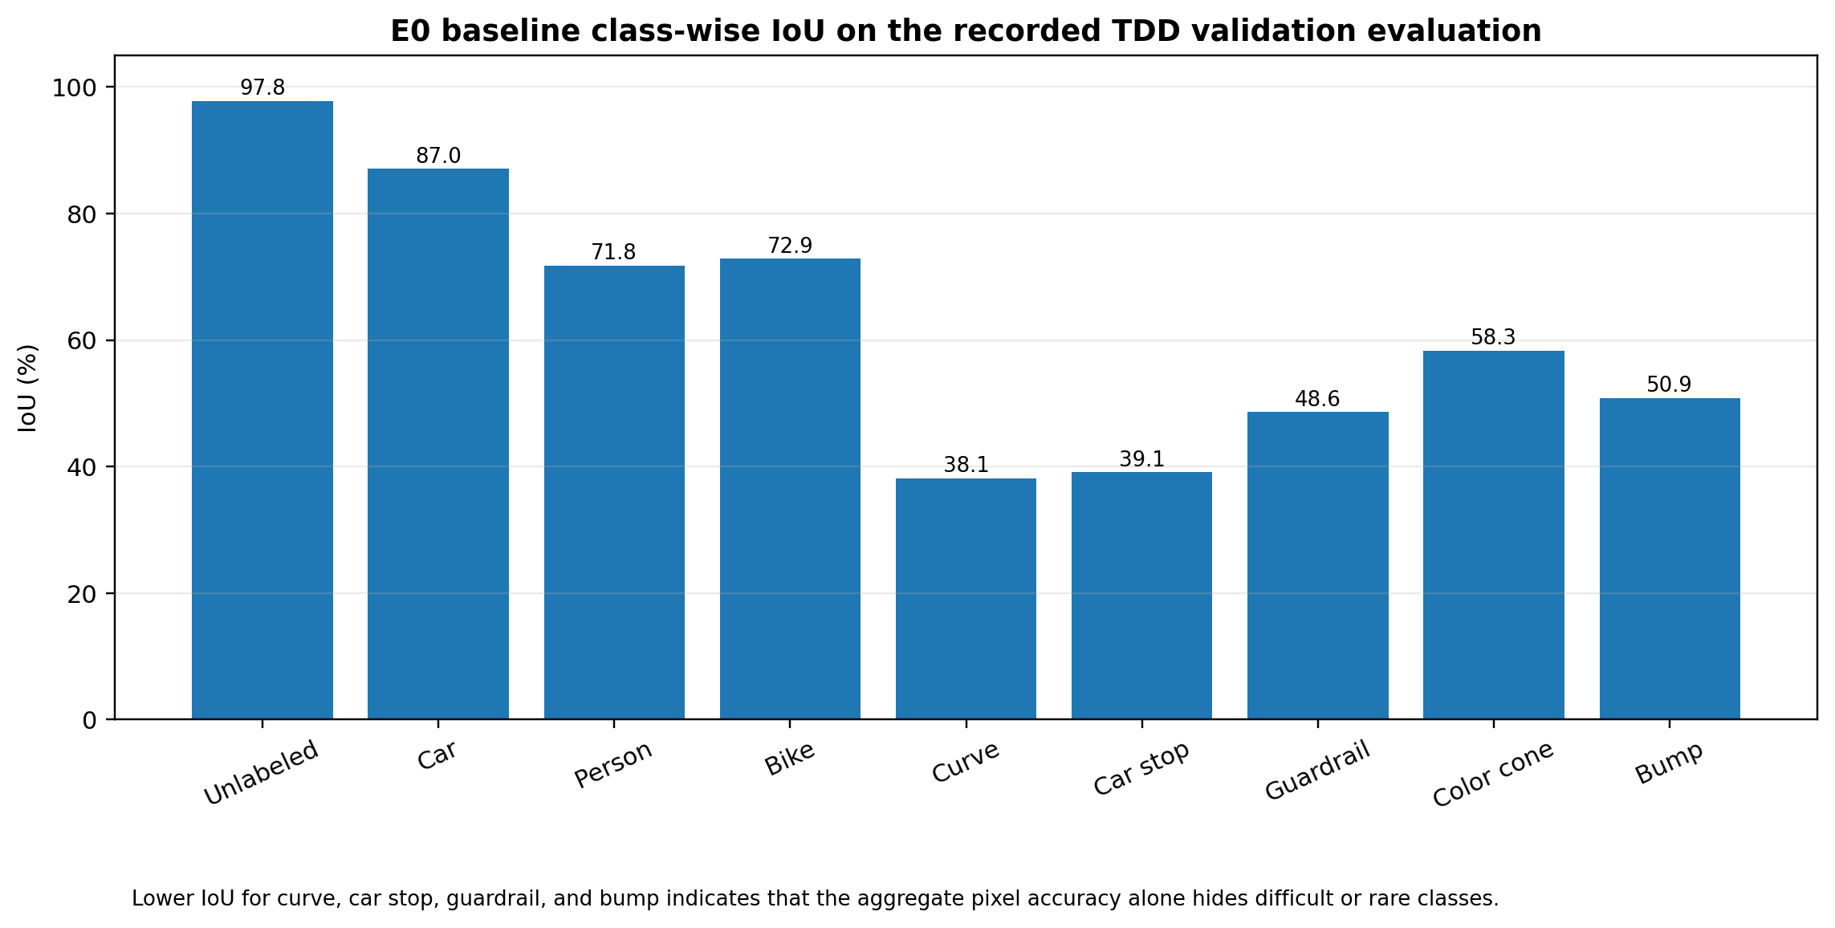
Figure 6. E0 class-wise IoU. The class-level results explain why pixel accuracy alone is insufficient.

9.3 Additional metrics available for E0/E1
Metric | E0 validation | E1 validation | Difference (E1 − E0)
mIoU | 62.726% | 60.944% | −1.782 pp
Pixel accuracy (PA) | 97.732% | 97.684% | −0.048 pp
Mean pixel accuracy (mPA) | 72.982% | 70.880% | −2.102 pp
Frequency-weighted IoU | 95.784% | Not recorded in current summary | —

The recorded E0 evaluation used 392 validation prediction masks. E0 class-wise IoUs are available in the baseline result record. The E1 class-wise IoUs are: unlabeled 97.726%, car 87.001%, person 71.608%, bike 72.682%, curve 36.603%, car stop 32.581%, guardrail 45.387%, color cone 56.540%, and bump 48.367%. These average to the E1 mIoU after rounding.

9.4 Published CMX result versus local E0
The original CMX paper reports a top mIoU of 59.7% on the public MFNet RGB-T dataset under its own evaluation protocol [1]. The local E0 result is 58.923% on the project’s TDD test split and 62.726% on its TDD validation split. These numbers should not be used to state that the local implementation is better or worse than the paper: the local dataset contains 2,353 triplets while public MFNet is described as 1,569 pairs, and the data splits/protocols have not been shown to match. A direct comparison requires a separately verified run on official MFNet with the same split and evaluation conventions.

10. Interpretation of findings and current failure modes

10.1 E1: FRM contributes useful information in this setup
E1 loses 1.782 validation mIoU points and 2.137 test points versus E0. PA changes by only −0.048 points while mPA changes by −2.102 points. The pattern illustrates why the macro/class-balanced view matters: the model may retain nearly the same aggregate pixel correctness while more uniformly losing quality across classes. The result supports retaining a rectification mechanism, although repeated runs and a strict parameter-matched implementation are needed for a causal conclusion.

10.2 E2: global weights may be too coarse
E2 uses a pair of learnable scalar weights shared over spatial positions. It can discover a global preference for a modality, but it cannot represent “trust thermal at this pixel and RGB at another pixel.” Its validation score is 0.401 points below E0 and its test score is 1.093 points below E0. This is an empirical failure of the tested variant, not a proof that all learnable weighted fusion methods fail.

10.3 E3: spatially varying reliability is not automatically calibrated reliability
E3 predicts local weights, but the weights are learned only through the downstream segmentation objective. The head is not directly told how accurate each modality-only prediction is. In addition, the recorded training mIoU is high (94.915%) while validation/test remain near 62%/58%, suggesting either overfitting or a mismatch between how training and evaluation metrics are computed. This is a key diagnostic. Save exact training metric code and compute confusion-matrix metrics from predictions using one shared function for train, validation, and test.

10.4 E4: better insertion point, same supervision limitation
E4 adds reliability gating before fusion, so an untrustworthy source can be down-weighted while it would otherwise rectify the other stream. This is a mechanistically stronger design than only weighting the already cross-attended streams. However, its reliability is still self-estimated without counterfactual labels. E4 may help, but its result must be measured; a more complex architecture alone does not guarantee a gain. A verified E4 evaluation record is required before the final comparison can include it.

10.5 E5: supervision and stress tests are the key
E5 should be evaluated as both a segmentation model and a reliability estimator. Clean-data mIoU is necessary but insufficient: if E5 only improves accuracy on synthetically corrupted examples that were also seen during training, it may have memorized the corruption generator. Hold out some corruption families or severities, evaluate complete modality dropout, and report the change relative to E0 under identical corruptions. Reliability maps should also track observed modality-only local IoU; otherwise their interpretation as calibrated reliability is not justified.

10.6 Train/validation/test gap
All recorded train mIoU values (92.646–94.915%) are more than 29 percentage points above validation mIoU. Compute the train/validation gap using the same exact evaluation code, split-specific transforms, upsampling method, ignore-label mask, and class averaging. If the metrics are truly computed comparably, the gap is evidence of overfitting/domain mismatch; if not, it is an instrumentation issue that must be corrected before submission. Do not dismiss the gap or present high train mIoU as generalization evidence.

11. Research gap and proposed contribution

11.1 Confirmed limitations in the current experimental ladder
- The original CMX baseline remains best among E0–E3 on recorded validation and test mIoU.
- Global scalar weights in E2 do not provide local adaptive trust.
- E3 reliability is spatial, but its supervision is implicit and can overfit downstream segmentation labels.
- E4 inserts reliability into rectification and fusion, but the saved module explicitly lacks counterfactual supervision.
- Rare/small/elongated classes (curve, car stop, guardrail, bump) have substantially lower E0 IoU than unlabeled/car.
- The local dataset label TDD and 2,353 sample count need provenance documentation before external-paper comparison.
- Published reliability-aware and complementarity-aware RGB-T methods already exist, so generic gate naming is not novelty.

11.2 Proposed E5 contribution statement
A suitably cautious working statement is: “We investigate SCR-CMX, a CMX-compatible RGB–thermal segmentation design that learns spatial and semantic-conditioned modality reliability from counterfactual correctness targets generated by modality-specific predictions under controlled sensor corruptions. The learned reliability modulates both feature rectification and final fusion. We evaluate the method on clean and corrupted inputs and compare it with controlled CMX ablations.”
This statement accurately describes the intended method without asserting a performance improvement or a first-ever result. A stronger novelty claim should only be written after a focused equation/module-level comparison against CCFFNet, region-adaptive cross-modulation, CAFNet, DCBF-Net, scene-aware reliability networks, and mixture-of-experts fusion [4–9].

11.3 What evidence would make the contribution defensible?
- Ablation A: E0 vs E5 with the same encoder, decoder, split, seed, schedule, and evaluation code.
- Ablation B: E5 without counterfactual reliability loss (λ₁=0) to isolate the supervisory signal.
- Ablation C: E5 with reliability gating removed from FRM but retained in FFM, and vice versa.
- Ablation D: E5 without semantic/class conditioning to test whether class conditioning is needed.
- Ablation E: E5 without calibration/consistency/balance terms one at a time, with coefficients and losses explicitly stated.
- Robustness: clean, RGB-only corruption, thermal-only corruption, joint corruption, full RGB dropout, full thermal dropout, and unseen corruption families.
- Efficiency: parameter count, FLOPs or MACs, peak memory, inference latency, and FPS alongside mIoU.
- Reliability validity: compare predicted reliability with local modality-only accuracy/IoU and report calibration (e.g., Brier score or expected calibration error with a documented protocol).

12. E5 evaluation protocol and acceptance criteria
The E5 run is in progress. The following protocol should be applied when its checkpoint becomes available. No result below is claimed as already achieved.
Evaluation condition | Construction | Required measures | What it establishes
Clean TDD test | Original paired images; no synthetic corruption | mIoU, per-class IoU, PA, mPA | Checks whether robustness method harms normal accuracy.
RGB-only corruption | Apply fixed severity of low-light/noise/blur/blackout to RGB only | mIoU, per-class IoU, relative drop vs clean | Tests if model falls back toward thermal evidence.
Thermal-only corruption | Apply fixed-pattern/noise/blur/contrast-loss/gain drift to thermal only | mIoU, per-class IoU, relative drop vs clean | Tests if model falls back toward RGB evidence.
Joint corruption | Degrade both modalities independently or in a documented correlated way | mIoU, per-class IoU | Measures robustness when both streams are imperfect.
RGB dropout | Replace RGB stream with documented blank/dropout input | mIoU, recovery relative to E0 | Tests whether thermal path remains usable.
Thermal dropout | Replace thermal stream with documented blank/dropout input | mIoU, recovery relative to E0 | Tests whether RGB path remains usable.
Unseen corruption | Hold out corruption type/intensity during training | mIoU and reliability calibration | Tests generalization beyond synthetic training patterns.
Public MFNet transfer | Run zero-shot inference on official benchmark first | mIoU, class-wise IoU, documented split | Tests cross-dataset transfer without fine-tuning.

12.1 Proposed relative-degradation metrics
For condition k with mIoUᵏ and clean mIoUᶜˡᵉᵃⁿ, report absolute degradation and relative degradation:
ΔmIoUₖ = mIoUclean − mIoUₖ
RelativeDropₖ(%) = 100 × (mIoUclean − mIoUₖ) / max(mIoUclean, ε)
For a model comparison, also report robustness gain relative to baseline under the same corruption: Gainₖ = mIoU(E5, k) − mIoU(E0, k), in percentage points. A positive robustness gain with a large clean-data drop must be interpreted as a trade-off rather than a universal improvement.

12.2 Design targets are not achieved results
The earlier SCR-CMX planning note listed aspirational targets of roughly 58.9–60.4% clean test mIoU, +2 to +5 mIoU under mild corruption, +4 to +8 under severe corruption, and +5 to +10 under modality dropout. These are planning targets only. They must not appear in an abstract, conclusion, or result table as achieved gains until verified by the final E5 evaluation.

13. Limitations, reproducibility, and reporting checklist

13.1 Current limitations
- Only E0–E3 currently have consolidated quantitative validation/test results in the reviewed records; E4 scores are not verified and E5 is ongoing.
- Training mIoU appears much higher than validation/test mIoU; metric implementations must be harmonized before strong generalization claims.
- The local TDD dataset count does not match public MFNet sample count. Provenance/relationship must be explained.
- Single-seed results do not quantify training variance.
- No documented corruption benchmark results are yet available for E5.
- Latency, FLOPs, parameter count, memory, and calibration statistics are not consolidated in the current result record.
- Loss coefficients and exact formulas for E5 calibration, consistency, and balance terms need to be extracted from the running implementation.

13.2 Reproducibility checklist before professor submission
- Archive final config.py and a diff against the original CMX config for each E0–E5 variant.
- Archive the exact source files for each architecture: builder.py, dual_segformer_e*.py, net_utils_e*.py, decoder code, train.py, and eval.py.
- Export full package versions, Python version, CUDA/driver/GPU, random seeds, deterministic flags, and Git commit hash.
- Record each checkpoint filename, epoch, file size, SHA-256 hash, and how it was initialized.
- Archive full train/validation/test logs, exact evaluation command, split-list checksums, and per-image prediction masks.
- Run a shared metric script on stored prediction masks and the same ground-truth masks for every model.
- Confirm class ID mapping and ignore index, including whether label 0 is treated as a class and label 255 is ignored.
- Run at least three seeds for the final baseline and proposed model if compute allows, reporting mean ± standard deviation.
- Keep official MFNet transfer/fine-tuning results separate from the local TDD result.
- Include a complete equation-level comparison to related work before making a novelty claim.

13.3 Authorship and attribution note
This report distinguishes the original CMX and SegFormer components from the project’s modified E1–E5 variants. The original methods should be cited to their authors, and the project’s own implementation choices, experiments, and results should be described accurately. Use of open-source code or pretrained weights does not by itself establish exclusive ownership of the whole model; institutional rules and the relevant software/model licenses govern attribution and permissible use.

14. Conclusion
The project has established a working CMX/SegFormer MiT-B2 RGB–thermal semantic segmentation baseline and conducted three quantitatively recorded architectural changes. The original CMX E0 remains strongest among E0–E3 on the recorded validation and test splits. E1 indicates that removing FRM lowers mIoU; E2 shows that globally learned modality weights did not improve test performance; and E3 shows that spatially varying self-estimated reliability was not sufficient to improve generalization. E4 extends reliability to the rectification stage, but its final metric record must be supplied before comparison. These negative results are informative because they narrow the design problem: reliability should be trained against semantic correctness and evaluated under explicit sensor degradation, not judged by architectural intuition alone.
E5 SCR-CMX is designed to address that problem through class-conditioned counterfactual reliability targets, reliability-calibrated FRM/FFM, and corruption-aware supervision. Its architecture is described in this report, but it is still running and has no reported final validation/test numbers here. The decisive next step is an auditable, same-protocol evaluation on clean and corrupted test data, followed by ablation and public MFNet transfer checks. A publication-quality novelty claim should follow the evidence, not precede it.
The most important data-integrity requirement is to resolve the local TDD/public MFNet relationship. The local dataset contains 2,353 triplets, while the public MFNet benchmark is described as containing 1,569 pairs [3]. Until provenance and protocols are reconciled, local numbers should be labeled as TDD results, not as direct MFNet results. With these safeguards, the project’s architecture evolution, failure analysis, and E5 research hypothesis can be presented transparently and professionally.

References
[1] Zhang, J., Liu, H., Yang, K., Hu, X., Liu, R., & Stiefelhagen, R. (2022). “CMX: Cross-Modal Fusion for RGB-X Semantic Segmentation with Transformers.” arXiv:2203.04838. Link
[2] Xie, E., Wang, W., Yu, Z., Anandkumar, A., Alvarez, J. M., & Luo, P. (2021). “SegFormer: Simple and Efficient Design for Semantic Segmentation with Transformers.” Advances in Neural Information Processing Systems 34 (NeurIPS 2021). Link
[3] Ha, Q., W arter, K., Lien, J., & Lazarus, C. (2017). “MFNet: Towards Real-Time Semantic Segmentation for Autonomous Vehicles with Multi-Spectral Scenes.” IEEE/RSJ International Conference on Intelligent Robots and Systems (IROS). Official project/dataset implementation information. Link
[4] Wu, W., Chu, T., & Liu, Q. (2022). “Complementarity-aware cross-modal feature fusion network for RGB-T semantic segmentation.” Pattern Recognition, 131, 108881. DOI: 10.1016/j.patcog.2022.108881. Link
[5] Peng, F. et al. (online 2023; journal issue 2024). “Region-adaptive and context-complementary cross modulation for RGB-T semantic segmentation.” Pattern Recognition, 147, 110092. DOI: 10.1016/j.patcog.2023.110092. Link
[6] “Cross-Modal Adaptive Fusion Network With Attention and Gated Weighting for RGB-T Semantic Segmentation.” IEEE Access (2025). DOI: 10.1109/ACCESS.2025.3595811. Link
[7] He, X. et al. (2026). “Dynamic cross-modal rectification and bidirectional fusion for RGB-thermal semantic segmentation.” Infrared Physics & Technology, 158, 106793. Link
[8] Guo, Y. et al. (2026). “ASNet: An adaptive scene-aware network for RGB-thermal urban scene semantic segmentation.” Journal of Visual Communication and Image Representation. DOI: 10.1016/j.jvcir.2026.104822. Link
[9] “Multi-scale rectified mixture-of-experts fusion for RGB–Thermal semantic segmentation.” Image and Vision Computing, 174, 106109 (October 2026). DOI: 10.1016/j.imavis.2026.106109. Link
Bibliographic note: verify the exact metadata and full texts of all related papers before submitting a journal/conference manuscript. In particular, perform a structured comparison of E5 equations, target construction, module placement, losses, and corruption protocol against references [4]–[9].

Appendix A. Configuration snapshot
Configuration field | Recorded value
seed | 12345
dataset_name | TDD
num_train_imgs | 1568
num_eval_imgs | 392
test list entries | 393
image_height / image_width | 480 / 640
num_classes | 9
class_names | unlabeled, car, person, bike, curve, car_stop, guardrail, color_cone, bump
rgb normalization mean | [0.485, 0.456, 0.406]
rgb normalization std | [0.229, 0.224, 0.225]
backbone family | mit_b2 or variant-specific mit_b2_e1/e2/e3/e4
pretrained_model | pretrained/segformer/mit_b2.pth
decoder | MLPDecoder
decoder_embed_dim | 512
optimizer | AdamW
learning rate | 6e-5
weight decay | 0.01
batch_size | 2
nepochs | 100
niters_per_epoch | 1568 // 2 + 1 = 785
lr_power | 0.9
ignore index | 255

Appendix B. Mathematical notation
Symbol | Meaning
Xᵣ, Xₜ | RGB and thermal input tensors
Y | Ground-truth segmentation mask
Eᵣ, Eₜ | RGB and thermal MiT-B2 encoder streams
Fᵣˢ, Fₜˢ | Per-modality feature maps at stage s
FRM / FFM | Feature Rectification Module / Feature Fusion Module
F̄ᵣ, F̄ₜ | Features after cross-modal interaction/attention
wᵣ, wₜ | Fusion weights for RGB and thermal modalities
Rᵣ, Rₜ | Predicted modality reliability maps
R*ᵣ, R*ₜ | Counterfactual reliability supervision targets
eᵣ, eₜ | Evidence scores in E5 fusion design
ε | Small positive constant for numerical stability
Ω | Set of pixels not ignored by label 255
mIoU | Mean intersection over union across nine classes
pp | Percentage points; absolute difference between percentages

Appendix C. Supervisor-ready summary
We reproduced an RGB–thermal CMX baseline using dual SegFormer MiT-B2 encoders and an MLP decoder on the local TDD dataset. The dataset contains 2,353 paired RGB/thermal/label triplets at 480 × 640 with nine classes (1,568 train, 392 validation, 393 test). E0 achieved 62.726% validation mIoU and 58.923% test mIoU. E1 removed FRM and fell to 60.944%/56.786%; E2 introduced learnable global modality weights and reached 62.325%/57.830%; E3 introduced spatially varying reliability weights and reached 61.961%/57.894%. E0 remains the best among the variants with confirmed metrics.
E4 combines a reliability-gated rectification module with the E3 reliability-guided fusion module, but a verified E4 metric log must be added before it can be compared quantitatively. E5 is the in-progress SCR-CMX architecture: it adds semantic-conditioned reliability estimation, modality-specific auxiliary prediction heads, counterfactual reliability targets created under controlled corruption, and reliability-calibrated FRM/FFM. E5 performance is pending. The next research step is to verify the local dataset’s relationship to public MFNet and evaluate E5 on clean, corrupted, and modality-dropout conditions with ablations and a transparent metric protocol.
Key caution: the local TDD dataset has more samples than the 1,569-pair public MFNet dataset described in published sources. Therefore local results must not be reported as direct MFNet benchmark results until dataset identity, split, label mapping, and evaluation protocol are aligned. The novelty of SCR-CMX should be claimed only as an experimentally supported distinction after a full comparison with existing complementarity-aware and reliability-aware RGB-T fusion methods.

