**Creating Python Programs**

Dayna Harbour

Colorado State University Global

CSC500-1: Intro to Programming

Douglas Mujeye

13 July 2025

**Creating Python Programs**

**Part 1**

Sourcecode:

## Program to calculate average rainfall over a period of years

# Ask the user for the number of years

years = int(input("Enter the number of years: "))

# Make variables for total rainfall and total months

total_rainfall = 0.0

total_months = 0

# Outer loop - iterate once per year

for year in range(1, years + 1):

print(f"\nYear {year}")

# Inner loop - iterate once per month (12 months)

for month in range(1, 13):

# Get rainfall for the month

rainfall = float(input(f"Enter inches of rainfall for month {month}: "))

total_rainfall += rainfall

total_months += 1

# Calculate average rainfall

average_rainfall = total_rainfall / total_months

# Display results rounding to 2 decimal points

print("\nRainfall Report")

print(f"Total months: {total_months}")

print(f"Total inches of rainfall: {total_rainfall:.2f}")

print(f"Average rainfall per month: {average_rainfall:.2f}")

Screenshot:

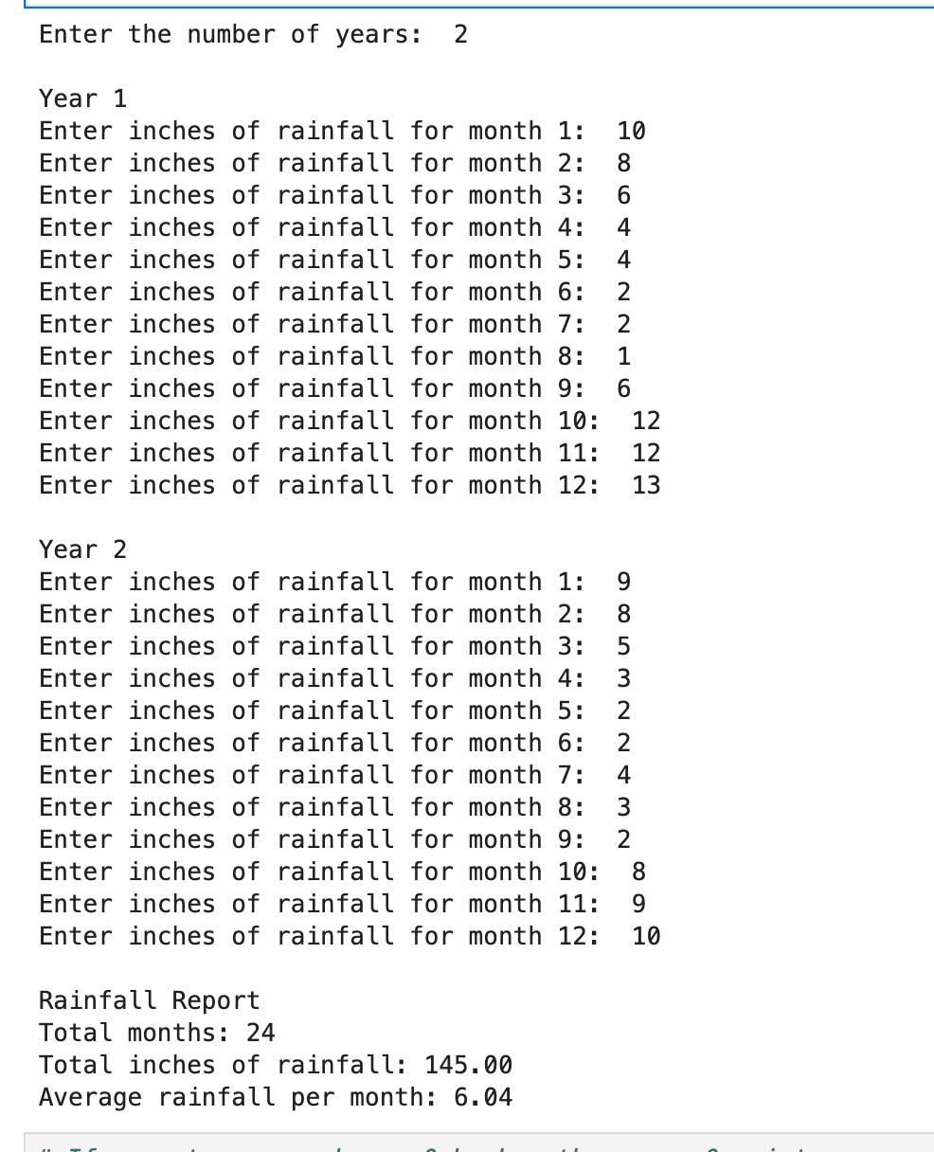

**Part 2**

Python source code:

# Calculate points earned

# Create variable for books purchased and points earned

books_purchased = int(input("Enter books purchased during the month: "))

points_earned = 0

# Evaluate for points earned

if books_purchased >= 8:

points_earned = 60

elif books_purchased >= 6:

points_earned = 30

elif books_purchased >= 4:

points_earned = 15

elif books_purchased >= 2:

points_earned = 5

else:

points_earned = 0

# Display points

print(f"You have earned {points_earned} points this month!")

Screenshot: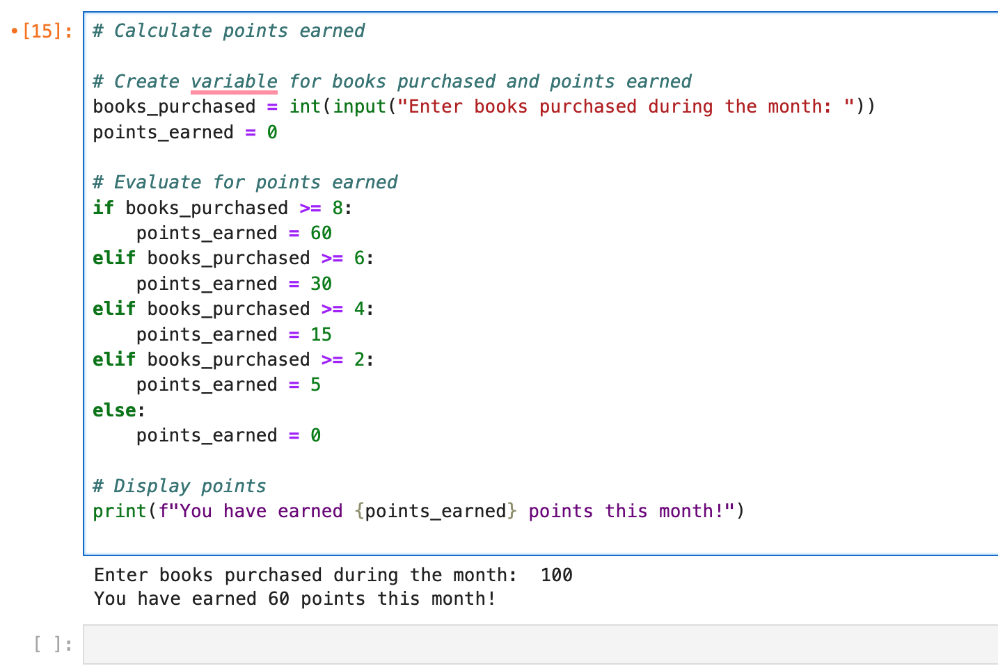

GIT: <https://github.com/dharbour12/IntroToProgramming/blob/main/CriticalThinking5.ipynb>

**References**

*zyBooks*. (2025). Zybooks.com. https://learn.zybooks.com/zybook/CSC500-1_8/chapter/4/section/1

‌