**Creating Python Programs**

Dayna Harbour

Colorado State University Global

CSC500-1: Intro to Programming

Douglas Mujeye

27 July 2025

**Creating Python Programs**

**Part 1**

**Pseudocode:**

BEGIN

// Define dictionaries (as key-value mappings)

SET room_numbers TO {

"CSC101": "3004",

"CSC102": "4501",

"CSC103": "6755",

"NET110": "1244",

"COM241": "1411"

}

SET instructors TO {

"CSC101": "Haynes",

"CSC102": "Alvarado",

"CSC103": "Rich",

"NET110": "Burke",

"COM241": "Lee"

}

SET meeting_times TO {

"CSC101": "8:00 a.m.",

"CSC102": "9:00 a.m.",

"CSC103": "10:00 a.m.",

"NET110": "11:00 a.m.",

"COM241": "1:00 p.m."

}

// Prompt user for input

DISPLAY "Enter a course number (e.g., CSC101):"

GET user_input

CONVERT user_input TO UPPERCASE

// Check if course exists in dictionary

IF user_input EXISTS IN room_numbers THEN

DISPLAY "Course: " + user_input

DISPLAY "Room Number: " + room_numbers[user_input]

DISPLAY "Instructor: " + instructors[user_input]

DISPLAY "Meeting Time: " + meeting_times[user_input]

ELSE

DISPLAY "Sorry, that course number is not recognized."

END IF

END

**Sourcecode (Python):**

# Dictionaries information

room_numbers = {

"CSC101": "3004",

"CSC102": "4501",

"CSC103": "6755",

"NET110": "1244",

"COM241": "1411"

}

instructors = {

"CSC101": "Haynes",

"CSC102": "Alvarado",

"CSC103": "Rich",

"NET110": "Burke",

"COM241": "Lee"

}

meeting_times = {

"CSC101": "8:00 a.m.",

"CSC102": "9:00 a.m.",

"CSC103": "10:00 a.m.",

"NET110": "11:00 a.m.",

"COM241": "1:00 p.m."

}

# User input

course = input("Enter a course number: ").strip().upper()

# Display information if course exists

if course in room_numbers:

print(f"Course: {course}")

print(f"Room Number: {room_numbers[course]}")

print(f"Instructor: {instructors[course]}")

print(f"Meeting Time: {meeting_times[course]}")

else:

print("Invalid Course Number")

Screenshot: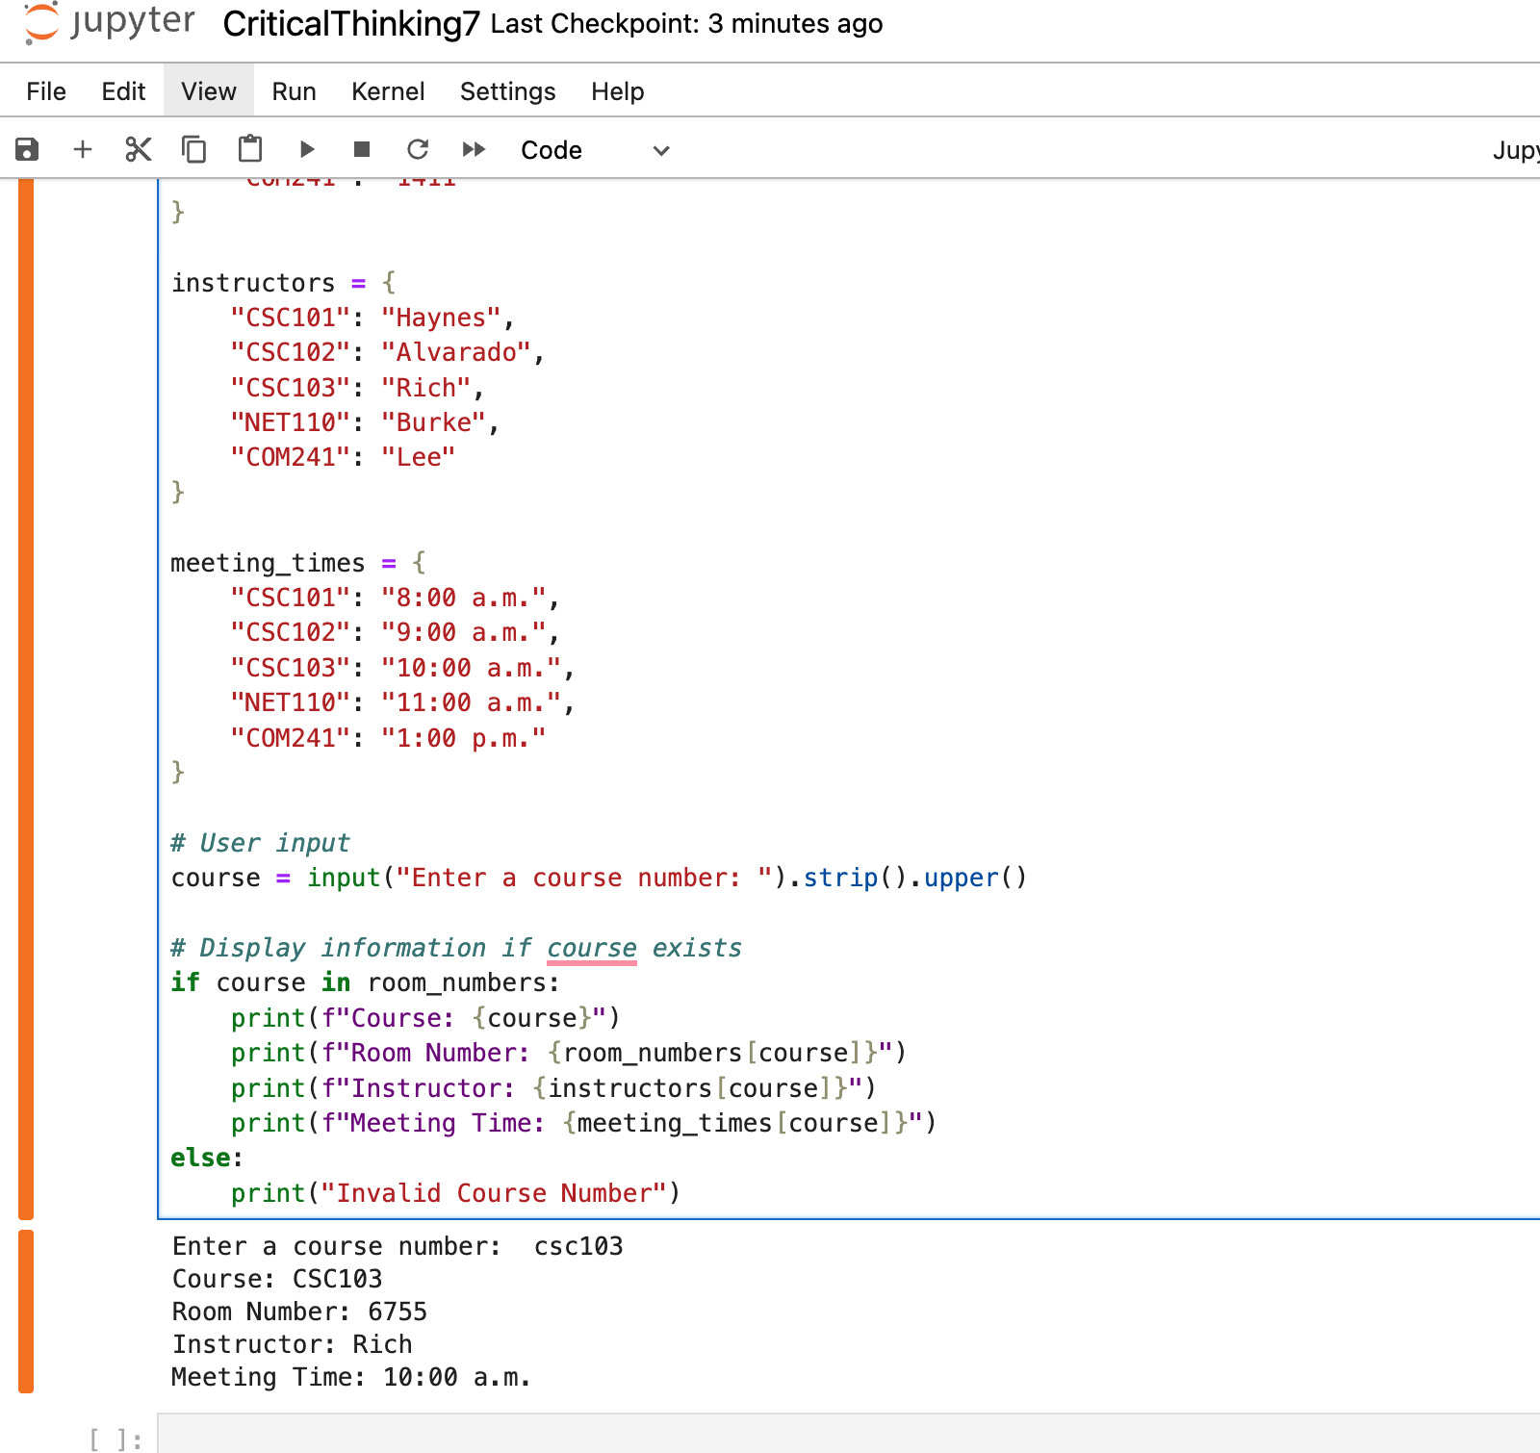

GIT: <https://github.com/dharbour12/IntroToProgramming/blob/main/CriticalThinking7.ipynb>

**References**

*zyBooks*. (2025). Zybooks.com. <https://learn.zybooks.com/zybook/CSC500-1_8/chapter/5/section/1>

*zyBooks*. (2025). Zybooks.com. <https://learn.zybooks.com/zybook/CSC500-1_8/chapter/6/section/12>

‌