**Creating Python Programs**

Dayna Harbour

Colorado State University Global

CSC500-1: Intro to Programming

Douglas Mujeye

15 June 2025

**Creating Python Programs**

**Part 1**

Pseudocode:

START

DISPLAY "Enter number 1:"

GET input from user

CONVERT input to integer and STORE in num1

DISPLAY "Enter number 2:"

GET input from user

CONVERT input to integer and STORE in num2

SET numsum = num1 + num2

DISPLAY "The sum of entered numbers is", numsum

SET numdifference = num1 - num2

DISPLAY "The difference of the entered numbers is", numdifference

END

Python source code:

# Ask User for input on 2 numbers

print("Enter number 1:")

num1 = int(input())

print("Enter number 2:")

num2 = int(input())

# Perform addition of numbers

numsum = num1 + num2

print("The sum of entered numbers is", numsum)

# Perform subtraction of numbers

numdifference = num1 - num2

print("The difference of the entered numbers is", numdifference)

Screenshot: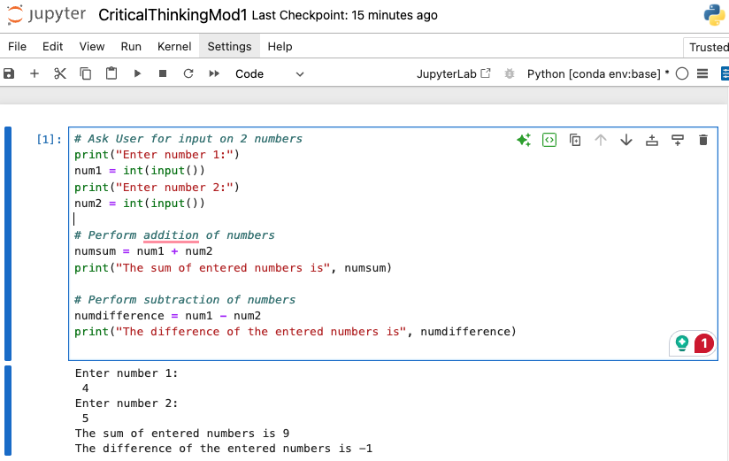

**Part 2**

Pseudocode:

START

DISPLAY "Enter number 1:"

GET input from user

CONVERT input to integer and STORE in num1

DISPLAY "Enter number 2:"

GET input from user

CONVERT input to integer and STORE in num2

SET numproduct = num1 * num2

DISPLAY "The product of entered numbers is", numproduct

SET numquotient = num1 / num2

DISPLAY "The quotient of the entered numbers is", numquotient

END

Python source code:

# Ask User for input on 2 numbers

print("Enter number 1:")

num1 = int(input())

print("Enter number 2:")

num2 = int(input())

# Perform mutiplication of numbers

numproduct = num1 * num2

print("The product of entered numbers is", numproduct)

# Perform division of numbers

numquotient = num1 / num2

print("The quotient of the entered numbers is", numquotient)

Screenshot: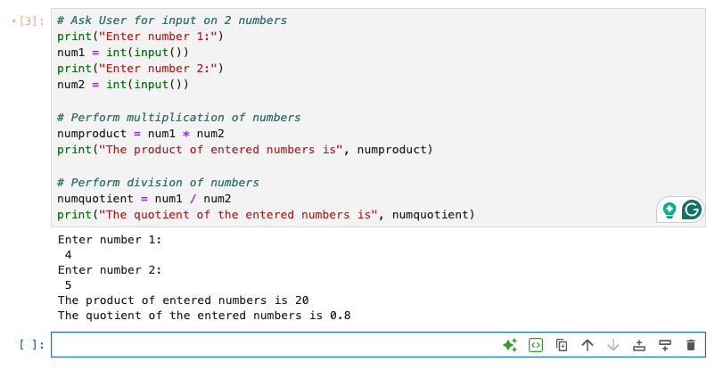

GIT: <https://github.com/dharbour12/IntroToProgramming/blob/main/CriticalThinkingMod1.ipynb>