**Creating Python Programs**

Dayna Harbour

Colorado State University Global

CSC500-1: Intro to Programming

Douglas Mujeye

29 June 2025

**Creating Python Programs**

**Part 1**

Pseudocode:

START

DISPLAY "Enter cost of food:"

GET input from user

CONVERT input to float → base_cost_of_food

COMPUTE calculated_tip_amount = base_cost_of_food × 0.18

DISPLAY "Recommended 18% tip: $" + calculated_tip_amount (formatted to 2 decimal places)

COMPUTE calculated_tax = base_cost_of_food × 0.07

DISPLAY "Tax: $" + calculated_tax (formatted to 2 decimal places)

COMPUTE total_bill = base_cost_of_food + calculated_tip_amount + calculated_tax

DISPLAY "Total bill: $" + total_bill (formatted to 2 decimal places)

END

Python source code:

*# Critical Thinking 3 Part 1*

*# Ask user to input price for meal*

print('Enter cost of food:')

base_cost_of_food **=** float(input())

*# Calculate tip before taxes*

calculated_tip_amount **=** float(base_cost_of_food **\*** 0.18)

print('Recommended 18% tip: $' **+** format(calculated_tip_amount,'.2f'))

*# Calculate taxes on original amount*

calculated_tax **=** float(base_cost_of_food **\*** 0.07)

print('Tax: $' **+** format(calculated_tax, '.2f'))

*# Display total cost*

print('Total bill: $' **+** format(base_cost_of_food **+** calculated_tip_amount **+** calculated_tax, '.2f'))

Screenshot: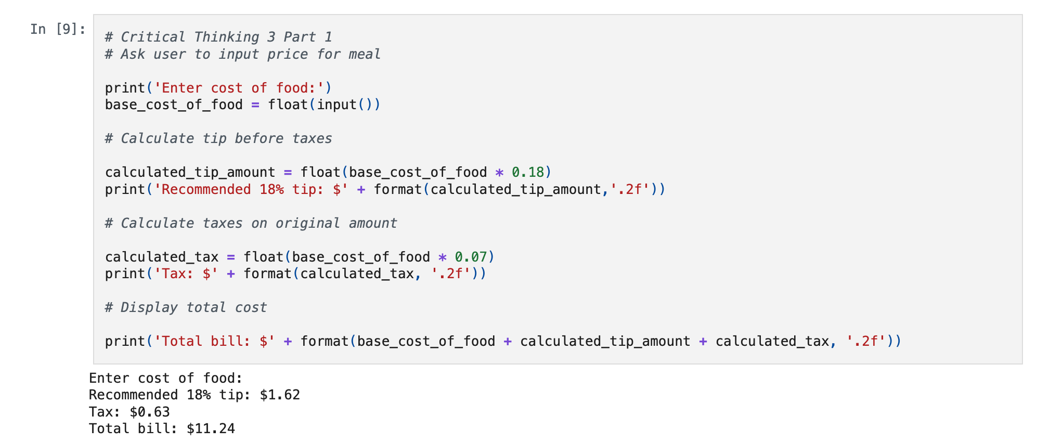

**Part 2**

Pseudocode:

START

DISPLAY "What is the current time in hours using 24-hour time?"

GET input from user

CONVERT input to integer → current_time

DISPLAY "How many hours until your alarm?"

GET input from user

CONVERT input to integer → hours_until_alarm

COMPUTE alarm_time = (current_time + hours_until_alarm) MOD 24

DISPLAY "Your alarm will be at" + alarm_time + ":00"

END

Python source code:

*# Critical Thinking 3 Part 2*

*# Ask user for current time in hours*

print('What is the current time in hours using 24-hour time?')

current_time **=** int(input())

*# Ask for hours until alarm*

print('How many hours until your alarm?')

hours_until_alarm **=** int(input())

*# Calculate remainder*

alarm_time **=** (current_time **+** hours_until_alarm) **%** 24

print('Your alarm will be at', (str(alarm_time) **+** ':00'))

Screenshot: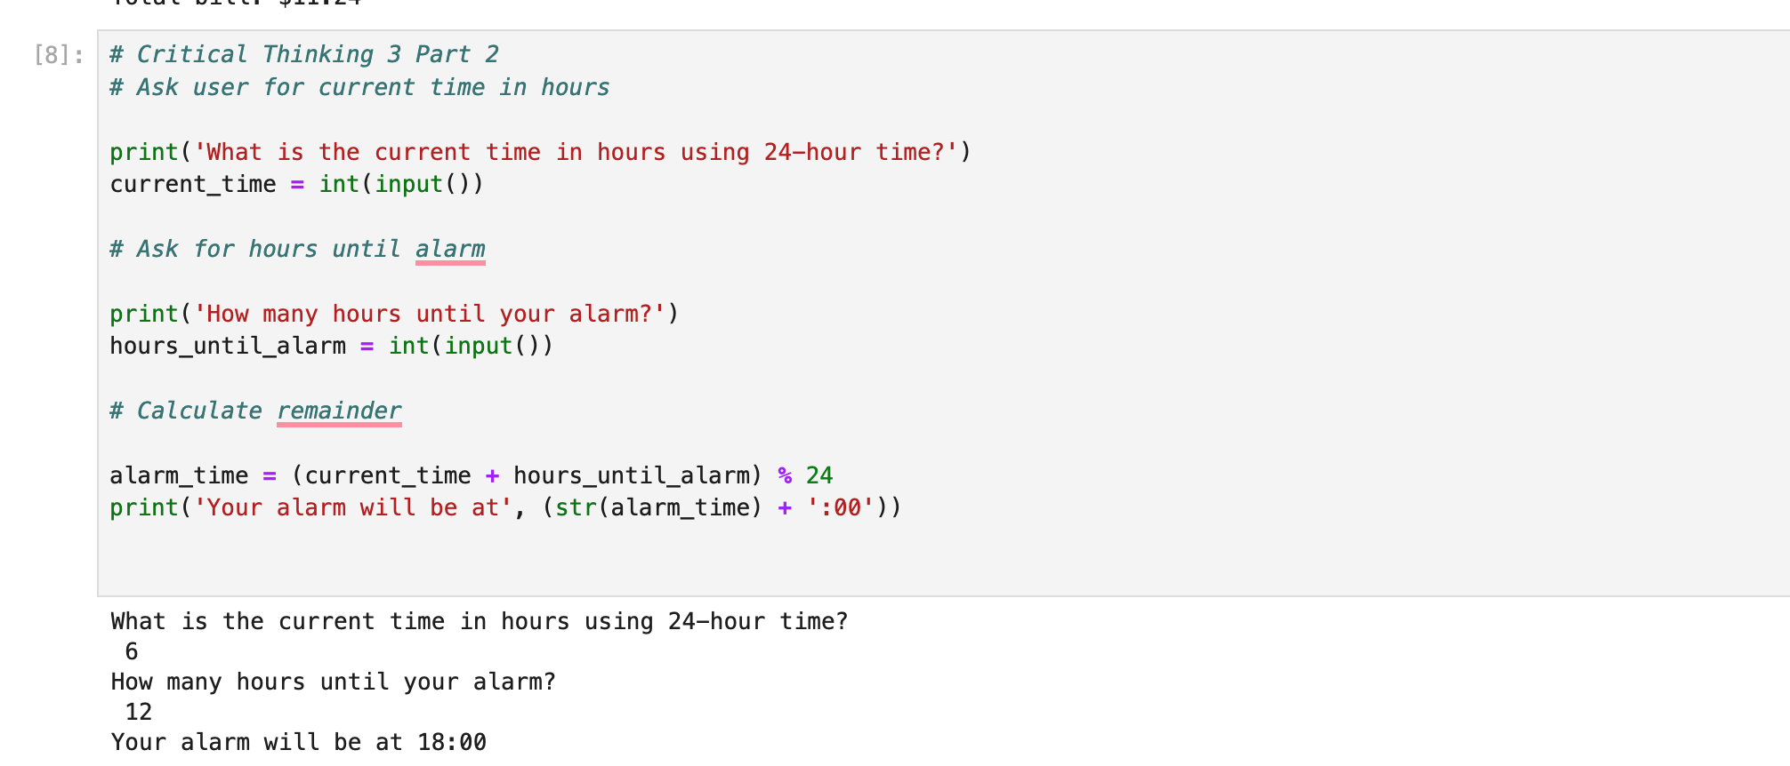

GIT: <https://github.com/dharbour12/IntroToProgramming/blob/main/CriticalThinking3Part1.ipynb>

**References**

(2025). Linkedin.com. https://www.linkedin.com/learning/python-theory-for-network-engineers/python-data-types?autoAdvance=false&u=2245842

*zyBooks*. (2025). Zybooks.com. https://learn.zybooks.com/zybook/CSC500-1_8/chapter/2/section/7

‌