**Online Shopping Cart**

Dayna Harbour

Colorado State University Global

CSC500-1: Intro to Programming

Douglas Mujeye

6 July 2025

**Online Shopping Cart**

**Part 1**

Creating the ItemToPurchase class:

# Define the ItemToPurchase class

class ItemToPurchase:

def __init__(self):

# Default constructor initializes default values

self.item_name = "none"

self.item_price = 0.0

self.item_quantity = 0

def print_item_cost(self):

# Calculates total cost and prints item cost details

total_cost = int(self.item_price * self.item_quantity)

print(f"{self.item_name} {self.item_quantity} @ ${int(self.item_price)} = ${total_cost}")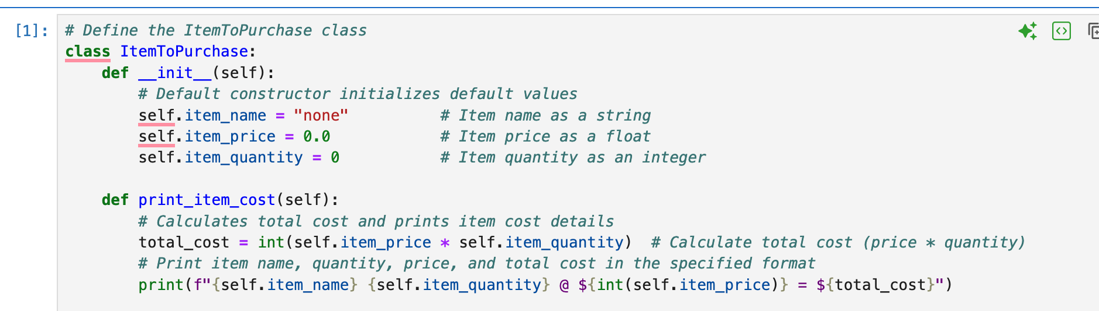

**Part 2**

Prompt user for items:

def main():

# --- ITEM 1 ---

print("Item 1")

item1 = ItemToPurchase()

# Get item 1 details from user

item1.item_name = input("Enter the item name:\n")

item1.item_price = float(input("Enter the item price:\n"))

item1.item_quantity = int(input("Enter the item quantity:\n"))

print()

# --- ITEM 2 ---

print("Item 2")

item2 = ItemToPurchase()

# Get item 2 details from user

item2.item_name = input("Enter the item name:\n")

item2.item_price = float(input("Enter the item price:\n"))

item2.item_quantity = int(input("Enter the item quantity:\n")) # Get item quantity (convert to int)

print() # Blank line for spacing

# --- OUTPUT TOTAL COST ---

print("TOTAL COST”)

item1.print_item_cost()

item2.print_item_cost()

# Calculate and print total cost of both items

total = int(item1.item_price * item1.item_quantity + item2.item_price * item2.item_quantity)

print(f"Total: ${total}")

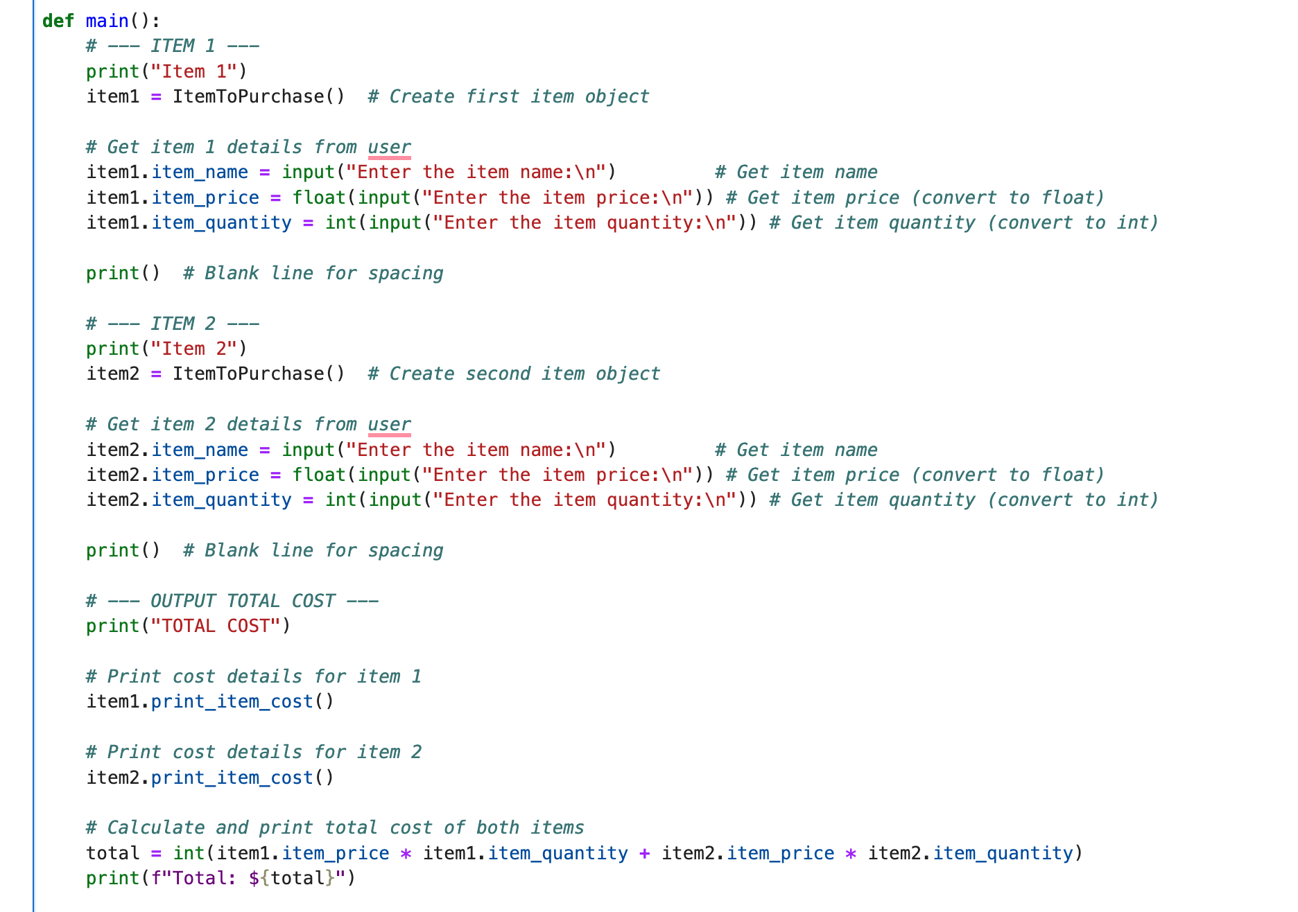

**Part 3**

Add costs and print total: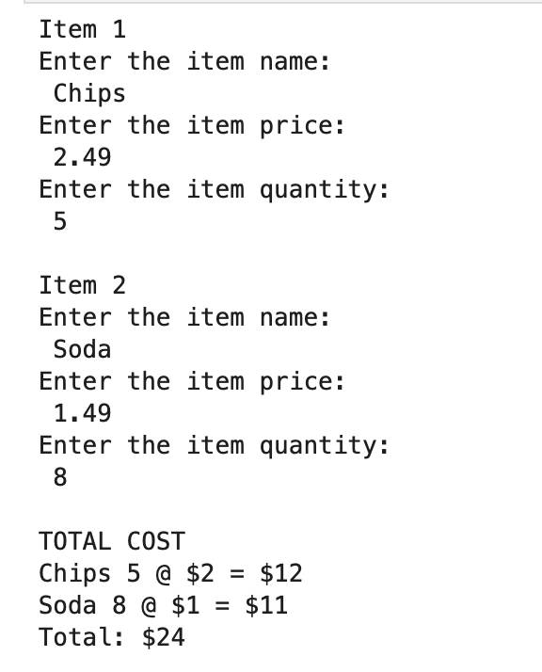

GIT: <https://github.com/dharbour12/IntroToProgramming/blob/main/PortfolioMilestone4.ipynb>

**References**

*Python Classes and Objects [With Examples]*. (2019). Programiz.com. https://www.programiz.com/python-programming/class

*zyBooks*. (2025). Zybooks.com. https://learn.zybooks.com/zybook/CSC500-1_8/chapter/8/section/1

‌