**Online Shopping Cart**

Dayna Harbour

Colorado State University Global

CSC500-1: Intro to Programming

Douglas Mujeye

20 July 2025

**Online Shopping Cart**

**Part 4**

Build the Shopping Cart class:

class ShoppingCart:

def __init__(self, customer_name="none", current_date="January 1, 2020"):

self.customer_name = customer_name

self.current_date = current_date

self.cart_items = [] # This will store ItemToPurchase objects

def add_item(self, item):

# item should be an instance of ItemToPurchase

self.cart_items.append(item)

def remove_item(self, item_name):

# Tries to remove item by name

found = False

for item in self.cart_items:

if item.item_name == item_name:

self.cart_items.remove(item)

found = True

break

if not found:

print("Item not found in cart. Nothing removed.")

def modify_item(self, item_to_modify):

# Looks for item by name and updates it if found

found = False

for item in self.cart_items:

if item.item_name == item_to_modify.item_name:

found = True

if item_to_modify.item_description != "none":

item.item_description = item_to_modify.item_description

if item_to_modify.item_price != 0:

item.item_price = item_to_modify.item_price

if item_to_modify.item_quantity != 0:

item.item_quantity = item_to_modify.item_quantity

break

if not found:

print("Item not found in cart. Nothing modified.")

def get_num_items_in_cart(self):

total_quantity = 0

for item in self.cart_items:

total_quantity += item.item_quantity

return total_quantity

def get_cost_of_cart(self):

total_cost = 0

for item in self.cart_items:

total_cost += item.item_price * item.item_quantity

return total_cost

def print_total(self):

print(f"{self.customer_name}'s Shopping Cart - {self.current_date}")

print(f"Number of Items: {self.get_num_items_in_cart()}")

if not self.cart_items:

print("SHOPPING CART IS EMPTY")

else:

for item in self.cart_items:

item.print_item_cost()

print(f"\nTotal: ${self.get_cost_of_cart():.0f}")

def print_descriptions(self):

print(f"{self.customer_name}'s Shopping Cart - {self.current_date}")

print("Item Descriptions")

for item in self.cart_items:

item.print_item_description()

**Part 5/6**

Menu:

def print_menu(cart):

menu_options = {

"a": "Add item to cart",

"r": "Remove item from cart",

"c": "Change item quantity",

"i": "Output items' descriptions",

"o": "Output shopping cart",

"q": "Quit"

}

choice = "" # initialize empty choice

while choice != "q":

print("\nMENU")

for key, desc in menu_options.items():

print(f"{key} - {desc}")

choice = input("Choose an option:\n").lower()

while choice not in menu_options:

choice = input("Invalid option. Choose a valid option:\n").lower()

if choice == "q":

break

elif choice == "a":

print("ADD ITEM TO CART")

name = input("Enter the item name:\n")

description = input("Enter the item description:\n")

price = float(input("Enter the item price:\n"))

quantity = int(input("Enter the item quantity:\n"))

item = ItemToPurchase(name, price, quantity, description)

cart.add_item(item)

elif choice == "r":

print("REMOVE ITEM FROM CART")

name = input("Enter name of item to remove:\n")

cart.remove_item(name)

elif choice == "c":

print("CHANGE ITEM INFORMATION")

name = input("Enter the item name to modify:\n")

# Prompt for new values; use defaults if nothing entered

description = input("Enter the new description (or leave blank to skip):\n")

price_input = input("Enter the new price (or leave blank to skip):\n")

quantity_input = input("Enter the new quantity (or leave blank to skip):\n")

# Set fallback/defaults if fields are skipped

description = description if description else "none"

price = float(price_input) if price_input else 0.0

quantity = int(quantity_input) if quantity_input else 0

# Create a temp ItemToPurchase with just the new values

updated_item = ItemToPurchase(item_name=name, item_price=price, item_quantity=quantity, item_description=description)

cart.modify_item(updated_item)

elif choice == "i":

print("OUTPUT ITEMS' DESCRIPTIONS")

cart.print_descriptions()

elif choice == "o":

print("OUTPUT SHOPPING CART")

cart.print_total()

def main():

customer_name = input("Enter customer's name:\n")

current_date = input("Enter today's date:\n")

print()

print(f"Customer name: {customer_name}")

print(f"Today's date: {current_date}\n")

cart = ShoppingCart(customer_name, current_date)

print_menu(cart)

Running Code:

Initiate and add item:

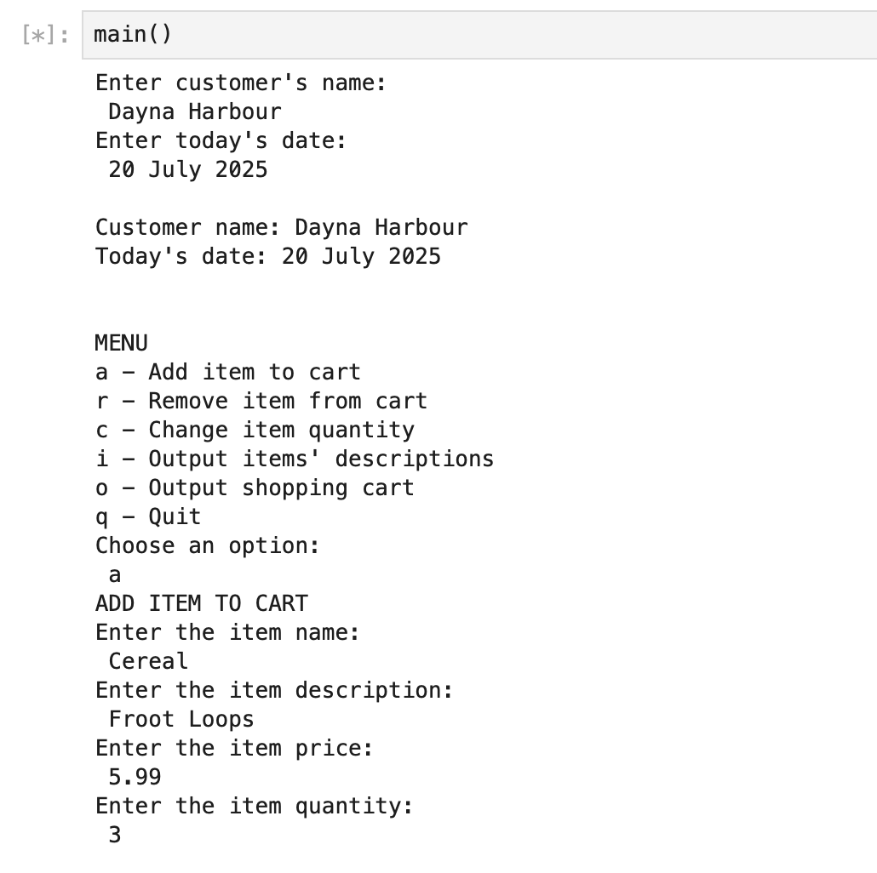

Change quantity: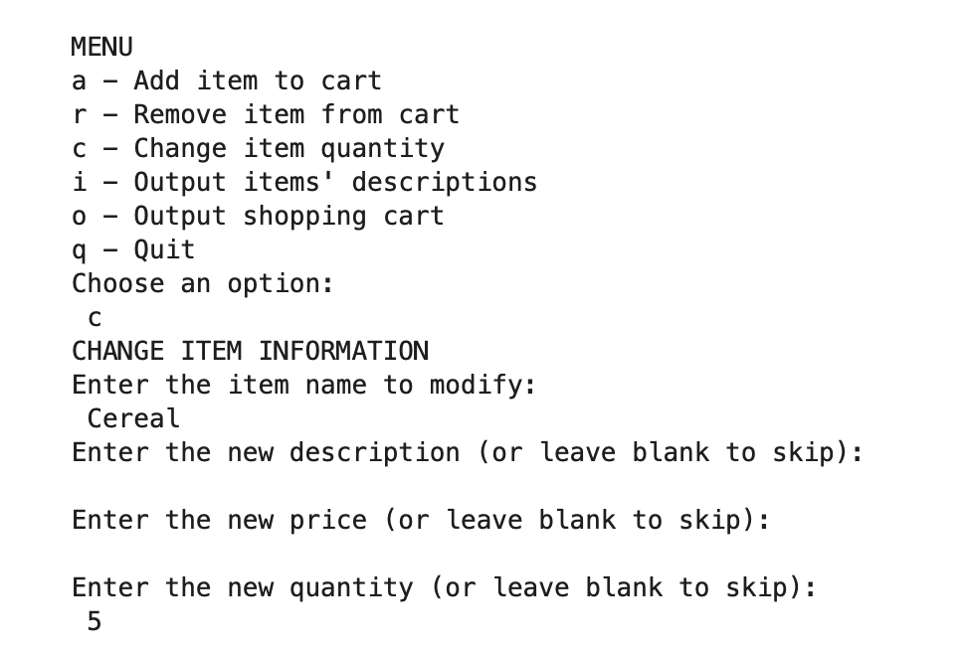

Output of cart and items descriptions: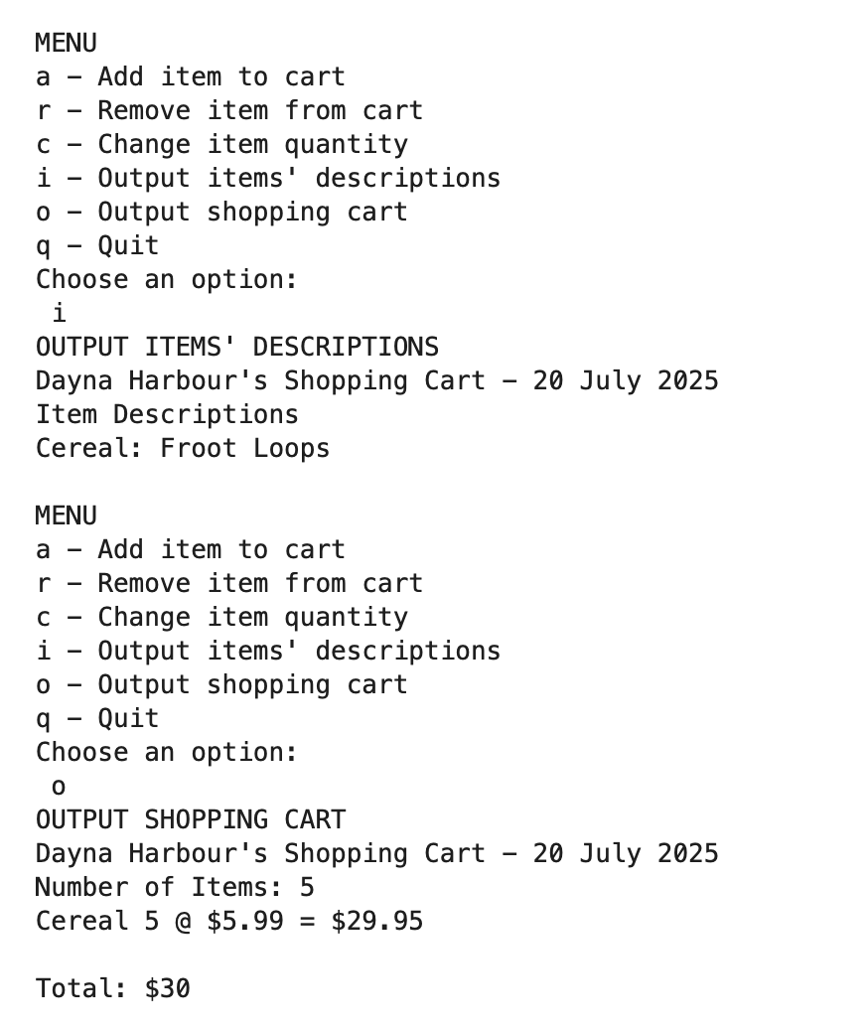

Remove item and print empty cart: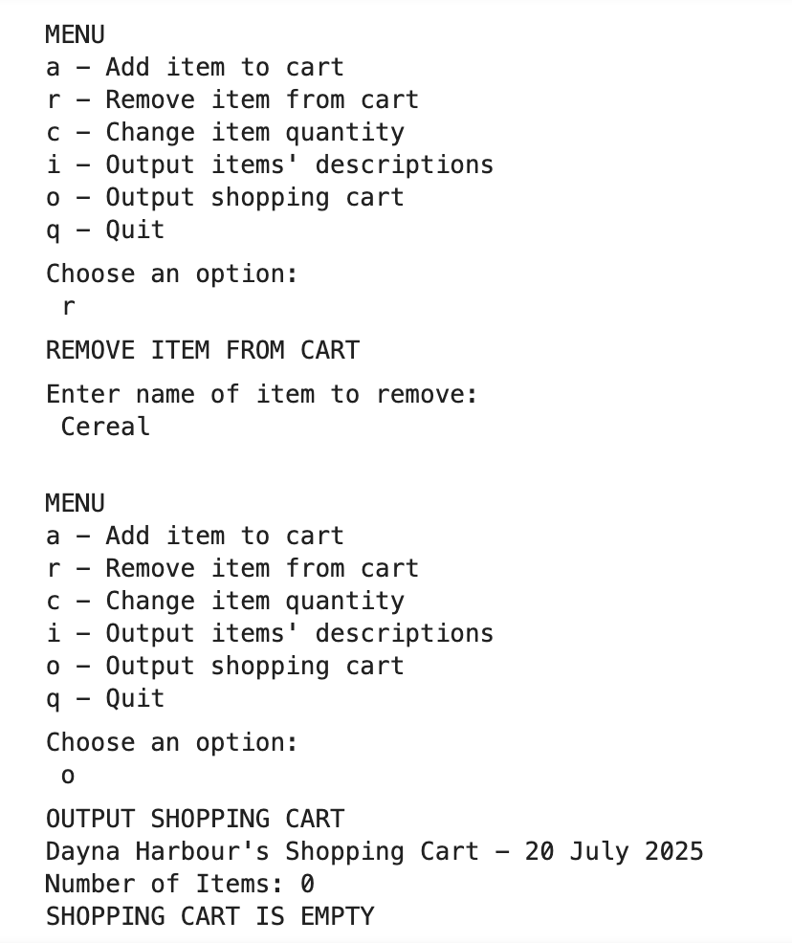

GIT: [https://github.com/dharbour12/IntroToProgramming/blob/main/PortfolioMilestone6.ipynb](https://github.com/dharbour12/IntroToProgramming/blob/main/PortfolioMilestone4.ipynb)

**References**

*Python Classes and Objects [With Examples]*. (2019). Programiz.com. https://www.programiz.com/python-programming/class

W3 Schools. (2019). *Python Functions*. W3schools.com. https://www.w3schools.com/python/python_functions.asp

‌ *zyBooks*. (2025). Zybooks.com. <https://learn.zybooks.com/zybook/CSC500-1_8/chapter/6/section/12>

‌