**Online Shopping Cart**

Dayna Harbour

Colorado State University Global

CSC500-1: Intro to Programming

Douglas Mujeye

3 August 2025

**Online Shopping Cart**

Pseudocode:

BEGIN PROGRAM

FUNCTION: ItemToPurchase class

ATTRIBUTES:

item_name (string)

item_price (float)

item_quantity (int)

item_description (string)

METHOD: print_item_cost()

CALCULATE total_cost = item_price * item_quantity

PRINT item_name, item_quantity, item_price, total_cost in formatted string

METHOD: print_item_description()

PRINT item_name and item_description

FUNCTION: ShoppingCart class

ATTRIBUTES:

customer_name (string)

current_date (string)

cart_items (list of ItemToPurchase objects)

METHOD: add_item(item)

APPEND item to cart_items list

METHOD: remove_item(item_name)

FOR each item in cart_items:

IF item_name matches:

REMOVE item

RETURN

IF no item found:

PRINT "Item not found in cart. Nothing removed."

METHOD: modify_item(item_to_modify)

FOR each item in cart_items:

IF item_name matches:

IF item_to_modify has non-default values:

UPDATE item's description, price, or quantity

RETURN

IF no item found:

PRINT "Item not found in cart. Nothing modified."

METHOD: get_num_items_in_cart()

RETURN sum of item_quantity for each item in cart_items

METHOD: get_cost_of_cart()

RETURN sum of item_price * item_quantity for each item

METHOD: print_total()

PRINT customer_name and current_date

IF cart is empty:

PRINT "SHOPPING CART IS EMPTY"

ELSE:

PRINT each item's cost

PRINT total cart cost

METHOD: print_descriptions()

PRINT customer_name and current_date

PRINT descriptions of each item

FUNCTION: print_menu(cart)

DEFINE menu options: add, remove, change, descriptions, cart total, quit

LOOP until user selects "q":

DISPLAY menu

GET user input

IF input is invalid:

PROMPT again

IF input is "a":

PROMPT user for item details

CREATE ItemToPurchase

CALL cart.add_item()

IF input is "r":

PROMPT user for item name

CALL cart.remove_item()

IF input is "c":

PROMPT user for item name and new quantity

CREATE ItemToPurchase with new quantity

CALL cart.modify_item()

IF input is "i":

CALL cart.print_descriptions()

IF input is "o":

CALL cart.print_total()

MAIN FUNCTION:

PROMPT user for customer name and date

PRINT customer name and date

CREATE ShoppingCart with user input

CALL print_menu(cart)

END PROGRAM

Python Code:

# Define the ItemToPurchase class

class ItemToPurchase:

def __init__(self, item_name="none", item_price=0.0, item_quantity=0, item_description="none"):

# Parameterized constructor with default values

self.item_name = item_name

self.item_price = item_price

self.item_quantity = item_quantity

self.item_description = item_description

def print_item_cost(self):

# Calculates and prints the total cost for this item

total_cost = self.item_price * self.item_quantity

print(f"{self.item_name} {self.item_quantity} @ ${self.item_price:.2f} = ${total_cost:.2f}")

def print_item_description(self):

print(f"{self.item_name}: {self.item_description}")

# Define the ShoppingCart class

class ShoppingCart:

def __init__(self, customer_name="none", current_date="January 1, 2020"):

self.customer_name = customer_name

self.current_date = current_date

self.cart_items = [] # This will store ItemToPurchase objects

def add_item(self, item):

# item should be an instance of ItemToPurchase

self.cart_items.append(item)

def remove_item(self, item_name):

# Tries to remove item by name

found = False

for item in self.cart_items:

if item.item_name == item_name:

self.cart_items.remove(item)

found = True

break

if not found:

print("Item not found in cart. Nothing removed.")

def modify_item(self, item_to_modify):

# Looks for item by name and updates it if found

found = False

for item in self.cart_items:

if item.item_name == item_to_modify.item_name:

found = True

if item_to_modify.item_description != "none":

item.item_description = item_to_modify.item_description

if item_to_modify.item_price != 0:

item.item_price = item_to_modify.item_price

if item_to_modify.item_quantity != 0:

item.item_quantity = item_to_modify.item_quantity

break

if not found:

print("Item not found in cart. Nothing modified.")

def get_num_items_in_cart(self):

total_quantity = 0

for item in self.cart_items:

total_quantity += item.item_quantity

return total_quantity

def get_cost_of_cart(self):

total_cost = 0

for item in self.cart_items:

total_cost += item.item_price * item.item_quantity

return total_cost

def print_total(self):

print(f"{self.customer_name}'s Shopping Cart - {self.current_date}")

print(f"Number of Items: {self.get_num_items_in_cart()}")

if not self.cart_items:

print("SHOPPING CART IS EMPTY")

else:

for item in self.cart_items:

item.print_item_cost()

print(f"\nTotal: ${self.get_cost_of_cart():.0f}")

def print_descriptions(self):

print(f"{self.customer_name}'s Shopping Cart - {self.current_date}")

print("Item Descriptions")

for item in self.cart_items:

item.print_item_description()

def print_menu(cart):

menu_options = {

"a": "Add item to cart",

"r": "Remove item from cart",

"c": "Change item quantity",

"i": "Output items' descriptions",

"o": "Output shopping cart",

"q": "Quit"

}

choice = "" # initialize empty choice

while choice != "q":

print("\nMENU")

for key, desc in menu_options.items():

print(f"{key} - {desc}")

choice = input("Choose an option:\n").lower()

while choice not in menu_options:

choice = input("Invalid option. Choose a valid option:\n").lower()

if choice == "q":

break

elif choice == "a":

print("ADD ITEM TO CART")

name = input("Enter the item name:\n")

description = input("Enter the item description:\n")

price = float(input("Enter the item price:\n"))

quantity = int(input("Enter the item quantity:\n"))

item = ItemToPurchase(name, price, quantity, description)

cart.add_item(item)

elif choice == "r":

print("REMOVE ITEM FROM CART")

name = input("Enter name of item to remove:\n")

cart.remove_item(name)

elif choice == "c":

print("CHANGE ITEM INFORMATION")

name = input("Enter the item name to modify:\n")

# Prompt for new values; use defaults if nothing entered

description = input("Enter the new description (or leave blank to skip):\n")

price_input = input("Enter the new price (or leave blank to skip):\n")

quantity_input = input("Enter the new quantity (or leave blank to skip):\n")

# Set fallback/defaults if fields are skipped

description = description if description else "none"

price = float(price_input) if price_input else 0.0

quantity = int(quantity_input) if quantity_input else 0

# Create a temp ItemToPurchase with just the new values

updated_item = ItemToPurchase(item_name=name, item_price=price, item_quantity=quantity, item_description=description)

cart.modify_item(updated_item)

elif choice == "i":

print("OUTPUT ITEMS' DESCRIPTIONS")

cart.print_descriptions()

elif choice == "o":

print("OUTPUT SHOPPING CART")

cart.print_total()

def main():

customer_name = input("Enter customer's name:\n")

current_date = input("Enter today's date:\n")

print()

print(f"Customer name: {customer_name}")

print(f"Today's date: {current_date}\n")

cart = ShoppingCart(customer_name, current_date)

print_menu(cart)

Screenshots:

Initiate and add item: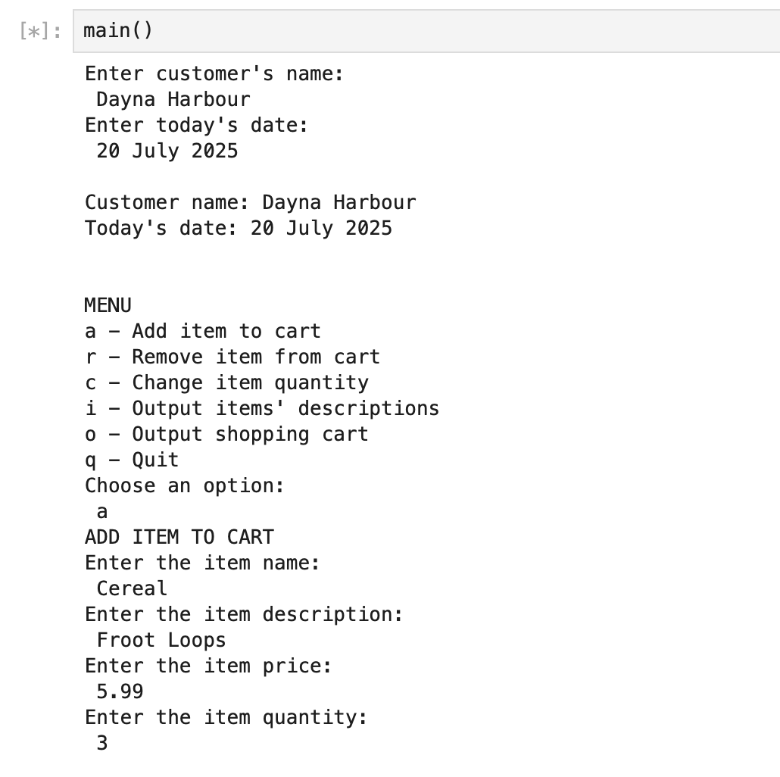

Change quantity: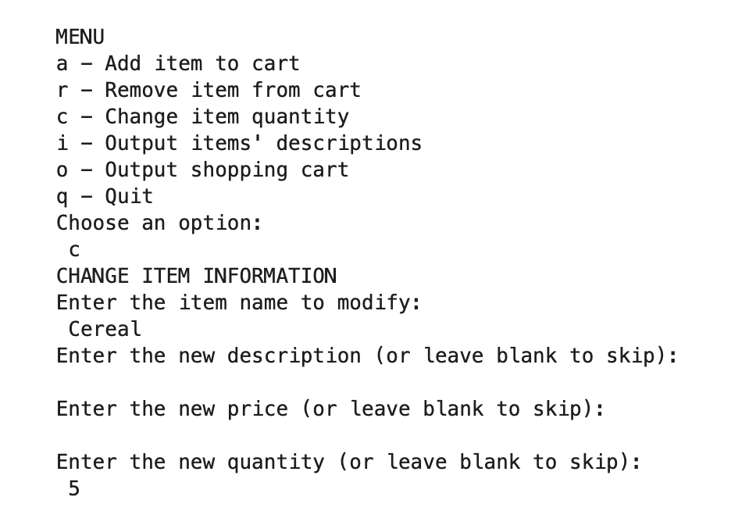

Output of cart and items descriptions: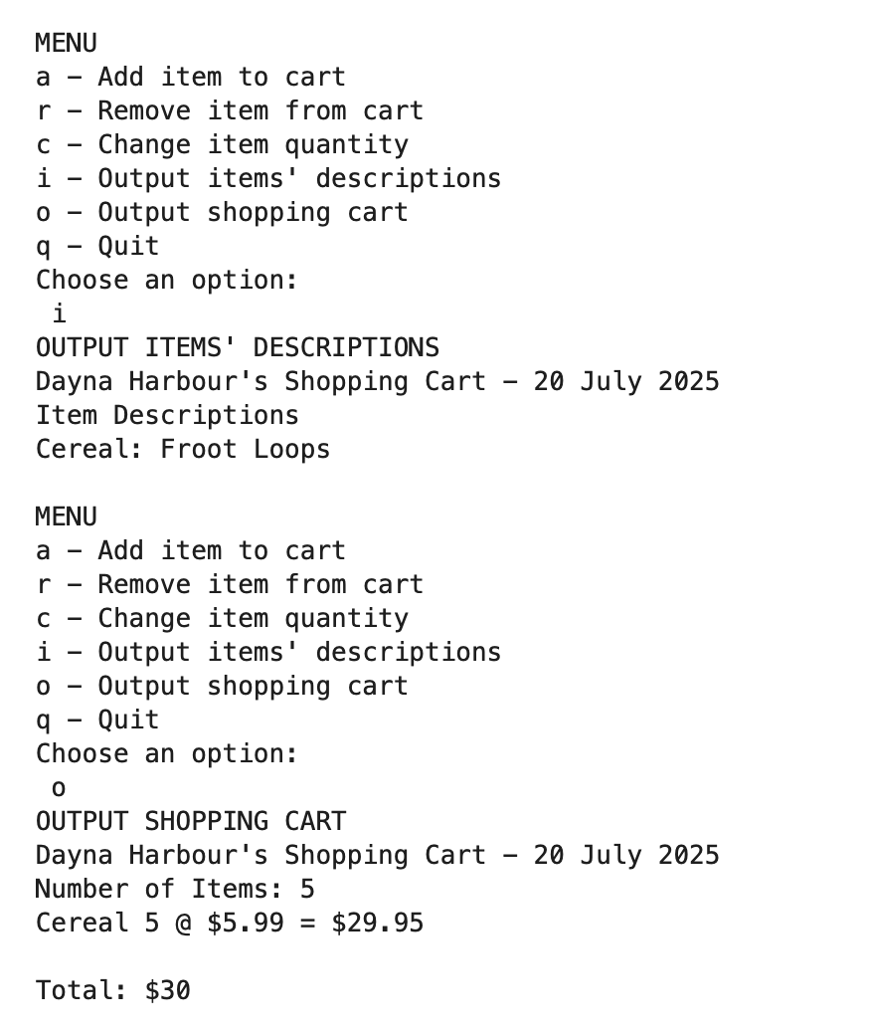

Remove item and print empty cart: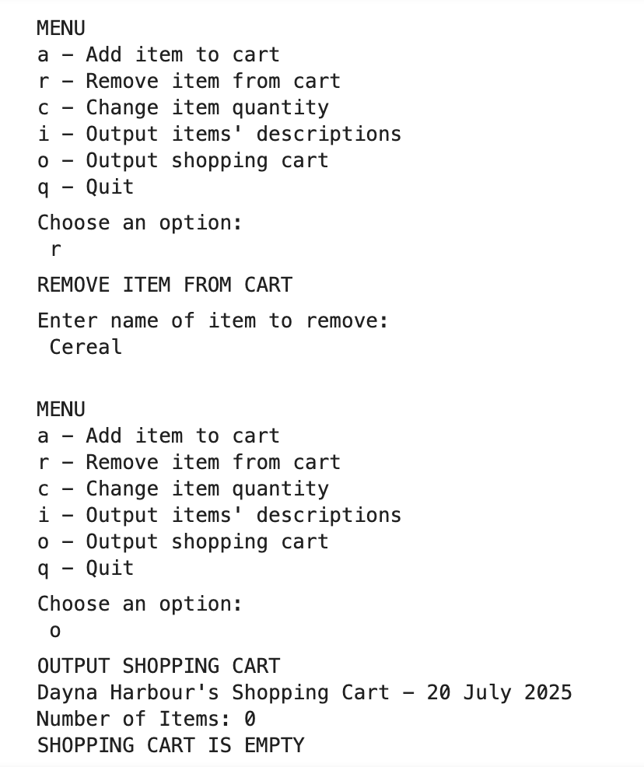

GIT: <https://github.com/dharbour12/IntroToProgramming/blob/main/PortfolioProjectFinal.ipynb>

**References**

*Python Classes and Objects [With Examples]*. (2019). Programiz.com. https://www.programiz.com/python-programming/class

W3 Schools. (2019). *Python Functions*. W3schools.com. https://www.w3schools.com/python/python_functions.asp

‌ *zyBooks*. (2025). Zybooks.com. [https://learn.zybooks.com/zybook/CSC500-1_8/](https://learn.zybooks.com/zybook/CSC500-1_8/chapter/6/section/12)

‌