**PYTHON MCQ AND FINAL ASSESSMENT**

**NAME: DHARINEESH.K.M.**

**EMPLOYEE ID: 2150471**

**MCQ**

1. Who developed Python Programming Language?  
a) Wick van Rossum  
b) Rasmus Lerdorf  
c) Guido van Rossum  
d) Niene Stom

2. Which type of Programming does Python support?  
a) object-oriented programming  
b) structured programming  
c) functional programming  
d) all of the mentioned

3. Is Python case sensitive when dealing with identifiers?  
a) no  
b) yes  
c) machine dependent  
d) none of the mentioned

4. Which of the following is the correct extension of the Python file?  
a) .python  
b) .pl  
c) .py  
d) .p

5. Is Python code compiled or interpreted?  
a) Python code is both compiled and interpreted  
b) Python code is neither compiled nor interpreted  
c) Python code is only compiled  
d) Python code is only interpreted

6. All keywords in Python are in _________  
a) Capitalized  
b) lower case  
c) UPPER CASE  
d) None of the mentioned

7. What will be the value of the following Python expression?

4 + 3 % 5

1. 7  
   b) 2  
   c) 4  
   d) 1

8. Which of the following is used to define a block of code in Python language?  
a) Indentation  
b) Key  
c) Brackets  
d) All of the mentioned

9. Which keyword is used for function in Python language?  
a) Function  
b) Def  
c) Fun  
d) Define

10. Which of the following character is used to give single-line comments in Python?  
a) //  
b) #  
c) !  
d) /*

11. What will be the output of the following Python code?

i = 1

**while** True:

**if** i%3 == 0:

**break**

**print**(i)

i + = 1

a) 1 2 3  
b) error  
c) 1 2  
d) none of the mentioned

12. Which of the following functions can help us to find the version of python that we are currently working on?  
a) sys.version(1)  
b) sys.version(0)  
c) sys.version()  
d) sys.version

13. Python supports the creation of anonymous functions at runtime, using a construct called __________  
a) pi  
b) anonymous  
c) lambda  
d) none of the mentioned

14. What is the order of precedence in python?  
a) Exponential, Parentheses, Multiplication, Division, Addition, Subtraction  
b) Exponential, Parentheses, Division, Multiplication, Addition, Subtraction  
c) Parentheses, Exponential, Multiplication, Division, Subtraction, Addition  
d) Parentheses, Exponential, Multiplication, Division, Addition, Subtraction

15. What will be the output of the following Python code snippet if x=1?

x<<2

a) 4  
b) 2  
c) 1  
d) 8

16. What does pip stand for python?  
a) unlimited length  
b) all private members must have leading and trailing underscores  
c) Preferred Installer Program  
d) none of the mentioned

17. Which of the following is true for variable names in Python?  
a) underscore and ampersand are the only two special characters allowed  
b) unlimited length  
c) all private members must have leading and trailing underscores  
d) none of the mentioned

18. What are the values of the following Python expressions?

2**(3**2)

(2**3)**2

2**3**2

a) 512, 64, 512  
b) 512, 512, 512  
c) 64, 512, 64  
d) 64, 64, 64

19. Which of the following is the truncation division operator in Python?  
a) |  
b) //  
c) /  
d) %

20. What will be the output of the following Python code?

l=[1, 0, 2, 0, 'hello', '', []]

list(filter(bool, l))

a) [1, 0, 2, ‘hello’, ”, []]  
b) Error  
c) [1, 2, ‘hello’]  
d) [1, 0, 2, 0, ‘hello’, ”, []]

21. Which of the following functions is a built-in function in python?  
a) factorial()  
b) print()  
c) seed()  
d) sqrt()

22. Which of the following is the use of id() function in python?  
a) Every object doesn’t have a unique id  
b) Id returns the identity of the object  
c) All of the mentioned  
d) None of the mentioned

23. The following python program can work with ____ parameters.

**def** f(x):

**def** f1(*args, **kwargs):

**print**("Sanfoundry")

**return** x(*args, **kwargs)

**return** f1

a) any number of  
b) 0  
c) 1  
d) 2

24. What will be the output of the following Python function?

min(max(False,-3,-4), 2,7)

a) -4  
b) -3  
c) 2  
d) False

25. Which of the following is not a core data type in Python programming?  
a) Tuples  
b) Lists  
c) Class  
d) Dictionary

26. What will be the output of the following Python expression if x=56.236?

**print**("%.2f"%x)

a) 56.236  
b) 56.23  
c) 56.0000  
d) 56.24

27. Which of these is the definition for packages in Python?  
a) A set of main modules  
b) A folder of python modules  
c) A number of files containing Python definitions and statements  
d) A set of programs making use of Python modules

28. What will be the output of the following Python function?

len(["hello",2, 4, 6])

a) Error  
b) 6  
c) 4  
d) 3

29. What will be the output of the following Python code?

x = 'abcd'

**for** i **in** x:

**print**(i.upper())

a) a B C D  
b) a b c d  
c) error  
d) A B C D

30. What is the order of namespaces in which Python looks for an identifier?  
a) Python first searches the built-in namespace, then the global namespace and finally the local namespace  
b) Python first searches the built-in namespace, then the local namespace and finally the global namespace  
c) Python first searches the local namespace, then the global namespace and finally the built-in namespace  
d) Python first searches the global namespace, then the local namespace and finally the built-in namespace

**PROBLEM**

1. Python Program to Compute the Power of a Number

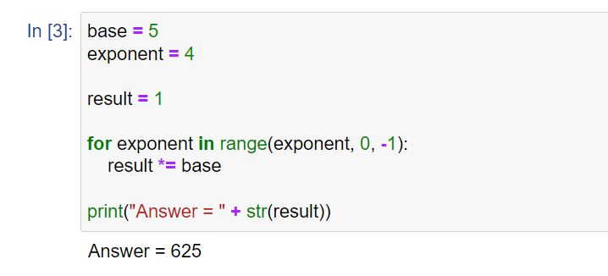

1. Python Program to Find LCM

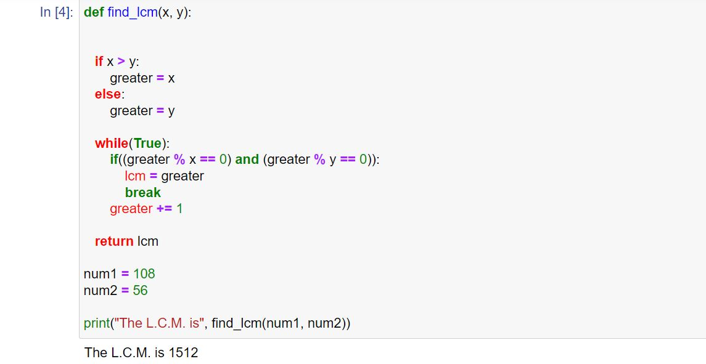

1. Python Program to check if given array is Monotonic

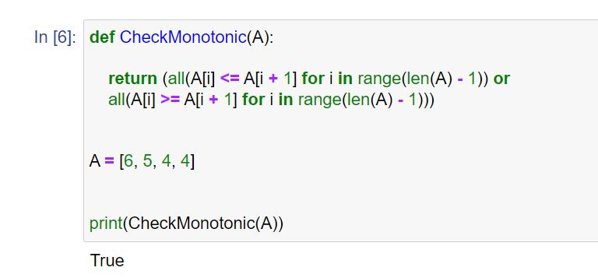

1. Python program to print all negative numbers in a range

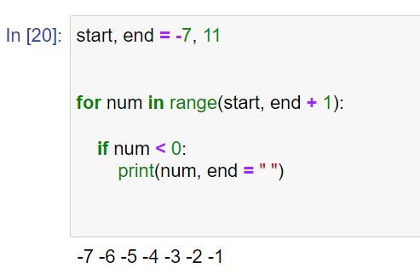

1. A. Python program to split and join a string

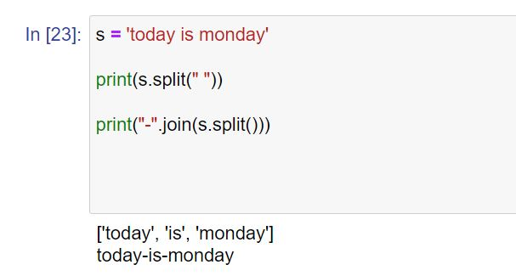

B. Python | Check if a given string is binary string or not

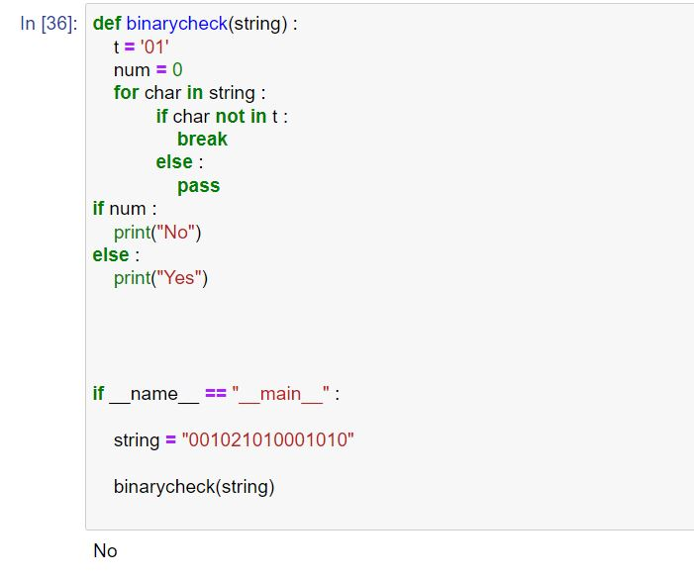

1. A. Python program to convert time from 12 hour to 24 hour format

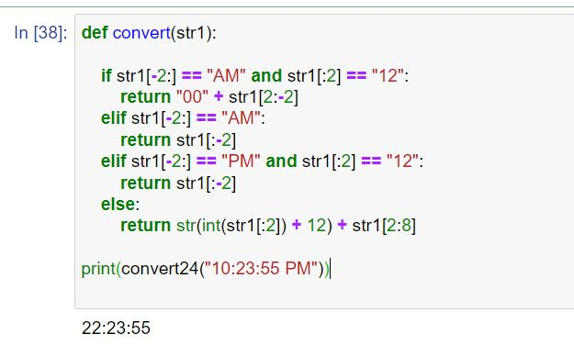

B. Python program to find difference between current time and given time

