**Exercise 6: DIHEDRAL ANGLE CALCULATION USING PHP**

**Aim :**

To calculate the Dihedral angles for the given protein and to develop **RAMACHANDRAN** plot using **GD** module in PHP.

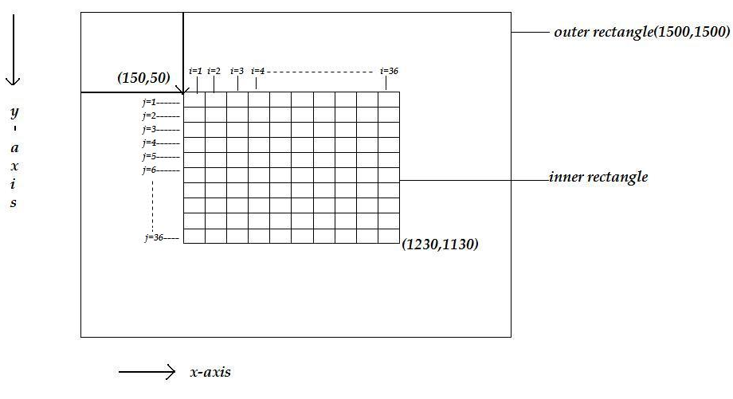

**Figure 1: RAMACHANDRAN plot**

**Steps to calculate dihedral angle:**

i)For the given PDB file ,retrieve the atom coordinates of N,CA and C and store it in the array and also store the distinct residue number in another array.

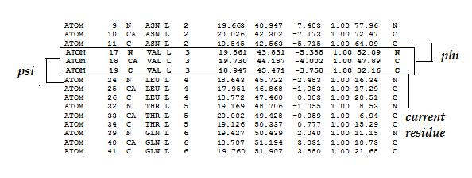

ii) Calculate the phi and psi angle for the amino acids in the PDB file except the first and last amino acid .

**For example**

Take the current amino acid “**VAL**” , angle phi is calculated by taking the previous residue **“Carbon”** atom and angle psi is calculated by taking the next residue **“Nitrogen ”** atom which is shown above in the figure 1.Likewise calculate the angles for the whole PDB file .

**Algorithm Steps**

**PHI angle calculation:**

i)Extract the x,y,z coordinates of N,CA,C of the current residue and carbon atom of previous residue .

Example

d1 stores the x,y,z coordinates of carbon atom of previous residue

d2 stores the x,y,z coordinates of Nitrogen atom of current residue

d3 stores the x,y,z coordinates of Alpha Carbon atom of current residue

d4 stores the x,y,z coordinates of Carbon atom of current residue

ii)Find the vectors for the atoms using the extracted x,y,z coordinates.

**Example :**

**C C**

**v1 \ / v3**

**N- - - -CA**

**v2**

where v1,v2,v3 are the vectors

v1= find the distance between “N” and “C”

v2= find the distance between “N” and “CA”

v3= find the distance between “C” and “CA”

(v1 is an array which stores 3 values as follows

v1[0] => x coordinate of N-C

v1[1] => y coordinate of N-C

v1[2] => z coordinate of N-C )

iii)Find the cross product for the v1 and v2 vectors and get the value in a variable (assume it is “p1” )

iv)Find the cross product for the v2 and v3 vectors and get the value in a variable (assume it is “q”)

**Finding Cross product between the two vectors:(v1 ,v2)**

p1[0]=v1[1]*v2[2]-v1[2]*v2[1];

p1[1]=v1[2]*v2[0]-v1[0]*v2[2];

p1[2]=v1[0]*v2[1]-v1[1]*v2[0];

=>These values corresponds to the array “p1”

**Find the angle between “p” and “q”**

Before finding the angle , find the dot product of “p” and “q” and find the length of a vector.

|  |
| --- |
| W.k.t ,  **p1 . p2 = |p1| |p2| cos (phi)**  **Then cos (phi)= p1 . p2/|p1| |p2|**  **sinsq=1-cos2(phi)**  **sin(phi)=sqrt(sinsq);**  **phi=atan2[sin(phi)/cos(phi)** |

**PSI calculation:**

i)Extract the x,y,z coordinates of N,CA,C of the current residue and nitrogen atom of next residue .

Example

d1 stores the x,y,z coordinates of Nitrogen atom of current residue

d2 stores the x,y,z coordinates of Alpha carbon of current residue

d3 stores the x,y,z coordinates of carbon atom of current residue

d4 stores the x,y,z coordinates of Nitrogen atom of next residue

ii)Find the vectors for the atoms using the extracted x,y,z coordinates.

**Example :**

**N N**

**v1 \ / v3**

**CA- - - -C**

**v2**

where v1,v2,v3 are the vectors

v1= find the distance between “CA” and “N

v2= find the distance between “CA” and “C”

v3= find the distance between “N” and “C”

(v1 is an array which stores 3 values as follows

v1[0] => x coordinate of CA-N

v1[1] => y coordinate of CA-N

v1[2] => z coordinate of CA-N )

Follow the similar steps for remaining calculations .

**Steps to plot dihedral angles:**

i)outer rectangle 🡪 use imagecreate()

ii)inner rectangle 🡪 use imagerectangle()

iii)36*36 rectangles 🡪use imagefilledrectangle()