**E_Auction Application - Dharini**

**Back End microservices** :

**AuctionService -** Login functionality using JWT and crud operations for user details and Admin.

**AuctionService** module lists the trip details of Products.

**AuctionServiceUI –** Developed using React

MSA Architecture

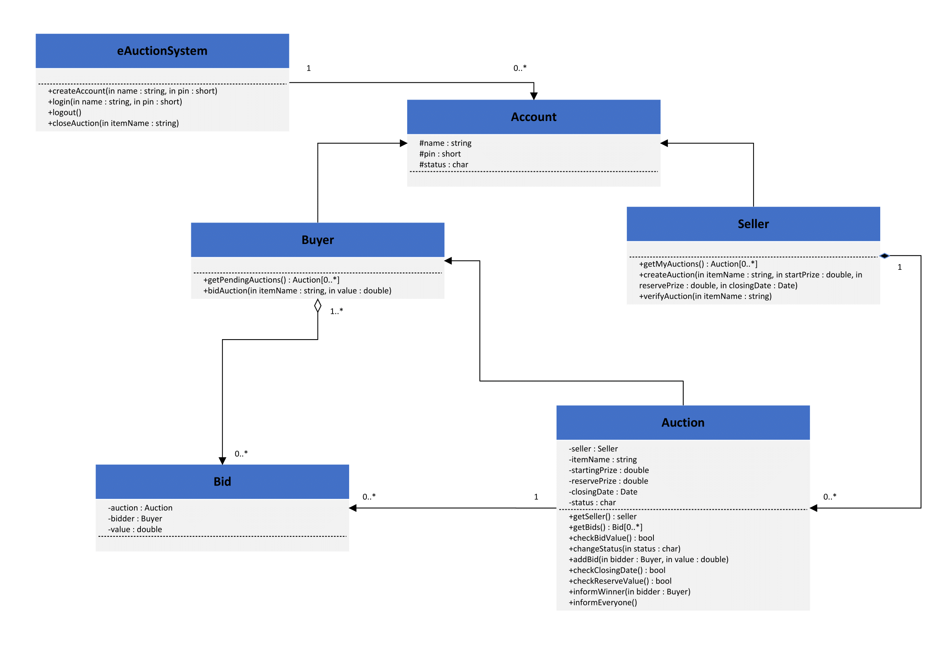

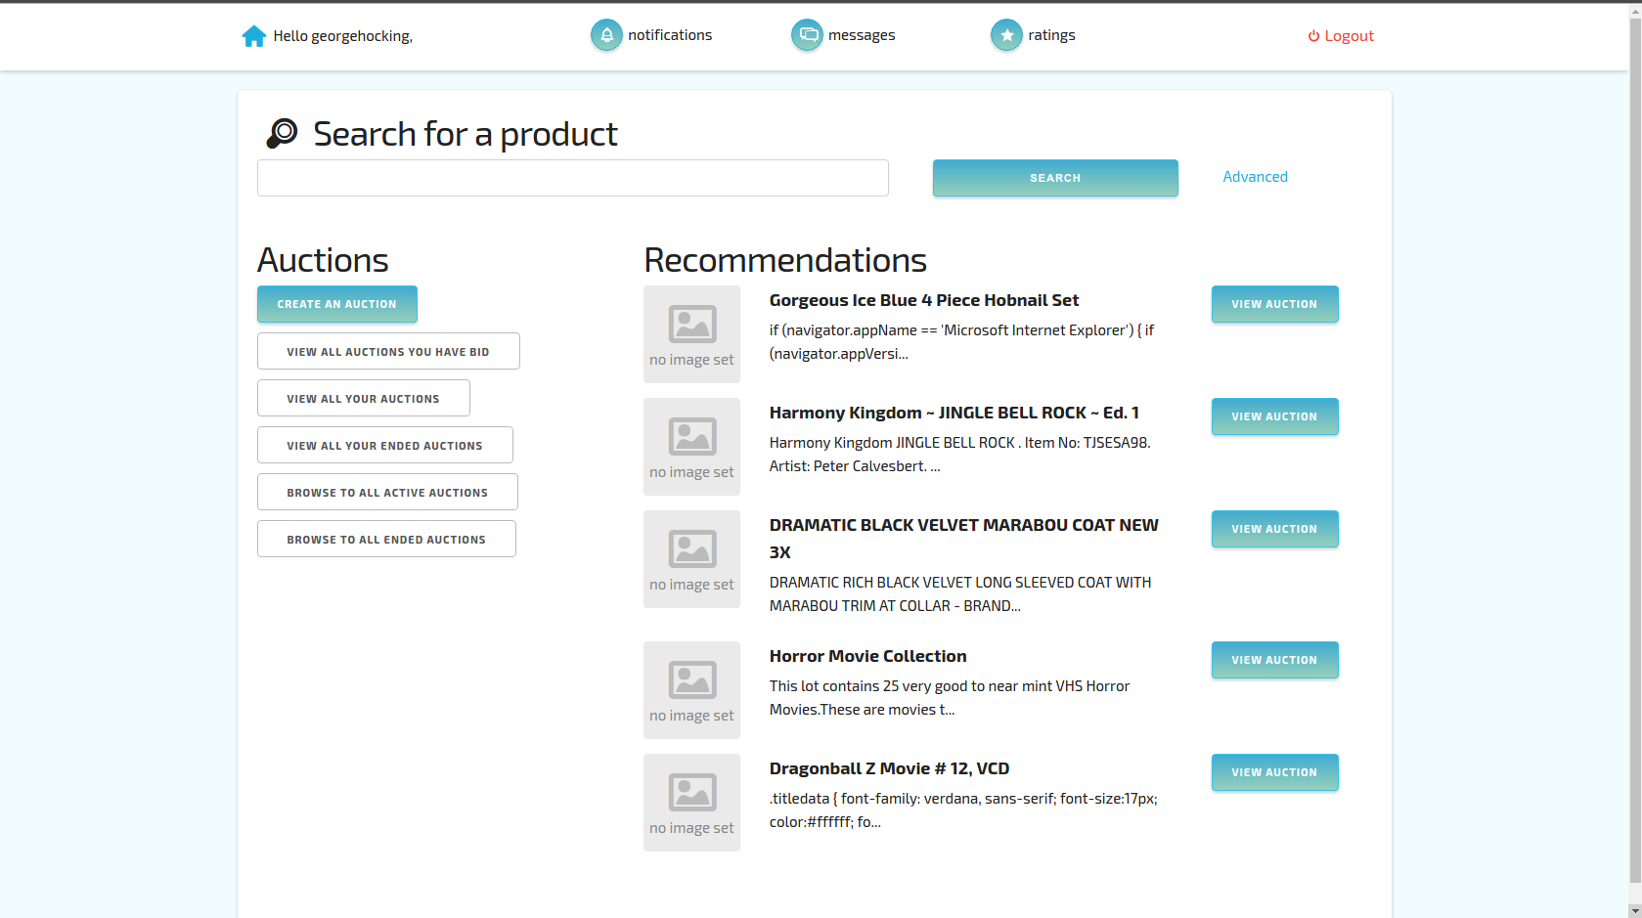

* implementation of JWT Authentication for RESTful Web Service using Spring Security
  + Securing web application with Spring Security, HTTP Basic Authentication, @Configuration, @EnableWebSecurity, AuthenticationManagerBuilder, in memory authentication, URL authorization configuration with antMatchers, JWT stands for JSON Web Token, JWT Process Flow, JWT structure, Base64 encoding and decoding, Authorization header, create JWT, set token expiry, authorize requests using Spring Filters
* Include spring security related libraries by adding the below dependency in pom.xml

<dependency>

<groupId>org.springframework.boot</groupId>

<artifactId>spring-boot-starter-security</artifactId>

</dependency>

* Rebuild the project in command line using mvn clean package command (ensure to include proxy details in mvn command).
* Create a new class SecurityConfig in the new package created which extends from WebSecurityConfigurerAdapter
* Include annotations @Configuration and @EnableWebSecurity at class level
* Import appropriate classes using Ctrl + Shift + O

Start the application and check the logs and test the REST service.

React Application in EBS: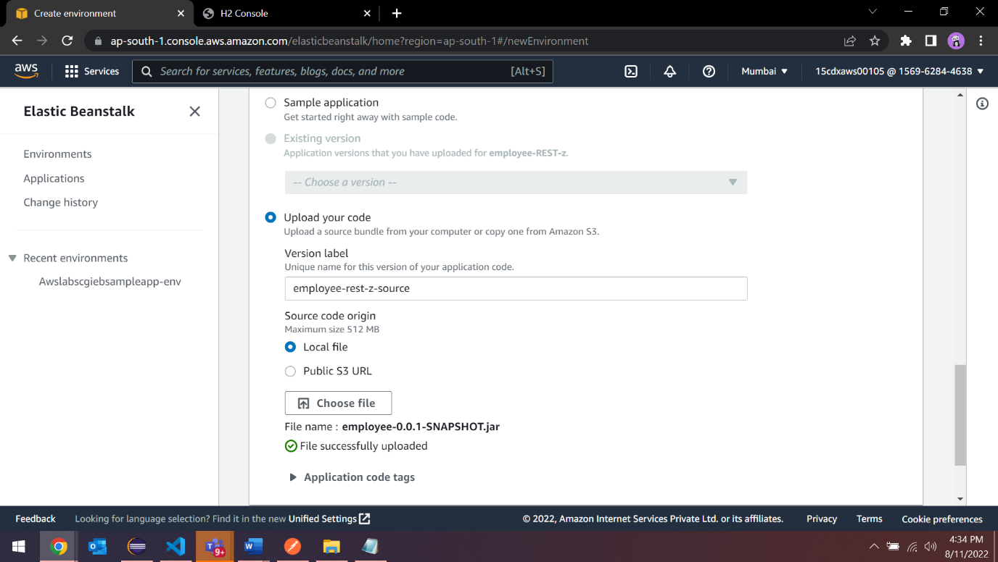

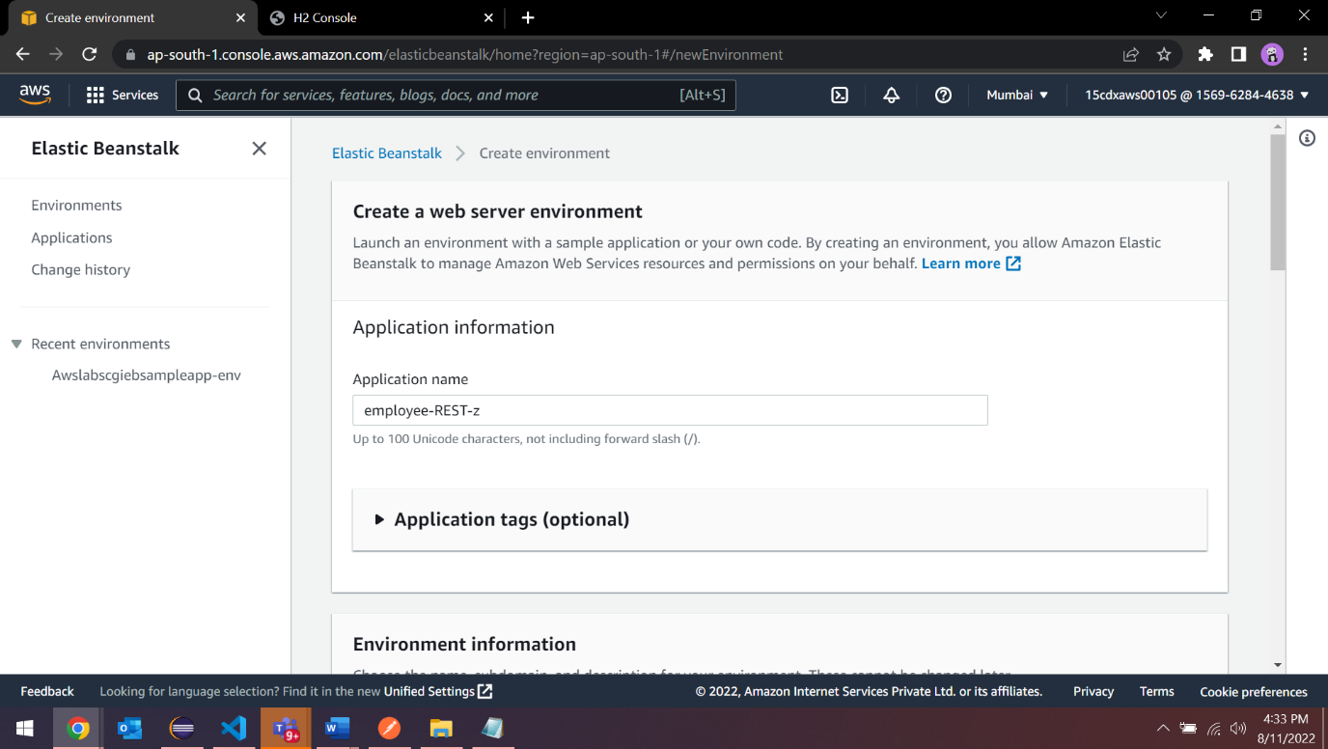

AWS Lambda and DynamoDB:

