Contents

Home Page 1

List Customers 1

Create Customer 2

Sample Data 3

# Home Page

http://localhost:55611/Customer/Index

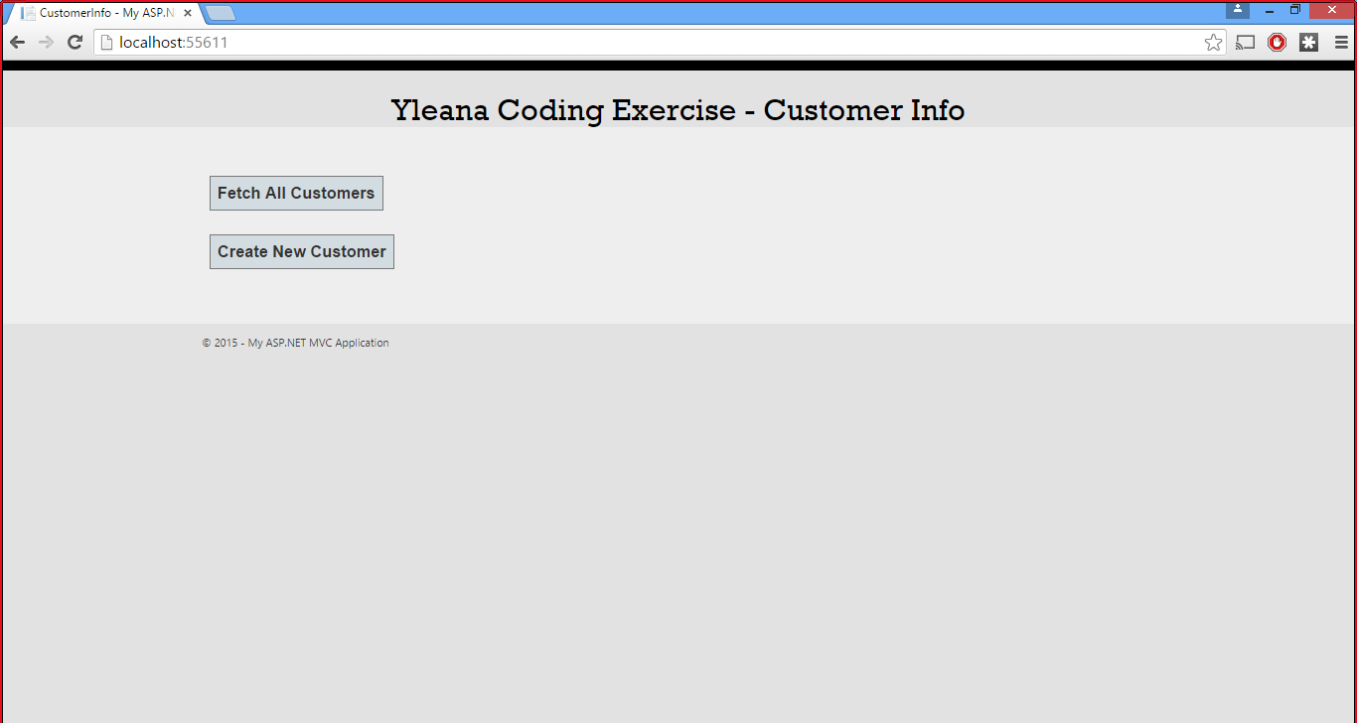

## List Customers

http://localhost:55611/Customer/ListCustomers

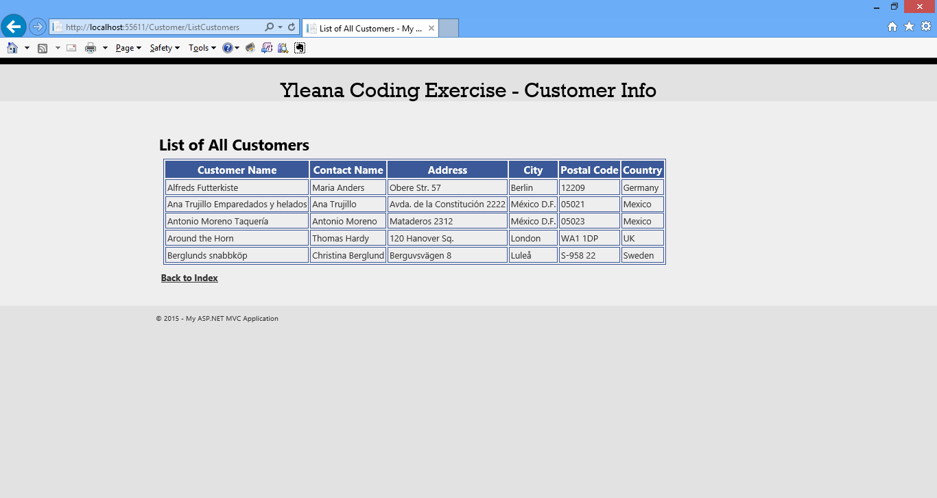

## Create Customer

http://localhost:55611/Customer/Create

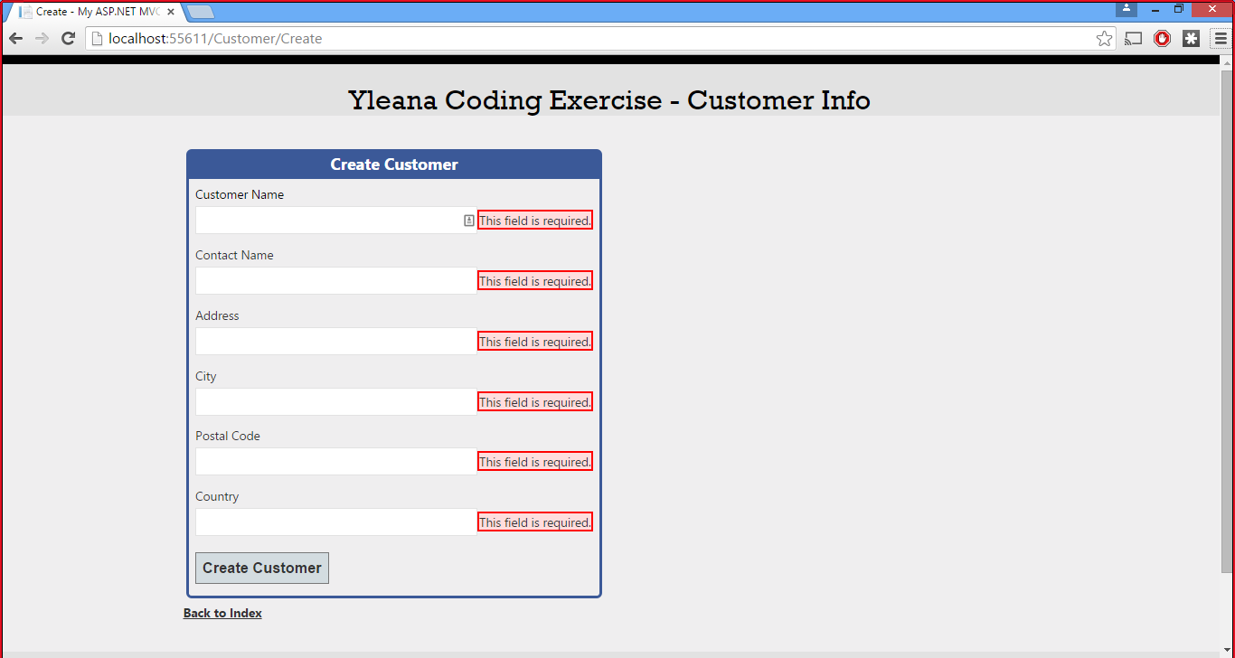

### Sample Data

http://localhost:55611/Customer/Create

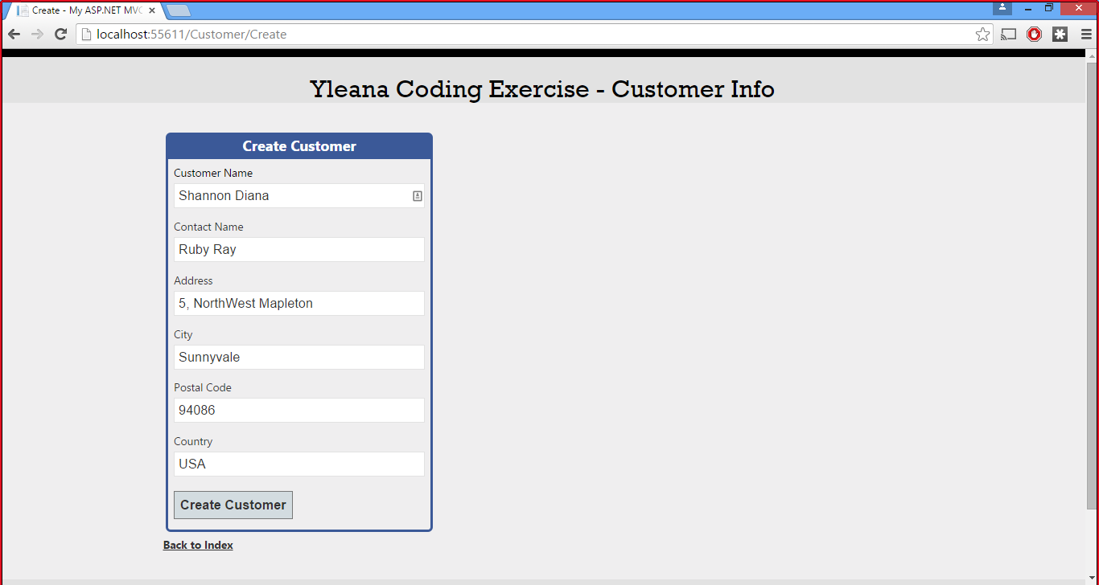

#### Create Customer Confirmation

http://localhost:55611/Customer/Create

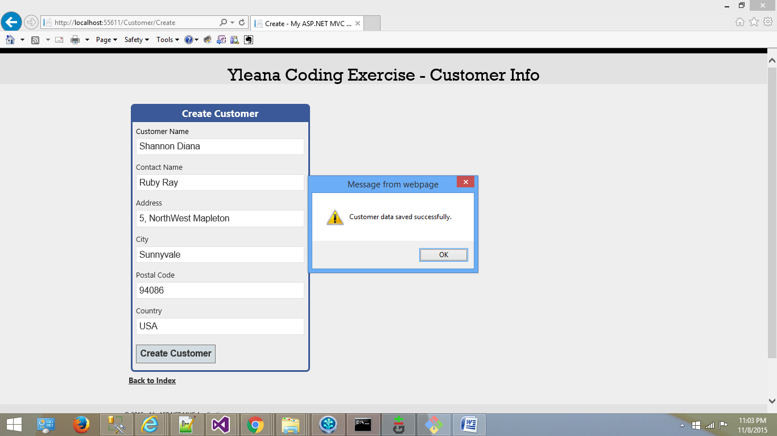

http://localhost:55611/Customer/ListCustomers

