Secret management in Aws:

Open aws console

Search for secret manager

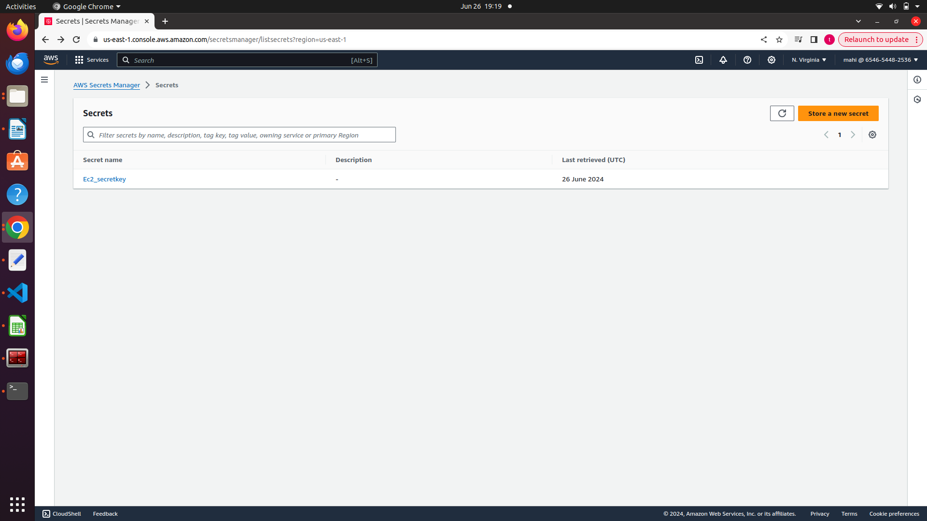
click on store a secret key

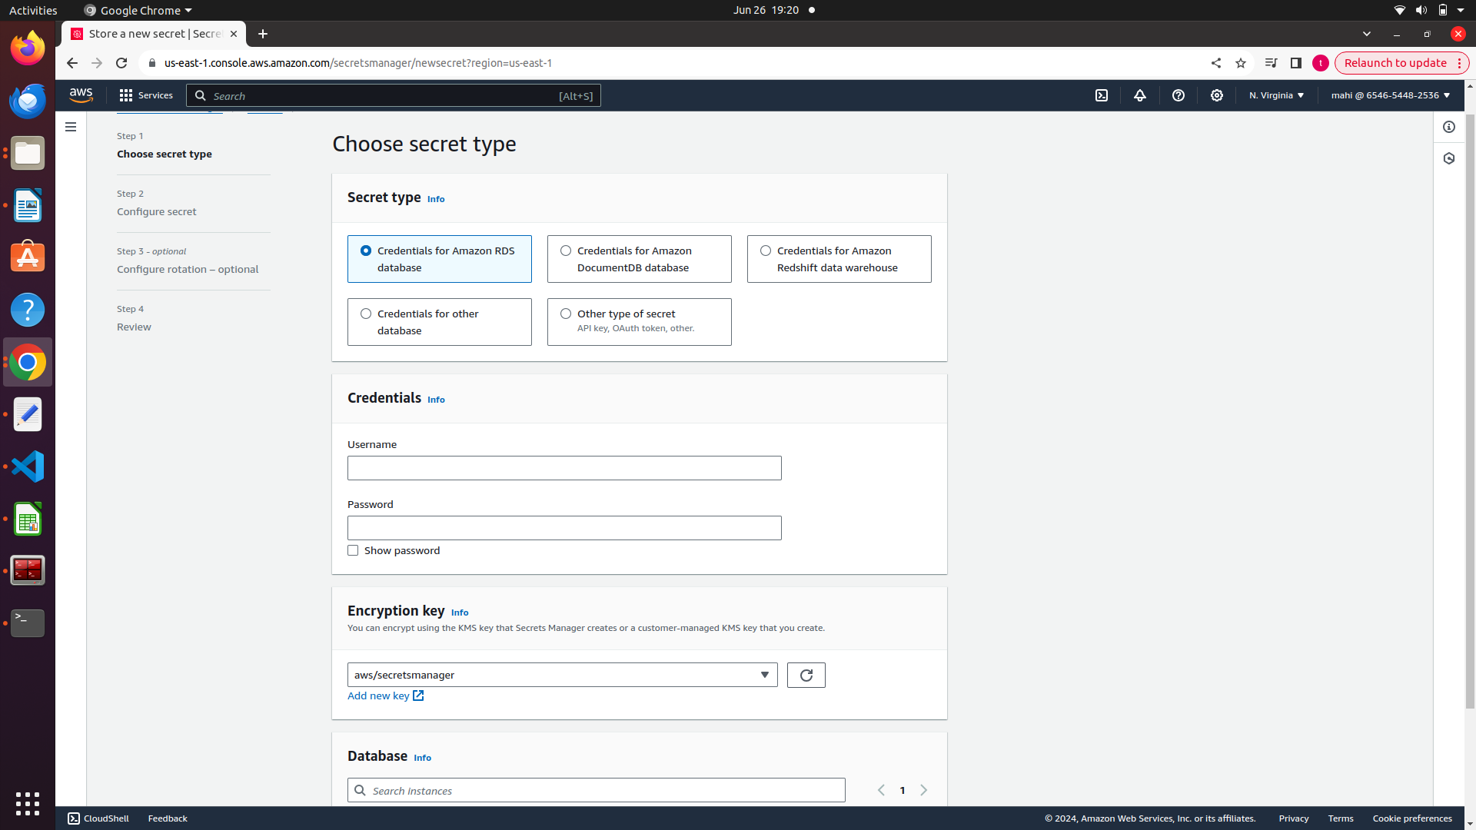
select the type of secfret we want to store and save it.

Step 2:

Create policy for this in Iam .

Click on policies in the left pane.

Click on create policy.

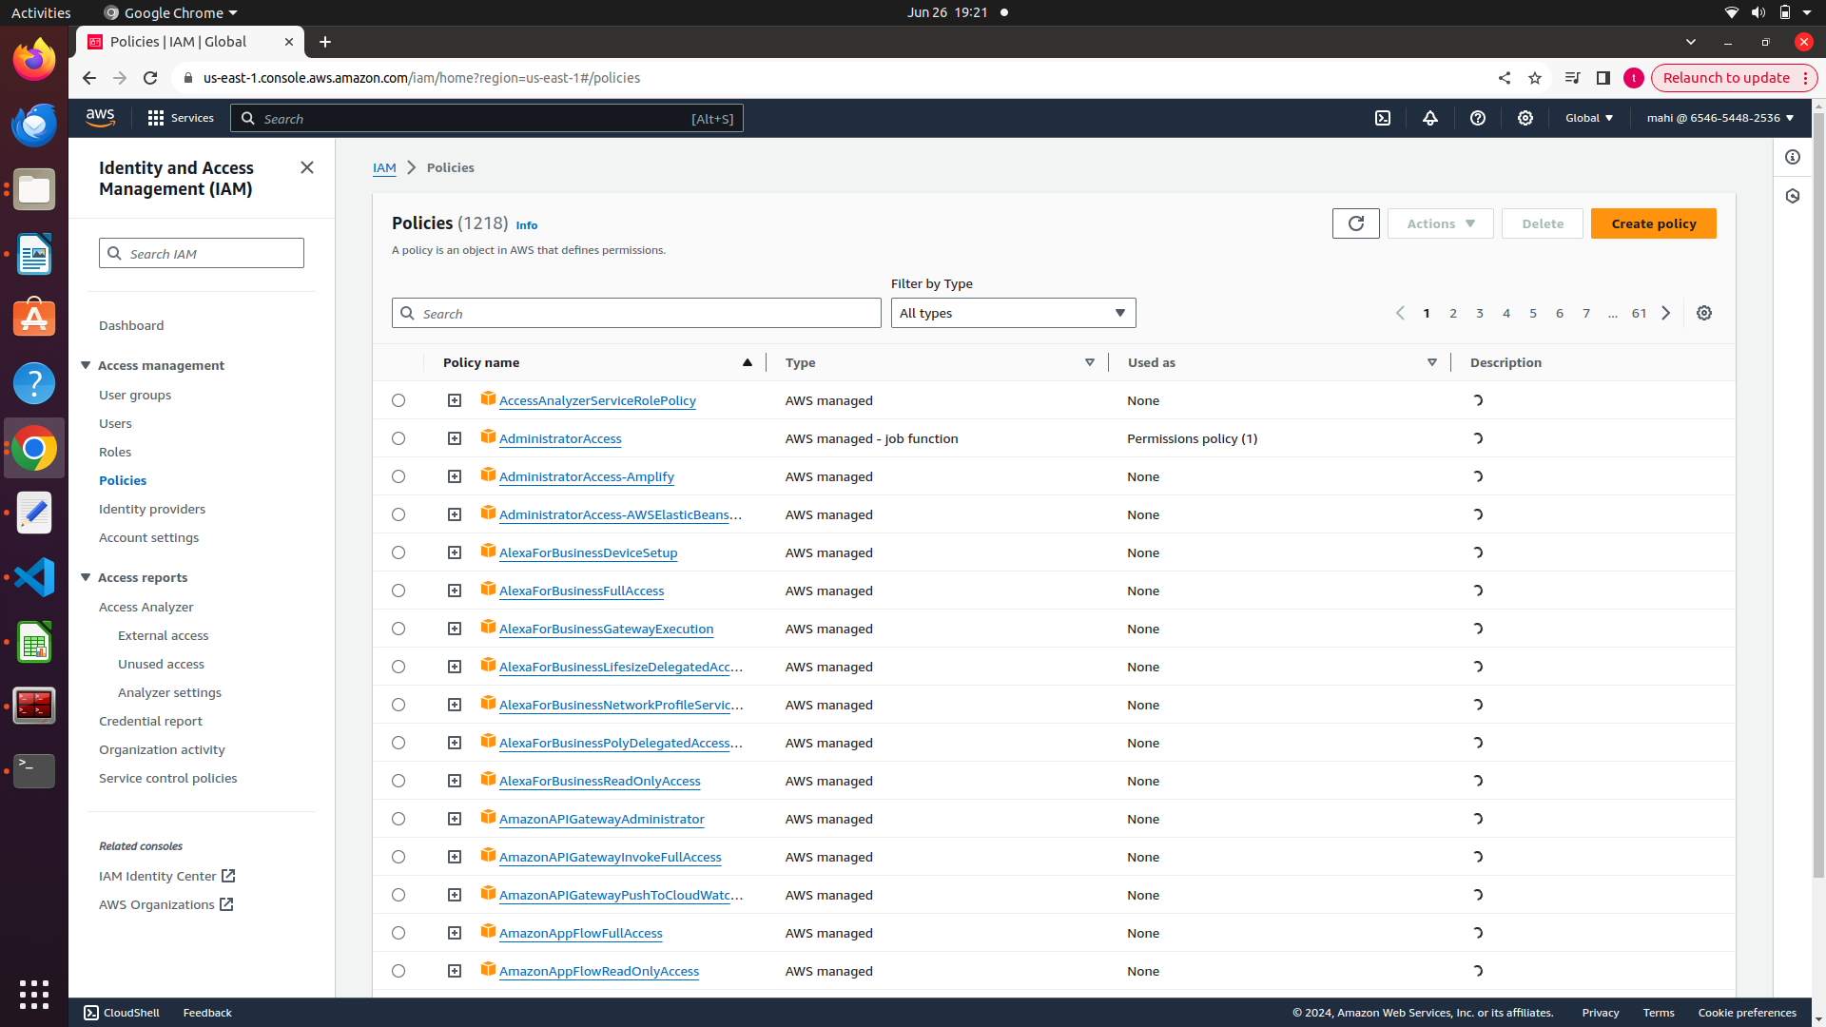
Select the service from the drop down

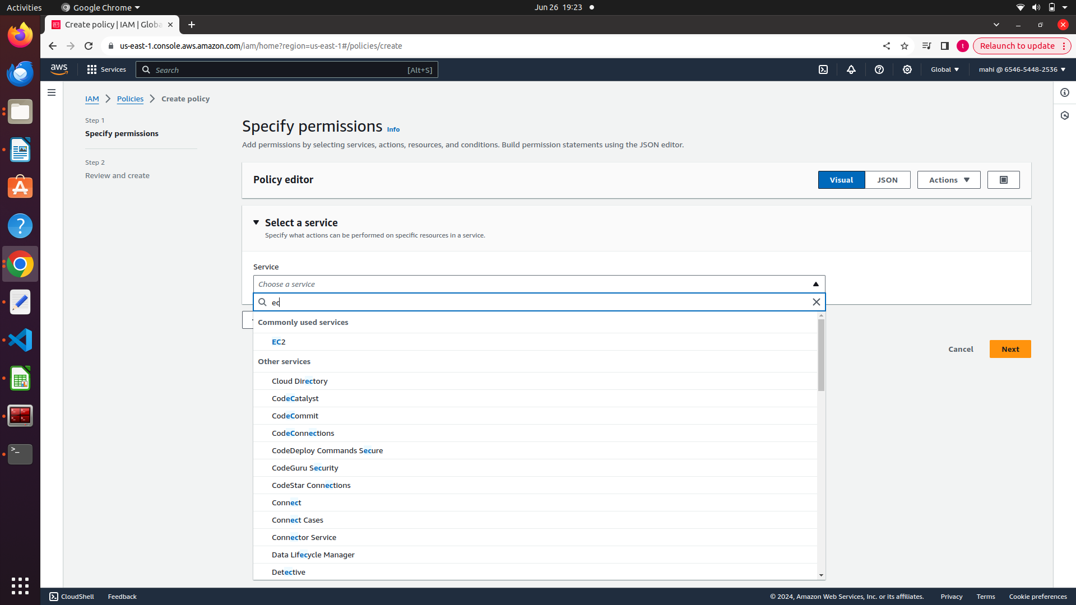

Now select the specify action (list read write and edit)

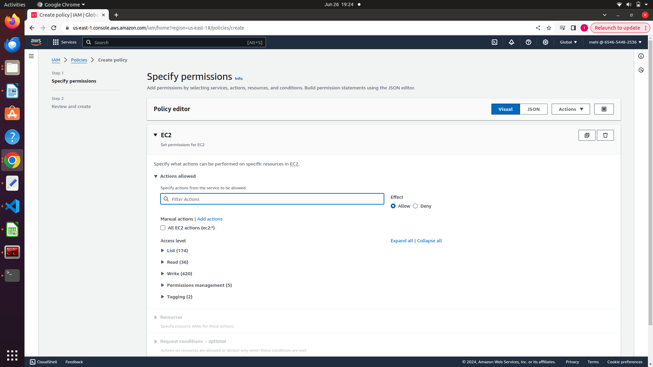
click on next and review it and create.

Step 3:

Go to roles --> click on role

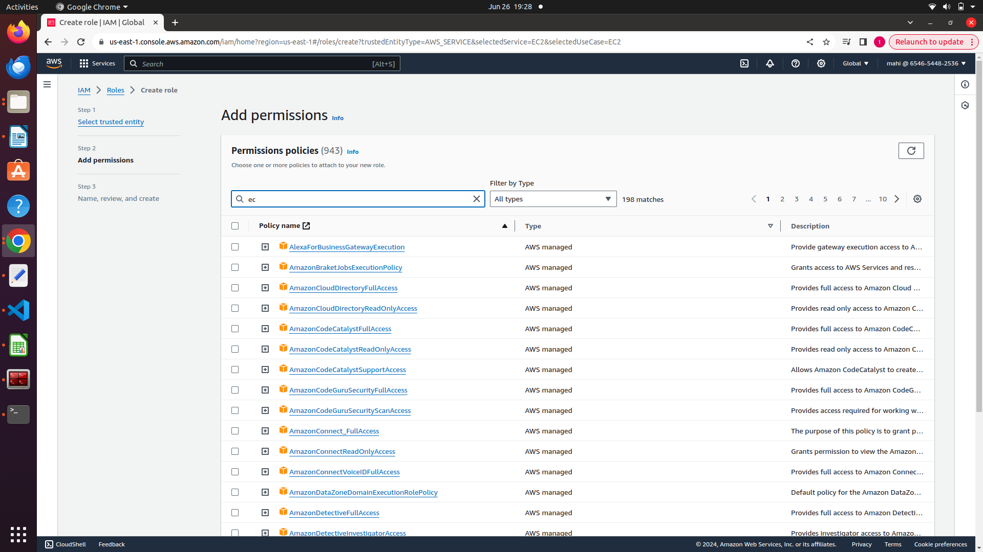
selct the policy that was created.

Click on next

Add role name

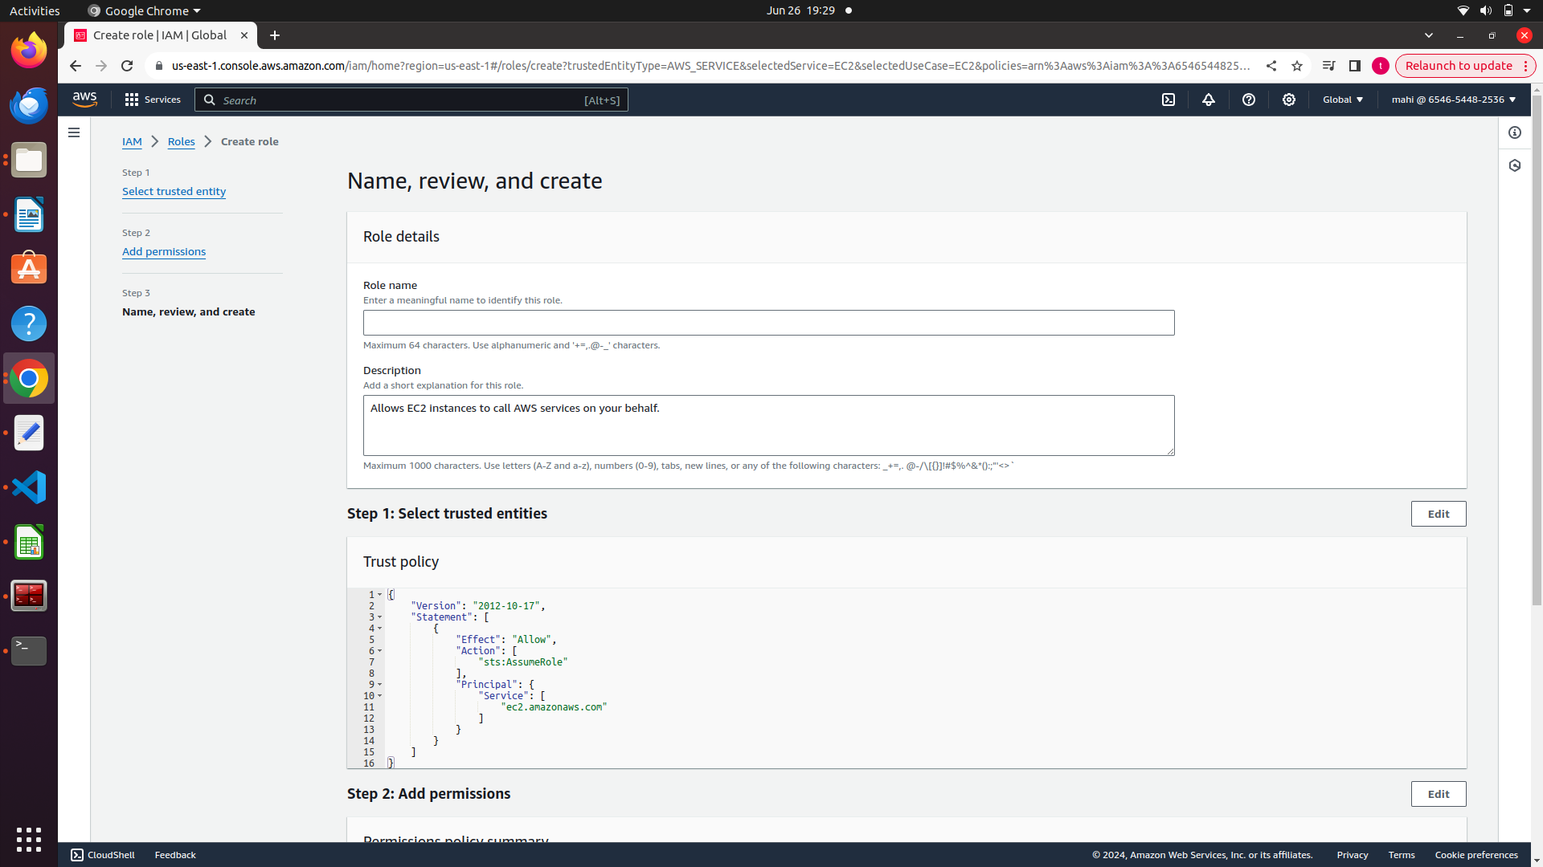
Clcik on create role.

Role was created.

Here we have created roles to ec2.

Go to EC2 dasboard and attach role that was created.

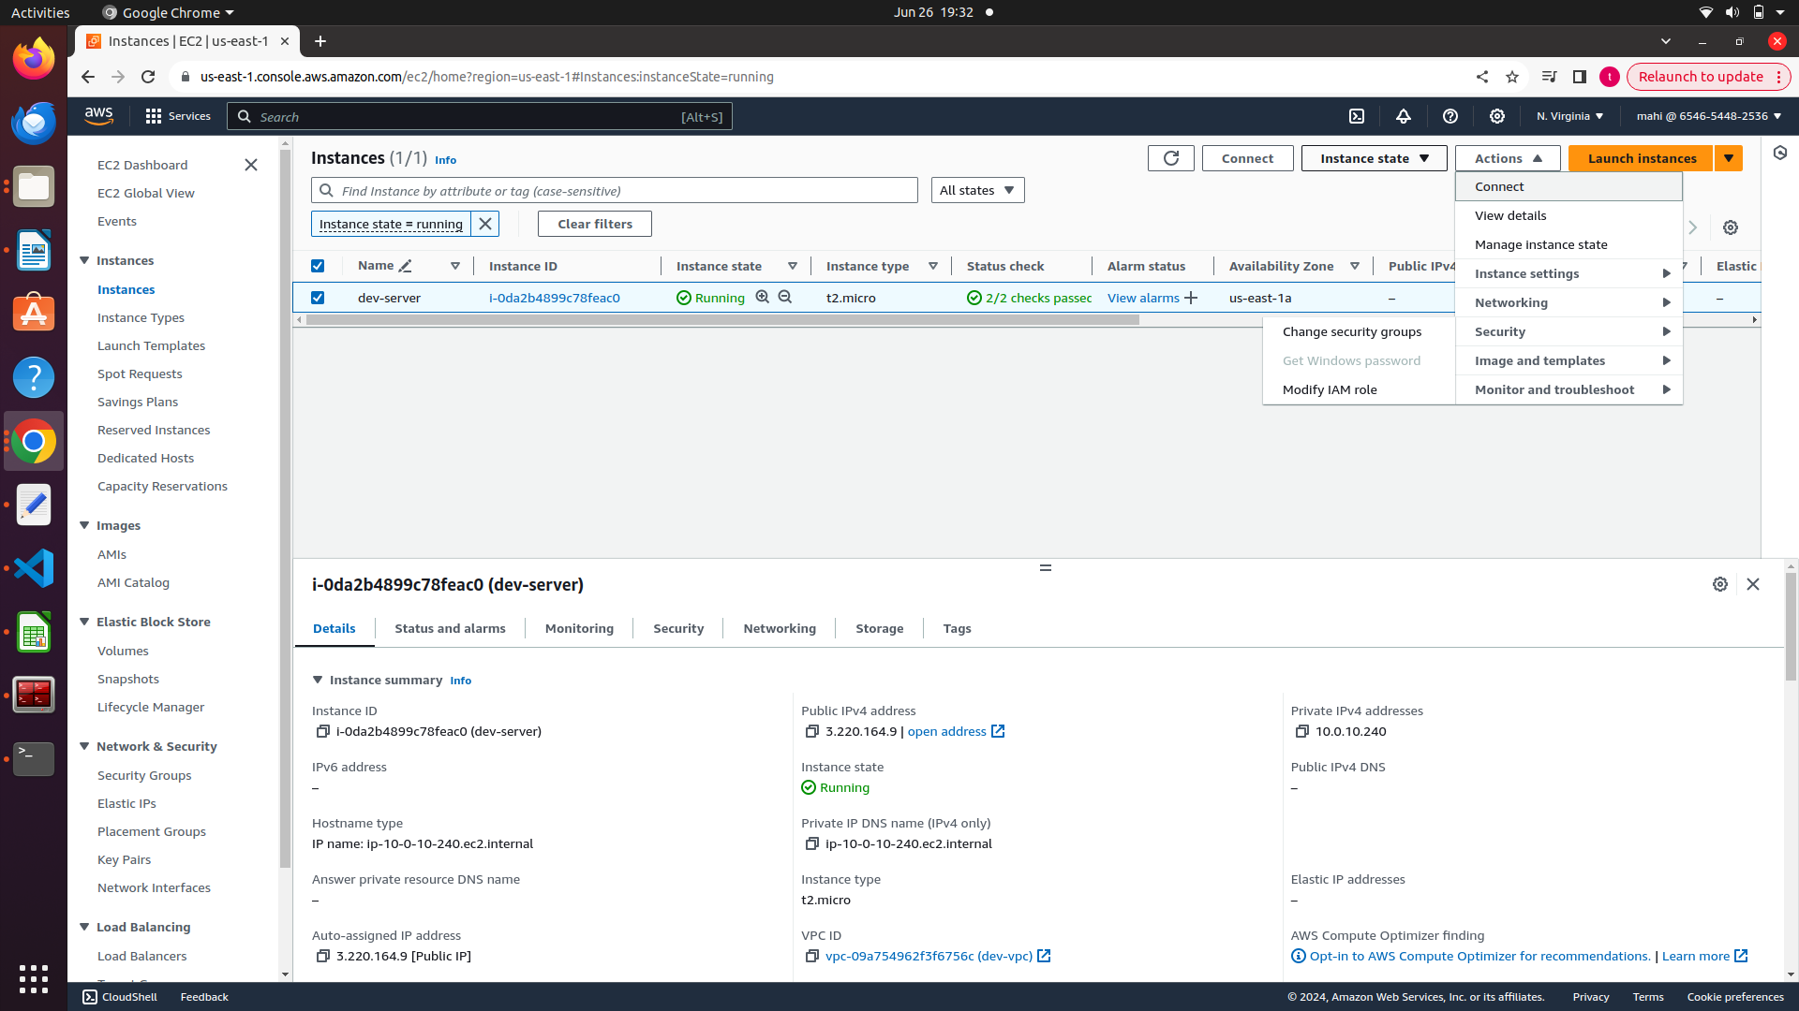
Click on ec2 instance---> clcik on actions--->clcik on modify iam role
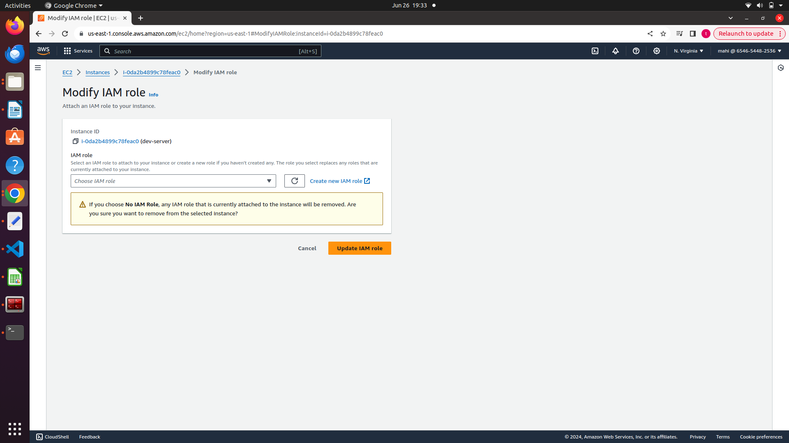
Chose the role and update the role.

Login into instace and check for the policy by using command

aws secretmanagers get-secret-value –secret-key name

