Monitor, alters and logging:

In Aws for monitoring and logging purpose we are using aws cloud watch

we can configure email for notification using alerts in cloud watch ui

example:

Let's say we want to monitor ec2 instance.

Go to cloud watch

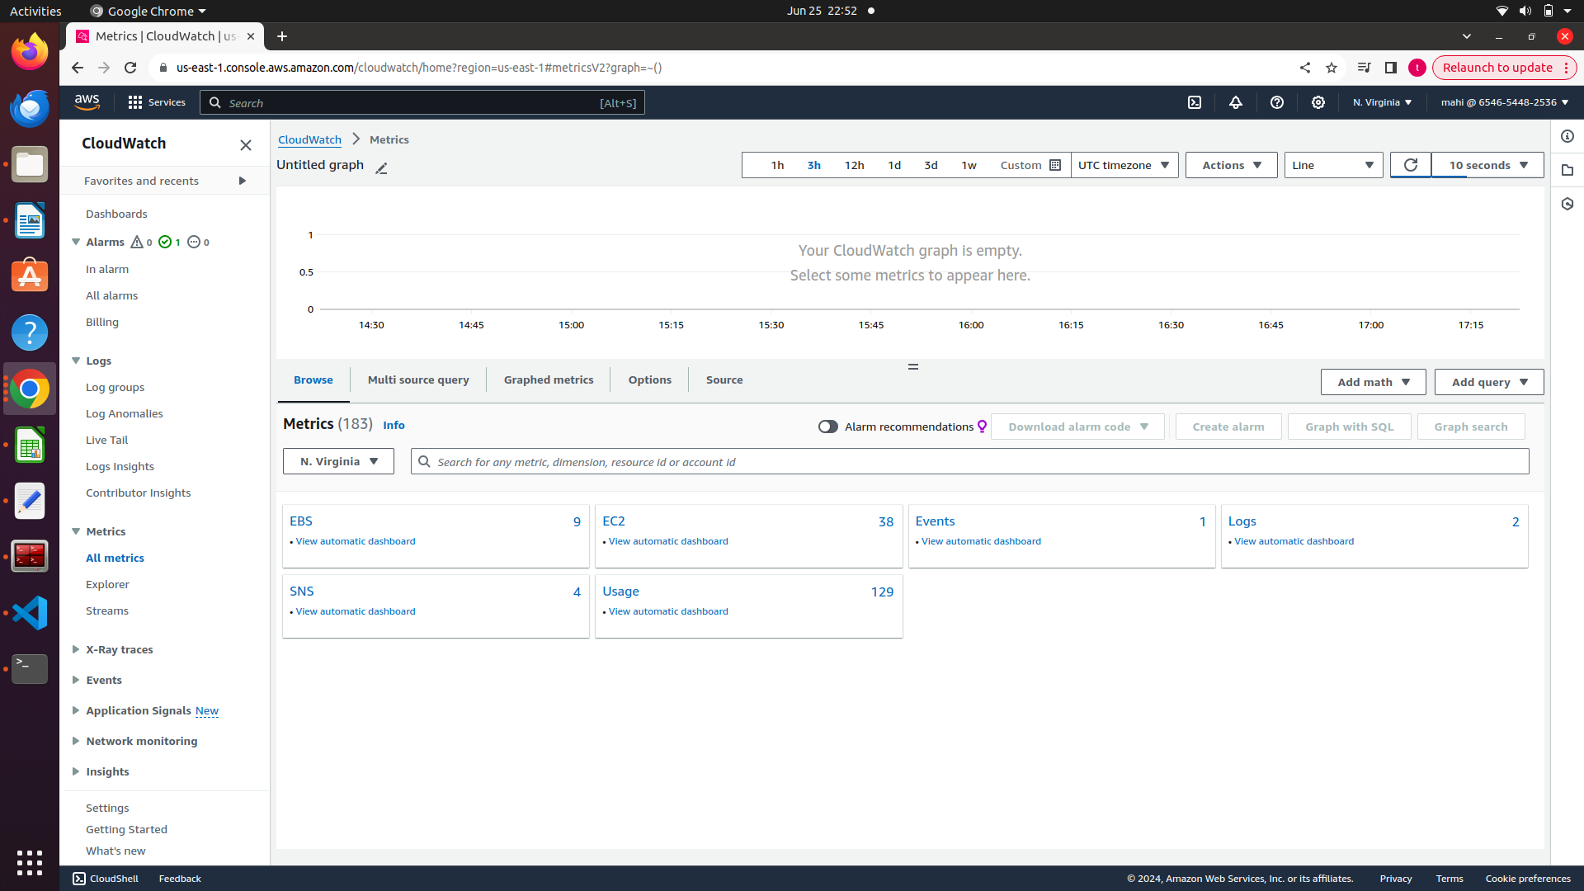
In

In left side , click on all metrics and select EC2, here we choose multiple options for graphs.

Let’s say we want create cpu or memeory then we need to select the cpu utilization.

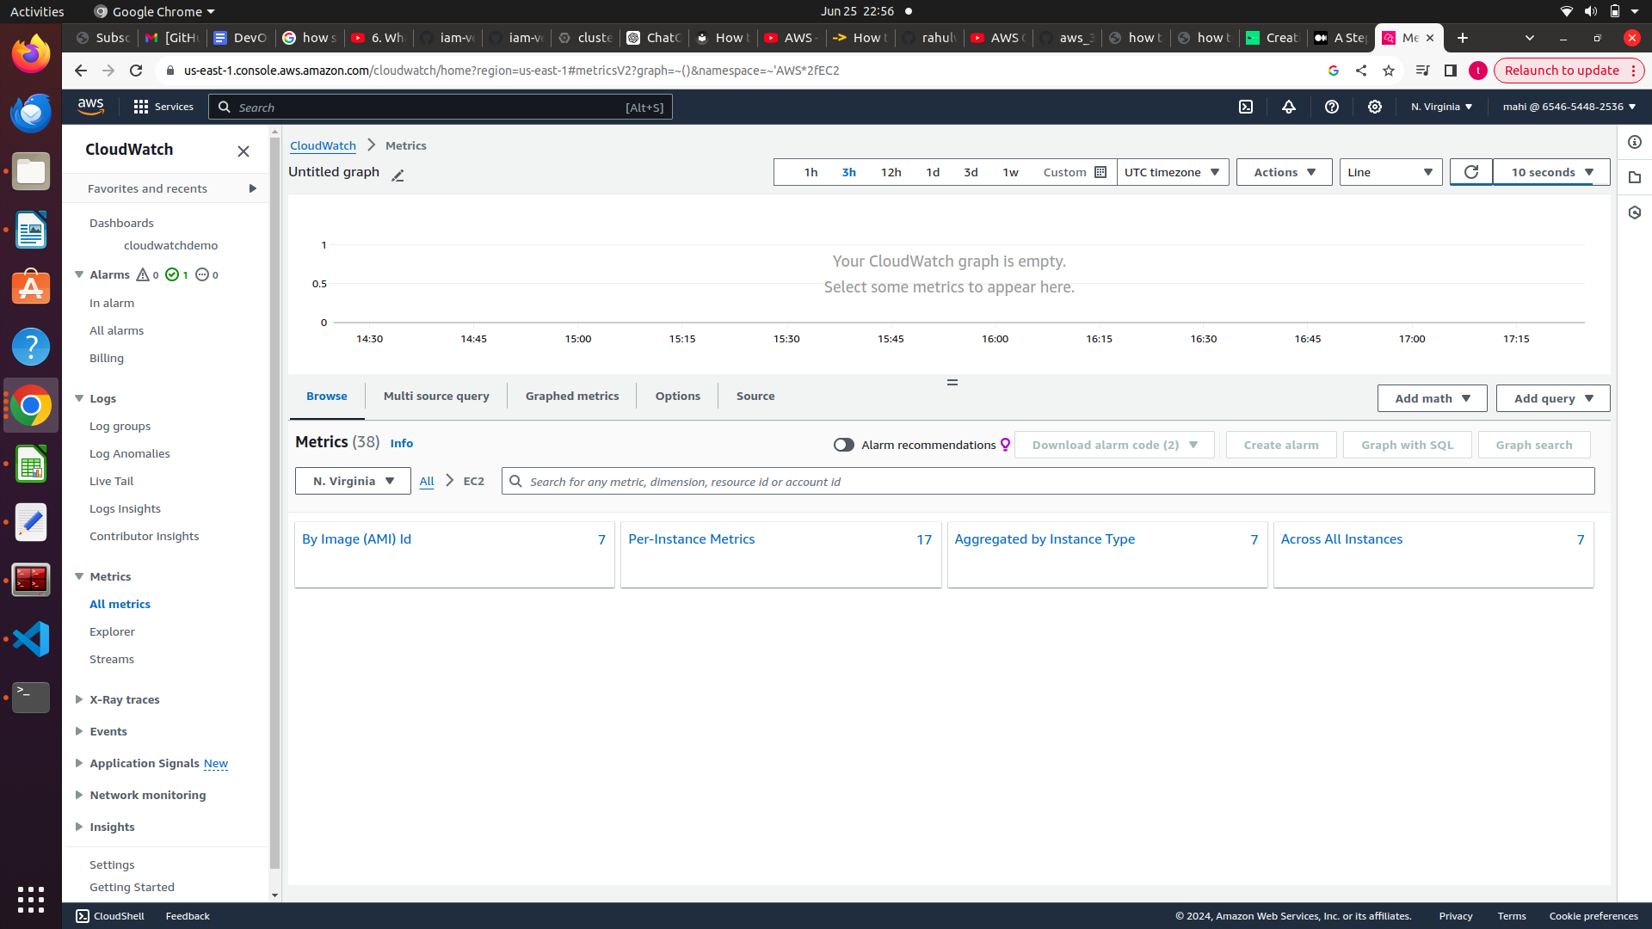
Select per instance type and select cpu graph or whatever is required to display and click on alarm.
Complete all the steps here

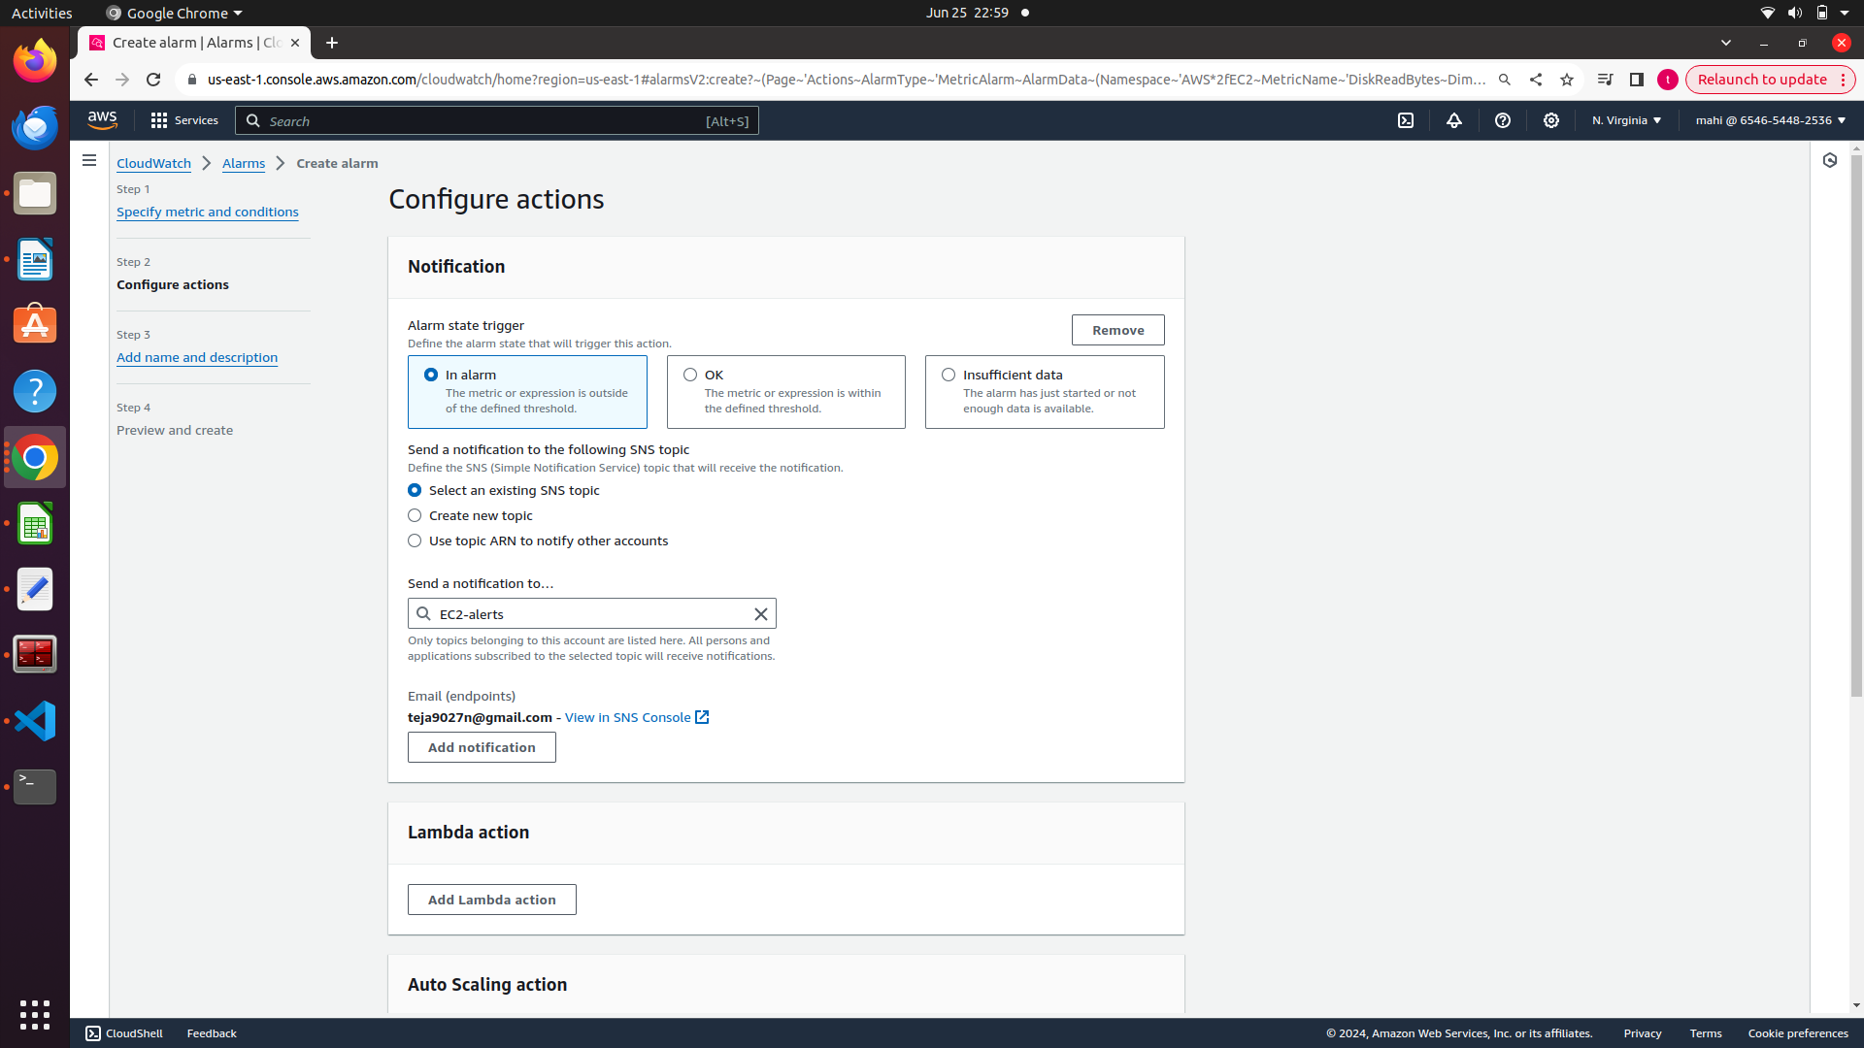

complete all the steps as shown above

For dashbords:

From left panel go to dashboards.

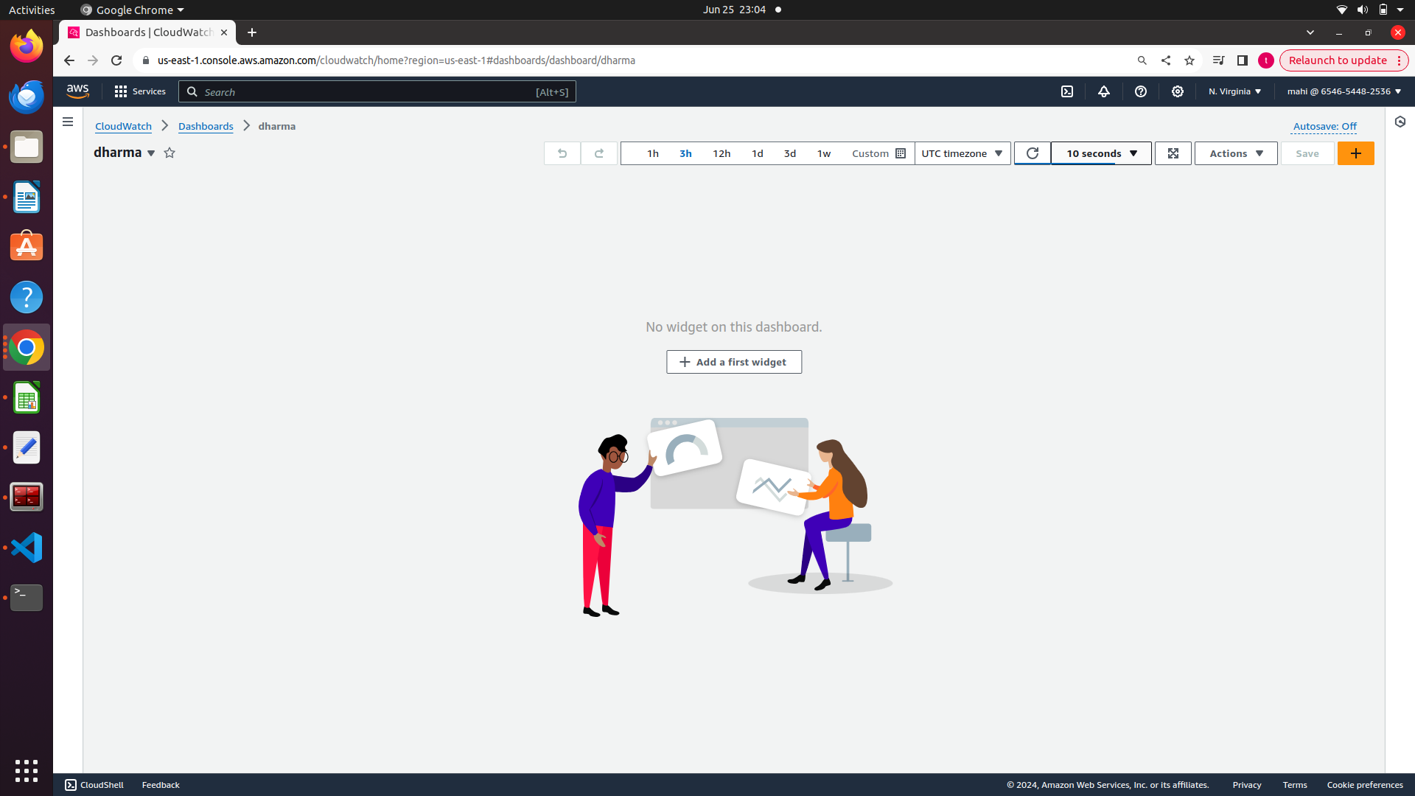
Click on ‘+’ symbol and fill required details

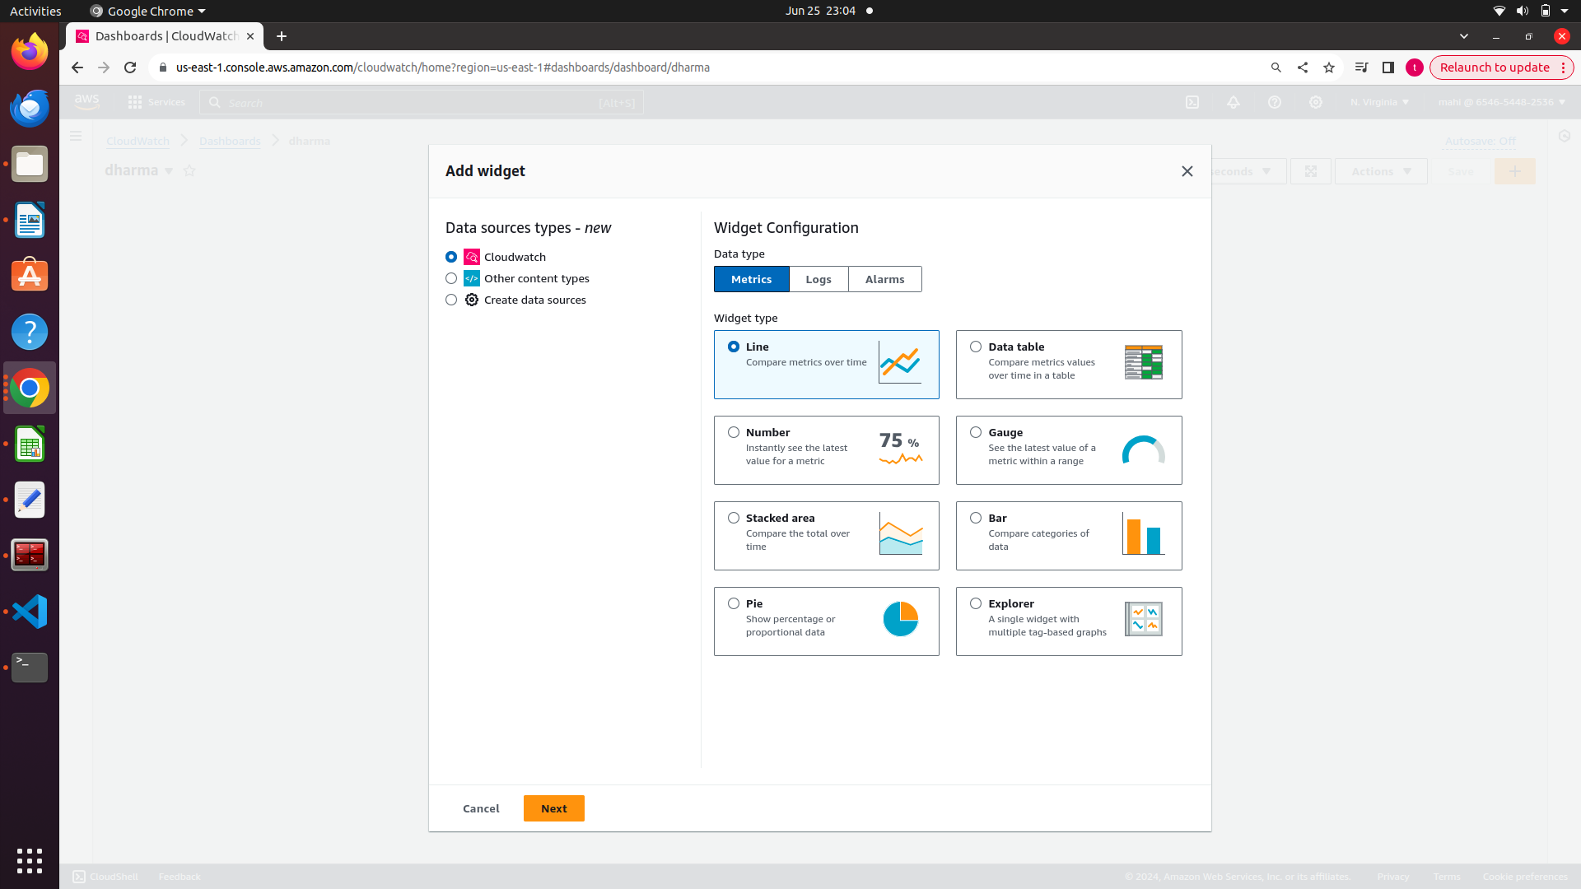
select and wigets for graphs and click on next.

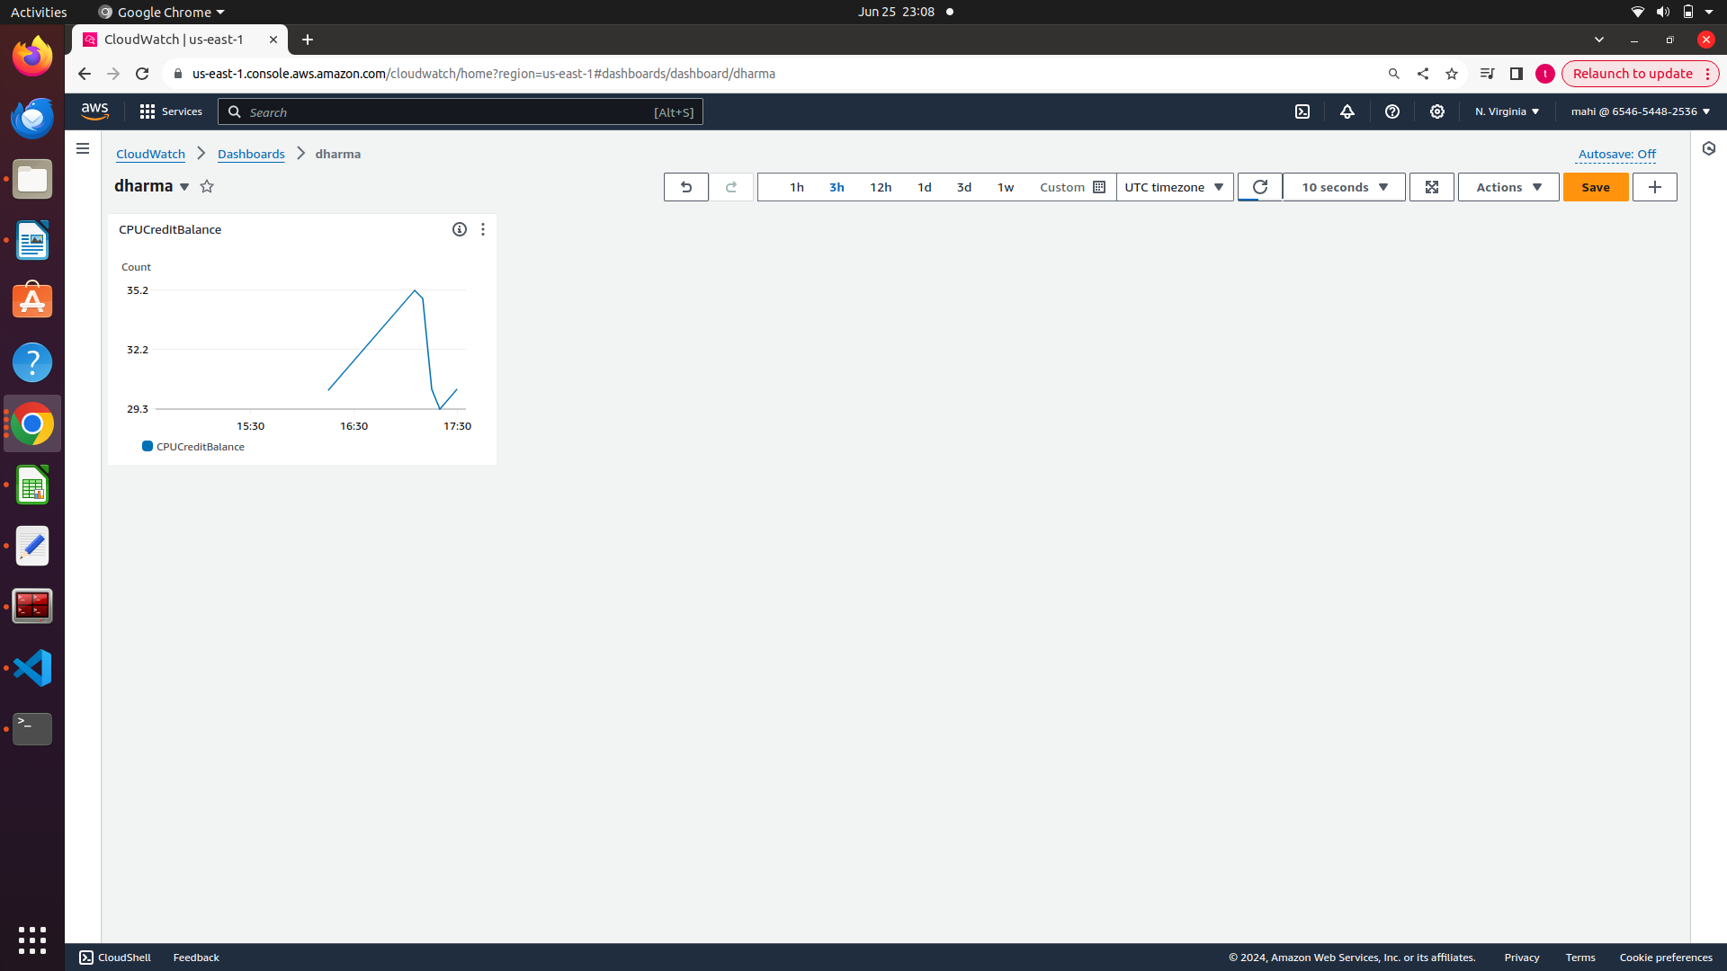
Click on save button to save this dashboard.

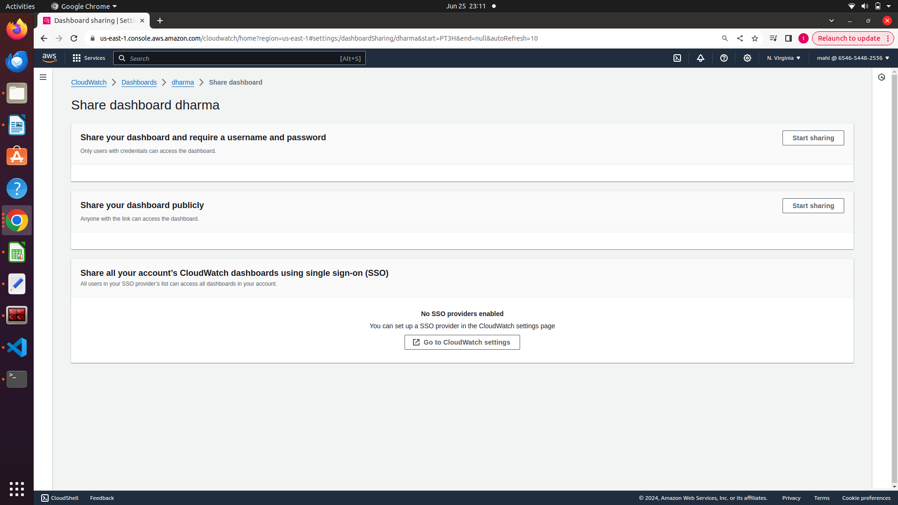
We can share this dashboards with others also as shown above.

Email trigger:

I have configured email id for ec2 instance. I have run some command to increase cpu and check working state.

If cpu more then 80percent then meil will be triggered.

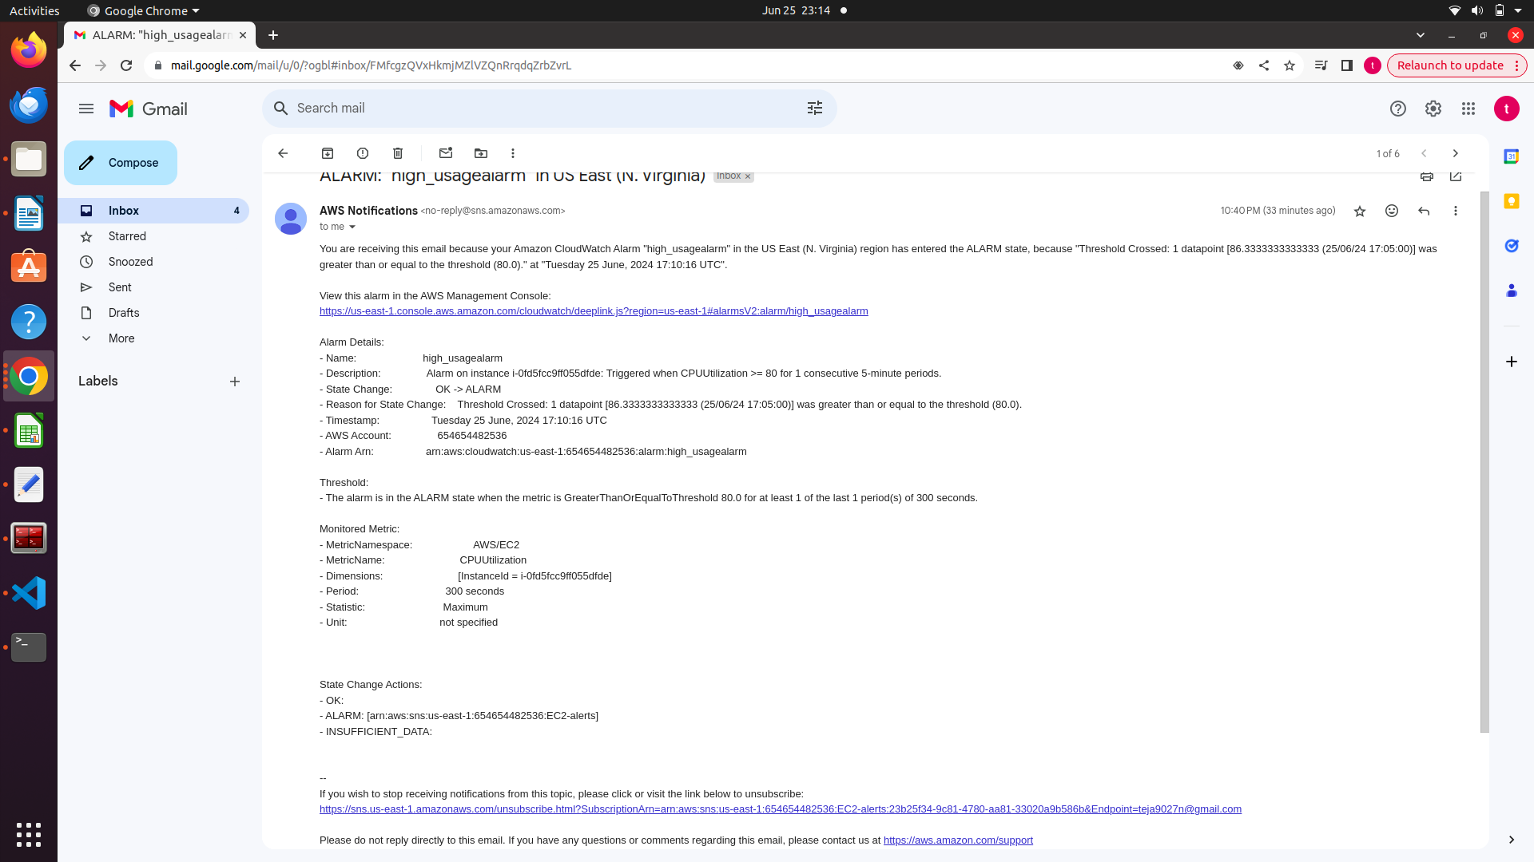
This is my inbox where i received a alter mail.

In the sameway we can use logs also.

Sample dashboards:

