**Multi Vendor MarketPlace**

**Architectures**

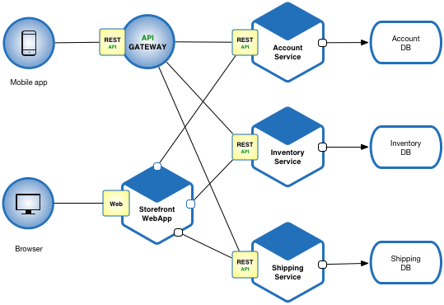

**Data Flow Diagram**

**Front End framwork**

**ESB – Event Bus,Web API**

**DB**

**Technical Services**

**Unified Front End**

**Unified Front End**

**Front End framwork**

**Technologies Used**

* Asp.net
* MSSqlServer
* WebAPI
* Ember MVC Framework
* Publish Subscribe
* SignalR – To support Full Duplex Communication
* Claims based security – get token from ADFS
* Caching using CDM
* Store and Forward – offline functionality
* Routing

**SOA**

* Configure Physical services
* Create virtual service
* Apply mediation policy on virtual service
* Monitor / audit log for service call

**Messaging Framework**

* Outbound communication –SMS, Email, Print
* Integration with SharePoint – Document Storage
* Inbound communication

**Methodologies Used**

**Development methodologies Used:**

* Agile(Scrum): For Projects and CRs and small enhancements kanban

**Source control**

* GIT Hub