LIBRARY MANAGEMENT SYSTEM

Submitted By:
Group 5
Dharma Kshetri
Shankalpa Chaudhary

Submitted To:
Dr Shaqfat Shaad

Maharishi University of Management
Department of Computer Science

Contents
Introduction 3
Scope 3
Tools 3
Class Diagram 4
Functionality 6
Add Book 6
Add Member 6
Checkout 7
Screenshots 8
Conclusion:………………………………………………………………………………………………..13

Introduction
Library management system is a project which aims in developing a computerized system to maintain all the daily work of library. This project has many features like library member login and a admin of library login .It also has a facility of admin login through which the admin can monitor the whole system. Admin add new student , add new book as well as overdue maintaining and monitoring in the whole system and for each library member, the system will keep a record of his/her checkout activities in a checkout record.
Overall this project of ours is being developed to help the students as well as staff of library to maintain the library in the best way possible and also reduce the human efforts. Which class attributes and operations, associations, and inheritance relationships on the basis of above principle, we are going to develop main function on Project:
- User and Admin Login
- Add a new library member to the system
- Checkout a book (if available) for a library member.
- Add a copy of an existing book to the library collection.
- Add a book to the library collection
- Overdue

Scope
This project is helpful to track all the book and library information and to rate the maximum number of books, the library member can borrow book and pay overdue. The software will be able to handle all the necessary information.

Tools
- Programming Language: Java
- UI Development: Java Fx and Screen Builder
- Database: Using HashMap on flat file
- IDE: Eclipse, StartUML

Class Diagram
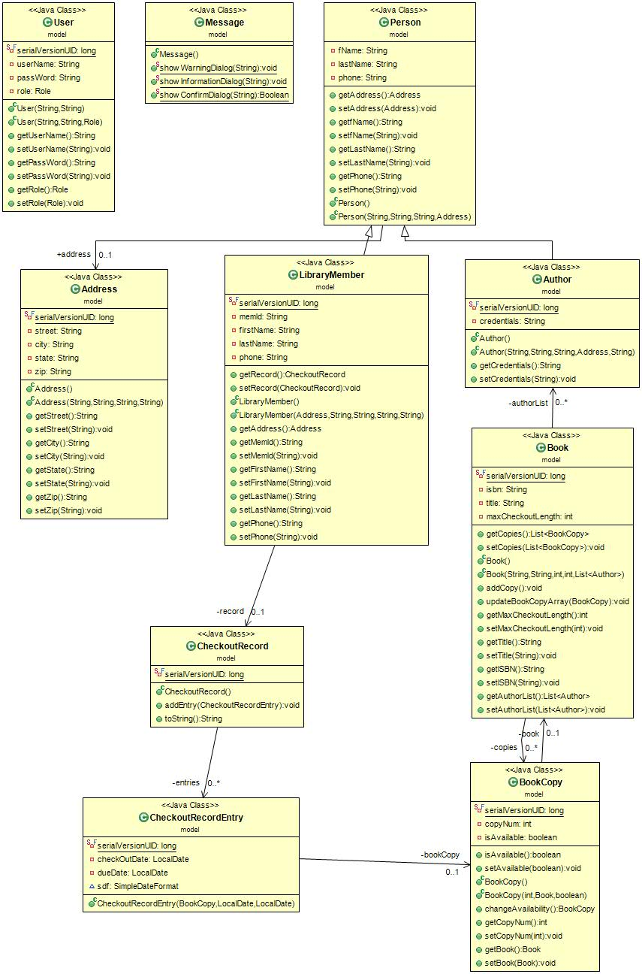

Functionality

Add Book
In Library Management System Admin member have the privilege to add the book to the system. When the process of adding the book is successful, a success message is displayed to the user.
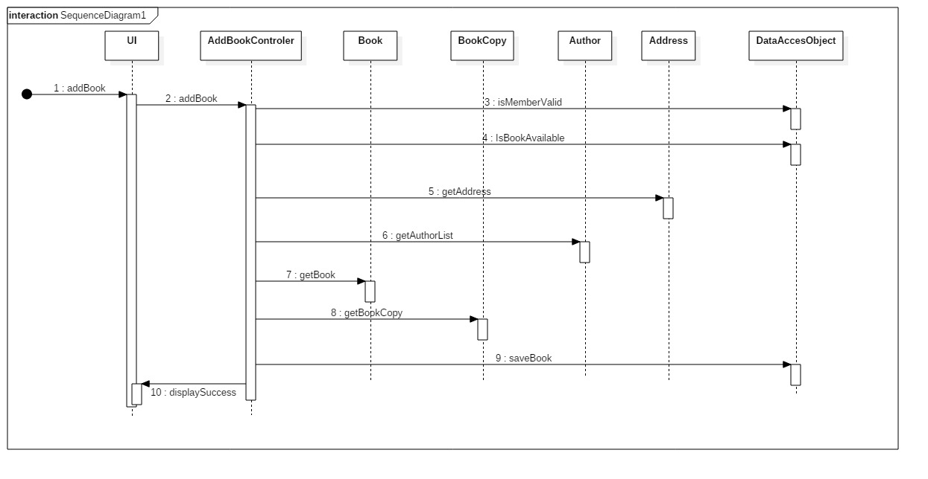

Add Member
Admin member have the privilege to add the member to the system.
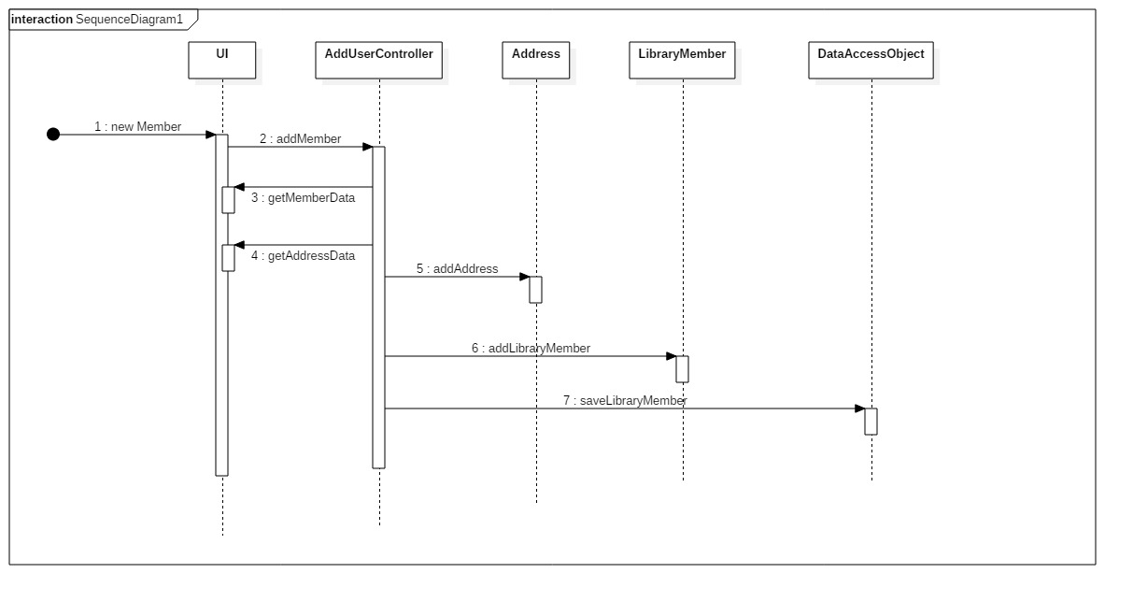

Checkout
Member with the role “Librarian” can checkout the required book from the system.
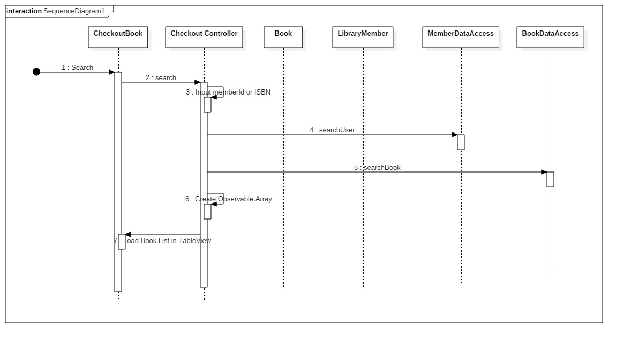

Screenshots
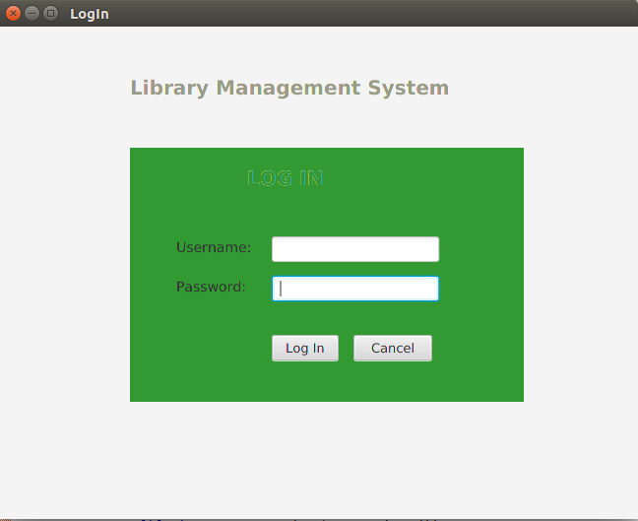
Fig: Login Screen
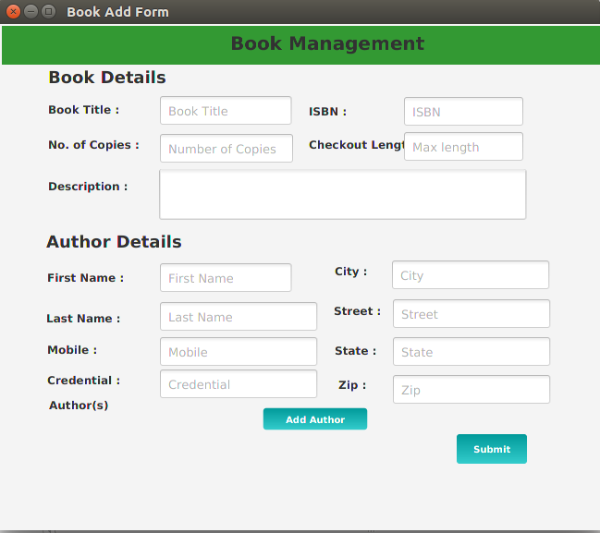
Fig: Add Book

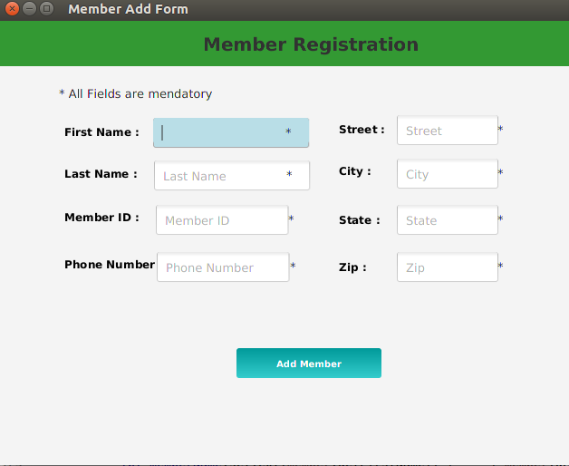
Fig: Add Member
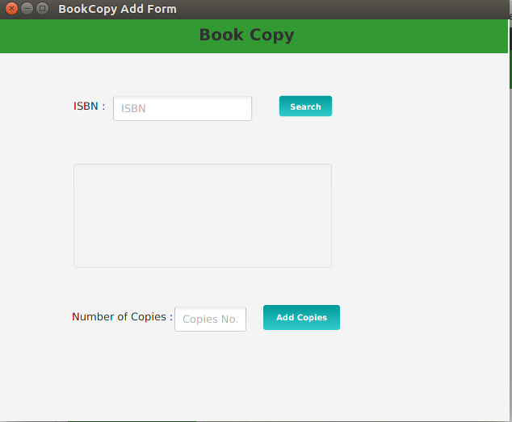
Fig: Book Copy
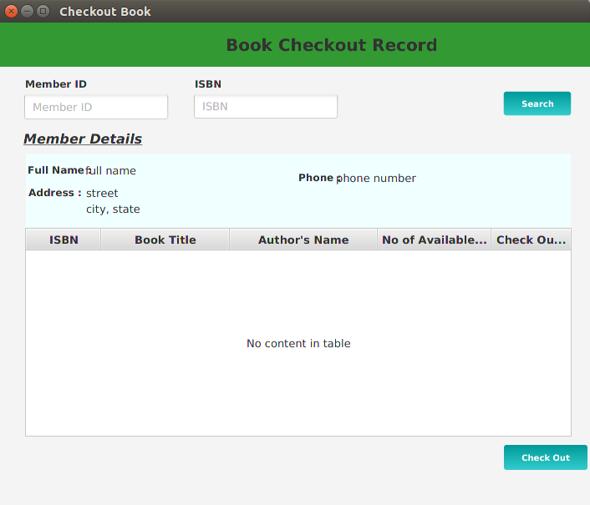
Fig: CheckOut
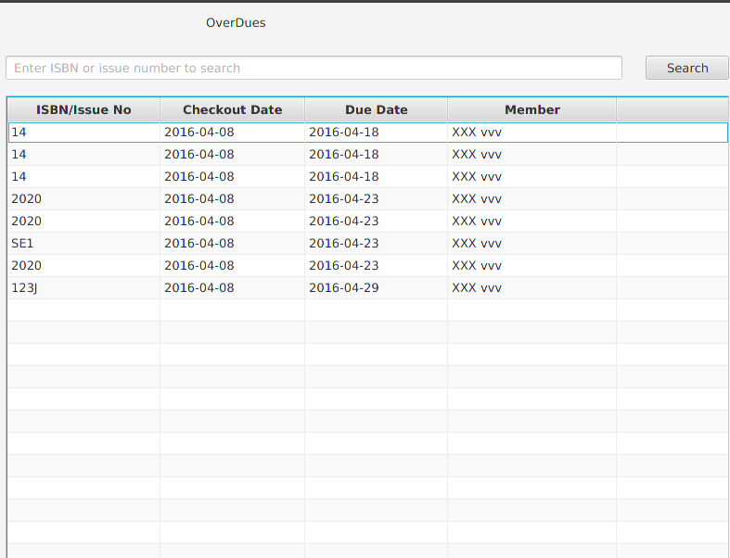
Fig: Overdue
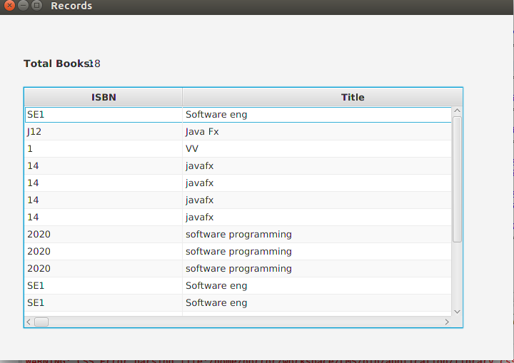
Fig: Book Report

Conclusion:
This project provides a computerized version of library management system which will benefit the students as well as the staff of the library.
It makes entire process online where student can search books,staff can generate reports and do book transactions. It also has a facility for student login where librain can login and issues the book

