Integrating Insight Edge with Grafana and influxdb on minikube

Install Influxdb 1

Create faresandrules database in influxdb 1

Install Grafana 1

Configure Datasource in Grafana 2

Import dashboard 3

ProcessingUnit-faresandrules 3

Space-faresandrules.json 4

Install Insightedge 4

1. Edit insight edge helm chart image to point to custom image 4

2. install insightedge-manager 5

3. install insightedge-pu 5

Submit Spark Job 5

Sample Grafana dashboard with metrics displayed 6

# Install Influxdb

1. Copy influxdb chart (<https://github.com/helm/charts/tree/master/stable/influxdb>)
2. Run helm install –name insightedge .\influxdb\

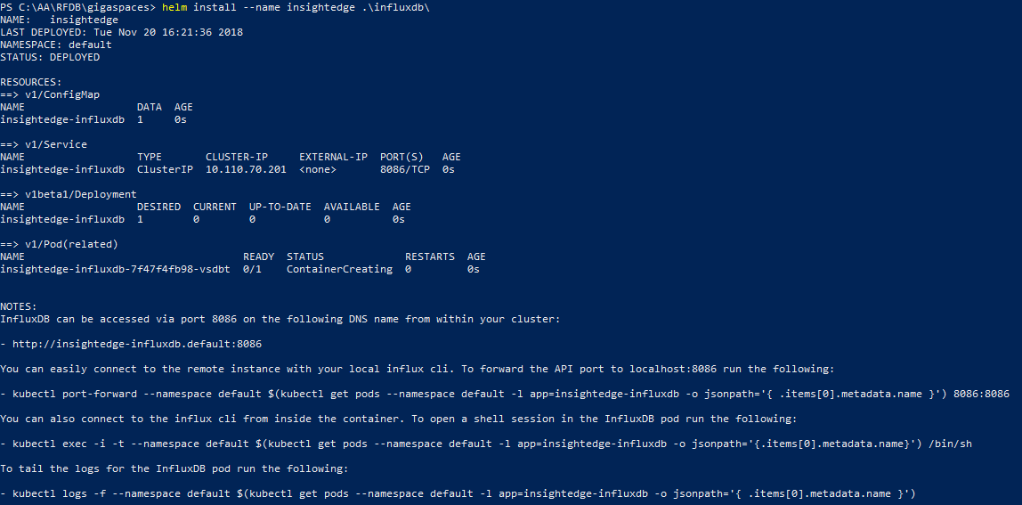

1. kubectl port-forward --namespace default $(kubectl get pods --namespace default -l app=insightedge-influxdb -o jsonpath='{ .items[0].metadata.name }') 8086:8086

## Create faresandrules database in influxdb

1. Open influx cli
2. Create Database as shown below

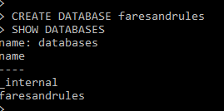

# Install Grafana

1. Copy Grafana chart (https://github.com/helm/charts/tree/master/stable/grafana)
2. Run helm install –name insightedge-grafana stable/grafana

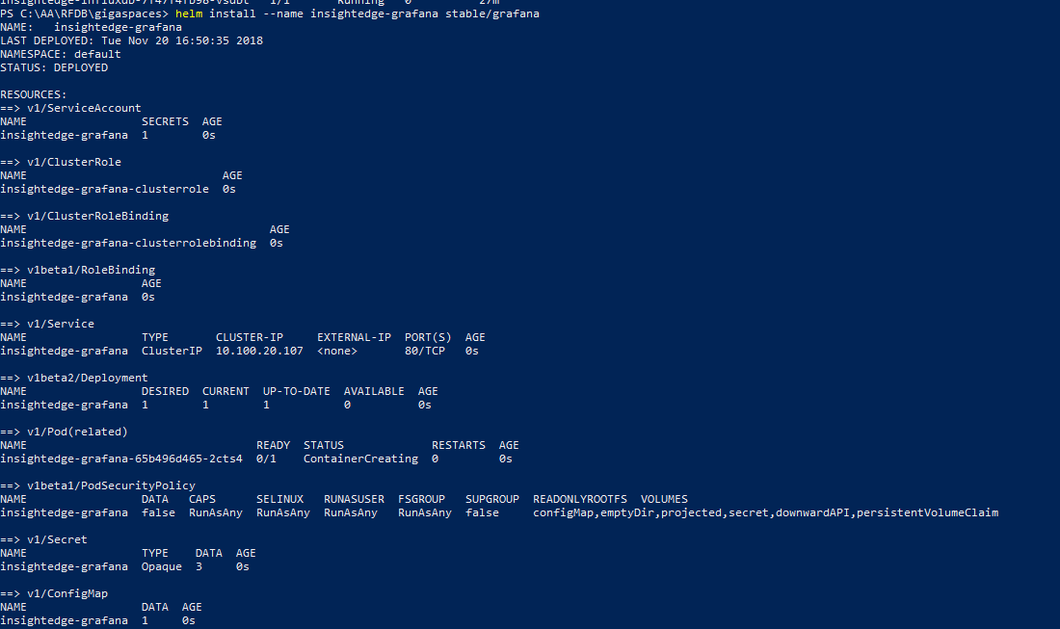

1. Run below command in Cygwin or bash to get admin password of grafana
2. Set up port forwarding to localhost:3000

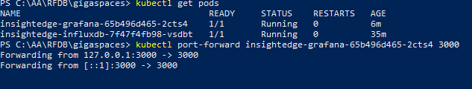

## Configure Datasource in Grafana

1. Open up browser <http://localhost:3000>
2. Login as “admin”
3. Retrieve password by running
   1. kubectl get secret --namespace default insightedge-grafana -o jsonpath="{.data.admin-password}" | base64 --decode ; echo
4. Configure datasource as seen in below image

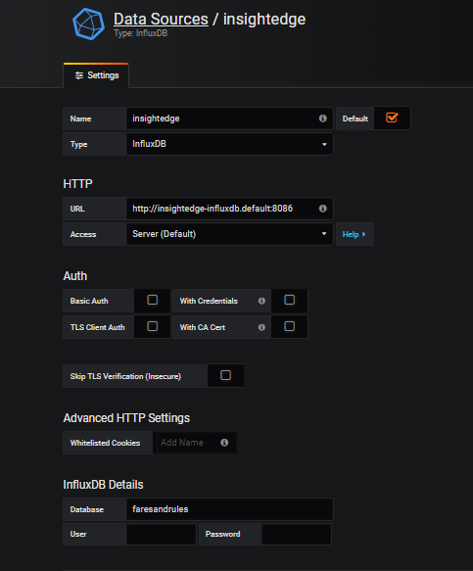

## Import dashboard

### ProcessingUnit-faresandrules([**rfdb**](https://github.com/dharmaprakash/rfdb)/**ProcessingUnit-faresandrules-1542749860799.json)**

* Once you import make sure to select the xap-rfdb-datasource

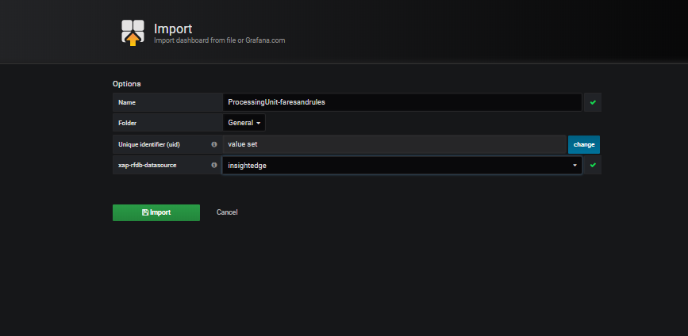

### Space-faresandrules.json (**[rfdb](https://github.com/dharmaprakash/rfdb)**/**Space-faresandrules.json)**

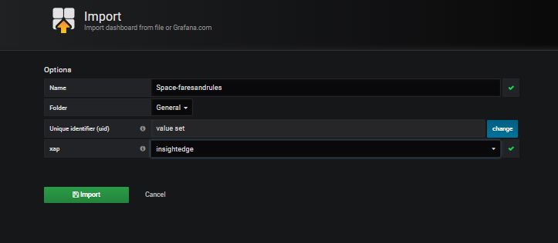

# Install Insightedge

## Edit insight edge helm chart image to point to custom image

* 1. Goto <IE>/tools/kubernetes/chart/
  2. Edit below ymls
     1. **insightedge-manager/values.yml**
     2. **insightedge-pu/values.yml**

**with**

**repository: dharmaprakash/faresandrules-insightedge**

**tag: 0.1**

## install insightedge-manager

* 1. helm install insightedge-manager --name faresandrulesmgr

## install insightedge-pu

* + helm install insightedge-pu --name faresandrules --set manager.name=faresandrulesmgr,resources.limits.memory=5G,java.heap=85%,partitions=2,resourceUrl=https://github.com/dharmaprakash/rfdb/raw/master/FaresAndRulesSpace-0.0.1-SNAPSHOT.jar

# Submit Spark Job

./insightedge-submit --master k8s://https://192.168.99.100:8443 --deploy-mode cluster --name i9e-saveRdd --class org.insightedge.examples.basic.SaveRdd --conf spark.kubernetes.authenticate.driver.serviceAccountName=spark --conf spark.kubernetes.container.image=dharmaprakash/mycustomgigaspaces-insightedge:1.6 --conf spark.insightedge.space.manager=faresandrulesmgr --conf spark.insightedge.space.name=faresandrules local:///opt/gigaspaces/insightedge/examples/jars/insightedge-examples.jar

# Sample Grafana dashboard with metrics displayed

