**Online Railway Reservation System**

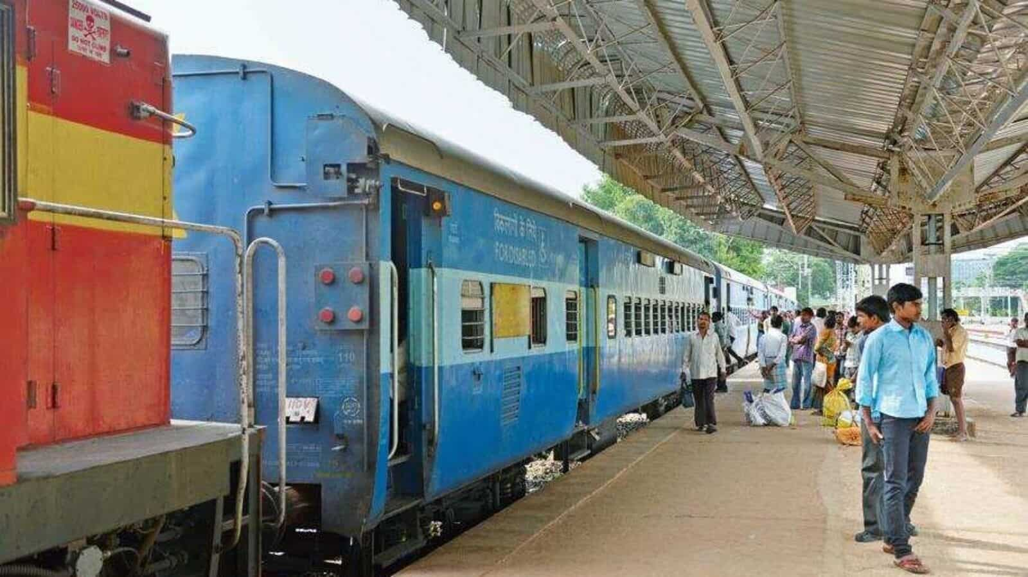

**Low Level Design**

**(LLD)**

**Team Members**

**LAKSHMI SOWMYA  CHILAKA**

**VARUN  YADAV**

**UJUAL SREEDHARAN MURIKKAL**

**ABHISHEK SATISH DASARI**

**SHUBHAM VINOD VERMA**

**SIDDHANT SUNIL PATOLE**

**PUJA  SAMADDER**

**BALAJI  JAYAKUMAR**

**DHARMA REJESH**

**ISAN BAIN (GL)**

Date:

Document Version:

**DOCUMENT APPROVAL**

**Approvers of this document**

|  |  |  |  |  |
| --- | --- | --- | --- | --- |
| **Name** | **Department** | **Role** | **Signature** | **Date** |
|  |  |  |  |  |
|  |  |  |  |  |
|  |  |  |  |  |
|  |  |  |  |  |

**DOCUMENT CHANGE HISTORY**

|  |  |  |  |
| --- | --- | --- | --- |
| **Document**  **Version #** | **Author** | **Date** | **Description** |
|  |  |  |  |
|  |  |  |  |
|  |  |  |  |

**TABLE OF CONTENTS**

1. **Document Purpose** ……………………………………………………………………. 4
2. **Intended Audience** ……………………………………………………………………. 4
3. **Project Background & Objective**

3.1. Problem with Offline Railway Ticket Booking ………………………. 5

3.2. Solution to the above Issue …………………………………………………. 5

3.3. Project Objective …………………………………………………………………. 5

1. **Design Pattern** …………………………………………………………………………… 6
2. **Solution Diagram** ……………………………………………………………………….. 7
3. **Function of Project** …………………………………………………………………….. 8

1. Book Reservations

2. Cancel Reservation

3. Add/Update Train Details

4. Generate Report

5. Verify login

6. View Reservation Details

7. View Train Timetable

1. **UML Diagrams**

7.1. Sequence Diagram ……………………………………………………………….. 9 & 10

7.2. Use Case Diagram ………………………………………………………………… 11

7.3. Activity Diagram …………………………………………………………………… 12

7.4. Class Diagram ………………………………………………………………………. 13

7.5. Database Diagram ……………………………………………………………….. 14

**1.   Document Purpose**

This document describes the Online Railway Reservation System.

**2.  Intended Audience**

This document is intended as a reference for the following roles and stakeholders who are interested in the Railway Reservation System technical architecture.

|  |  |
| --- | --- |
| **Role** | **Nature of Engagement in the Online Railway Reservation System Architecture** |
| Product Owners/SME | Key stakeholder to ensure that the architecture is aligned with business goals. |
| Business Analysts | Business analysts are one of the stakeholders who are informed with the key architectural decisions. |
| Enterprise Architects | To enforce User Management Platform Architecture is aligned to business goals and architecture, architectural guidelines. |
| Solution Architects | To ensure solution design and architecture is aligned to business requirements, architectural guidelines. |
| Developers | Use Technical Architecture Document as the guiding document for detail design and implementation approach to align with User Management Microservice |
| End User | An End User can check the train timings ,train fares and other train details. |

**3.Project Background & Objective(s)**

**3.1.   Problem with Offline Railway Ticket Booking**

The current system for railway ticket booking is to go to railway station and stand in queue for a long time to get the tickets which is very difficult for the user.

* It is very time-consuming
* User must go to the railway station and search which all trains are available.
* It is less user-friendly.
* And for printing tickets more papers are wasted.

**3.2.   Solution to the above issue**

In the proposed system user will not be required to go to the railway station. Users can book the ticket anytime and from anywhere according to their comfort. There will be an admin who will be updating the train details. The motive of this system is to:

* To make things easier and user friendly and flexible.

**3.3.    Project Objectives**

* Online Railway Reservation System will perform various operations like reservation, and cancellation of ticket details.
* The user must first register to the web application. After registering they

can book and cancel tickets. Users can search the trains without logging but for

reservations, users must log in to the site.

***4.*    Design Pattern**

|  |  |  |
| --- | --- | --- |
| **No** | **Name** | **Description** |
| 1 | Angular | For creating a user interface(front-end) |
| 2 | ASP.Net Web API | Using Https requests, we will use respective actions to trigger various operations. |
| 3 | Database | For storing and maintaining booking and user and train details |

**5.   Solution Diagram**

**ANGULAR**

**WEB API**

**DATABASE**

**6.** **Functions of Project:**

**1.** **Book Reservations:** A User can book a ticket from anywhere. User should Search for the trains between two stations and select a train. Then fill up the Reservation form and add the Passengers details, then make the payment. One user can book a maximum of six seats at a time. If the seats are not available that is informed to the User or else the User will receive the ticket with the PNR Number.

**2. Cancel Reservation:** The user can Cancel the reservation at any time after the reservation. So check the PNR, if it is there then Cancel the Reservation and send the cancellation ticket to the User, else Show the user that the ticket does not exist.

**3. Add/Update Train Details:** Only Admin can Add or Update the Train Number, Train Name, Seats, Classes, and all the train details.

**4. Generate Report:** Provision for the generation of different reports should be given in the system. The system should be able to generate Booking details, all train details, etc.

**5. Verify login:** For security reasons all the users need to register to avail reservation facility, after registration User will have their user id and a password. Only if the user id and password are correct is the user allowed entry to the system for reservation.

**6. View Reservation Details:** All the users should be able to see the reservation details that User has done.

**7. View Train Timetable:** Provision should be given to see information related to the train schedules for the search between two stations. The user should be able to see the train name, train number, boarding and destination stations, duration of the journey, etc.

**7.   UML Diagrams**

**7.1. SEQUENCE DIAGRAM***:*

7.1.1 User Sequence Diagram

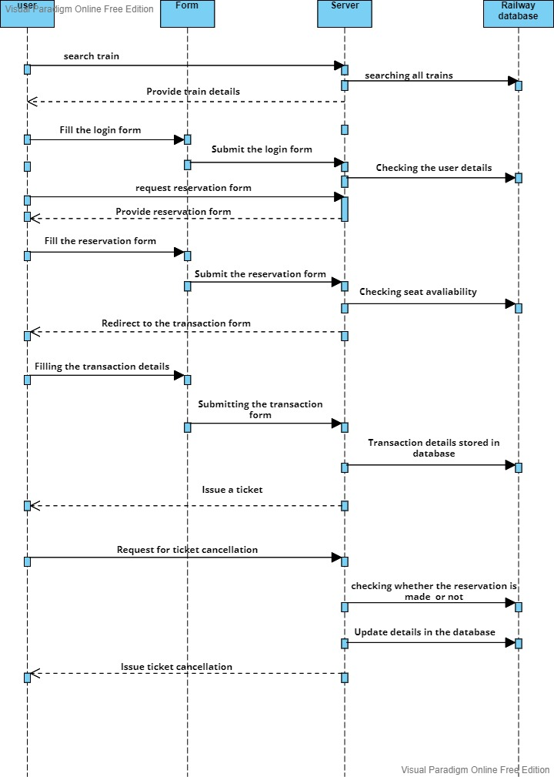

**7.1.2. Admin Sequence Diagram**

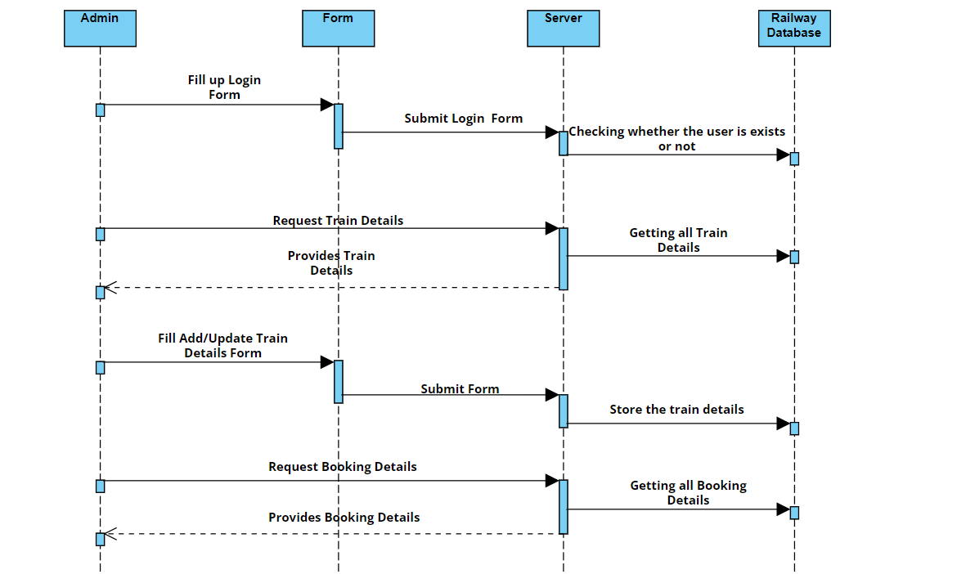

**7.2. USECASE DIAGRAM:**

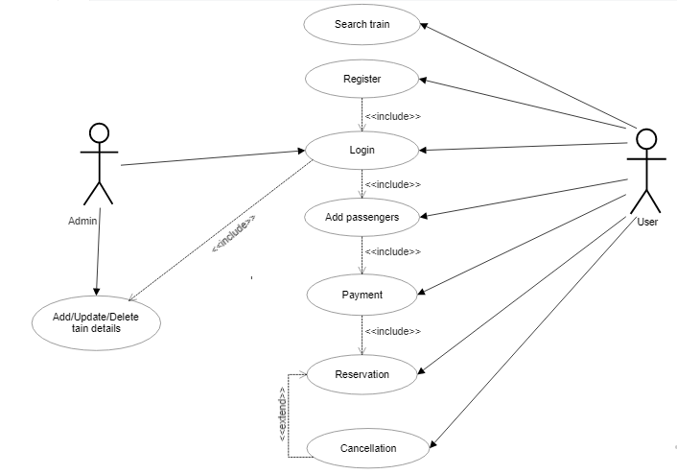

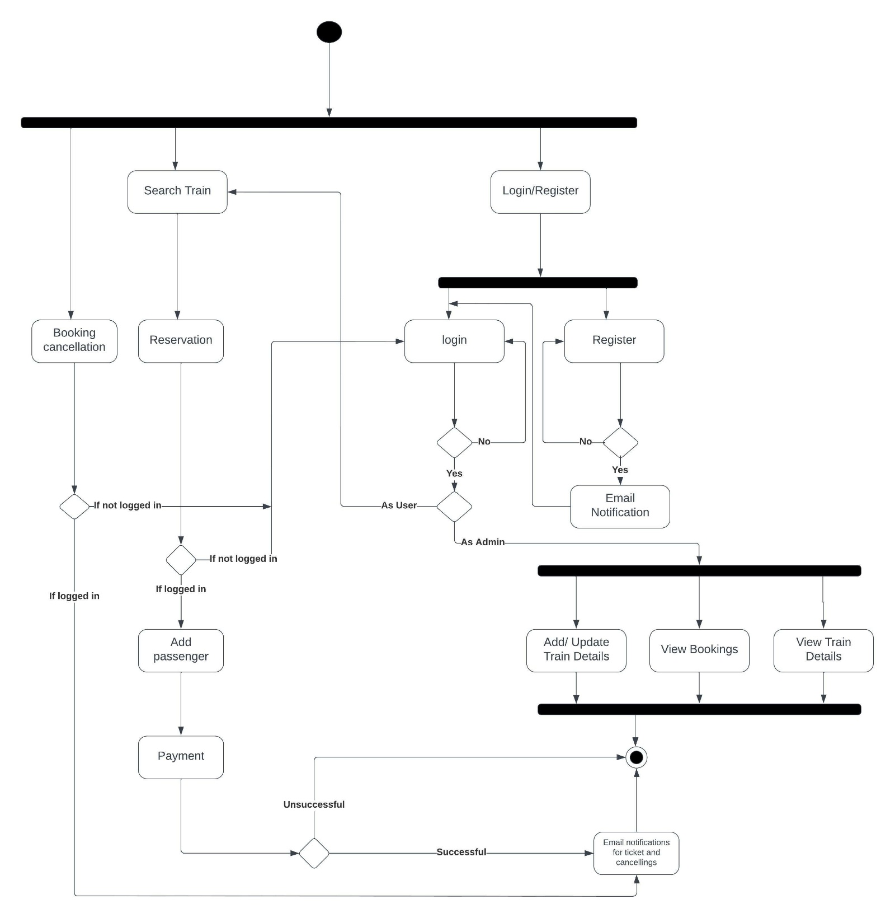**7.3. Activity Diagram:**

**7.4. Class Diagram**

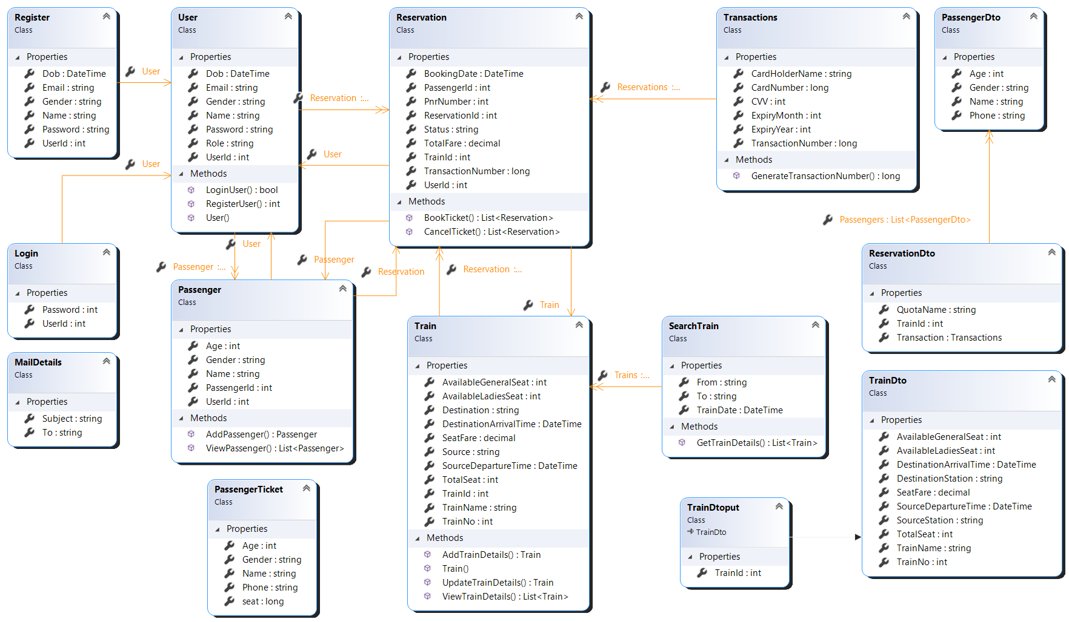

**7.5 Database Diagram**

