ServiceNow Project Documentation

**Automated Network Request Handling in ServiceNow**

# 1. Project Overview

The Automated Network Request Handling system is designed to streamline how organizations deal with network-related service needs. In most enterprises, employees frequently seek services such as new network setups, modifications to existing connections, access adjustments, or device-specific network changes. Traditionally, these requests are processed using manual communication methods like calls, emails, or paper forms, which often lead to errors, bottlenecks, and a lack of visibility. This project addresses these limitations by creating a single digital platform within ServiceNow where employees can log their network requests, track their progress, and IT staff can review, approve, and complete tasks in a structured and automated way. By using ServiceNow’s Service Catalog, Flow Designer, UI Policies, Notifications, and Custom Tables, the system reduces manual overhead while improving service delivery speed, accuracy, and transparency. The approach results in improved user satisfaction and operational efficiency across the organization.

# 2. Objectives

Business Goals: • Improve speed of request processing through automation. • Enhance accuracy with structured forms and validations. • Provide full visibility into request status for end-users. • Optimize IT resources and reduce time-consuming manual tasks. • Ensure flexibility to support a variety of network-related scenarios. Specific Deliverables: • A Service Catalog item for raising network service requests. • Dynamic forms with ServiceNow variables and UI rules. • Automated approval and routing processes based on defined criteria. • A Network Request Table to capture and store structured data. • Notifications to keep users and approvers informed throughout the process. • Analytical reports for evaluating system performance.

# 3. ServiceNow Features Utilized

Service Catalog: Acts as the gateway for all network service requests. Items are grouped under the 'Network & Connectivity' category and include fields for requester details, request type, and technical specifications. Catalog Variables & UI Policies: Dynamic variables such as text boxes, dropdowns, and conditional sections ensure relevant fields appear only when applicable. For instance, relocation-related details are shown only if relocation is chosen as the request type. Workflows & Flow Designer: Automated workflows drive approvals, request routing, and task assignment. Flow Designer is used to build automation steps such as notifications, record updates, and conditional branching. Custom Tables: A 'Network Request Table' maintains detailed information about each request, making it easier to audit, analyze, and report. Client Scripts & Notifications: Client-side scripts enforce real-time validation while notifications keep users, managers, and IT staff updated at every stage.

# 4. Solution Design Process

Data Models: • Network Request Table to store service request data. • User Profiles integrated with ServiceNow’s core user data. • Dynamic request variables for different service categories. • Feedback records for collecting satisfaction scores. User Interface: • A streamlined Service Catalog item with grouped fields and conditional sections. Business Logic: • Approval routing based on request category and hierarchy. • Automated assignment to designated support groups. • SLA timers and escalation rules for overdue items. • Notification triggers at submission, approval, and closure stages.

# 5. Testing & Validation

• Unit Testing: Verification of variables, UI behavior, and workflow execution. • User Testing: Feedback collection on usability and clarity of forms. • Integration Testing: Ensure Service Catalog, custom tables, and notifications work seamlessly. • Load Testing: Confirm performance stability under multiple concurrent requests.

# 6. Implementation Scenarios

Network Setup Request: • Employees request new network connectivity specifying device and location. Relocation Scenario: • Specialized fields capture old and new locations, with automated notifications. Device-Specific Configuration: • Requests for configuration updates are routed to appropriate technical staff. Tracking & Approvals: • Users can view their request progress, while managers receive alerts for approvals.

**7. Sample Outputs**

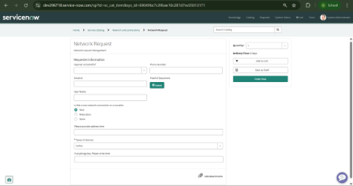 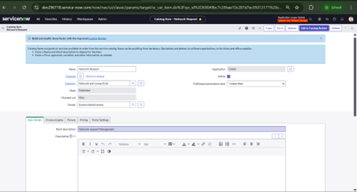

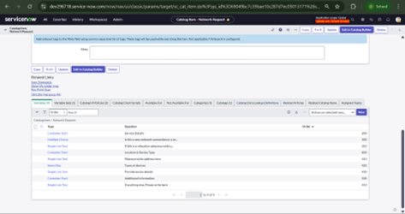 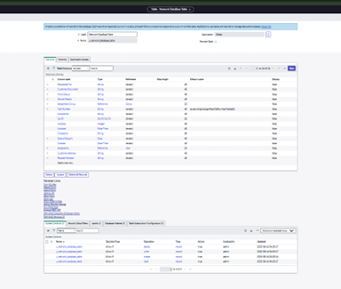

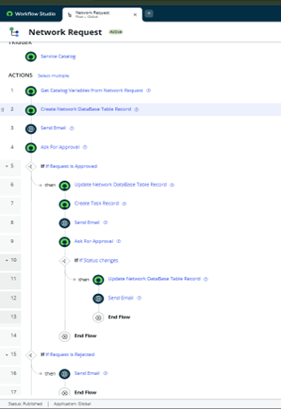

# 8. Conclusion

The Automated Network Request Handling project demonstrates ServiceNow’s ability to digitize and optimize IT service operations. By leveraging Service Catalog, Workflows, and Custom Tables, the solution reduces manual work, accelerates delivery, and ensures accurate tracking of network requests. This implementation highlights improved transparency, stronger communication, and the ability to scale as organizational needs grow. Future work may include CMDB integration, AI-based assistants, and advanced analytics for demand prediction.

BY A. Dharma Teja

Mail: 22331a4704@mvgrce.edu.in