Project Documentation

Laptop Request Catalog Item

# 1. INTRODUCTION

## Project Overview

Handling laptop requests manually often leads to confusion, delays, and inefficiencies. To overcome these challenges, this project introduces an automated Laptop Request Catalog Item in ServiceNow. The solution incorporates features such as dynamic input fields, conditional visibility, a reset option, and portability through update sets.

## Purpose

The catalog item replaces outdated manual processes with a structured digital form in ServiceNow, ensuring: - Quicker request handling - Standardized data collection - Enhanced user experience - Seamless migration between instances using update sets

# 2. IDEATION PHASE

## Problem Statement

Laptop requests via email or verbal communication frequently result in incomplete information, difficulty in tracking, and increased workload for IT staff. A centralized ServiceNow catalog item resolves these inefficiencies.

## Empathy Map (Users: Employees)

- Think/Feel: Unclear process, frequent delays - See: No transparency in request progress - Say/Do: Repeated follow-ups with IT staff - Hear: Complaints from colleagues about slow response - Pain: Miscommunication, missed deadlines - Gain: Smooth and transparent request handling

## Brainstorming Options

1. Emails (inefficient, error-prone) 2. Spreadsheets or third-party tools (limited integration) 3. ServiceNow Catalog Item (selected) – scalable, integrated, and user-friendly

# 3. REQUIREMENT ANALYSIS

## Customer Journey

Employee logs into ServiceNow → Accesses Service Catalog → Selects Laptop Request → Completes dynamic form → Request routed automatically.

## Solution Requirements

- Single catalog item for laptop requests - Fields for laptop model, justification, and accessories - Conditional display for accessories details - Reset button to clear inputs - Update set support for migration

## Data Flow Diagram

User → Catalog Form → UI Policies → Submission ↓ Update Set ↓ Export/Import XML ↓ Target Instance Execution

## Technology Stack

- Platform: ServiceNow (Orlando or later) - Scripting: JavaScript (GlideForm APIs), XML - Modules: Service Catalog, UI Policy, UI Action, Update Sets - Testing: Manual verification

# 4. PROJECT DESIGN

## Problem-Solution Fit

Transitioning from a manual to a digital form ensures complete, accurate data collection, reduces IT workload, and improves user satisfaction.

## Proposed Solution

- Catalog item under Hardware category - Dynamic form with conditional fields - Reset button for usability - Portability via update sets

## Solution Architecture

- Frontend: Catalog form with dynamic behavior - Logic Layer: JavaScript for UI policies and actions - Persistence Layer: ServiceNow tables for data storage - Deployment Layer: XML update sets for import/export

# 5. PROJECT PLANNING

## Steps Followed

1. Create Update Set 2. Build Catalog Item 3. Add Variables 4. Configure UI Policies 5. Add Reset Button 6. Test functionality 7. Export/Import Update Set

# 6. IMPLEMENTATION WORKFLOW

## 6.1 Create Update Set

Navigate: All → Update Sets → Local Update Sets → New → Name: Laptop Request → Save → Make Current

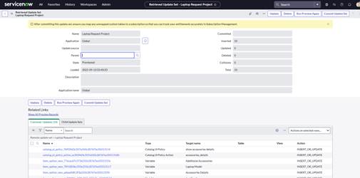

## 6.2 Create Catalog Item

Navigate: All → Service Catalog → Maintain Items → New → Name: Laptop Request → Catalog: Service Catalog → Category: Hardware → Save

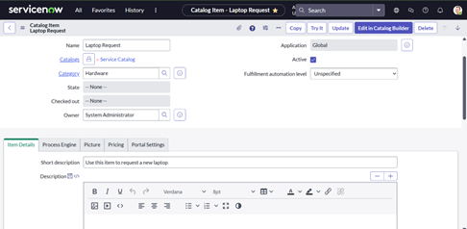

## 6.3 Add Variables

Add variables: Model, Justification, Accessories, Accessories Details → Save

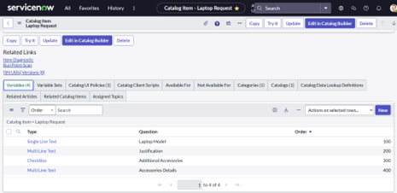

## 6.4 Configure UI Policy

Condition: If Accessories = Yes → Show Accessories Details as mandatory

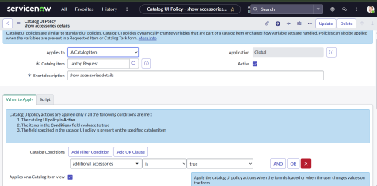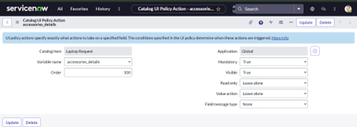

## 6.5 Create Reset Button (UI Action)

Navigate: System Definition → UI Actions → New - Table: sc_cart - Action: Reset Form - Client: Checked function resetForm() { g_form.clearForm(); alert("The form has been reset."); }

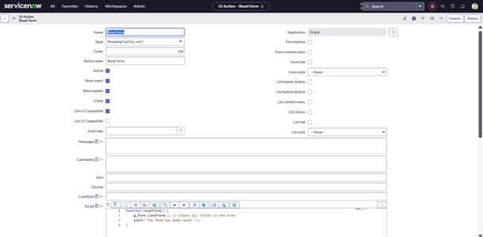

## 6.6 Export Update Set

Navigate: Update Sets → Local Update Sets → Laptop Request → Set State: Complete → Export as XML

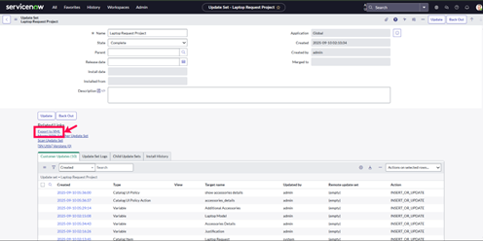

## 6.7 Import Update Set

Navigate: System Update Sets → Retrieved Update Sets → Import XML → Preview → Commit

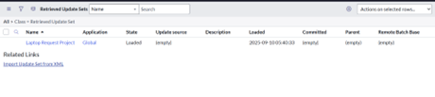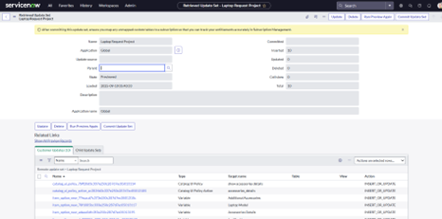

## 6.8 Testing

- Only essential fields visible at start - Accessories details appear when checkbox selected - Form submission restricted if mandatory fields empty - Reset clears all inputs

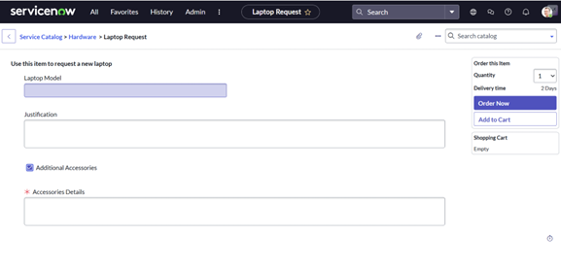

# 7. FUNCTIONAL & PERFORMANCE TESTING

- Verified dynamic visibility of fields - Checked mandatory field validations - Confirmed reset button functionality - Ensured update set migration works correctly

# 8. ADVANTAGES & DISADVANTAGES

## Advantages

- Faster request handling - Reduced manual errors - Simple customization - Portable across instances - User-friendly interface

## Disadvantages

- Requires ServiceNow knowledge - Admin access necessary for deployment

# 9. CONCLUSION

The ServiceNow Laptop Request Catalog Item streamlines the laptop request process by providing dynamic forms, validations, and easy deployment features. It enhances IT efficiency and delivers a better experience for employees.

# 10. FUTURE SCOPE

- Implement approval workflows - Send automatic notifications - Add dashboards for monitoring - Extend to mobile devices and other hardware requests

# 11. APPENDIX

## UI Action Script

function resetForm() { g_form.clearForm(); alert("The form has been reset."); }

By: A. Dharmateja

Mail: 22331a4704@mvgrce.edu.in