**REPORT**

**i iOn i**

**MINI iPROJECT iWORK i**

**Generating iAssociation iRules ifrom iMedical iDatasets iusing iData iMining**



**Submitted ito**

**The ifaculty iof iEngineering iand iTechnology iof**

**Kakatiya iUniversity, iWarangal**

**In ipartial ifulfilment iof ithe irequirements**

**to iaward**

**Bachelor iof iTechnology**

**in**

**Information iTechnology**

**BY**

**DHARMATEJA iKONDA**

**(B18IT039)**

**Under ithe iGuidance iof**

**Sri. iK. iGoutham iRaju i**

**Assistant iProfessor, iDept. iof iI.T.**

**DEPARTMENT iOF iINFORMATION iTECHNOLOGY**

**KAKATIYA iINSTITUTE iOF iTECHNOLOGY i& iSCIENCE, iWARANGAL** i(An iAutonomous iInstitute iunder iKakatiya iUniversity)

**2020 i- i2021**



i

**i iC iE iR iT iI iF iI iC iA iT iE**

This iis ito icertify ithat i**Dharmateja iKonda i(B18IT039) i**of iVI- iSemester iB.Tech. iInformation iTechnology ihas isatisfactorily icompleted ithe iMini iProject ientitled i**“Generating iAssociation irules ifrom iMedical iDatasets iusing iData iMining”** iin ithe ipartial ifulfilment iof ithe irequirement iof iB. iTech idegree iduring ithis iacademic iyear i2020-2021.

**i iSUPERVISOR i I CHAIRMAN, iDMPEC**

**i iSri. iK. iGoutham iRaju i iDr. iP. iKAMAKSHI i**

**Assistant iProfessor, iDept. iof iI.T. Professor i& iHead, iDept.iof iI.T.**

**ACKNOWLEDGEMENT**

I iwish ito itake ithis iopportunity ito iexpress imy ideep igratitude ito iall ithe ipeople iwho ihave iextended itheir icooperation iin ivarious iways iduring imy iMini iproject. iIt iis imy ipleasure ito iacknowledge ithe ihelp iof iall ithose iindividuals.

I ithank i**Dr. iK. iAshoka iReddy**, iPrincipal iof iKakatiya iInstitute iof iTechnology i& iScience, iWarangal, ifor ihis istrong isupport.

I ithank i**Dr. iP. iKamakshi, i**Professor i& iHead, iDepartment iof iInformation iTechnology ifor iher iconstant isupport iin ibringing ishape ito ithis iMini iproject.

I iwould ilike ito ithank imy isupervisor, i**Sri. iK. iGoutham iRaju,** iAssistant iProfessor, iDepartment iof iInformation iTechnology ifor ihis iguidance iand ihelp ithroughout ithe iMini iproject.

In icompleting ithis iMini iproject isuccessfully iall iour ifaculty imembers ihave igiven ian iexcellent icooperation iby iguiding ius iin ievery iaspect. iAll iyour iguidance ihelped ime ia ilot iand iI iam ivery igrateful ito iyou.

**Dharmateja iKonda**

**(B18IT039)**

**CONTENTS**

**Abstract vi**

**List iof iFigures vii**

**1. iIntroduction**

1.1 iIntroduction ito i **01**

1.2 iAssociation irule igenerating iAlgorithms **02**

1.2.1 iApriori iAlgorithm **02**

1.2.2 iFP iGrowth iAlgorithm **02**

1.3 iEvolutionary iAlgorithms **03**

1.3.1 iEARMA **03**

1.3.2 iMOEA **03**

**2. iLiterature iSurvey**

2.1 iResearch iHistory **05**

**3. iDesign**

3.1 iSoftware iRequirements iSpecification **07**

3.1.1 iHardware iRequirements **07**

3.1.2 iSoftware iRequirements **07**

3.2 iProposed iModel i

3.2.1Apriori iProperty **08**

3.2.2 iLimitations **10**

3.3 iBenefits iand iDrawbacks iof iApriori iAlgorithm 3.3.1 iBenefits **11**

3.3.2 iDrawbacks **11**

**4. iImplementation**

4.1 iData icollection i i**12**

4.2 iPreprocessing i i i**13**

4.3 iCode ifor iData ipreprocessing i i**14**

4.3.1 iExtraction iof itablet inames i i**14**

4.3.2 iDeleting iDuplicate ivalues i i**14**

4.4 iCode ifor iImplementation iof iApriori iAlgorithm i i**15**

4.4.1 iStoring ivalues iin ia iData iFrame i i**15**

i 4.4.2 iTesting iwith iApriori iAlgorithm i i**16**

4.4.3 iDisplaying ithe iResults i i**16**

**5. iResults 18-20**

**Conclusion i i21**

**Future iScope i i22**

**Bibliography i i23-24**

**ABSTRACT**

i iMedical iHealth iRecords iis imade idata isources ifor idata iprocessing. ithe iprovision iof ihuge iamounts iof imedical iinformation imay ibe iutilised ito iextract iconstructive ifacts iexploitation ivaried idata iprocessing itechniques. ivaried iresearches iare iconducted iwithin ithe ifield iof imedical idata iprocessing. iThe iaim iof ithis iproject iis ito iseek iout iassociations ibetween ioft ipurchased imedicines ithroughout itotally idifferent iseasons. iwe've igot icollected ia iperiod iof itime idataset ifrom imedical istore ito iextract iassociation irules ifrom imedical irecords iby iselecting ithe isimplest iassociation irule imining ialgorithmic iprogram iexploitation imultiple-criteria icall ianalysis. iBy iimplementing ithis iproject iMedical ilook ikeepers iwill ikeep iample istock iof imedication iprior ito i(before ibegin iof ithe iseason) ito iavoid iinconvenience ito ithe ishoppers.

**LIST iOF iFIGURES**

|  |  |  |  |
| --- | --- | --- | --- |
| **S.NO** | **FIG.NO** | **i iFIGURE iNAME** | **iPAGE iNO i** |
| 1 | 1.1 | List iof iTID’s iand iItems iC1 | 08 |
| 2 | 1.2 | Itemset iand iSupport icount ifor iL1 | 08 |
| 3 | 1.3 | List iof iTID’s iand iItems iC2 | 09 |
| 4 | 1.4 | Itemset iand iSupport icount ifor iL2 | 09 |
| 5 | 1.5 | iList iof iTID’s iand iItems iC3 | 10 |
| 6 | 1.6 | Itemset iand iSupport icount ifor iL3 | 11 |
| 7 | 1.7 | Dataset ibefore iPreprocessing | 12 |
| 8 | 1.8 | Extracting iTablet iNames ifrom iDataset i | 13 |
| 9 | 1.9 | Extracting iUnique iValues ifrom iDataset | 13 |
| 10 | 2.0 | Dataset iafter iPreprocessing iand icleaning | 15 |
| 11 | 2.1 | Code | 18 |
| 12 | 2.2 | Code | 19 |
| 13 | 2.3 | Code | 20 |
| 14 | 2.4 | Code | 21 |

**CHAPTER i1**

**INTRODUCTION**

**1.1 iINTRODUCTION i**

Mining ifrequent iitemsets iis ione iin ievery iof ivaried| ithe inumerous iand iessential iproblems iin ivarious iprocessing iapplications ilike imarket-basket ianalysis, ithe iinvention iof iassociation irules, imonetary ibusiness, inetwork iinvasion idetection ietc. ithe imatter iis idevised ias ifollows: ia igaggle iof ithings iassociate idegreed ian ioversized iassortment iof itransactions isquare imeasure igiven, ievery idealing icould ibe ia iset iof ithese ithings, inotice ifrequent ithings iset ifrom iall iof ithese iitems.

Most iwork iof ithe iApriori iformula iis ipresently idistributed ion iup ithe ipotency iof ithe iApriori iformula. iThe ideep-rooted itheoretical istudy iof ithe iassociation irule iformula iis icomparatively itiny, iparticularly ithe ianalysis iconcerning inative irule idiscovery. i

i iLiu iand ihis icolleagues iinitial iplanned ithe iconstruct iof imulti-support iassociation irules iin ifound ithe inative irules. itotally idifferent i ithings iprovide iendif idifferent iminimum isupport it ito iunravel idifferent ifrequencies iof ithe ifactors. iseveral iresearchers iconjointly istudied iand iimproved imulti-support iassociation irules, ito isome iextent, iimprove ithe ipotency iof imining. iDuan iand ihis icolleagues iprovide imultiple isupports imining iweighted iassociation irules iformula iin iline iwith ithe idefects iof iclassic iApriori iformula, ithis ipaper ipresents i2 ikinds iof icorrection iformula ito ihunt iout ia ilot iof inative iassociation irules. iThe iformula iaims ito irelinquish ithe ichosen iprinciple iof inative iassociation irules. ithe ifirst iis iApriori iformula isupported iconfidence. ithe ithought iof ithe iformula irelies ion ithe irule iof ihigh iconfidence ito ichoose iout ia iprimary icondition, ito ifound ithe inative ipotential iassociation irules. iThe isecond iis iApriori-class iformula isupported ithe iclassification. iThe iformula iis imore idivided iinto i3 ispecific ialgorithms, iApriori-class-int iformula isupported iinterest iclasses, iApriori-class isupported iexpected iclasses, iApriori-class- iCLR isupported ibunch iclasses. ithe ielemental iplan iof ithe iApriori-class iformula iis ito ienvision ithe iuser's ipurpose iof iInterest ithrough ibunch ior iclassification, ito ifigure iout ithe iscope iof ithe isupport ithrough ithe ipoints iof iinterest, itargeted ito ifaucet ithe inative ipotential iassociation irule is. iCase ishows, ithese i2 iforms iof iformula ii iis ieffective. iIt iwill ido itargeted imining iassociation irule, iimprove ithe ipotency iof ithe iformula, iimprove ithe iquality iand idependableness iof irules, iand iscale iback iredundant irules.

Association iRule iMining iaccustomed ibe iinitial idelivered iin. iin iline iwith iAgrawal, ithe iformal ideclaration iis i“Let iI i= i ibe ia igroup iof in ibinary iattributes icalled ithings. iLet iD i= i ibe ia igroup iof itransactions ispoken ibecause ithe iinformation. ievery idealing iin iD iincorporates ia ispecial idealing iID iand iconsists iof ia iset iof ithe igadgets iin iME. iA irule iis idelineated i ias

an iimplication iof ithe istructure iX-> iY ithe iplace iX, iY i⊆ iI iand iX∩Y=0. iThe iunits iof igadgets i(for ifast iitemsets) iX iand iY isquare imeasure iknown ias iantecedent i(left-hand-side ior iLHS) iand iensuant

(right-hand-side ior iRHS) iof ithe irule. i“. iIt iaccustomed ibe iintroduced ibecause ithe idrawback iof imining iaffiliation ilaws iover ibasket iinformation. ithe iprimary iformula, iintroduced iin i[1], ifor ilocating iall iaffiliation irules, ispoken ibecause ithe iAIS iformula. iIt iaccustomed ibe iestablishing iof isearch ion iaffiliation irule imining. iSince ithen, iaffiliation irule imining ihas ibeen iassociate idegree ienticing itopic iof ianalysis. iseveral iresearchers ihave icontributed ito ithe icurrent ispace. iMoving ion ifrom itypical iaffiliation irule imining, ihefty igrowth ihas ibeen icreated ion imining iin isuch iareas ias iquantitative iaffiliation irules, icausative irules, iexceptional irules, iterrible iaffiliation irules, iaffiliation irules iin imulti-databases, iand iaffiliation ipolicies iin itiny idatabases. iThese iproceed ito ibe ifuture imatters iof ihobby iregarding iaffiliation irule imining.

With ithe iup-gradation iwithin ithe ispace iof irecords itechnology, ithe idimension iof ithe idatabases iis iincreasing imassively. iThis ihuge iinfo imerging iwith ithe ineed iof ipowerful iinformation ianalysis iinstrumentation ihave ibrought ion ithe iemergence iof ia ifield icalled istatistics imining iand iexperience idiscovery i(KDD). iMining ifrequent ipatterns ifrom ia igiven idataset isquare imeasure ione iamong ithe iforemost ianalysis icertainties iin iinfo imining. iThe iintention iof ifrequent ipattern imining iis iinvestigation irepetition irelationships iin ian iexceedingly igiven iinfo iset ithat iis ithat ithe ikey ifor ilocating iquite ia inumber iof ikinds iof iassociations iand icorrelations iamongst iextraordinary iobjects iin idatasets.

**1.2 iAlgorithms**

iClassical ialgorithms iuse iassist iand icertainty ivalues ifor imining ifascinating ipatterns. iAssociation ilaws isquare imeasure ifascinating iif ithey ifulfil ia ibottom iassist ithreshold iand ia iminimum iself-belief ithreshold i[1]. i2 imost ifar-famed iclassical irules ifor iaffiliation irule imining isquare imeasure iApriori irule iand iFP-growth ialgorithm. iBesides ithese i2 ialgorithms, ithere iexists iseveral iadditional iclassical ialgorithms ibut ithese i2 ialgorithms isquare imeasure iextensively iused.

**1.2.1 iApriori irule**

Apriori irule iwant ito ibe idelivered ithrough iRakesh iAgrawal iin i1994 i[2]. iits iassociate iunsupervised i irule iused ifor ifrequent iitem iset imining. iThis irule igenerates iaffiliation irules ifrom igiven irecords iset ithrough ithe iusage iof i’bottom-up’ istrategy iwherever ioft iused isubsets isquare imeasure iprolonged ione iby iapproach iof i1 iand irule iends ionce ino iequally iextension iought ito ibe icarried iforward. iit's ia istage iby ivictimization istage iwanting itechnique ithe iplace ik-itemsets isquare imeasure iwant ito idiscover i(k+1)-itemsets i[2]. iThis irule imakes iuse iof ia itechnique inamed iapriori irule iin iorder ithat iit iwill idecrease ithe ilarge ivariety iof icandidates iset igeneration. iApriori irule istates ithat, iif ia iset iis ino ilonger icustomary ithen inone iof iits isuperset iis inormal i[1]. iApriori irule iis iextremely ifar-famed ias iits iimplementation iis isimple. ihowever, ithis irule iscans iinformation ipersistently ifor ilooking iout iacquainted iitemsets ias ibrought iup iearlier, iovertime iand iassets isquare imeasure ineeded iin ibig itype iof iscans. iFor ithis ireason, iit's iinefficient ifor ienormous idatasets i[3].

**1.2.2 iFP-growth irule**

The iFP-Growth irule iis iprojected iby iapproach iof iJ. iHan i[4]. iFP iGrowth istands ifor inormal isample igrowth. iit's iassociate ieconomical iand iscalable i iapproach ifor imining ithe ientire iset iof ifrequent ipatterns iby ivictimization isample ifragment igrowth, ivictimization iassociate iextended iprefix-tree iform ifor iaccumulating icompressed iand idecisive idata iregarding iwidespread ipatterns inamed ifrequent-pattern itree i(FP-tree) i[4]. iFP iboom imakes iuse iof idivide iand iconquer istrategy. iIt ineeds i2 ipasses ias inicely ias i2 iscans iof ithe iinformation. ithroughout ithe iprimary iscan, iit icomputes ia irecord iof igeneral ithings isorted iby iapproach iof ifrequency iin ilosing iorder i(F-List). iat iintervals ithe isecond iscan, ithe iinformation iis icompressed iinto ia iFP-tree. iThis irule imines iFP-tree irecursively. iThis irule iconstructs ia iperceptibly icompact iFP-tree, ithat iis iusually itons ismaller ithan ithe iauthentic iinformation, iand itherefore isaves ithe ipricy iinformation iscans iwithin ithe isucceeding imining iprocesses. ihowever, ithere imay ioccur ia icase ithe iplace iFP-tree imight inot ihealthy iin imemory. iDB-projection iare ioften iwont ito iclear iup isuch ithings. iseveral iupgrades iare isuggested iafter iyou icontemplate ithat ithese ialgorithms iare iprojected. ihowever, ithe ibasic ithought ilies iin ithese ialgorithms. ieach ithe ialgorithms ihave isome iexcellences iand ia ifew ilimitations.

**1.3 iORGANIC iPROCESS iALGORITHMS**

The iimprovement iof iorganic iprocess iAlgorithms i(EA), iamong ithe iset iof isearch iand iimprovement itechniques, ihas ibeen ivital iwithin ithe iclosing idecade. iseveral ifunctions iuse iEAs iwith isuccess iwith iterrific iquality. iAt ipresent, ivariety iof iimplementations isquare imeasure iaccessible. iMost iof ithem ireturn ifrom iany iof ithose i3 istraightforward itypes: iGenetic iAlgorithms i(GA), iorganic iprocess iProgramming i(EP) iand iorganic iprocess imethods i(ES). iorganic iprocess ialgorithms iuse i2 imethods ifor imining iaffiliation irules. iOne itechnique iis ito iuse ione igoal iand ialso ithe idistinction iis ito iuse ione ior itwo iof iobjectives. ione iin ievery iof ithe iorganic iprocess ialgorithms ithat icreates iuse iof ione igoal iis iEARMGA iprojected iby iapproach iof iYan iet ial i[5]. iMOEA, ione iin ievery iof ithe iorganic iprocess ialgorithms, imakes iuse iof imultiple iobjectives iand iwas ionce iprojected iby iapproach iof iGhosh iet ial.

**1.3.1 iEARMGA**

EARMGA iis iassociate iorganic iprocess irule ithat idoesn't ineed ia iuser-specified ithreshold ior ibottom ifacilitate iprice ifor imining iassociation irules. iIt imakes iuse iof ia igenetic irule. ione iin ievery iof ithe iprincipal iaspects iof ithis irule iis iits iencryption itechnique. iIt ipermits iperson irule ito ibe ipictured iby isuggests ithat iof ivictimization ivariable isize ichromosomes. iIf ithe ifavoured irule isize iis ik, ithen ieverybody iencodes ia igeneralized ik-rule. iThe ipowerfulness iof ithe irules iis imeasured iwith ithe ihelp iof ithe ihealth iperform iand ifar ifewer ifascinating ipolicies isquare imeasure idiscarded i[7]. iRelative iconfidence iis iemployed ias ihealth ifeature i[5]. iThis irule ioffers ihigh iperformance iaffiliation irule imining iand icontrivance iautomation.

**1.3.2 iMOEA**

Association irule imining ihassle iare ioften ithought iof ias imulti-objective idownside. iMOEA imakes iuse iof iquality, ipowerfulness iand iprophetical iaccuracy ias igoal imeasures. iquality iis ioften idelineate ias i

Comprehensibility i= ilog i(1 i+ i|C|) i

log i(1 i+ i|A i∪ iC|)

Here, i|C| iand i|A i∪ iC| isquare imeasure ithe irange iof iattributes iconcerned iwithin ithe iresultant isection iand ialso ithe icomplete irule, iseverally. ipowerfulness iis ioften imeasured ias

Interestingness i= iSupp i(A i∪ iC)

Supp(A) i× iSupp i(A i∪ iC)

Supp(C) i× i[1− iSupp i(A i∪ iC) i| iD i|]

Here i| iD i| iis ithat ithe iwhole itype iof ifiles iwithin ithe iinformation. iConfidence iissue ior iprophetical iaccuracy iof ia irule iis ioutlined ias

Confidence i= isupp i(X i∪ iY) isupp(X)

Using ithese iobjectives, ithis irule iwill igenerate ivital irules. iit's iperpetually idifficult ito iget iout ione iresolution ifor ia imulti-objective idownside. iSo, iit's iflavourer ito iget iout ia igroup iof ichoices ihoping ion inon-dominance icriterion i[8]. iAt ithe itime iof itaking ia icall, ithe isolution ithat iappears ito isuit ihigher ilooking ion ithe ithings iare ioften ichosen ifrom ithe iset iof ithose icandidate isolutions. **i**

**CHAPTER i2**

**LITERATURE iSURVEY i i i**

**2.1 iRESEARCH iHISTROY**

i

Although isome itotally idifferent itechniques iare iplanned iby ivictimization ithe iresearchers ibut iaffiliation irule imining iis ione iamongst ithe idominant istrategies iin iexploring ipattern iof iinterest. iIn imight i1993, iAgrawal iR., iImielinsky iT. iand iHindu iA. igiven ithe iprimary iformula ias iAIS iformula ifor iassociation irule iMining. iit ihad ibeen ionce iassociate idegree isurroundings ifriendly iformula iat ithat ipoint, ihowever, iin iGregorian icalendar imonth i1993, iHoutsma iM. iand iHindu iA. iintroduced ianother iformula iSTEM, ithat iwas ionce ia iprotracted imethod ibigger ieffective ithan iAIS. i

In i1994, iAgrawal iR iand iSrikant iR, iintroduced i2 inew ialgorithms, iApriori iand iApriori iTID ithat idiffered ibasically ifrom ipreceding ialgorithms. iThey iintroduced iexperimental iresults, ithe iusage iof ievery iartificial iand iactual iexistence iinformation ithe iconsequences iof ithis inew iformula ioutperformed ithe iprevious ialgorithms. iThey iin iaddition iintegrated ithe ifine icomponents iof ithese iformulas iinto ia ibrand-new ialgorithm, icalled iApriori iHybrid. i

This iformula ihad iterrific iscale-up iproperties. iIt iin iaddition idetached ithe ipracticableness iof imining iassociation ipolicies iover iterribly ilarge iinformation. iThese ialgorithms iare ideveloped iwithin ithe icontext iof iQuest iproject iat ithe iIBM iAlmaden icentre, ithe iplace ithey iexplored iquite irange ielements iof iinformation imining idownside. iApriori imay ibe ian iancient iformula ifor imastering iaffiliation irules. iApriori iis imeant ito ioperate ion idatabases icontaining itransactions i(for iexample, icollections iof iobjects isold i iby imethod iof iconsumers, ior idetails iof ian ionline iwebsite ifrequentation). i

In ithe iidentical iyear, iMannila iH, iToivonen iH iand iVerkamo iA.I, igiven ieach ialternative iformula i[47] ithat iwas ionce ibased ion icombinatorial ianalysis iof ithe ifacts ireceived iwithin ithe iprevious ipasses; ithat icreated iit iviable ito iplace ioff ireserve icandidate irules. iIn i1995, iMueller iA., i[50] ihad icreated isome icontributions iassociated iwith iconsecutive ialgorithms. iHis iformula iis iassociate idegree iprogressive ipartitioning iformula ithat icreated idelicate iimprovement iover ithe iconventional ipartitioning itechnique. iHe iprovided ioverall iperformance ianalysis iof ithe iitem-list ibased imostly iwholly iomit

Park iJ.S. iet ial. i[54] ideveloped iassociate idegree iformula ifor imining iaffiliation ilaws iwith iadjustable iaccuracy. iduring ithis iformula, i2 itechniques ifor imining iaffiliation itips iwith iadjustable iaccuracy iis ideveloped. iBy ihandling ithe ithought iof isampling, ievery istrategy iachieves isome icrucial iability ifrom ia isampled iset i1st, iand iin idelicate iof ithat iability iperform isurroundings ifriendly iaffiliation irule imining ion ithe ifull iinformation. iTo ireap ithe ifavored idegree iof iaccuracy, ithe iapproach iof igratifying ithe ihelp iissue, ibased imostly iwholly ion isampling ithe idimension iwas ionce idevised.

Cheung iD.W. iet ial. i[13] iintroduced ia ispeedy iassigned iformula ifor imining iaffiliation irules. iThis iformula igenerates ia ilittle ivary iwide iselection ilarge ichoice} iof icandidate iunits iand iwell ireduces ithe irange iof imessages ito ibe iexceeded iat imining iaffiliation irules. iThis iformula idone iassociate idegree iexcessive iperformance ias iin idistinction ito isome itotally idifferent iconsecutive ialgorithms. iShintani iT. iet ial. i[70] iintroduced ifour ihash-based iparallel ialgorithms ifor iaffiliation irule imining. ithough ithese iwere iprime ialgorithms ithese ihad ibeen iclearly ideveloped ito ibe iIn iProcessed ion iparallel iIn iProcessor. iMeo iR. iet ial. i[49] iadditional ia ibrand inew iSQL-like ioperator.

This inew ioperator, inamed iMINE iRULE iwont ito iachieve isuccess iof iexpressing iall ithe itroubles iconcerning ithe imining iof iaffiliation irules. ithe iutilization iof ithe ioperator iwas ionce iproved i ivia ivaried iexamples. iIt iwont ito ibe ia icompletely iunique iplan. iIt iwont ito ibe ia itry iand ilengthen iSQL ilanguage ito ifulfil itroubles iof iaffiliation irule imining.

In i1997, iThomas iS. iet ial. i[74] iplanned iassociate idegree iprogressive ichange imethodology ibased imostly iwholly ion iunhealthy iborders ionce inew idealing irecords iarea iunit idelivered ito ior ideleted ifrom ia idealing iinformation. iThe iformula ifinds ithe inew ilarge iitem isets iwith ileast ire-computation. iIt iin iaddition istrives ito ilimit ithe iI/O ineeds ifor ichange ithe iset iof ilarge iitem isets.

M.J.Zaki iet ial. i[86] iintroduced iassociate idegree iformula ithat iproduces iuse iof ithe istructural ihomes iof ieveryday iitem isets ito ifacilitate ifast idiscovery. iThe iassociated iinformation iobjects iarea iunit iclassified iinto iclusters irepresenting ithe iattainable igreatest iwell-known iitem isets iwithin ithe iinformation. ievery icluster iinduces ia isublattice iof ithe iitemset ilattice. ieconomical ilattice itraversal istrategies iarea iunit iwont ito ishortly iunderstand iall ithe icorrect igreatest icommonplace iitem isets iand ievery ione itheir isubsets. iThis iformula iis iincredibly ieconomical.

**CHAPTER i3**

**DESIGN i**

**3.1 iSYSTEM iREQUIREMENTS iSPECIFICATIONS i**

**3.1.1 iHardware iRequirements:**

The ihardware irequirements ifor ithe iproject iare: i i

Processor i: Intel iCORE ii3 i

RAM i i: 3 iGB i i

HARDDISK i: 1 iTB

**3.1.2 iSoftware iRequirements:**

The isoftware ineeded ifor ithe idemonstration iof ithe iproject iare: i i

Operating iSystem i: i Any iOperating iSystem. i i

Language i: i Python3 i i

Libraries i: Pandas, iNumpy, iApriori, iData iFrame.

Apriori irule iis igiven iby iR. iAgrawal iand iR. iSrikant iin i1994 ifor ilocating ifrequent iitemsets iin ian iexceeding idataset ifor imathematician iassociation irule. iThe iname iof ithe irule iis iApriori ias ia iresult iof iit iuses iprevious idata iof ifrequent iitemset iproperties. iwe itend ito iapply ithe iAssociate iin iNursing irepetitive iapproach ior ilevel-wise isearch iwherever ik-frequent iitemsets iare iaccustomed inotice ik+1 iitemsets.

To iimprove ithe ipotency iof ilevel-wise igeneration iof ifrequent iitemsets, ia icrucial iproperty iis iemployed iknown ias iApriori iproperty ithat ihelps iby ireducing ithe isearch iarea.

**3.2 iPROPOSED iMODEL**

**3.2.1 iApriori iProperty i–**

All inon-empty iset iof ifrequent iitemset ishould ibe ifrequent. iThe ikey iconception iof ithe iApriori ialgorithmic irule iis iits ianti-monotonicity iof isupport ilive. iApriori iassumes ithat ieach isubset iof ia ifrequent iitemset ishould ibe ifrequent i(Apriori iproperty).

If ithe iassociate idegree iitemset iis iinfrequent, iall iits isupersets iare iinfrequent.

Consider ithe isubsequent idataset iand ithat iwe ican irealize ifrequent iitem isets iand igenerate iassociation irules ifor ithem.

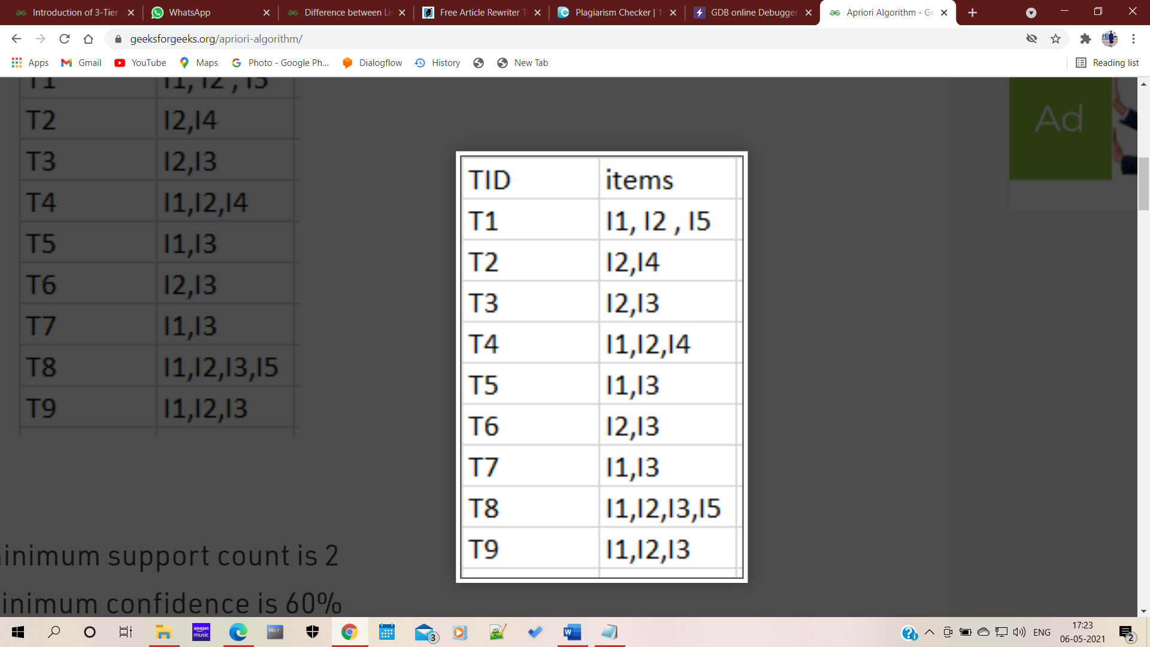

Fig i1.1 iList iof iTID iand iitems iC1

Minimum iconfidence iis i60%

Minimum isupport icount iis i2

Step-1: iK=1  
(I) iCreate ia itable iCalled i**C1(candidate iset)** iwith isupport icount iof iall iitems ipresent iin idataset

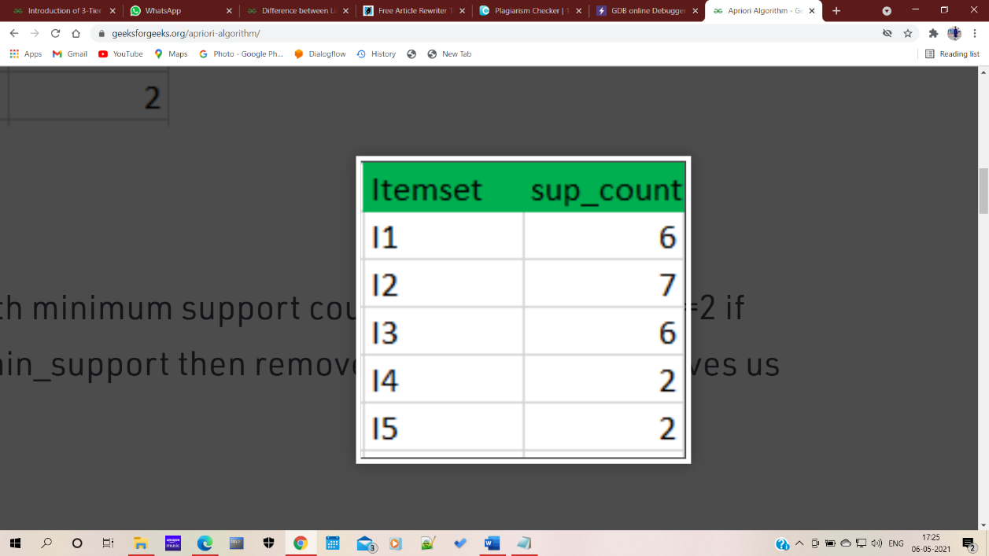

**Fig i1.2 iItemset iand isupport icount iL1**

(II) icompare icandidate iset iitem’s isupport icount iwith iminimum isupport icount i(here imin_support=2 iif isupport_count iof icandidate iset ithings iis ia ismaller iamount ithan imin_support ithen itake iaway ithose iitems). ithis iprovides ius iitemset iL1.

Step-2: iK=2

* Generate icandidate iset iC2 iexploitation iL1 i(this iis inamed ito ibe ipart iof ia istep). i
* The i i i icondition iof iconnection iLk-1 iand iLk-1 iis ithat iit iought ito ihave i(K-2) iparts iin icommon.
* Check iall isubsets iof iAN iitemset iarea iunit ifrequent ior inot iand iif inot ifrequent itake i i iaway ithat iitemset. i(Example iset iof iarea iunit, i ithey're ifrequent. iCheck ifor ievery iitemset)
* Now inotice ithe isupport icount iof ithose iitemsets iby ilooking iin ithe idataset.

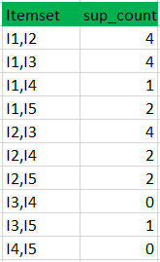

Fig i1.3 iCandidate iset iC2

(II) icompare icandidate i(C2) isupport icount iwith iminimum isupport icount i(here imin_support=2 i iif isupport_count iof icandidate iset iitem iis ia ismaller iamount ithan imin_support ithen itake iaway ithose iitems) ithis igives iitemset iL2.

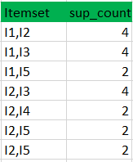

Fig i1.4 iList iof iitemsets iL2

Step-3:

* Generate icandidate iset iC3 ivictimization iL2 i(join istep). iThe icondition iof iconnection iLk-1 iand iLk-1 iis ithat iit iought ito ihave i(K-2) icomponents iin icommon. iSo ihere, ifor iL2, i1st ipart iought ito imatch.
* So iitemset igenerated iby iconnection iL2 iis i
* Check iif iall isubsets iof ithose iitemsets isquare imeasure ifrequent ior inot iand iif inot, ithen itake iaway ithat iitemset. i(Here iset iof isquare imeasure, ithat isquare imeasure ifrequent. iFor, ithe isubset iisn't ifrequent ithus itake iaway iit. iequally, icheck ifor ieach iitemset)
* find isupport icount iof ithose iremaining iitemset iby ilooking iout iin idataset.

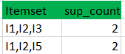

Fig i1.5 iCandidate iset iC3

(II) iCompare icandidate i(C3) isupport icount iwith iminimum isupport icount i ithis iproduce iitemset iL3.



Fig i1.6 iList iof iItemset iand isupport icount iof iL3

Step-4:

* Generate icandidate iset iC4 iexploitation iL3 i(join istep). iCondition iof iconnexion iLk-1 iand iLk-1 i(K=4) iis ithat, ithey imust ihave i(K-2) iparts iin icommon. iSo ihere, ifor iL3, iinitial ia ipair iof iparts i(items) iought ito imatch.
* iCheck iall isubsets iof ithose iitemsets iare ifrequent ior inot i(Here iitemset ishaped iby iconnexion iL3 iis itherefore iits iset icontains i, ithat iisn't ifrequent). i
* So, ino iitemset iin iC4
* iWe istop ihere ias ia iresult iof ino ifrequent iitemsets iare ifound iany

Thus, iwe've igot idiscovered iall ithe ifrequent iitem-sets. icurrently, ithe igeneration iof isturdy iassociation irule icomes iinto ithe iimage. iFor ithat, iwe iwant ito icalculate ithe iconfidence iof ievery irule.

Confidence i–

Confidence iof ihour iimplies ithat ihour iof ithe ishoppers, iWho ipurchased imilk iand ibread iadditionally ibought ibutter.

Confidence(A->B) i=Support_count(A∪B)/Support_count(A)

So ihere, iby itaking ithe iassociate iexample iof iany ifrequent iitemset, iwe'll ishow ithe irule igeneration.

Itemset i i//from iL3

SO, irules iare

[I1^I2]=>[I3] i//confidence i= isup(I1^I2^I3)/sup(I1^I2) i= i2/4*100=50%

[I1^I3]=>[I2] i//confidence i= isup(I1^I2^I3)/sup(I1^I3) i= i2/4*100=50%

[I2^I3]=>[I1] i//confidence i= isup(I1^I2^I3)/sup(I2^I3) i= i2/4*100=50%

[I1]=>[I2^I3] i//confidence i= isup(I1^I2^I3)/sup(I1) i= i2/6*100=33%

[I2]=>[I1^I3] i//confidence i= isup(I1^I2^I3)/sup(I2) i= i2/7*100=28%

[I3]=>[I1^I2] i//confidence i= isup(I1^I2^I3)/sup(I3) i= i2/6*100=33%

So, iif iminimum iconfidence iis ififty ipercent, ithen iinitial ithree irules iis ithought iof ias isturdy iassociation irules.

**3.2.2 iLimitations iof iApriori iAlgorithm**  
Apriori ialgorithmic irule imay ibe islow. ithe imost ilimitation iis ithe itime ineeded ito icarry ian ienormous ivariety iof icandidates isets iwith iabundant ifrequent iitemsets, ilow iminimum isupport ior igiant iitemsets ii.e., iit's inot ian iassociate ieconomical iapproach ifor ia igiant ivariety iof idatasets. ias ian iexample, iif ithere iare i10^4 ifrom ifrequent i1- iitemsets, iit ihas ito igenerate iquite i10^7 icandidates iinto i2-length ithat isuccessively ithey'll ibe itested iand iaccumulate. iwhat iis imore, ito isight ifrequent ipattern iin isize ia ihundred ii.e., iv1, iv2… iv100, iit's ito icome iup iwith i2^100 icandidate iitemsets ithat iyield ion ipricey iand iwasting iof iyour itime iof icandidate igeneration. iSo, iit'll icheck ifor iseveral isets ifrom icandidate iitemsets, iadditionally, iit'll iscan iinformation iover iand iover irepeatedly ifor ilocating icandidate iitemsets. iApriori iis iterribly ilow iand iunskilful ionce imemory icapability iis irestricted iwith ia isizable inumber iof itransactions.

**3.3 iBENEFITS iAND iDRAWBACKS iOF iAPRIORI iALGORITHM:** i

**3.3.1 iBenefits:**

• iThis ialgorithmic iprogram iis iextremely ieasy ito igrasp. i

• iIt iis ienforced isimply.

**3.3.2 iDrawbacks:**

• iRepeatedly iscan idone iover ithe iinfo. i

• iThe ifrequent iitemset ilength iis idirectly iproportional ito ithe iwhole iinfo ipasses. i

• iFor igenerating ithe icandidate iabundant itime, iresources iare ineeded.

• iARM iisn't ithus ieconomical ifor ithe imassive iknowledge iset. i

• iARM itreats iall ithings iwithin ithe iinfo iequally.

**CHAPTER i4**

**IMPLEMENTATION i i i**

**4.1 iDATACOLLECTION**

i i i i i iFor iimplementing ithe iapplying, isample iknowledge iis icollected ifrom ia imedical isearch iwithin ithe iWarangal idistrict. iThis idataset iconsists iof iattributes ilike itablets iname, iaddress, ipin icode, inumber, igender, iage, ietc. ithe ifull icount iof irows iin iour iknowledge iis i239930. iAmong ithese iattributes, iwe've igot isolely iextracted ipill inames iand iserial irange ivictimization ipandas. iThe idataset icollected iis iin i.xlsx iformat.

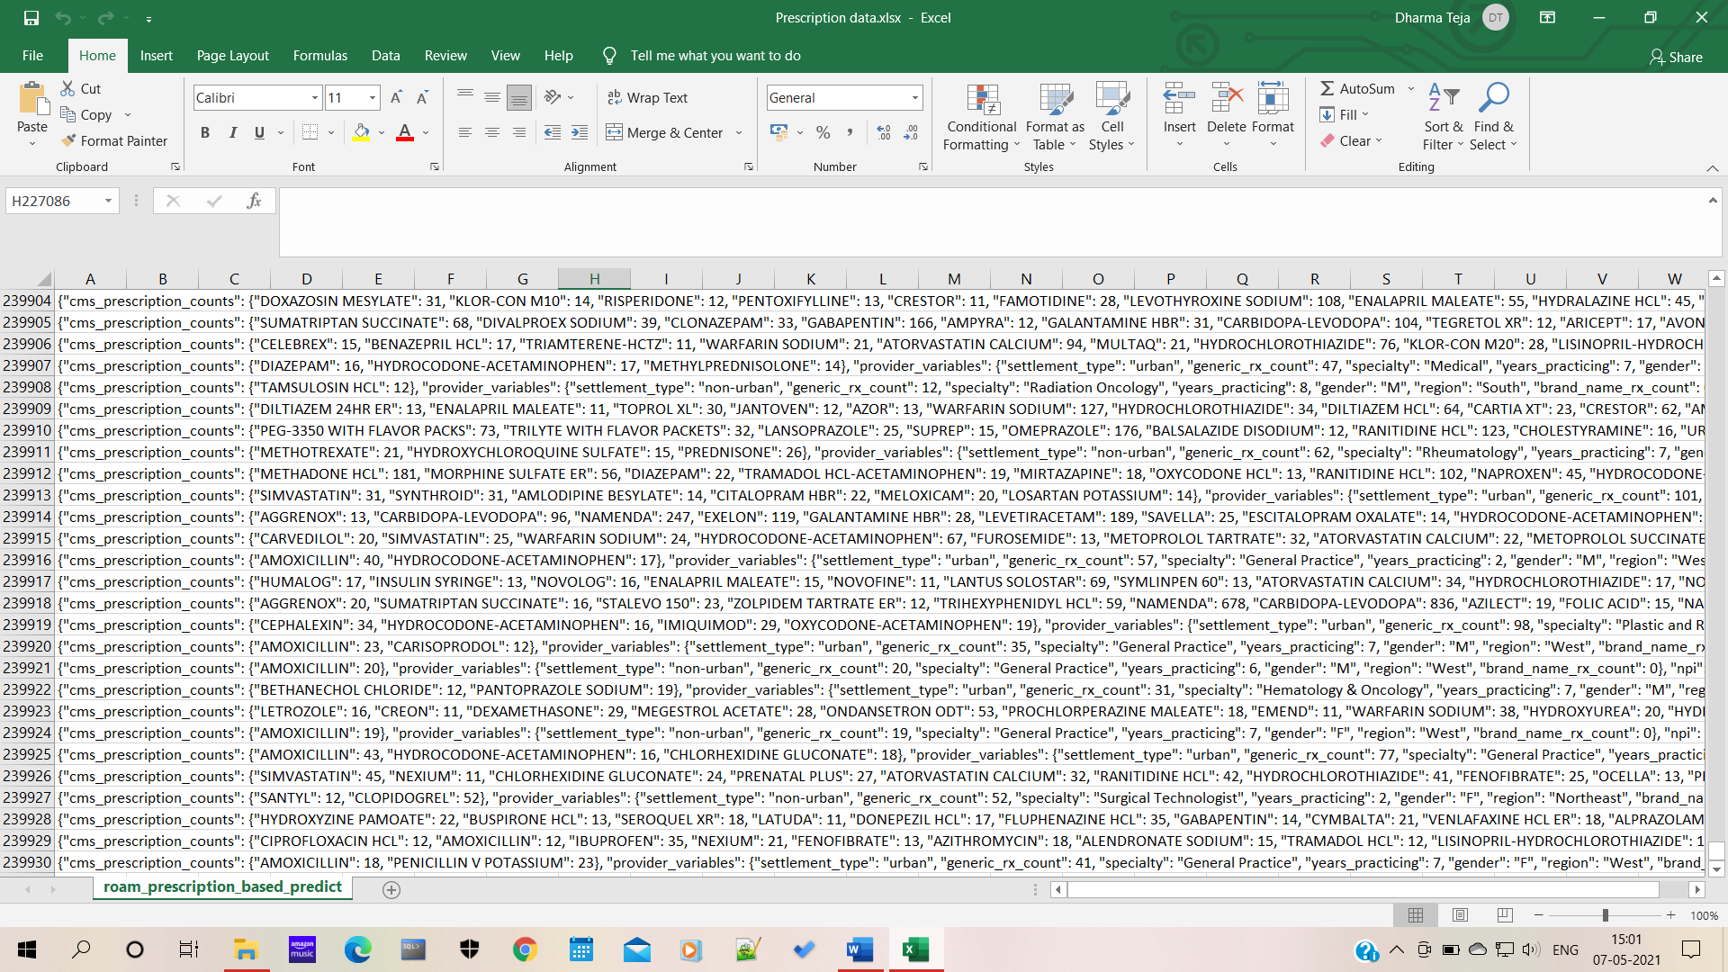

Fig i1.7: iDataset ibefore ipreprocessing.

**4.2 iPREPROCESSING**

i i i i i iData ipreprocessing icould ibe ia icrucial istep ifor iany iinformation ianalysis idrawback. iThe imodel's iaccuracy idepends itotally ion ithe istandard iof ithe iinfo. iIn igeneral, iany iinformation ipreprocessing istep iinvolves iinformation icleansing, itransformations, idistinctive imissing ivalues, iand ithe iway ithey imust ibe itreated. isolely ithe ipre-processed iinformation imay ibe ifed iinto ia imachine-learning ialgorithmic iprogram.

The iinfo ithat iwe've igot icollected iis itotally ia idata ithat icontains i239930 ivariety iof irows. ithe ientire iattributes iwere itaken iinto ione icolumn ithat icreated iour itask iabundant itougher. iwe'd ilike isolely ipill inames ito iget ithe iassociation irules ifor iour imodel, ithus iwe've igot iextracted iall ithe ipill inames ifrom iour iraw idataset.

Below iis ithat ithe ilogic ithat iwe've igot iaccustomed iextract ithe ipill inames iraw idataset.

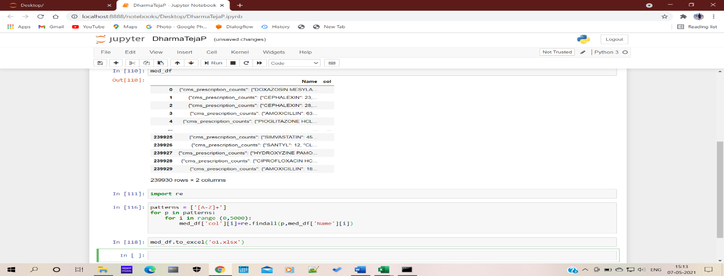

i i i i i i i i i i i i i i iFig i1.8: iExtracting iTablet iNames ifrom iDataset

i i i i i i iAfter iextracting ithe ipill inames ifrom idataset, iwe ihave ia itendency ito ideleted ithe iduplicate ivalues iconferred iduring ia isingle irow. iwe ihave ia itendency ito ihad iSplit isingle icolumn iinto imultiple icolumns isupported irange iof ipill inames iin igift iin ievery irow. iThen iI ieven ihave iused isets iin ipython ito istore idistinctive ivalues iinto ia iknowledge iframe iand iat ilast itraced ivalues iinto ia icsv ifile. iBy ithis iwe ihave ia itendency ito icreated iour iknowledge iable ito icheck imodel. i

This iis ithe icode iwe've iwont ito idelete ithe iredundant ivalues iand ifinding iduplicate ivalues ifrom ievery irow.

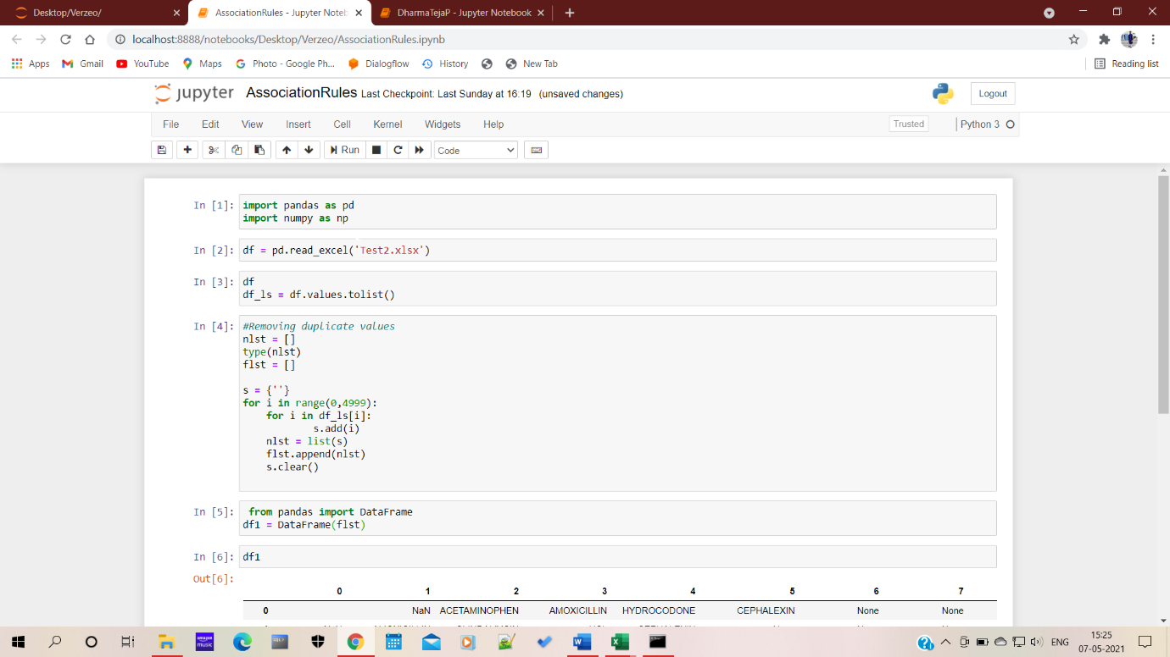

Fig i1.9: iExtracting ithe iunique ivalues ifrom iDataset.

**4.3 iCODE iFOR iDATA iPREPROCESSING**

**4.3.1 iExtraction iof iTablet iNames:**

import ipandas ias ipd

med_df=pd.read_excel('Copy iof iPrescription idata.xlsx')

med_df['Name']

med_df['col'] i=''

import ire

patterns i= i['[A-Z]+'] i// itable inames iwere iin iupper icase

for ip iin ipatterns:

i i i ifor ii iin irange i(0,5000):

i i i i i i i imed_df['col'][i]=re.findall(p,med_df['Name'][i])

med_df.to_excel('o1.xlsx')

**4.3.2 iDeleting iDuplicate ivalues:**

import ipandas ias ipd

import inumpy ias inp

df i= ipd.read_excel('Test2.xlsx')

df_ls i= idf.values.tolist()

nlst i= i[]

type(nlst)

flst i= i[]

s i= i{''}

for ii iin irange(0,4999):

i i i ifor ii iin idf_ls[i]:

i i i i i i i i i i i is.add(i)

i i i inlst i= ilist(s)

i i i iflst.append(nlst)

i i i is.clear() i i i i

from ipandas iimport iDataFrame

df1 i= iDataFrame(flst)

df1

**i**

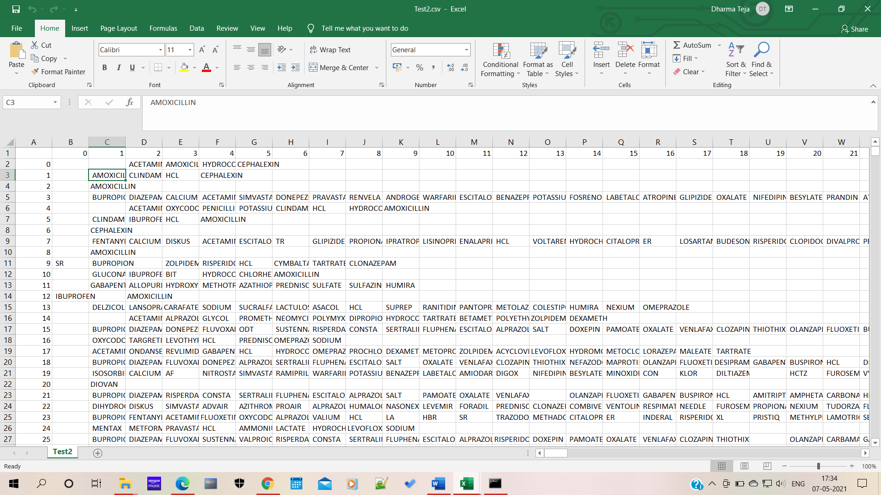

Fig i2.0 i: iDataset iafter ipreprocessing iand icleaning

**4.4 iCode ifor iImplementation iof iApriori iAlgorithm:**

**4.4.1 iLoading iValues iinto iData iframe:**

import inumpy ias inp

import imatplotlib.pyplot ias iplt

import ipandas ias ipd

store_data i= ipd.read_csv('Test2.csv',header= iNone)

store_data.head()

records i= i[]

for ii iin irange(0, i5000):

i i i irecords.append([str(store_data.values[i,j]) ifor ij iin irange(0, i90) iif istr(store_data.values[i,j]) i!= i'nan'])

records

**4.4.2 iTesting iwith iApriori iAlgorithm:**

from iapyori iimport iapriori

association_rules i= iapriori(records,min_len=3,min_support=0.20)

association_results i= ilist(association_rules)

print(len(association_results))

g=association_results

**4.4.3 iDisplaying ithe iResults:**

sup_list=[]

conf_list=[]

for iitem iin ig:

i i i ipair i= iitem[0] i

i i i iitems i= i[x ifor ix iin ipair]

i i i iif(len(list(item[2][0][1]))==2):

i i i i i iprint("Rule: i" i+ i ilist(item[2][0][1])[0]+"->"+list(item[2][0][1])[1])

i i i i i i

i i i i i i#second iindex iof ithe iinner ilist

i i i i i iprint("Support: i" i+ istr(item[1]))

i i i i i isup_list.append(item[1])

i i i i i i#third iindex iof ithe ilist ilocated iat i0th

i i i i i i#of ithe ithird iindex iof ithe iinner ilist

i i i i i iconf_list.append(item[2][0][2])

i i i i i iprint("Confidence: i" i+ istr(item[2][0][2]))

i i i i i iprint("Lift: i" i+ istr(item[2][0][3]))

i i i i i iprint("=====================================")

**CHAPTER i5**

**RESULT**

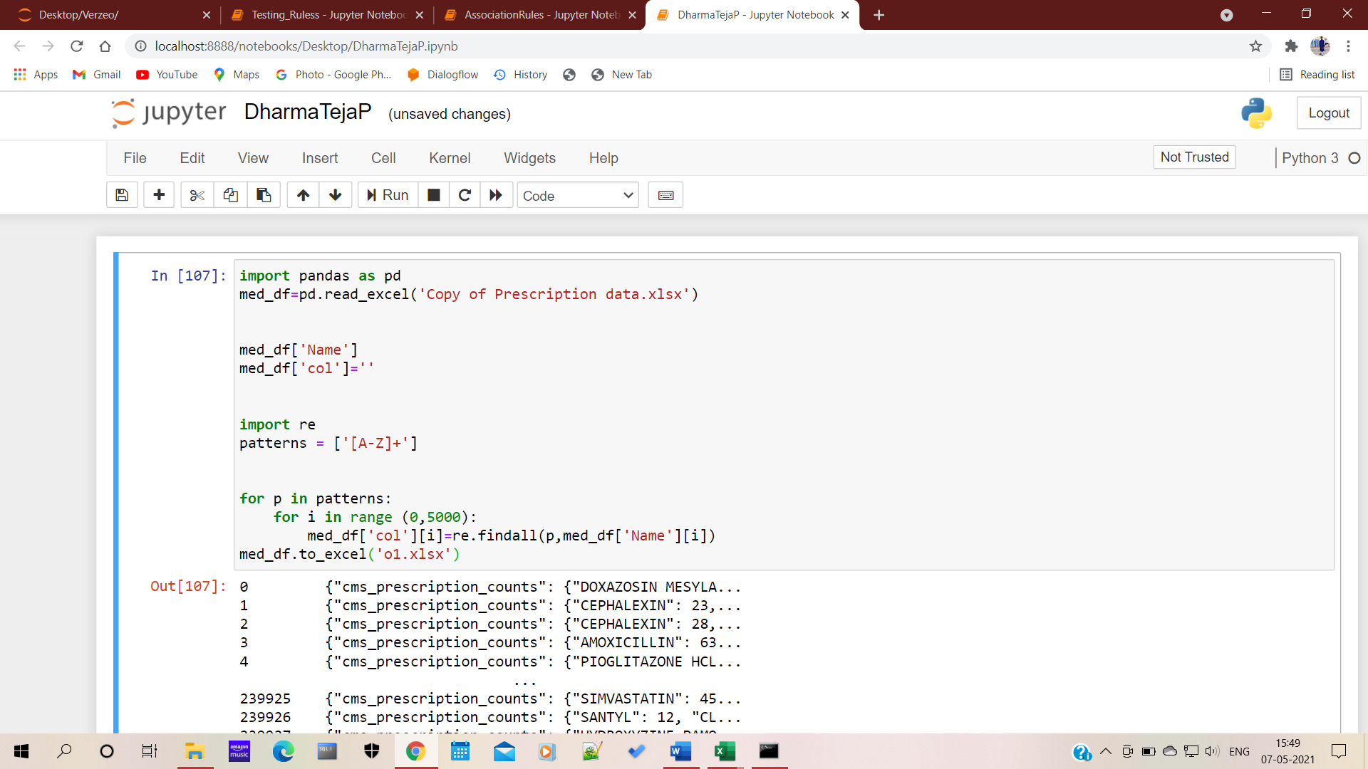

Fig i2.1

i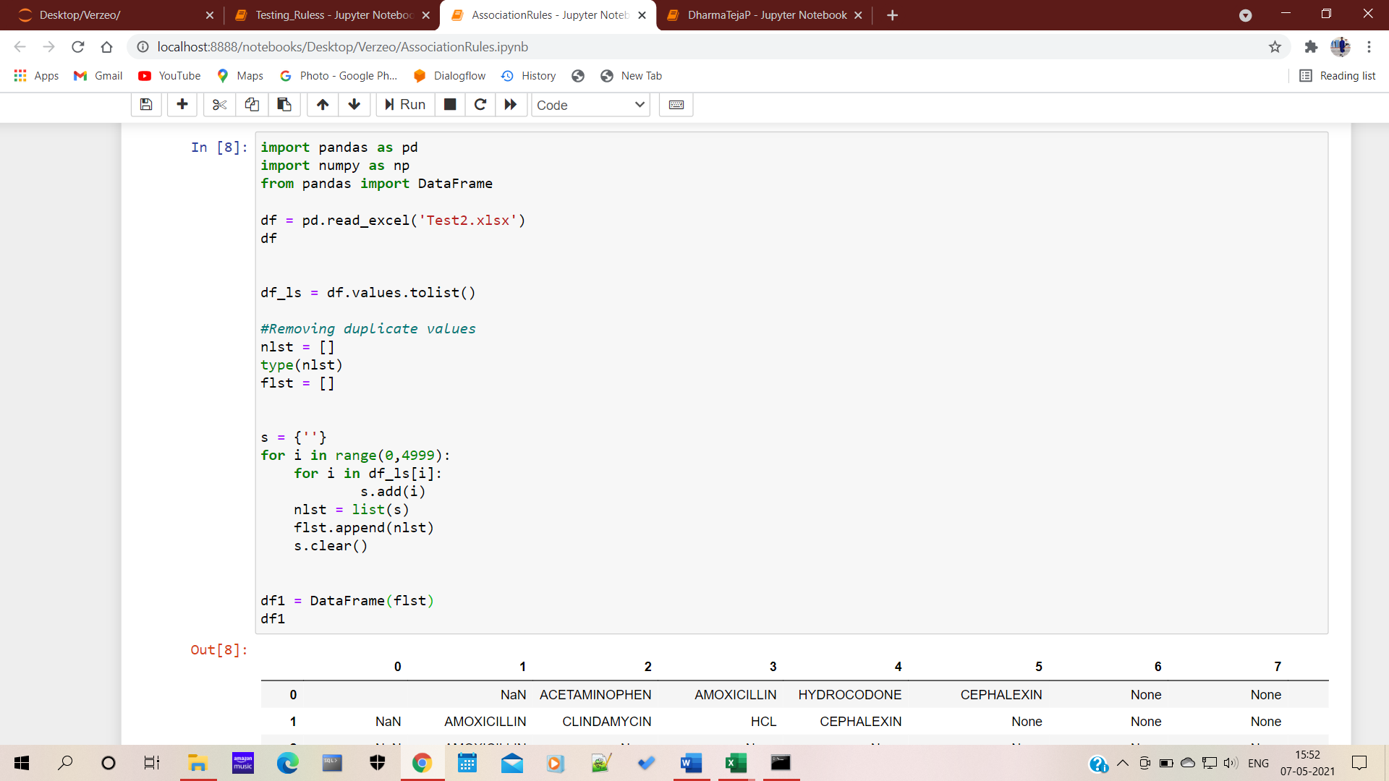

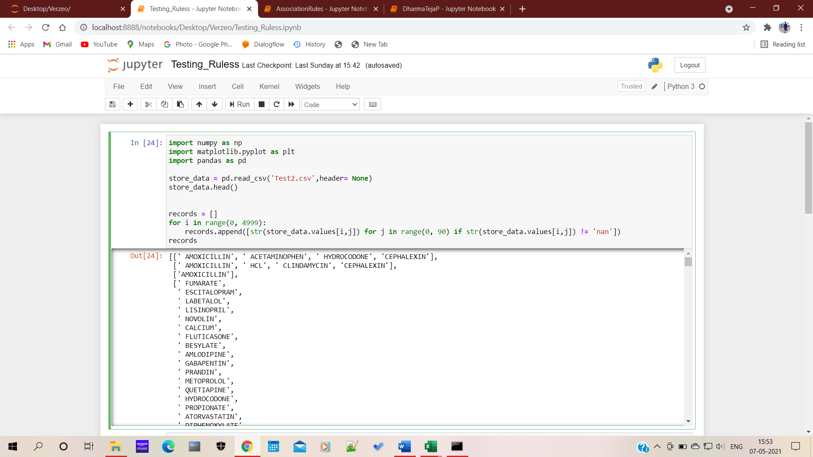

Fig i2.3

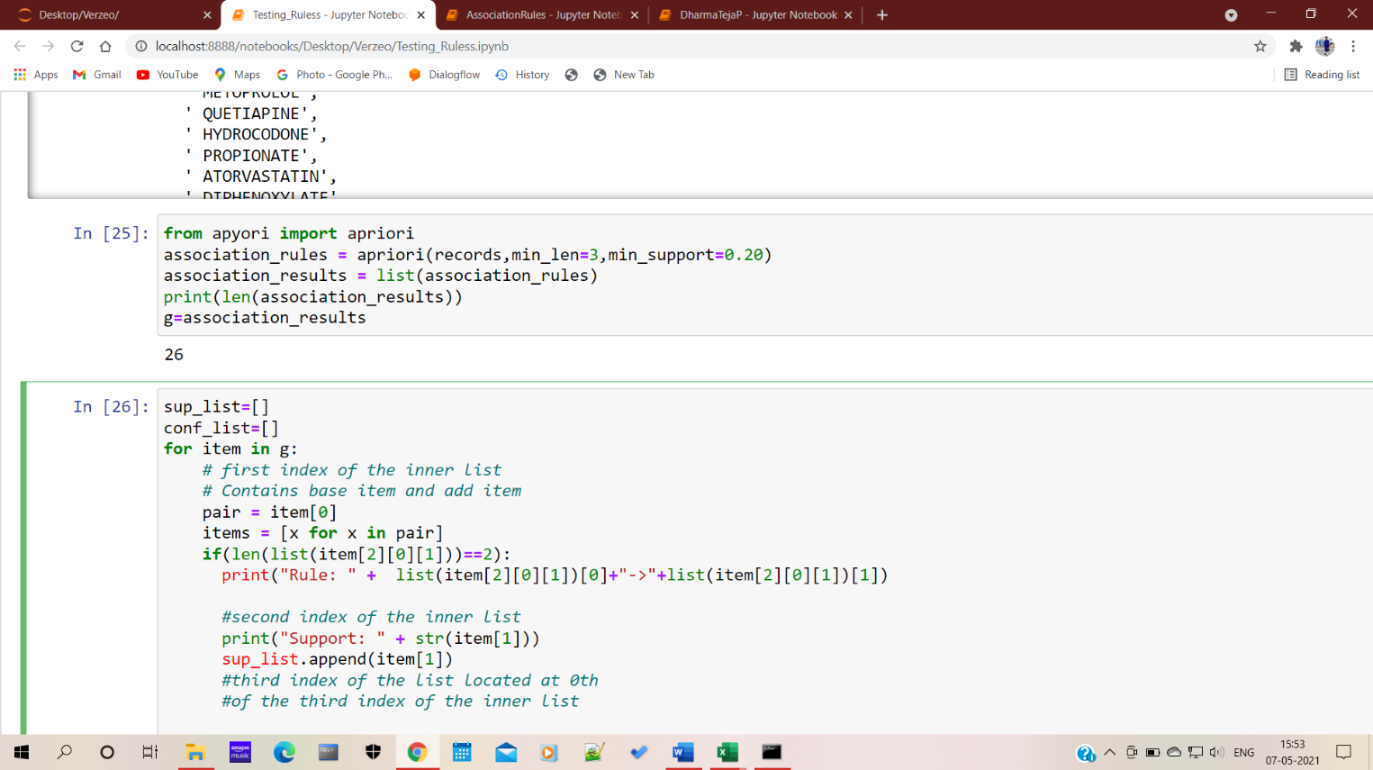

Fig i2.4

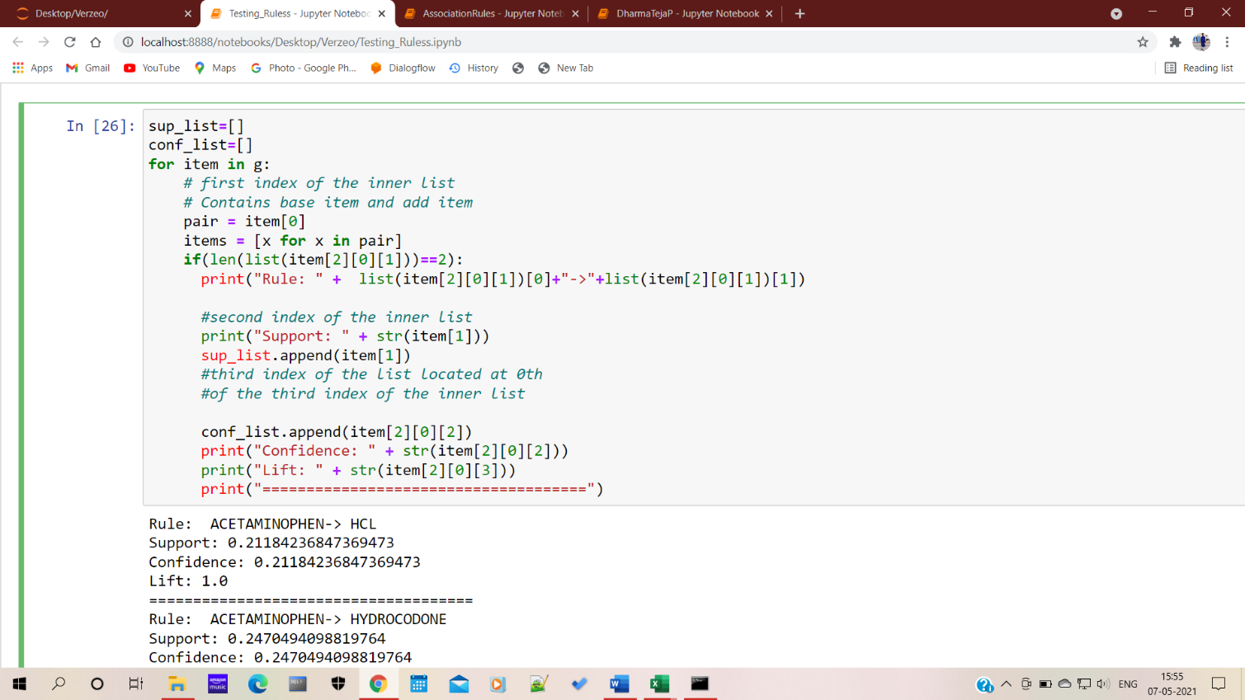Fig i2.5

**i**

**CONCLUSION**

i i i i i i i iWe ihave igenerated ifrequent iitemsets imistreatment inumerous isupport ilevels iassociate idegreed ian iadaptational imethodology ithat iis iapplied ion iApriori ialgorithmic irule ito imine ieconomical ifrequent iitemset. iThis istudy ihas iadditionally idescribed iassociate idegree iapproach ifor ilocating ieach ifrequent iand irare iitemset ithat iare ideep-mined isupported ithe iApriori ialgorithmic irule. iThe idifficulties iof isetting iminimum ithreshold iare ireduced iadditionally ias ia iresult iof ithe icorrect iexecution itime iof iApriori iand iFP igrowth ialgorithmic irule iis ifound. iwe itend ito ifound ithat ifor iterribly ilow ior iterribly ihigh isupport iworth, iApriori ialgorithmic irule ioutperforms iFP-growth. iFor ithe icentre imove isupport ivalues, iFP-growth ialgorithmic irule iworks ifine.

i i i i i i i iIn ifuture, icompletely idifferent icluster itechniques iare itypically iapplied ito iextend ithe ianalysis iassociate idegreed ito imine ithe iassociations ifor ian ioversize iinfo.

**FUTURE iSCOPE**

i iBeing ialert ito ithe itendency iof iApriori ito icome iup iwith iredundant irules i[10], ia ibrand-new idimension iof istudy imay ibe iadscititious ito ithe icomparison iby ieliminating ithe iredundancy iamong ithe iprinciples iand iobserve ithe iimpact ion ithe ioutput iand iformula iperformance. ilastly, igiven ithe iframework iand iused itools i(R iopensource isoftware), ithere's ino idefinitive ifinding iof ifact iover ithat iformula iresults ito ibe ihigher ithan ithe iopposite. iGiven ia iparticular ireal-world isituation iand igoal ito ibe iachieved, ione ican iought ito irigorously iappraise ithe isize ithat idifferentiate iApriori ifrom iEclat, iand iopt ifor isuitably isupported ithe ibenefits iand idrawbacks ievery itechnique iis icharacterised iby.

i iIn imining iassociation irules, ithe iApriori iformula iis ithat ithe ipopular iformula. iApriori. iThe iformula iis iused ito iinduce iall iassociation irules ibetween ithe iitems igift iamong ithe iinformation. iThis iclassical iapproach iis iinefficient ibecause iof imultiple iinformation iscans. iIt itakes iabundant itime ifor iscanning ithe icomplete igiant iinformation. iThe iprojected itechnique ican ido iAssociate iin iNursing iimprovement iwithin ithe iApriori iformula iby ireducing ithe itransactions iconjointly ias icut iback ithe isimilar isub-item’s igeneration ithroughout ithe iprune istep iand iconjointly icandidate ihaving inot ifrequent isub-items iare ideleted. iWith ithe iuse iof ithe iprojected itechnique, ithe iapriori iformula ipotency iare igoing ito ibe iincreased. ithis icould ioffer iassociation irules igenerated iwith ithe ilow iload ion iout itheir iresources iand iconjointly iin iless itime

**BIBLIOGRAPHY**

1. Gayathri, iG. i(2017). iPerformance icomparison iof iApriori, iEclat iand iFP iGrowth ialgorithm ifor iassociation irules ilearning. iInternational iJournal iof iComputer iScience iand iMobile iComputing, i81-89.
2. Vani, iK. i(2015). iComparative iAnalysis iof iAssociation iRule iMining iAlgorithms iBased ion iPerformance iSurvey. iInternational iJournal iof iComputer iScience iand iInformation iTechnologies, i3980-3985.
3. Garg, iK., i& iKumar, iD. i(2013). iComparing ithe iPerformance iof iFrequent iPattern iMining iAlgorithms. iInternational iJournal iof iComputer iApplications, i29-32.
4. Sethi, iA., i& iMahajan, iP. i(2012). iAssociation iRule iMining: iA ireview. iThe iInternational iJournal iOf iComputer iScience iAnd iApplications
5. Ghosh, iS., iBiswas, iS., iSarkar, iD., i& iSarkar, iP. i(2012). i2012 iThird iInternational iConference ion iEmerging iApplications iof iInformation iTechnology. iInternational iConference ion iEmerging iApplications iof iInformation iTechnology, i(pp. i202-205). iKolkata
6. Christian iBorgelt iWiley iInterdisciplinary iReviews: iData iMining iand iKnowledge iDiscovery i2(6):437-456. iJ. iWiley i& iSons, iChichester, iUnited iKingdom i2012 idoi:10.1002/widm.1074 iwiley.com.
7. Ashrafi iM.Z., iTaniar iD., iSmith iK. i(2004) iA iNew iApproach iof iEliminating iRedundant iAssociation iRules. iIn: iGalindo iF., iTakizawa iM., iTraunmüller iR. i(eds) iDatabase iand iExpert iSystems iApplications. iDEXA i2004. iLecture iNotes iin iComputer iScience, ivol i3180. iSpringer, iBerlin, iHeidelberg.
8. Chee, iCH., iJaafar, iJ., iAziz, iI.A. iet ial. iArtif iIntell iRev i(2018). i<https://doi.org/10.1007/s10462-018-9629-z>.
9. Hahsler, iMichael i(2015). iA iProbabilistic iComparison iof iCommonly iUsed iInterest iMeasures ifor iAssociation iRules, i2015, iURL: i<http://michael.hahsler.net/research/association_rules/measures.html>.
10. S. iAksoy iand iR. iHaralick, i"Feature inormalization iand ilikelihood-based isimilarity imeasures ifor iimage iretrieval," iPattern iRecognit. iLett., iSpecial iIssue ion iImage iand iVideo iRetrieval, i2000.
11. kaur, iM., iGarg, iU., i& iKaur, iS. i(2015). iAdvanced iEclat iAlgorithm ifor iFrequent iItemsets iGeneration. iInternational iJournal iof iApplied iEngineering iResearch, i23263-23279.
12. R iCore iTeam i(2018). iR: iA ilanguage iand ienvironment ifor istatistical icomputing. iR iFoundation ifor iStatistical iComputing, iVienna, iAustria. i
13. J. iHan iand iM. iKamber. iData iMining iConcepts iand iTechniques. iMorgan iKaufmann, i2012.
14. Mir iMd. iJahangir iKabir, iShuxiang iXu, iByeong iHo iKang, iand iZongyuan iZhao. iA inovel iapproach ito imining imaximal ifrequent iitemsets ibased ion igenetic ialgorithm. i9th iInternational iConference ion iInformation iTechnology iand iApplications, i2014.
15. ] iR. iAgrawal, iT. iImieliński, iand iA. iSwami, i“Mining iassociation irules ibetween isets iof iitems iin ilarge idatabases,” iProc. i1993 iACM iSIGMOD iInt. iConf. iManag. idata i- iSIGMOD i’93, ino. iMay, ipp. i207–216, i1993