Docker Notes:

Before Docker the deployment process:

Deploying an application on a physical server involves a series of steps to ensure the server is properly configured and the application runs smoothly. Here’s a simplified outline of the process:

**1. Prepare the Physical Server**

* **Hardware Setup**: Ensure the physical server is set up and connected to the network.
* **Operating System Installation**: Install the operating system (e.g., Linux, Windows Server) on the server.
* **Network Configuration**: Configure network settings, including IP address, DNS, and firewall rules.

**2. Server Configuration**

* **User Accounts**: Create user accounts and set appropriate permissions.
* **Security Setup**: Install and configure security measures such as antivirus software, intrusion detection systems, and firewalls.
* **System Updates**: Install the latest updates and patches for the operating system and essential software.

**3. Environment Setup**

* **Install Dependencies**: Install required software dependencies (e.g., runtime environments, libraries, frameworks).
  + **For web applications**: Install web server software (e.g., Apache, Nginx) and database systems (e.g., MySQL, PostgreSQL).
  + **For language-specific applications**: Install language runtimes (e.g., JDK for Java, Python, Node.js).

**4. Application Deployment**

* **Transfer Files**: Transfer application files to the server using secure methods like SCP, SFTP, or rsync.
* **Configuration Files**: Configure application-specific settings, usually via configuration files or environment variables.
* **Database Setup**:
  + **Schema Creation**: Create and configure databases and schemas.
  + **Data Migration**: Migrate any necessary data to the database.

**5. Service Configuration**

* **Start Application Services**: Start the application services, which may include web servers, application servers, and background services.
* **Configure Service Management**: Set up system service managers (e.g., systemd, init.d) to manage application processes, ensuring they start on boot and can be easily managed.

**6. Testing and Validation**

* **Smoke Testing**: Perform basic tests to ensure the application is running and accessible.
* **Functional Testing**: Conduct more thorough testing to validate application functionality and performance.
* **Monitoring Setup**: Install and configure monitoring tools to track application performance and server health.

**7. Maintenance and Updates**

* **Regular Updates**: Apply updates to the operating system, dependencies, and the application itself regularly.
* **Backup Solutions**: Implement backup solutions to regularly back up application data and configurations.
* **Performance Tuning**: Periodically review and optimize server performance and resource usage.

**Summary**

Deploying an application on a physical server involves setting up the hardware and operating system, configuring the environment, deploying the application, and ensuring everything runs smoothly through testing and monitoring. This process can be time-consuming and requires careful attention to detail to avoid downtime and ensure security and performance.

## Physical servers

* Physical servers are the traditional approach to hosting applications. They are physical machines dedicated to running specific workloads.
* Physical servers offer several benefits. They provide direct access to hardware resources, resulting in better performance and lower latency.
* They also provide more control over the infrastructure since there is no virtualization layer involved.

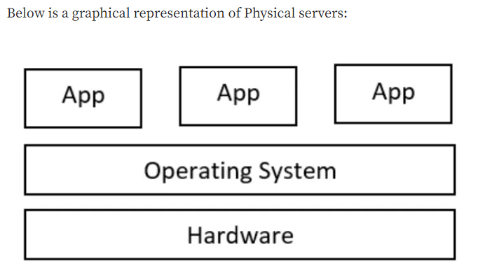

**Deploying applications on physical servers comes with several challenges** that can complicate the process and increase costs.

Here are the key challenges:

**1. Resource Utilization**

* **Underutilization**: Physical servers are often underutilized, leading to wasted resources and higher costs.
* **Overprovisioning**: To avoid underutilization, companies may overprovision resources, which is also inefficient.

**2. Scalability**

* **Hardware Limitations**: Scaling up requires purchasing and installing additional physical hardware, which is time-consuming and costly.
* **Downtime**: Scaling operations often require server downtime, affecting application availability.

**3. Configuration Management**

* **Manual Configuration**: Initial setup and ongoing configuration of servers are often manual processes, prone to human error.
* **Consistency**: Ensuring consistent configurations across multiple servers is challenging and can lead to discrepancies.

**4. Deployment Speed**

* **Slow Provisioning**: Setting up and provisioning new physical servers is slow compared to virtual machines or containers.
* **Complex Deployment Processes**: Deployments involve many manual steps, increasing the risk of errors and delays.

**5. Maintenance**

* **Hardware Failures**: Physical servers are susceptible to hardware failures, which require on-site repairs or replacements.
* **Software Updates**: Applying software updates and patches is a manual and time-consuming process.

**6. Cost**

* **High Capital Expenditure**: Purchasing physical servers involves significant upfront costs.
* **Operational Costs**: Ongoing costs for power, cooling, and physical space add to the total cost of ownership.

**7. Disaster Recovery**

* **Complex Backup Solutions**: Implementing reliable backup solutions is complex and costly.
* **Recovery Time**: Restoring data and applications after a failure can take a long time, affecting business continuity.

**8. Flexibility**

* **Limited Flexibility**: Physical servers are less flexible in adapting to changing workloads and demands compared to virtualized environments.

**9. Security**

* **Physical Security**: Ensuring the physical security of servers requires additional measures and controls.
* **Access Control**: Managing and securing access to physical servers can be more challenging than managing virtual environments.

**Summary**

Deploying applications on physical servers presents challenges related to resource utilization, scalability, configuration management, deployment speed, maintenance, cost, disaster recovery, flexibility, and security. These challenges can make physical server deployment more complex, time-consuming, and costly compared to virtualized or containerized environments**.**

**Deploying in Virtual machines process :**

Deploying an application on virtual machines (VMs) offers several advantages over physical servers but still involves a structured process.

Here's a step-by-step outline of how to deploy an application on VMs, along with some associated challenges and benefits:

**Steps to Deploy an Application on Virtual Machines**

1. **Prepare the Physical Host**
   * **Hardware Setup**: Ensure that the physical host machine is set up and connected to the network.
   * **Install Hypervisor**: Install a hypervisor (e.g., VMware ESXi, Microsoft Hyper-V, KVM) on the physical host to manage VMs.
2. **Create Virtual Machines**
   * **VM Provisioning**: Create one or more VMs using the hypervisor. Allocate appropriate CPU, memory, storage, and network resources to each VM.
   * **Install Operating System**: Install the desired operating system on each VM.
3. **Configure VMs**
   * **Network Configuration**: Set up networking for each VM, including IP addresses, DNS, and firewall rules.
   * **User Accounts and Security**: Create user accounts and configure security settings on each VM.
4. **Install Dependencies**
   * **Environment Setup**: Install all necessary software dependencies, such as runtime environments (Java, .NET, Python), web servers (Apache, Nginx), and database systems (MySQL, PostgreSQL).
   * **Library Management**: Use package managers (apt, yum, pip, npm) to install required libraries and tools.
5. **Deploy the Application**
   * **Transfer Application Files**: Upload application files to the VMs using secure methods (SCP, SFTP).
   * **Configuration**: Configure the application by setting up environment variables, configuration files, and database connections.
6. **Service Configuration**
   * **Start Application Services**: Launch the application services and ensure they are running correctly.
   * **Service Management**: Configure system service managers (systemd, init.d) to manage application processes, ensuring they start on boot and can be easily controlled.
7. **Testing and Validation**
   * **Smoke Testing**: Perform initial testing to ensure the application is running and accessible.
   * **Functional and Performance Testing**: Conduct more thorough tests to validate application functionality, performance, and stability.
8. **Monitoring and Maintenance**
   * **Monitoring Tools**: Set up monitoring tools (Nagios, Prometheus) to track application performance and VM health.
   * **Regular Updates**: Keep the OS, dependencies, and application updated with the latest patches and releases.
   * **Backup Solutions**: Implement regular backups of the VMs and application data.

**Benefits of Deploying on Virtual Machines**

1. **Resource Utilization**: Better utilization of hardware resources by running multiple VMs on a single physical server.
2. **Scalability**: Easier to scale applications by adding or cloning VMs.
3. **Isolation**: Each VM is isolated, reducing the risk of conflicts between applications.
4. **Flexibility**: VMs can be easily created, modified, and moved across different physical hosts.
5. **Disaster Recovery**: Simplified disaster recovery with VM snapshots and backups.

**Challenges of Deploying on Virtual Machines**

1. **Resource Overhead**: Each VM includes a full OS instance, leading to some resource overhead compared to **containers**.
2. **Management Complexity**: Managing multiple VMs can become complex, requiring robust management tools and practices.
3. **Performance**: VMs may not offer the same level of performance as physical servers due to the overhead of virtualization.
4. **Cost**: Licensing costs for hypervisors and potential additional hardware costs for physical hosts.

**Summary**

Deploying applications on virtual machines involves creating and configuring VMs, installing necessary software, deploying the application, and ensuring proper monitoring and maintenance. While VMs offer better resource utilization, scalability, and isolation compared to physical servers, they also introduce some resource overhead and management complexity. Nonetheless, VMs provide a flexible and efficient environment for deploying applications, particularly in dynamic and scalable IT environments.

## **Virtual Machines**

* Virtual machines are emulations of physical computers that run on top of a hypervisor.
* Each virtual machine operates as a self-contained system with its own operating system and resources.
* VMs provide strong isolation between workloads, ensuring that applications do not interfere with each other.
* They also offer flexibility in terms of resource allocation and scalability.
* Virtual machines can be easily provisioned and managed, allowing for dynamic scaling based on workload demands.

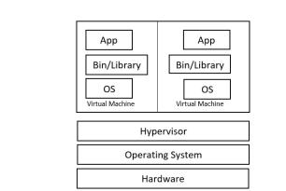

**Container** :

* A **container** is a lightweight, portable unit that packages an application and its dependencies together, ensuring it runs consistently across different environments.
* Unlike virtual machines (VMs), which include a full operating system, containers share the host system's OS kernel but operate in isolated user spaces. This makes containers more efficient and faster to start up.

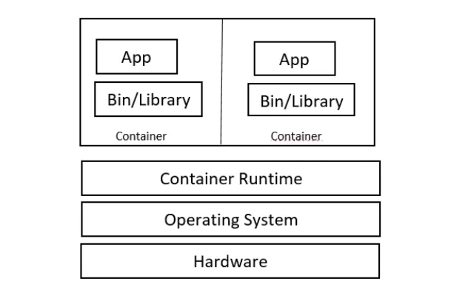

Containers solve several problems that arise in traditional application deployment and management scenarios. Here are the key problems that containers address:

1. **Dependency Management**:
   * **Problem**: Applications often require specific versions of libraries, frameworks, and runtime environments. Managing these dependencies manually can lead to compatibility issues and conflicts.
   * **Solution**: Containers package applications with all their dependencies, ensuring that they run consistently regardless of the environment.
2. **Environment Consistency**:
   * **Problem**: Developers face challenges in ensuring that applications behave the same way in different environments (development, testing, production).
   * **Solution**: Containers provide a consistent runtime environment, reducing the "it works on my machine" problem and improving reliability during deployment.
3. **Resource Utilization**:
   * **Problem**: Virtual machines (VMs) often require significant overhead in terms of memory, storage, and CPU resources due to the inclusion of full operating systems.
   * **Solution**: Containers share the host operating system's kernel, leading to more efficient resource utilization and allowing for higher density of applications on the same hardware.
4. **Deployment Speed**:
   * **Problem**: Traditional deployment methods can be slow and cumbersome, involving manual configuration and setup.
   * **Solution**: Containers streamline deployment processes by encapsulating applications and their dependencies into portable units that can be quickly started and stopped.
5. **Scalability**:
   * **Problem**: Scaling applications vertically (adding more resources to a single instance) or horizontally (adding more instances) can be complex and time-consuming.
   * **Solution**: Containers simplify scaling by allowing applications to be replicated and managed easily across multiple containers, either on the same host or distributed across a cluster.
6. **Isolation and Security**:
   * **Problem**: Running multiple applications on the same host can lead to security vulnerabilities and conflicts.
   * **Solution**: Containers provide lightweight isolation, ensuring that each application runs in its own secure environment without affecting others.
7. **Microservices Architecture**:
   * **Problem**: Monolithic applications can be difficult to maintain, update, and scale as they grow larger.
   * **Solution**: Containers are well-suited for microservices architectures, where applications are broken down into smaller, independent services that can be developed, deployed, and scaled independently.
8. **DevOps Practices**:
   * **Problem**: Traditional development and operations practices can create silos and slow down the release cycle.
   * **Solution**: Containers promote DevOps practices by enabling consistent environments for development, testing, and production, and facilitating continuous integration and continuous deployment (CI/CD) pipelines.

**Summary**

Containers solve problems related to dependency management, environment consistency, resource utilization, deployment speed, scalability, isolation and security, microservices architecture, and enablement of DevOps practices. These benefits make containers a valuable technology for modern application development and deployment workflows.