Report on
Exploratory Data Analysis



Submitted to
Department of Computer Science and Engineering
Nepal Engineering College

in Partial Fulfillment of the
Requirements for the Degree of B.E. in Computer

Submitted By
Lemphung Sherma (023-332)
Dhermadev Chai (023-348)
Nirab Subedi (023-341)

Supervised By: Harimohan Khatri
Submission Date: 16/08/2026

Exploratory Data Analysis (EDA) Report
Comment Classification Dataset
Final EDA of the combined comment-classification data

1. Introduction
This report presents an Exploratory Data Analysis of a comment-classification dataset. The analysis examines the structure and quality of the data, class distribution, comment length, duplicate records, and relationships among the classification labels. The findings are intended to support the preprocessing and machine-learning stages of the project.

2. Dataset Overview
The final dataset contains 7,171 unique comments after basic cleaning. The data includes five classification categories: Neutral, Hate Speech, Threatening, Offensive, and Harassment.
Dataset | Comments
nirab_ds | 2,895
sherma_ds | 2,181
dharm_ds | 2,095
Total | 7,171

3. Data Cleaning
Empty comment entries were removed before analysis. Exact duplicate comment texts were also removed. The combined data contained 9,714 records before duplicate removal, and 2,543 exact duplicates were removed, leaving 7,171 unique comments.
Blank values in the classification indicator columns were treated as zero for the analysis. These cleaning steps reduce redundancy and improve the reliability of the exploratory analysis.

4. Dataset Structure
Feature | Description
Comments | Comment text
neutral | Neutral indicator
hate_speech | Hate speech indicator
threatning | Threatening indicator
offensive | Offensive indicator
harassment | Harassment indicator
label | Derived class label
source | Dataset identifier
word_count | Number of words
char_count | Number of characters

5. Class Distribution
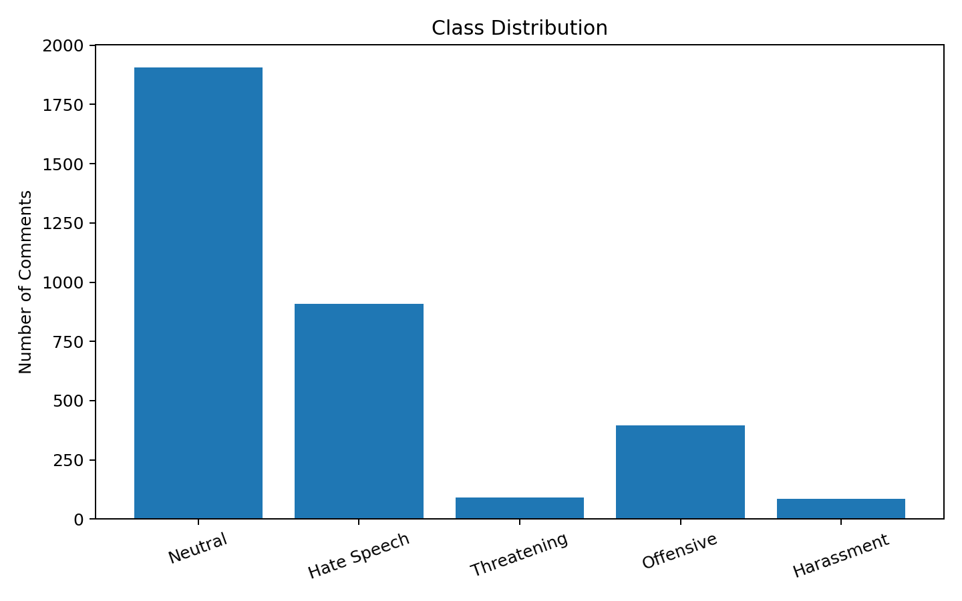
Neutral: 1,906 (26.58%)
Hate Speech: 908 (12.66%)
Threatening: 91 (1.27%)
Offensive: 395 (5.51%)
Harassment: 87 (1.21%)
The most frequent category is Neutral, while Harassment is the least frequent. The unequal class distribution indicates that class imbalance should be considered when training and evaluating a classification model.

6. Text Length Analysis
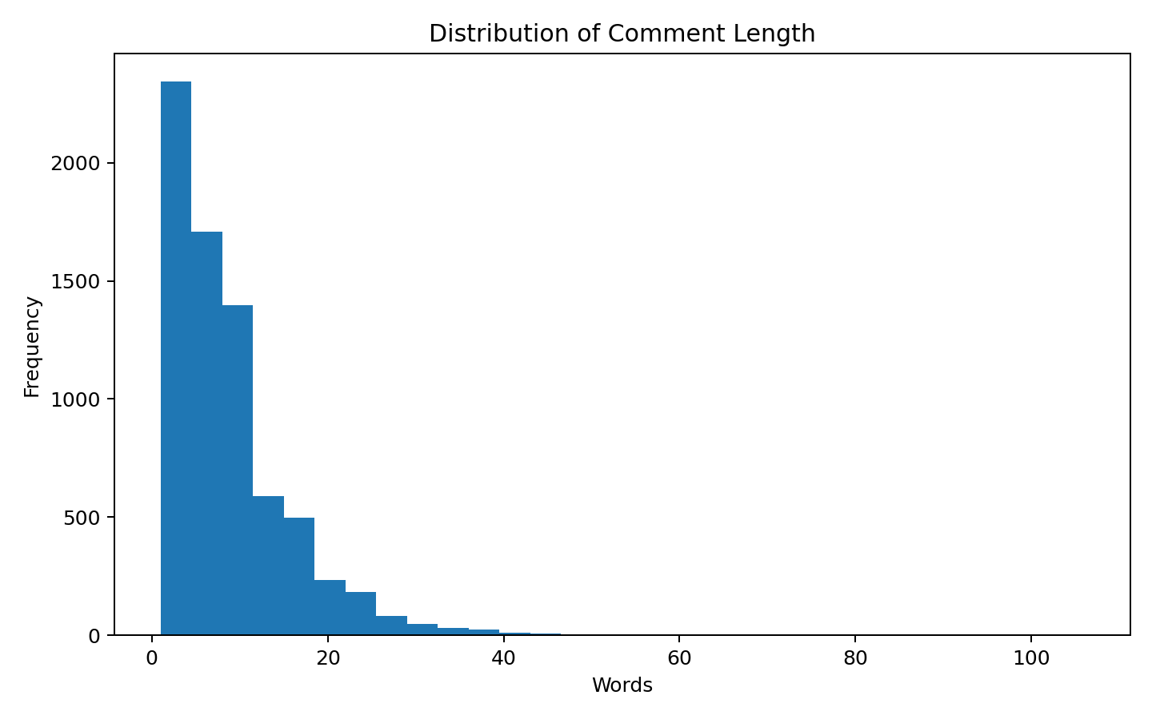
The average comment contains 8.53 words, with a median of 7 words. The average number of characters is 50.27, and the longest comment contains 106 words.
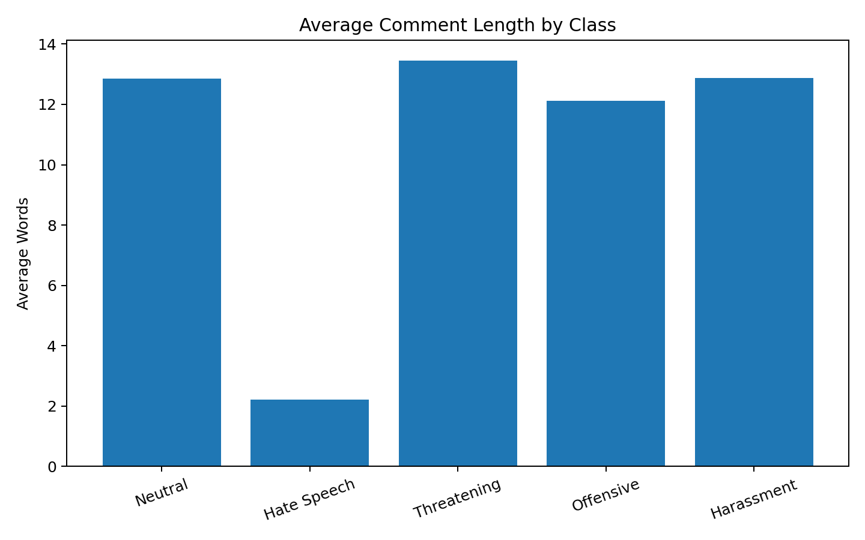
Average comment length varies across categories. Comment length may provide supporting information for classification, but it should not be considered a standalone indicator of the class.

7. Dataset Distribution
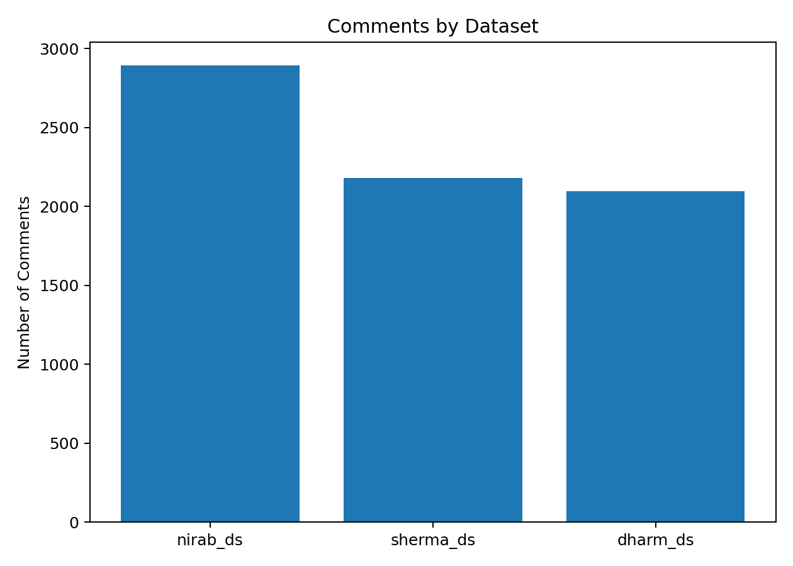
The chart shows the number of records represented by each dataset in the final analysis. This provides a clear view of the contribution of each source to the combined dataset.

8. Correlation Analysis
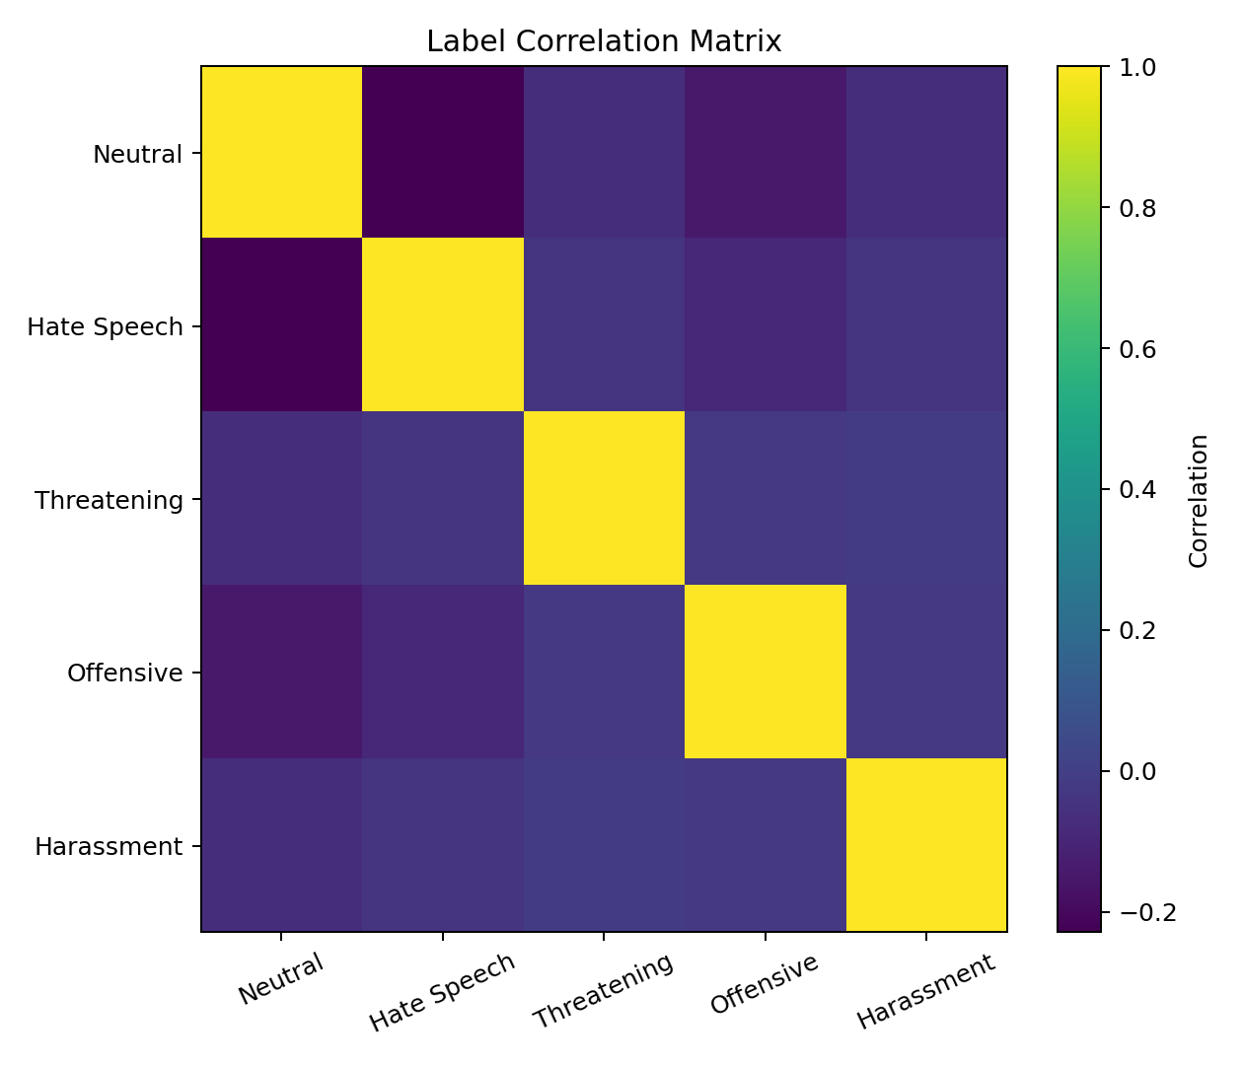
The correlation matrix shows relationships among the binary classification indicators. Positive relationships may indicate that certain labels occur together, while negative relationships suggest that the corresponding categories tend to occur separately.

9. Key Findings
- The final analysis contains 7,171 unique comments from all three datasets.
- Neutral is the most common class (26.58%).
- Harassment is the least common class (1.21%).
- 2,543 duplicate comment texts were removed during cleaning.
- The median comment length is 7 words.
- Class imbalance should be considered during model training and evaluation.

10. Recommended Preprocessing
- Remove duplicate comments before splitting the dataset.
- Normalize and clean the text while preserving meaningful language information.
- Handle URLs, usernames, punctuation, and repeated characters according to the NLP method.
- Use stratified train, validation, and test splits.
- Consider class weighting or resampling for underrepresented categories.
- Use precision, recall, F1-score, and a confusion matrix in addition to accuracy.

11. Conclusion
The EDA provides an overview of 7,171 unique comments across the three datasets. The analysis identifies the main class distribution, text-length characteristics, duplicate records, and relationships among labels. These findings provide a foundation for text preprocessing, feature extraction, model training, and evaluation.

12. Python Code Used
import pandas as pd
# Load the three sheets
nirab = pd.read_excel("comment_classification.xlsx", sheet_name="nirab_ds")
sherma = pd.read_excel("comment_classification.xlsx", sheet_name="sherma_ds")
dharm = pd.read_excel("comment_classification.xlsx", sheet_name="dharm_ds")
# Combine the data for EDA
df = pd.concat([nirab, sherma, dharm], ignore_index=True)
# Remove empty comments and exact duplicates
df["Comments"] = df["Comments"].fillna("").astype(str).str.strip()
df = df[df["Comments"] != ""]
df = df.drop_duplicates(subset=["Comments"])
# Text features
df["word_count"] = df["Comments"].str.split().str.len()
df["char_count"] = df["Comments"].str.len()
# Basic EDA
print(df.shape)
print(df.isnull().sum())
print(df.duplicated().sum())
print(df["word_count"].describe())

