# Use Wikipedia As A Data Source To Prepare Power BI Report

**Example**

In this example, we will prepare a report of the largest selling pharma products. We will use the following URL as a Data Source -

[*https://en.wikipedia.org/wiki/List_of_largest_selling_pharmaceutical_products*](https://en.wikipedia.org/wiki/List_of_largest_selling_pharmaceutical_products)

**Step 1**Open Power BI Desktop and click on Get Data.

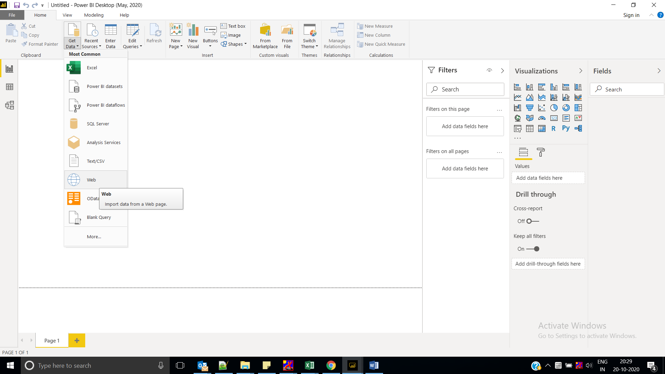

**Step 2**

Select Other Services > Web as a data source. Then, click "Connect".

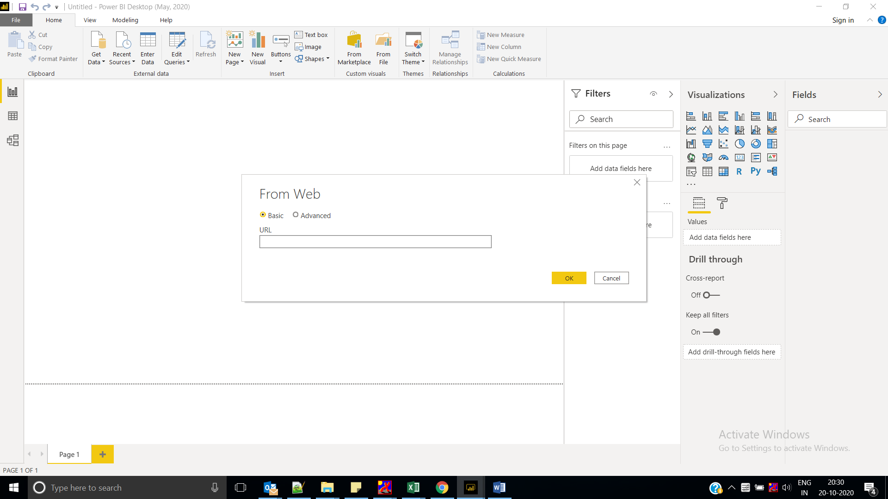

**Step 3**

It will ask you to enter the URL. Post the URL as following-

[*https://en.wikipedia.org/wiki/List_of_largest_selling_pharmaceutical_products*](https://en.wikipedia.org/wiki/List_of_largest_selling_pharmaceutical_products)

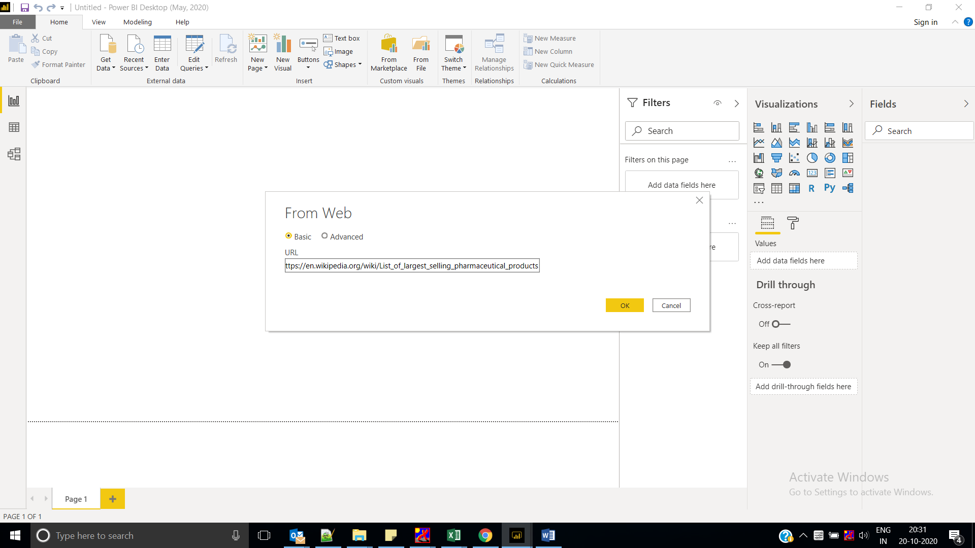

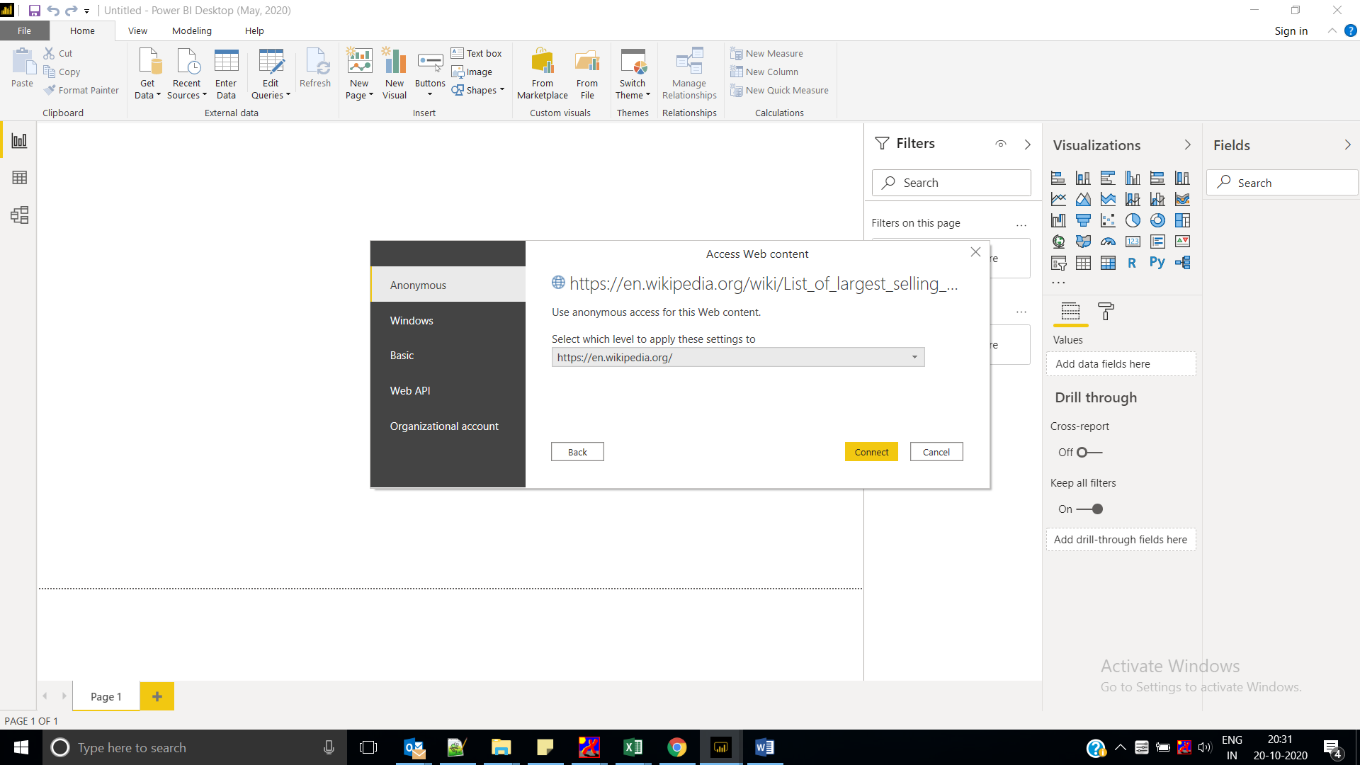

**Step 4**

It will show all available tables from Wikipedia. We will select both the tables. Now, click "Load".

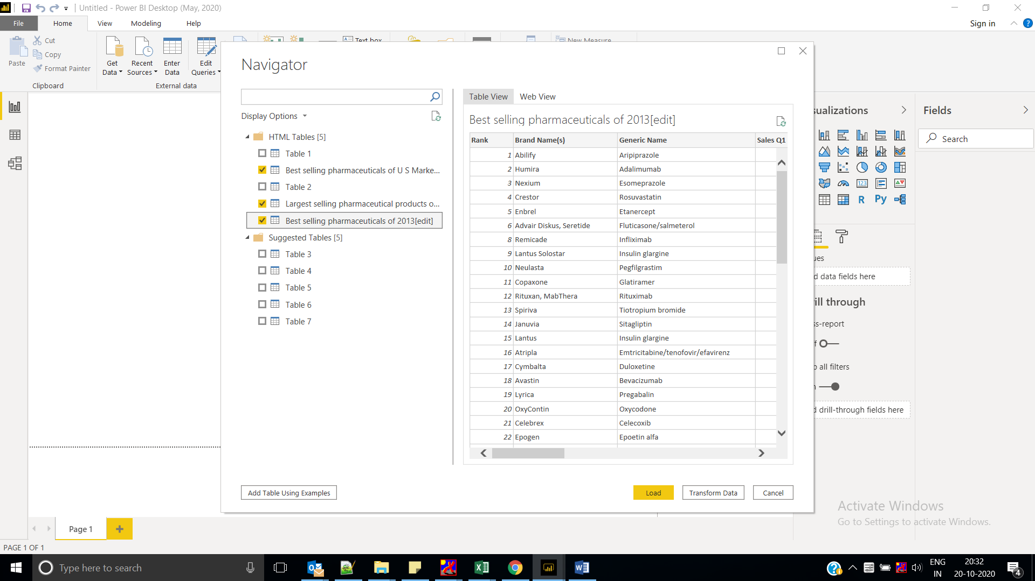

Now, we will rename our tables. Double click the name of an old table and rename it.

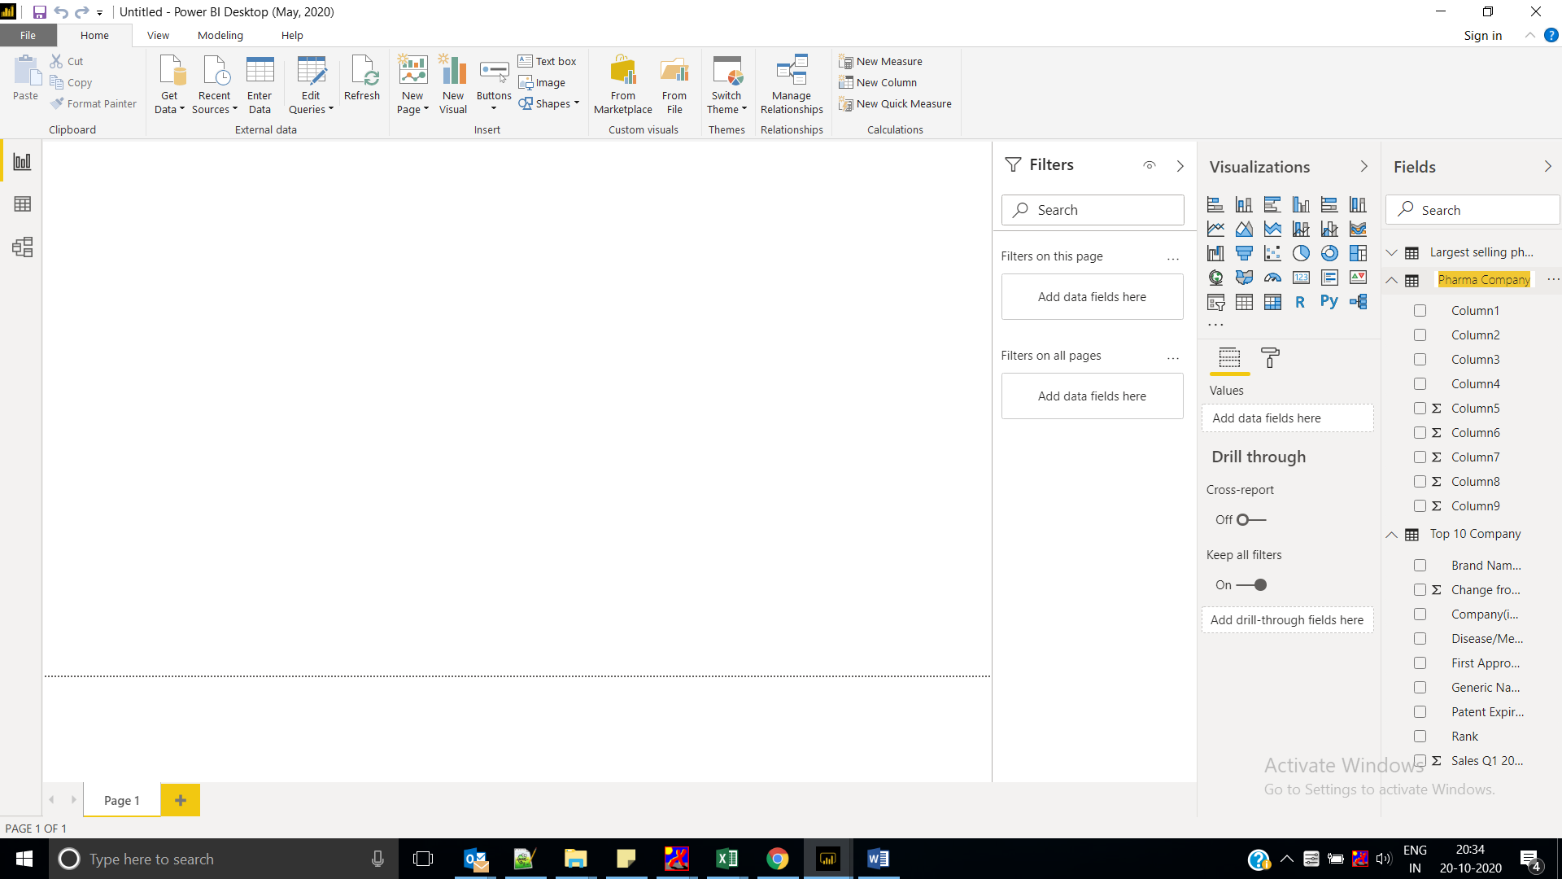

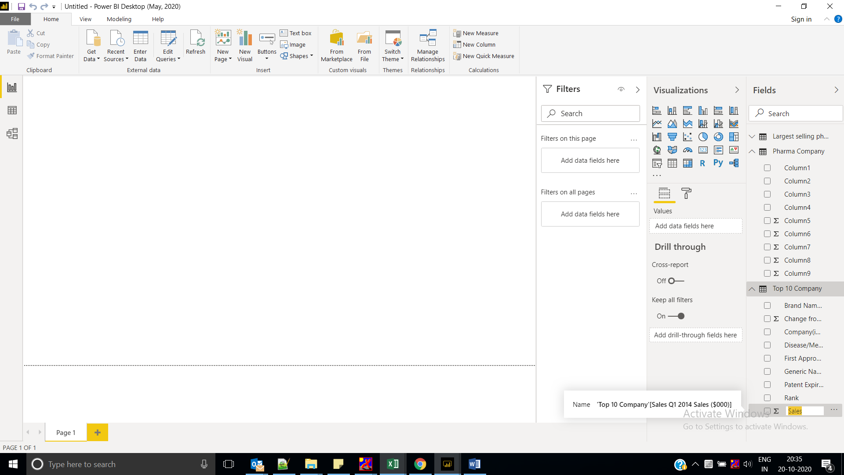

add visuals. We will add one “Table" visual and one “Staked bar chart” visual.

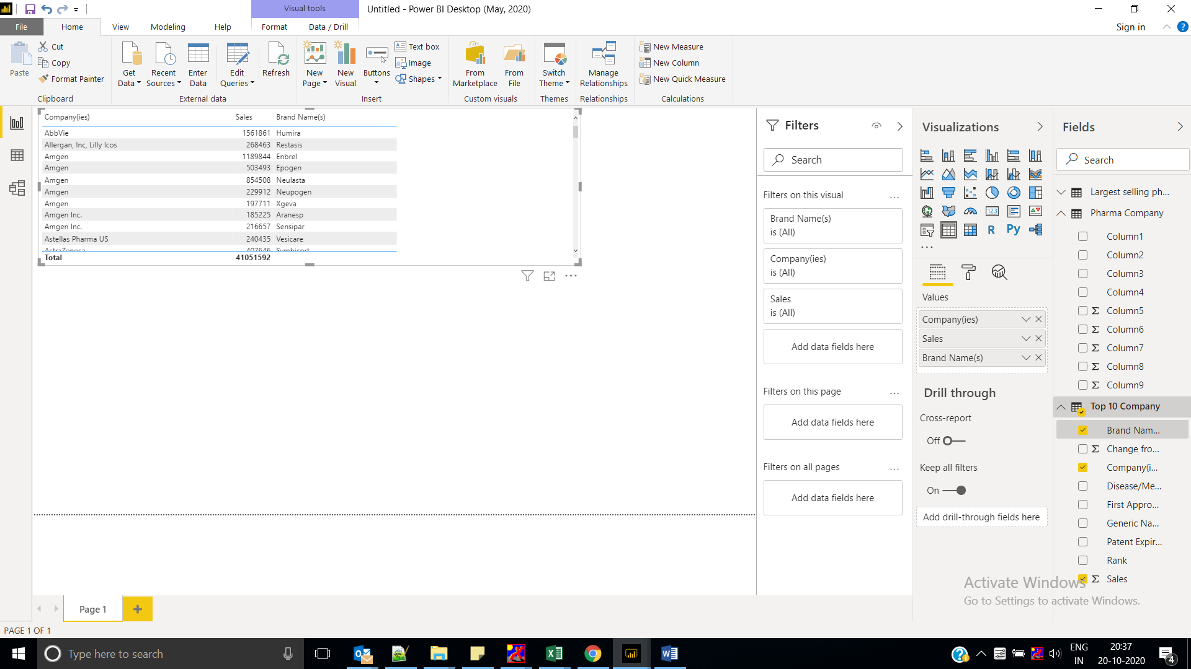

staked bar chart visualThis visual shows the sales report data with respect to the company name.

