**TEAM:** Technostack

________________________________________________________

Arayan Jakhar 21BCS11851

Anupam 21BCS3710

Isha Limbasiya 21CBS1066

Dhruv 21BCS11322

Sanskar Gautam 21BCS4553 Dharmesh Gidwani 21BCS10745

________________________________________________________

E-LEARNING PLATFORM

1. **Introduction :**
   * **Purpose –** The purpose is to develop an E-Learning website to facilitate remote learning, improve access to educational resources, and enhance the overall learning experience. It should support various types of content, assessments, and user interactions.
   * **Scope -** The scope of an e-learning platform encompasses creating a digital space for educational content delivery from any device connected to Internet and have wed browser.

It includes features like course creation, user management, content sharing, assessments, and progress tracking. It aims to provide accessible, engaging, and interactive learning experiences for students, instructors, and administrators while ensuring data security and compliance with educational goals.

It will also offer more integrate e-commerce for paid courses.

1. **General description :**

In this project we will be focusing on deploying our website’s backend on a server that will cost a little money. We try to find free webhosting website to host our front end website and try to reduce our cost as much as possible. In terms of management of our project we will effectively distribute our human resources in the frontend and backend development. We will focus on building a robust and user friendly solution.

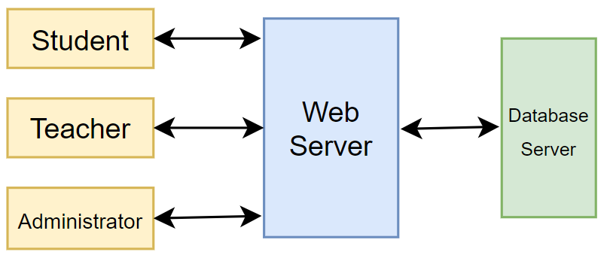

**User Characteristics:**

* Student:
  + Our main focus will be on students who leave in rural areas.
  + Student will able to register for courses, attend assignment and quizzes, ask doubts, give exam for the registered course, etc.
* Educator:
  + Professors from college and also college students(Bachelor’s degree).
  + Teachers can add courses, edit/delete courses, set assessment, quizs and exams, reply doubts send by students, receive feedback for courses, etc.
* Administrator:
  + He/She can manage users (create, edit and delete), get data of no. of students and teachers registered, check system operation, edit system configuration, etc.

1. **Functional Requirements :**

* The Features of the e-learning website will be:
  + The data will be stored in a single centralized database.
    - Student details
    - Teacher details
    - Course Content
    - Payment Details
* User registration and authentication.
* Course creation, management, and publishing.
* Content upload and organization.
* Most popular courses
  + Most popular course section will be based on completion of courses by large number of students.
* Admin dashboard for user and content management.
* Student Payment details

1. **Non-Functional Requirements**

* Scalability to accommodate a growing user base.
* High availability and reliability.
* Secure data storage and transmission.
* Performance optimization for quick content loading.
* Cross-browser compatibility.
* Data backup and recovery mechanisms.
* We will use less animation
* We try do provide external data
* Response time and concurrency
* Authentication, authorization, data encryption and protection against cyber threats
* We try to increase the number of user that can interact with our website in a given time.

1. **Interface Requirements :**

User Interface:

* Home Page 🡪Home, Courses, Payment Status, Login, Siginup, Feedback, Contact us.
* Home 🡪 The button is part of navigator bar and will redirect us to the home page of our website
* Courses🡪 This button will redirect you to the courses pages available on the website
* Payment Stauts🡪The button will redirect you to the check whether your payment has been completed or not.
* Login🡪 Helps the user to login into our website
* Sign up🡪 Helps the user to register to our website.
* Feedback🡪 Helps the user to give feedback to our website
* Contact us 🡪Helps the user to contact us.
* Dashboard For Students🡪Profile, My Courses, Feedback, Change Password, Logout
  + Profile🡪It enables user to update profile picture, name, email and occupation and it also allows user to view his/her Student id.
  + My Courses🡪It redirects user to a page where he can view enrolled courses.
  + Feedback🡪It enables user to give feedback about particular course or website.
  + Change Password🡪It enables user to reset password.
  + Logout🡪This button logout user from account and redirect him/her to home page.
* Dashboard For Admin🡪View total number of courses, number of registered students, number of enrolled students, and course ordered details.
  + Courses🡪
  + Lessons🡪
  + Students🡪
  + Payment Status🡪
  + Feedback🡪
  + Change Password🡪
  + Logout🡪

Communication Protocol: HTTPS

Database Backend: A relational database system.

Hardware Interface: Web browser

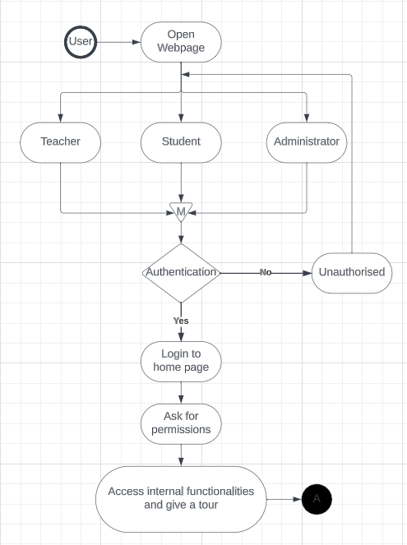

In this, software interfaces which mean how software program communicates with each other or users either in form of any language, code, or message are fully described and explained. Examples can be shared memory, data streams, etc.

1. **Performance Requirements :**
   * Low data speed or bandwidth: We will provide a feature to change resolution.

* Lower end devices in remote area: The type of available devices will be lower end devices so we will reduce the size of our website to reduce it.
* Higher end pc in the city: The teachers device have higher end pcs so we need to give them a advance front end to work in.

In this, how a software system performs desired functions under specific condition is explained. It also explains required time, required memory, maximum error rate, etc.

1. **Design Constraints :** In this, constraints which simply means limitation or restriction are specified and explained for design team. Examples may include use of a particular algorithm, hardware and software limitations, etc.
2. **Non-Functional Attributes :** In this, non-functional attributes are explained that are required by software system for better performance. An example may include Security, Portability, Reliability, Reusability, Application compatibility, Data integrity, Scalability capacity, etc.
3. **Preliminary Schedule and Budget :** In this, initial version and budget of project plan are explained which include overall time duration required and overall cost required for development of project.