**TEAM:** Technostack

**_____________**___________________________________________

Arayan Jakhar 21BCS11851

Anupam 21BCS3710

Isha Limbasiya 21CBS1066

Dhruv 21BCS11322

Sanskar Gautam 21BCS4553 Dharmesh Gidwani 21BCS10745

________________________________________________________

E-LEARNING PLATFORM

1. **Introduction :**An e-learning platform is a digital solution that leverages technology to facilitate and enhance the learning experience. It serves as a virtual classroom, connecting learners, instructors, and educational content online. Through this platform, users can access a wide array of educational resources, engage in interactive courses, and collaborate with peers and teachers from anywhere in the world. E-learning platforms offer flexibility, scalability, and accessibility, making them a powerful tool for institutions, businesses, and individuals seeking to acquire new knowledge, develop skills, and advance their education in the digital age.
   * **Purpose -** The purpose of this E-Learning Platform is to facilitate remote learning, improve access to educational resources, and enhance the overall learning experience. It should support various types of content, assessments, and user interactions.
   * **Scope -** The scope of an e-learning platform encompasses creating a digital space for educational content delivery. It includes features like course creation, user management, content sharing, assessments, and progress tracking. It aims to provide accessible, engaging, and interactive learning experiences for students, instructors, and administrators while ensuring data security and compliance with educational goals. It will also offer customization, integration, and support services for a comprehensive online learning environment. They prioritize accessibility, data security, and often integrate e-commerce for paid courses.
   * **Overview -** In this project we will be focusing on deploying our website’s backend on a server that will cost a little money. We try to find free webhosting website to host our front end website and try to reduce our cost as much as possible. In terms of management of our project we will effectively distribute our human resources in the frontend and backend development. We will focus on building a robust and user friendly solution.
2. **General description :**

An e-learning platform is a versatile digital system designed to revolutionize education by providing a comprehensive online learning environment. It serves as a virtual hub where students, instructors, and administrators can collaborate seamlessly. Users can access a wide range of educational resources, from text and multimedia content to interactive quizzes and assignments. Instructors can create, manage, and deliver courses, while learners benefit from flexible, self-paced learning experiences. Progress tracking and assessment tools help gauge and improve learning outcomes. E-learning platforms also prioritize data security, accessibility, and scalability, making them suitable for diverse educational institutions and industries. Customization options, integration capabilities, and support services further enhance their adaptability and effectiveness in delivering accessible, engaging, and efficient learning solutions.

**User Roles**

* Student: Our main focus is on students who leave in rural areas
* Educator
* Administrator

1. **Functional Requirements :**

* User registration and authentication.
* User profiles for students, educators, and administrators.
* Course creation, management, and publishing.
* Content upload and organization.
* Assessment and quiz creation.
* Progress tracking and reporting.
* Search and recommendation engine.
* Admin dashboard for user and content management.
* Language access for end users (Hindi or English)

1. **Non-Functional Requirements**

* Scalability to accommodate a growing user base.
* High availability and reliability.
* Secure data storage and transmission.
* Performance optimization for quick content loading.
* Cross-browser compatibility.
* Data backup and recovery mechanisms.
* We will use less animation
* We try do provide external data
* Response time and concurrency
* Authentication, authorization, data encryption and protection against cyber threats
* We try to increase the number of user that can interact with our website in a given time.

1. **Interface Requirements :**

User Interface:

* Home Page🡪 Recommended Courses, Ongoing Courses, Latest Courses.
* Course Pages🡪Content, Course Material, Assignments and quizzes.
* Profile Page🡪User details, Course completed, Course in progress.
* Login & Registration Page🡪User name, password, features like forget password.

Communication Protocol: HTTPS

Database Backend: A relational database system.

Hardware Interface:

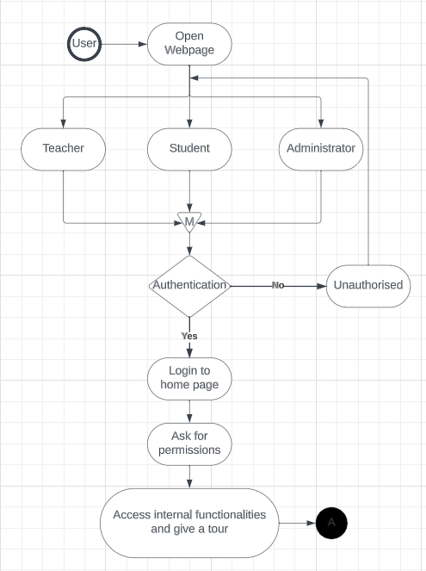

In this, software interfaces which mean how software program communicates with each other or users either in form of any language, code, or message are fully described and explained. Examples can be shared memory, data streams, etc.

1. **Performance Requirements :**
   * Low data speed or bandwidth: We will provide a feature to change resolution.

* Lower end devices in remote area: The type of available devices will be lower end devices so we will reduce the size of our website to reduce it.
* Higher end pc in the city: The teachers device have higher end pcs so we need to give them a advance front end to work in.

In this, how a software system performs desired functions under specific condition is explained. It also explains required time, required memory, maximum error rate, etc.

1. **Design Constraints :** In this, constraints which simply means limitation or restriction are specified and explained for design team. Examples may include use of a particular algorithm, hardware and software limitations, etc.
2. **Non-Functional Attributes :** In this, non-functional attributes are explained that are required by software system for better performance. An example may include Security, Portability, Reliability, Reusability, Application compatibility, Data integrity, Scalability capacity, etc.
3. **Preliminary Schedule and Budget :** In this, initial version and budget of project plan are explained which include overall time duration required and overall cost required for development of project.