Sales Performance Analysis Project
Dharmesh
Data Analyst

1. Project Overview
This project demonstrates an end-to-end Sales Performance Analysis workflow. The objective is to analyze sales data, clean and transform it using Python and SQL, store it in MySQL, and build an interactive Tableau dashboard to derive business insights.

2. Tools & Technologies Used
- Python (Pandas, NumPy)
- MySQL & MySQL Workbench
- Tableau Public
- Jupyter Notebook

3. Data Cleaning & Preparation (Python)
The raw CSV dataset was loaded into Pandas. Missing values, incorrect date formats, and data type issues were handled. Order Date and Ship Date were converted into datetime format, and invalid rows were removed to ensure data quality.
Key steps:
- Loaded CSV using pandas.read_csv()
- Checked missing values using df.isnull().sum()
- Converted date columns using pd.to_datetime()
- Removed rows with critical missing values

4. Database Storage (MySQL)
A MySQL database named 'sales_analysis' was created. The cleaned dataset was inserted into a table called 'superstore_sales' using Python's mysql-connector library.
SQL operations included:
- Table creation
- Data insertion
- Aggregation queries for sales, orders, regions, and categories

5. Data Visualization (Tableau)
The cleaned MySQL data was connected to Tableau Public. Multiple worksheets were created and combined into a single interactive dashboard.
Dashboard features:
- KPI Cards (Total Sales, Total Orders)
- Sales by Region
- Sales by Category & Sub-Category
- Monthly Sales Trend
- Top Customers
- Interactive filters for Category and Region

6. Final Dashboard
Below is the final Tableau Sales Performance Dashboard:
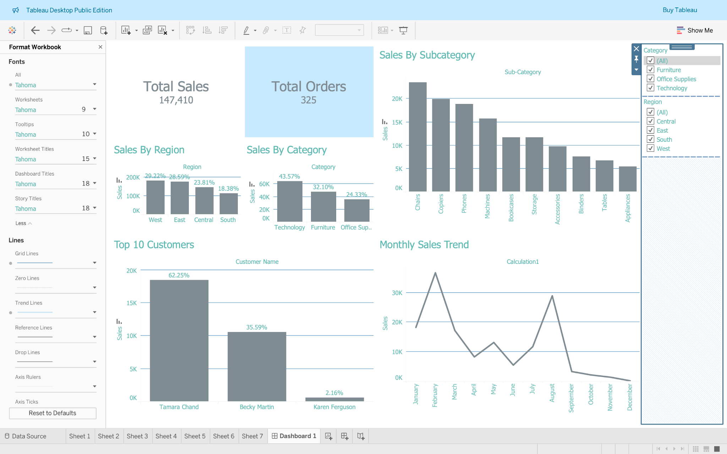

7. Key Business Insights
- Technology is the highest contributing category to sales.
- West region generates the highest revenue.
- Sales peak during early months of the year.
- A small set of customers contributes a significant portion of total sales.

8. Conclusion
This project highlights strong data analysis skills, including data cleaning, SQL querying, and dashboard storytelling. It is suitable for portfolio presentation and interviews.

