A

PROJECT REPORT ON

**INCOME - EXPENSE TRACKER**

**By**

**CHAVDA DHARMI (CE-24) (19CEUBS127)**

**HATVANI MITTAL (CE-82) (19CEUBS126)**

**B.Tech CE Semester-VI**

**Subject: System Design Practice**

**Guided by:**

Prof.Pandav K. Patel

Assistant Professor

Dept. of Comp. Engg.



**Faculty of Technology**

**Department of Computer Engineering**

**Dharmsinh Desai University**



**Faculty of Technology**

**Department of Computer Engineering**

**Dharmsinh Desai University**

**CERTIFICATE**

This is to certify that the practical / term work carried out in the subject of

**System Design Practice** and recorded in this journal is the

bonafide work of

**CHAVDA DHARMI (CE-24) (19CEUBS127)**

**HATVANI MITTAL (CE-82) (19CEUBS126)**

of B.Tech semester **VI** in the branch of **Computer Engineering**

during the academic year **2021-2022**.

Prof. Pandav K. Patel Dr. C. K. Bhensdadia,

Assistant Professor, Head,

Dept. of Computer Engg., Dept. of Computer Engg.,

Faculty of Technology Faculty of Technology

Dharmsinh Desai University, Nadiad Dharmsinh Desai University, Nadiad

**Contents**

1)Abstract.............................................................................. 04

# 2)Introduction…................................................................... 05

3) Software Requirements Specifications ............................. 06

4) Design

* 1. ER diagram .............................................................. 12
  2. Class diagram ........................................................... 12
  3. Sequence diagram ....................................................... 13
  4. Data dictionary ......................................................... 13

5)Implementation Details

i Modules .................................................................... 16

ii Major Functionality .................................................. 18

1. Testing ............................................................................. 16
2. Screen-shots ...................................................................... 18
3. Conclusion ........................................................................ 22
4. Limitation and future extension ........................................ 23

10) Bibliography .................................................................... 23

**1)Abstract**

Income - Expense Tracker is a software is a daily expense management system which is specially designed for non- salaried and salaried personnel for keeping track of their daily expenditure with easy and effective way through computerized system which tends to eliminate manual paper works.

It is a software that allows users to keep track of their own spending to ensure that they stick to a budget and don’t go overboard. Such a system will incorporate several modules to provide an intuitive and user-friendly interface. Including the option of setting a daily budget or spending limit can also help users as then they can monitor how much they are spending on a daily basis. Such a tool will prove to be beneficial to all kinds of people, including home-makers who are on a strict budget and college going students who have to get by with monthly pocket-money! Analysing the inputs made to this tool will help users understand they spend the most money on so that they can devise ways what to cut back on spending on that particular item.

Objectives :

* Manage Records Of Income
* Manage Records Of Expense
* Show Statistics of Income & Expense

User Views:

* Super User(Django superuser)
* End User

1. **Introduction**

Income – Expense Tracker is basically a software that records the amount of income and expense for end user. The purpose of developing this software is to computerize the traditional way of tracking their daily expense.

Firstly, the registered user can successfully login to the system. This system is specifically developed for the non- salaried and salaried personnel offices where user can enter the records of the daily expenses and income. Information entered can further be edited or deleted permanently. All the records would be stored according to date and would be visible in history. Further user can view their statistics by graph according to month which he/she selected changes reflected in graph. Further they can download excel file of their added records.

### Technologies/Tools used

**Technologies:**

* Django
* Bootstrap
* Chart Js
* HTML
* CSS

**Tools:**

* Git
* Visual studio code
* Chrome Browser

**3)Software Requirement Specifications**

### 1)Manage User

**R.1.1: Profile**

***Description:*** This section includes information related to user’s profile.

#### R.1.1.1: View profile

***Description:*** This option shows the profile of the user. It displays their user id, username and email id.

***Input:*** Click on the view profile option.

***Output:*** Profile screen would be displayed.

#### R.1.1.2: Edit profile

***Description:*** This option edits the profile of the User.

***Input:*** Click on the edit profile button .

# Manage registration/login

#### R.2.1: End User

#### R.2.1.1: Registration

***Description:*** If User doesn’t have any exiting account then they have to register themselves.

***Input:*** User have to provide their name, email, and password.

***Output:*** User would be redirected to login page.

**R.2.1.2: Login**

***Description*:** If User already have an account then this option will be used to display home page by logging in.

***Input:*** Operator have to give their username and password.

### Manage Expenses

#### R.3.1: Add expense category

***Description:*** This function will allow user to add the expense category name.

***Input:*** Click on the Add category.

***Output:*** Add category form would be displayed.

#### R.3.2: Add expense record

***Description:*** This function will allow user to add the expense information.

***Input:*** Click on the Add Expense.

***Output:*** Add record form would be displayed.

#### R.3.3: View expenses record

***Description:*** This function will show the list of all the expenses records along with date in tabular formate.

***Input:*** Click on the Dashboard.

***Output:*** List of all the entered expenses would be visible.

#### R.3.4: Edit expense record

***Description:*** This function will let user to edit any expense record and save changes to the database.

***Input:*** Click on buy edit record button.

***Output:*** edit form would be visible where user can edit and save changes to database.

#### R.3.5 : Delete expense record

***Description:*** This function will let operator to delete any expense record.

***Input:*** Click on delete record button.

***Output:*** Expense record would be deleted from the list.

#### R.3.6 : Search expense record

***Description:*** This function will let user search all the recorded expense with respect to amount, category, date and description.

***Input:*** Type text in the search bar.

***Output:*** Matched expense records would be visible accordingly.

#### R.3.7 : View expense summary

***Description:*** This function will let user to view history of all the entered expenses in different types of charts based on months we selected.

***Input:*** Click on Expense summary button from sidebar.

***Output:*** Expenses records summary would be visible.

#### R.3.8: Export expense

***Description:*** This function will let user download all expenses which recorded in database in excel sheet on their system.

***Input:*** Click on delete record button.

***Output:*** Logged in user’s expense records would be downloaded.

# Manage Income

#### R.4.1: Add Income source

***Description:*** This function will allow user to add the income source.

***Input:*** Click on the Add source.

***Output:*** Add source form would be displayed

#### R.4.2: Add Income record

***Description:*** This function will allow user to add the income information.

***Input:*** Click on the Add Income.

***Output:*** Add record form would be displayed.

#### R.4.3 : View income record

***Description:*** This function will show the list of all the income records along with date in tabular formate.

***Input:*** Click on the Dashboard.

***Output:*** List of all the entered income would be visible.

#### R.4.4: Edit income record

***Description:*** This function will let user to edit any income record and save changes to the database.

***Input:*** Click on buy edit record button.

***Output:*** edit form would be visible where user can edit and save changes to database.

#### R.4.5: Delete income record

***Description:*** This function will let operator to delete any income record.

***Input:*** Click on delete record button.

***Output:*** Income record would be deleted from the list.

#### R.4.6 : Search income

***Description:*** This function will let user search all the recorded income with respect to amount, category, date and description.

***Input:*** Type text in the search bar.

***Output:*** Matched income records would be visible accordingly.

#### R.4.7 : View income summary

***Description:*** This function will let user to view history of all the entered income in different types of charts based on months we selected.

***Input:*** Click on Income summary button from sidebar.

***Output:*** Income records summary would be visible.

#### R.4.8 : Export income

***Description:*** This function will let user download all income which recorded in database in excel sheet on their system.

***Input:*** Click on delete record button.

***Output:*** Logged in user’s income records would be downloaded.

### 5)Logout user

#### R.5.1: logout

***Description:*** Operator can logout after completion of task. All the entered records would not be affected due to logout.

***Input:*** Click on logout option in side bar.

***Output:*** Operator would be redirected to login page again.

**4)Design**

* + 1. E-R diagram

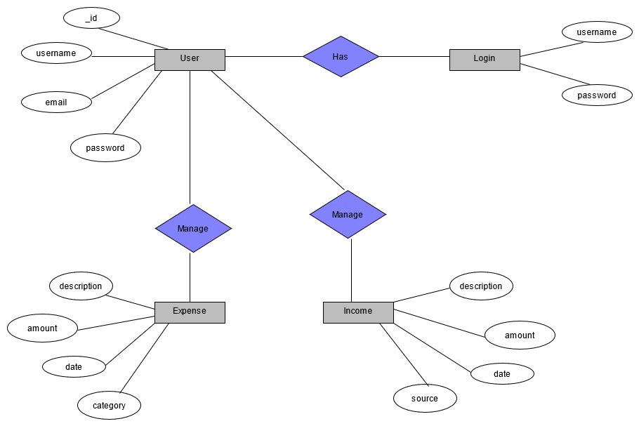

* + 1. Class diagram

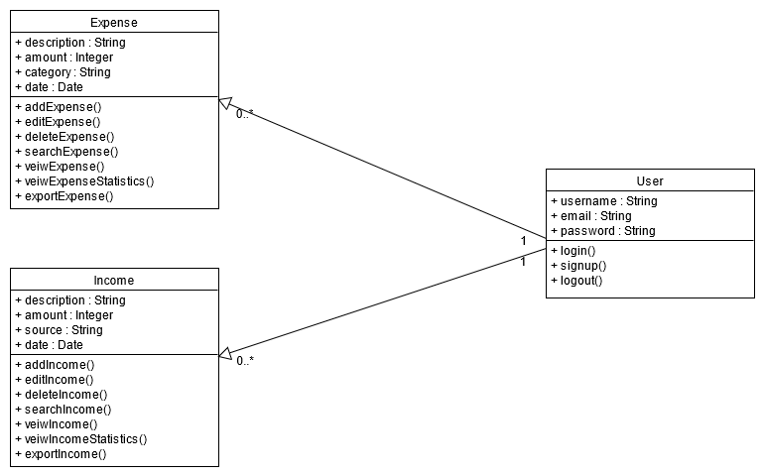

* + 1. Sequence diagram

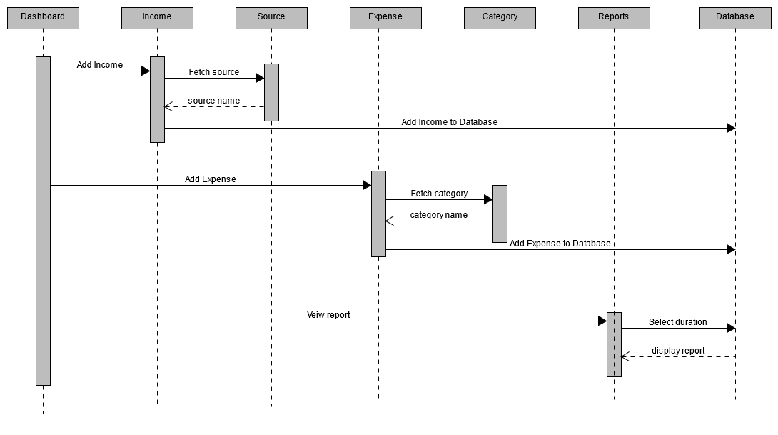

* + 1. Data Dictionary

|  |  |  |  |  |  |  |  |
| --- | --- | --- | --- | --- | --- | --- | --- |
|  |  |  | **Users** | |  |  |  |
| Sr No. | Field name | Data type | Required | Unique | PK/FK | Referred table | Description |
| 1 | _id | Int32 | yes | yes | yes | - | Autoincrement |
| 2 | name | String | yes | yes | no | - | - |
| 3 | email | String | yes | no | no | - | - |
| 4 | password | String | yes | no | no | - | - |

|  |  |  |  |  |  |  |  |
| --- | --- | --- | --- | --- | --- | --- | --- |
|  |  |  | **Category** | |  |  |  |
| SrNo. | Field name | Data  type | Required | Unique | PK/FK | Referred table | Description |
| 1 | name | String | yes | yes | no | - | - |

|  |  |  |  |  |  |  |  |
| --- | --- | --- | --- | --- | --- | --- | --- |
|  |  |  | **Expense** | |  |  |  |
| Sr No. | Field name | Data type | Required | Unique | PK/FK | Referred table | Description |
| 1 | _id | Int32 | yes | yes | yes | - | Autoincrement |
| 2 | amount | Int32 | yes | yes | no | - | - |
| 3 | description | String | yes | no | no | - | - |
| 4 | category | String | yes | no | yes | Category | - |
| 5 | date | Date | yes | no | no | - | - |

|  |  |  |  |  |  |  |  |
| --- | --- | --- | --- | --- | --- | --- | --- |
|  |  |  | Source | |  |  |  |
| Sr No. | Field name | Data type | Required | Unique | PK/FK | Referred  table | Description |
| 1 | name | String | yes | yes | no | - | - |

|  |  |  |  |  |  |  |  |
| --- | --- | --- | --- | --- | --- | --- | --- |
|  |  |  | **Income** | |  |  |  |
| Sr No. | Field name | Data  type | Required | Unique | PK/FK | Referred table | Description |
| 1 | _id | Int32 | yes | yes | yes | - | Autoincrement |
| 2 | amount | Int32 | yes | yes | no | - | - |
| 3 | description | String | yes | no | no | - | - |
| 4 | source | String | yes | no | yes | Source | - |
| 5 | date | Date | yes | no | no | - | - |

# 5)Implementation Details

## a).Modules

#### Login-Registration

This module is the base for authentication authorization to ensure the security aspect of the user.

It consist of all the login and registration functionality. User can login to the system if account already exist. User can register with unique username to create an account.

User is supposed to provide correct credentials to successfully login to the system.

User can logout from the system whenever he/she wants. This functions would not delete the activities performed by user.

#### Expense Records

This module is basically used in entering the record of the expense. Once we enter the information and click on add record the following information would be added to the database.

User can edit the information of expense by clicking on the edit button. All the updated fields will be updated to the database.

User can delete the record of any particular expense by clicking on the delete button. That particular record would be deleted from the list of the expense.

User can search the expense from the list with respect to either amount, description, category date.

User can view statistics of the expense based on selected date by all types of graphs(Pie ,Bar ,Line,

Doughnut).

User can also export records of all expense in excel

Formate in their system by clicking on export CSV

Button.

#### Income Records

This module is basically used in entering the record of their income. Once we enter the information and click on add record the following information would be added to the database.

User can edit the information of income by clicking on the edit button. All the updated fields will be updated to the database.

User can delete the record of any particular income by clicking on the delete button. That particular record would be deleted from the list of the income.

User can search the income from the list with respect to either amount, description, source or date.

User can view statistics of the income based on selected date by all types of graphs(Pie ,Bar ,Line,

Doughnut).

User can also export records of all income in excel

Format in their system by clicking on Export CSV

Button.

## b).Major functionalities

## Login:

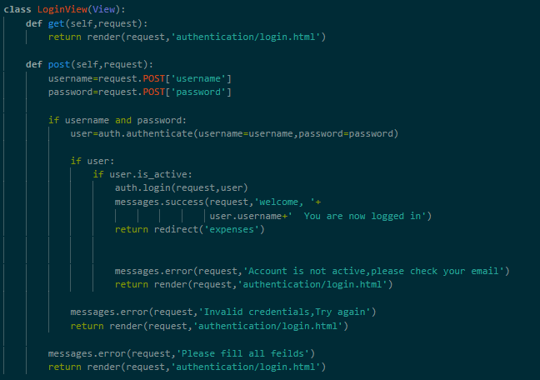

# Logout:

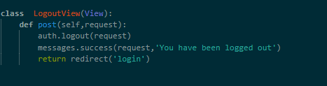

## Registration:

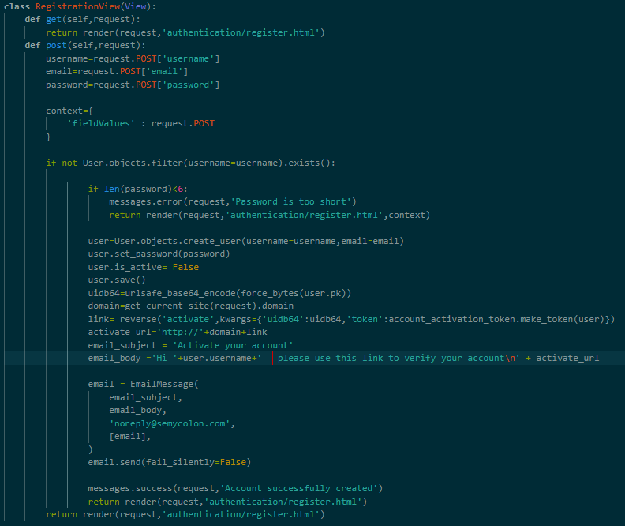

## Search Expense:

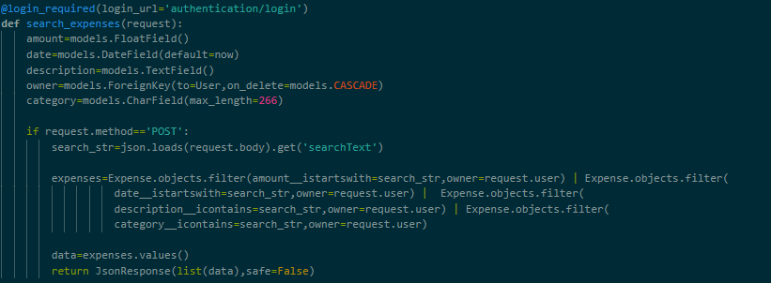

## Profile-Edit:

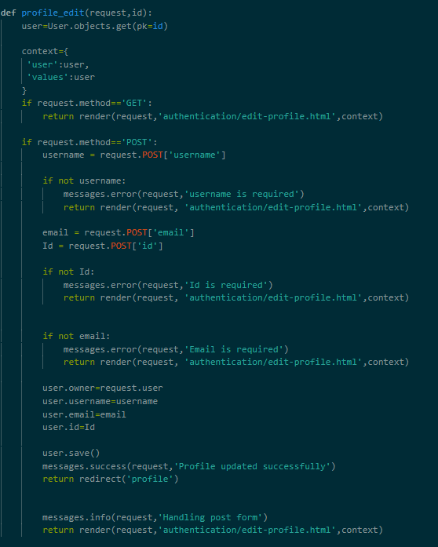

## Delete Expenes:

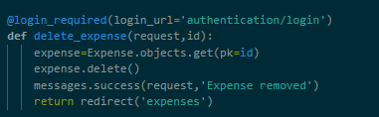

## Add Expense:

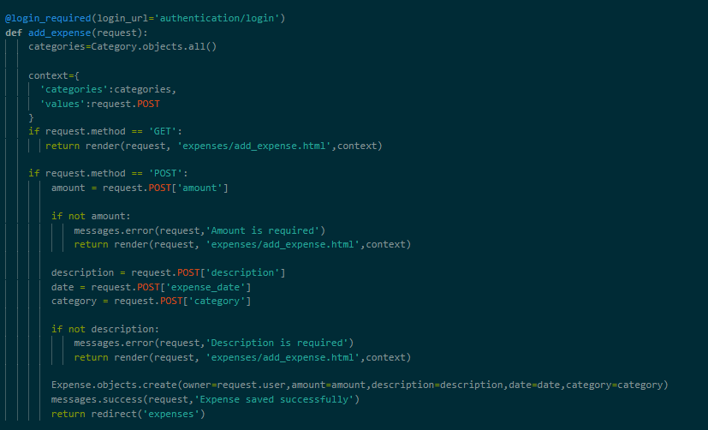

# Edit Expense :

## 

**Expense-Report:**

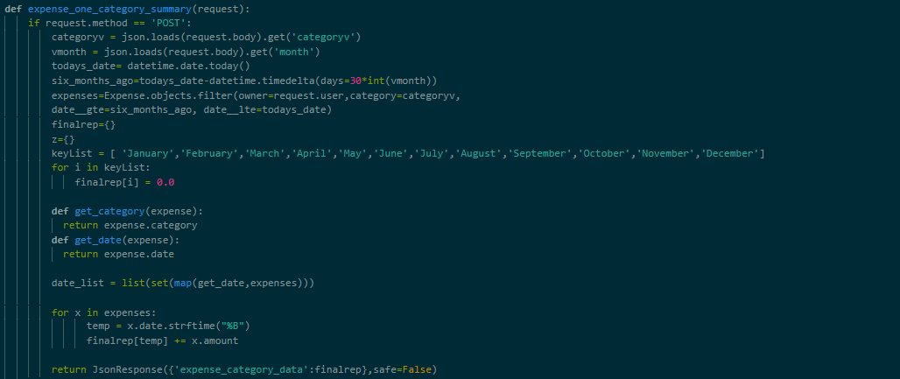

**Js file of Income Chart:**

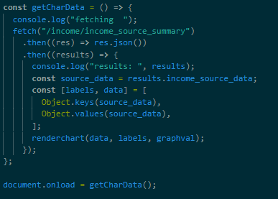

**Export-Income:**

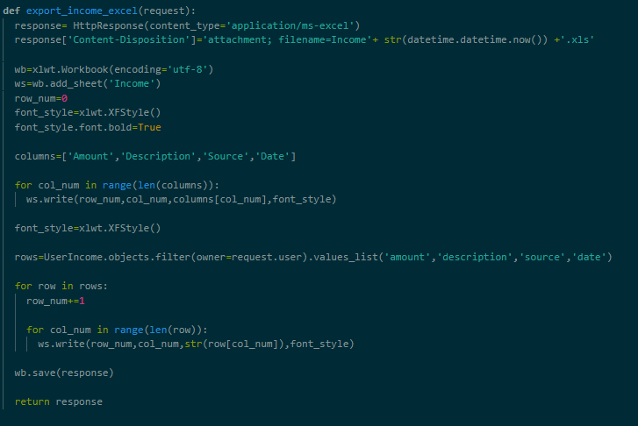

# Testing

### Testing method: Manual testing

Manual testing was performed in order to find and fix the bugs in development process.

|  |  |  |  |  |
| --- | --- | --- | --- | --- |
| **Sr no.** | **Test Scenario** | **Expected result** | **Actual result** | **Status** |
| 1 | Enter to the website | Login Page should be displayed | Login page is displayed | Success |
| 2 | Login with correct credentials | User should be able to login | User is redirected to home page | Success |
| 3 | Login with incorrect credentials | Alert box is popped up with a message | Alert box is popped up | Success |
| 4 | Registering with registered username | ‘user already registered’ alert box should be displayed | Alert box is popped up | Success |
| 5 | Entering different password and confirm password | ‘password does not match’ alert box should be displayed | ‘password does not match’ alert box is displayed | Success |
| 6 | Clicking on login/register button with empty  fields | ‘invalid input’ alert box should be appeared | ‘invalid input’ alert box is appeared | Success |
| 7 | Logout | User should logged out from the system | User is logged out from the system and cannot use the system until next login | Success |
| 8 | Add Expense/income record to the database | Record should be added to the list of all the Record | Record is added to the list | Success |
| 9 | Expense/income page | List of all  Expense/income should be appeared | List of all Expense/income is displayed | Success |
| 10 | Edit Expense/income record | Edit form should be visible | Edit form is visible | Success |
| 11 | Click on edit user Profile | User Record should be updated | Record is updated | Success |
| 12 | Click on Export Excel | Record File should be download | Record File download | Success |
| 13 | Expense/income record click on Delete | That recorded should be  Deleted | Recorded Deleted | Success |
| 14 | Search Expense/income  Record | Matched Expense/income record list should be visible | Matched Expense/income record  list is visible | Success |
| 15 | Click on Expense/income Report | Expense/income page should be visible and display summary | Expense/income page is visible display summary | Success |
| 16 | Expense/income Report changing Category/source it will Reflect graph and display | Reflected should be graph and display | Reflected graph and display | Success |
| 17 | Click on Profile option | Profile should be visible | Profile is visible | Success |
| 18 | Click on edit profile button | Profile should be updated | Profile is updated | Success |

# 7)Screen-shots

* **Registration**

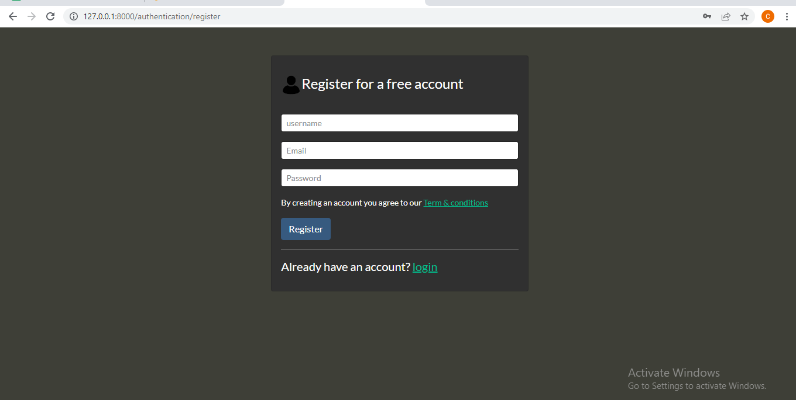

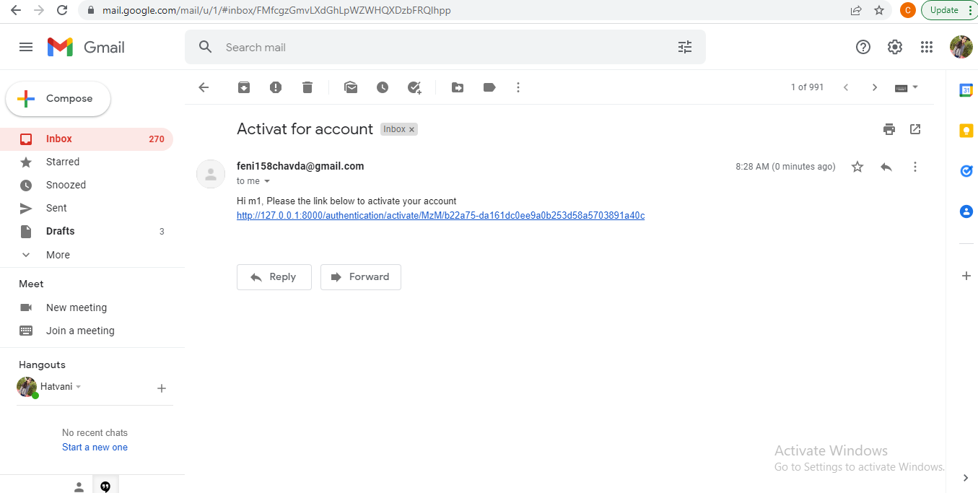

* **Login :**

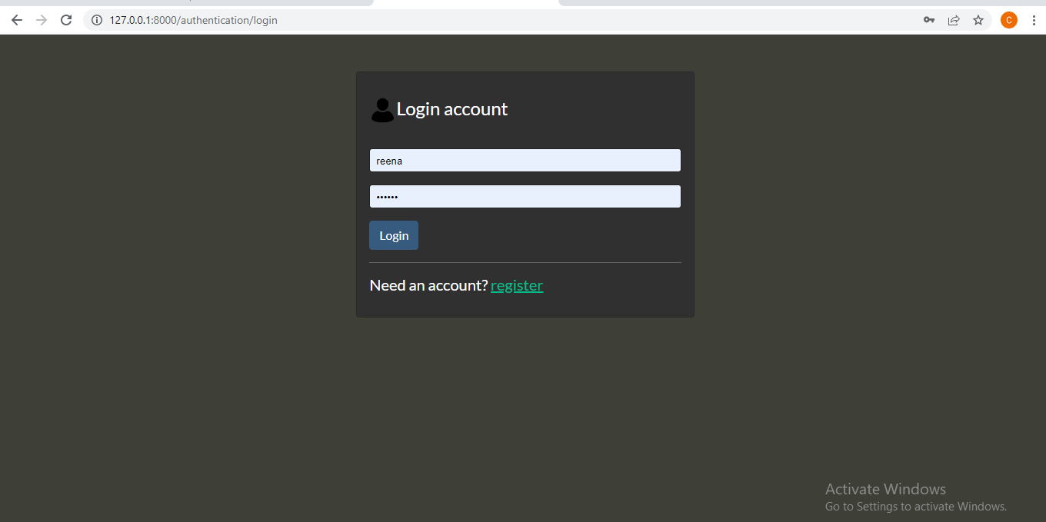

* **Add-Expense:**

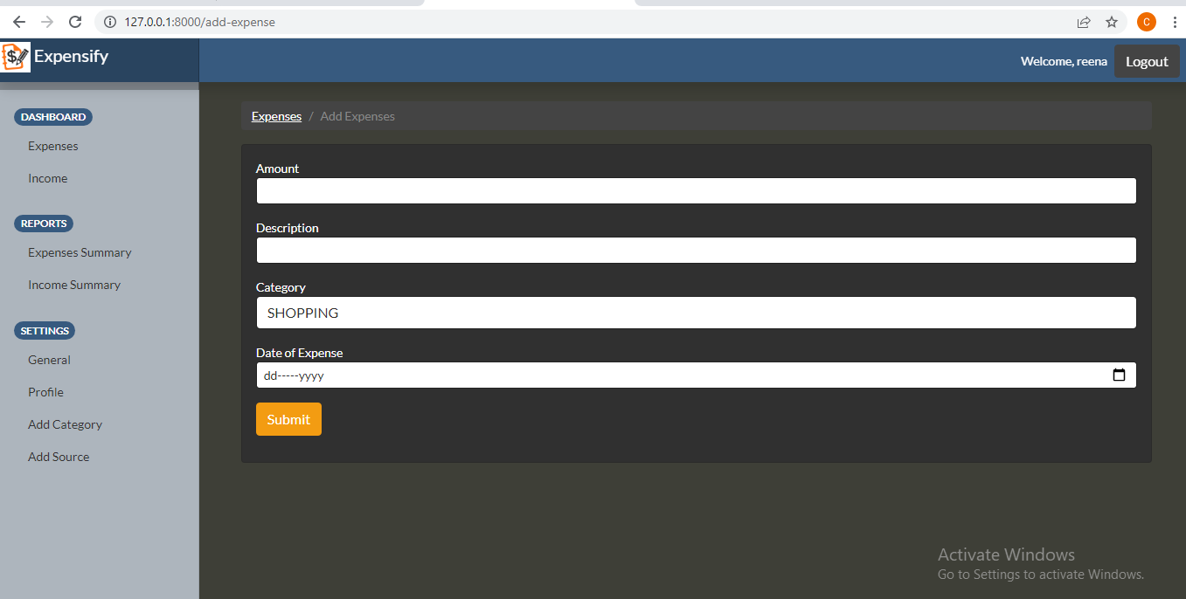

* **Edit-Expense:**

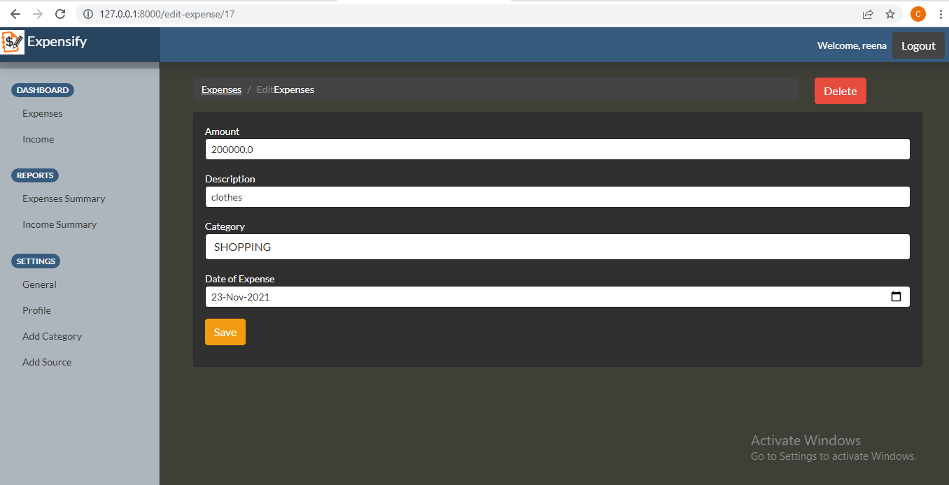

* **Pagination and Display Statistic:**

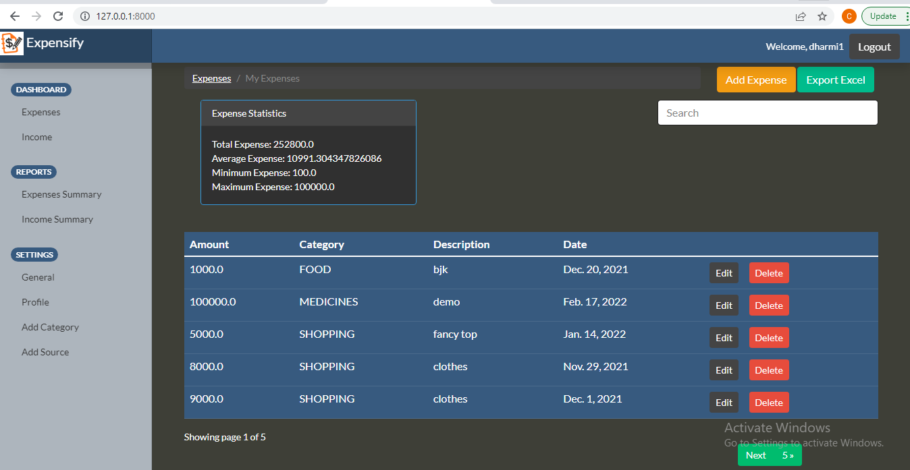

* **Expense Search :**

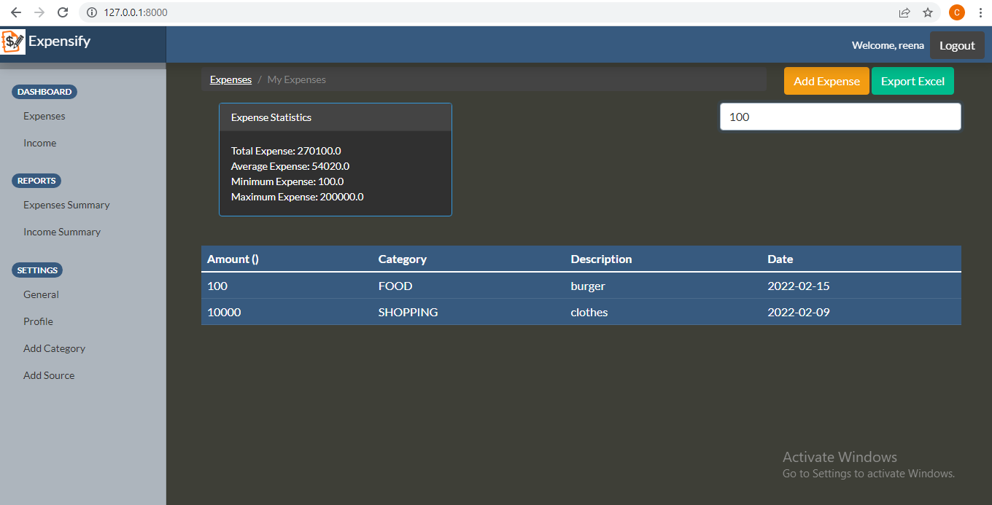

* **Export Excel File:**

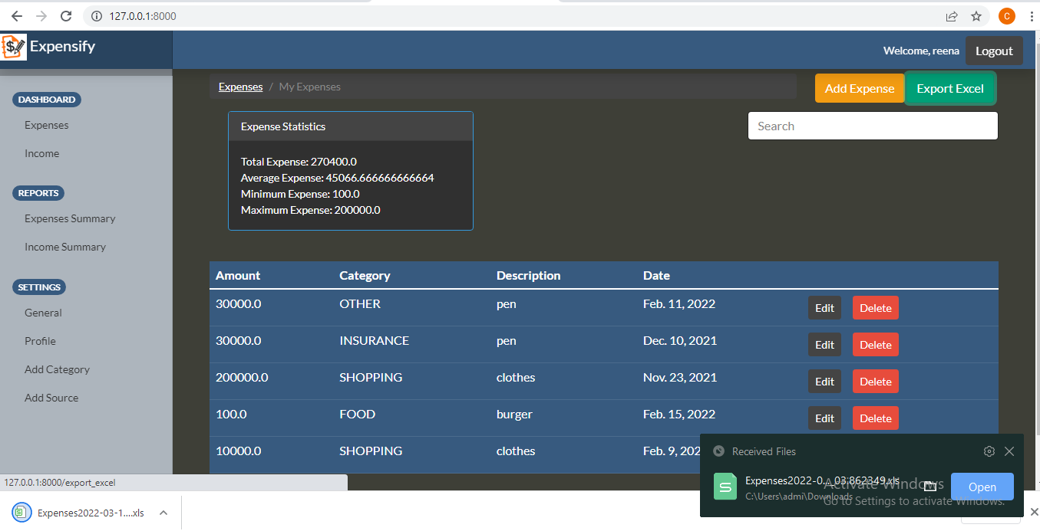

* **Income Delete:**

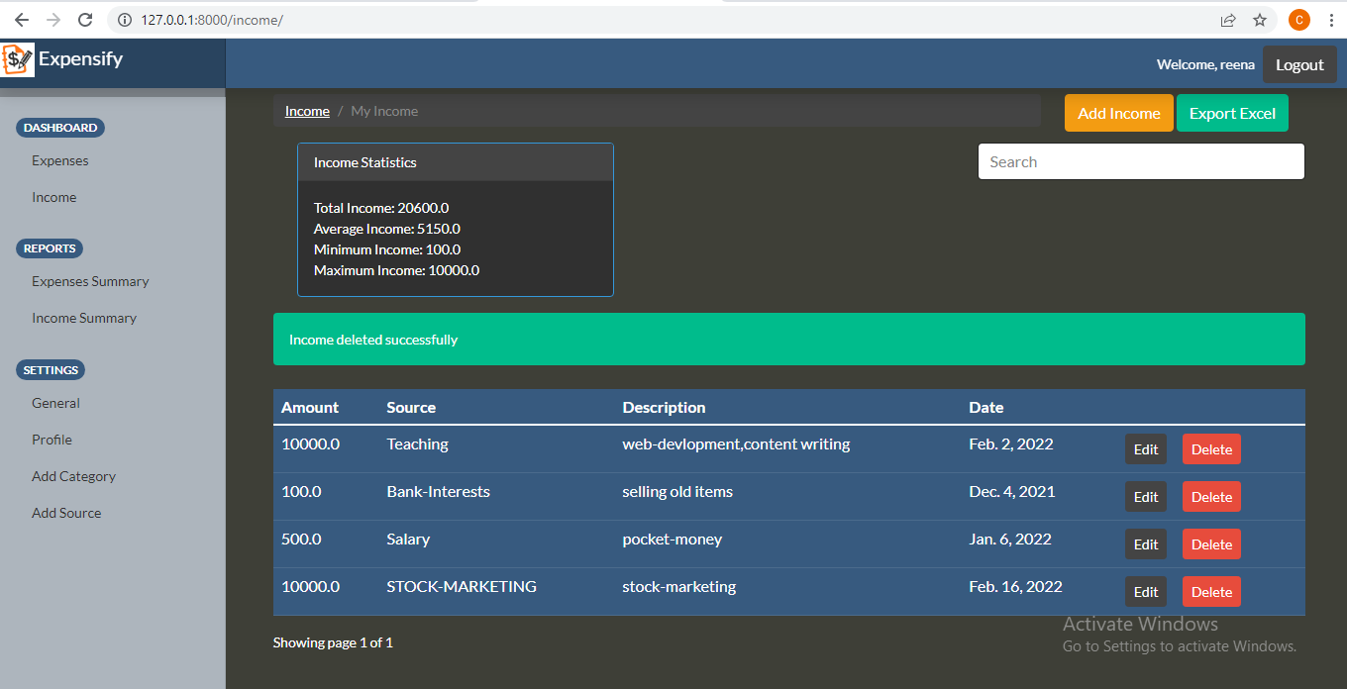

* **Display Income Record and Statistic:**

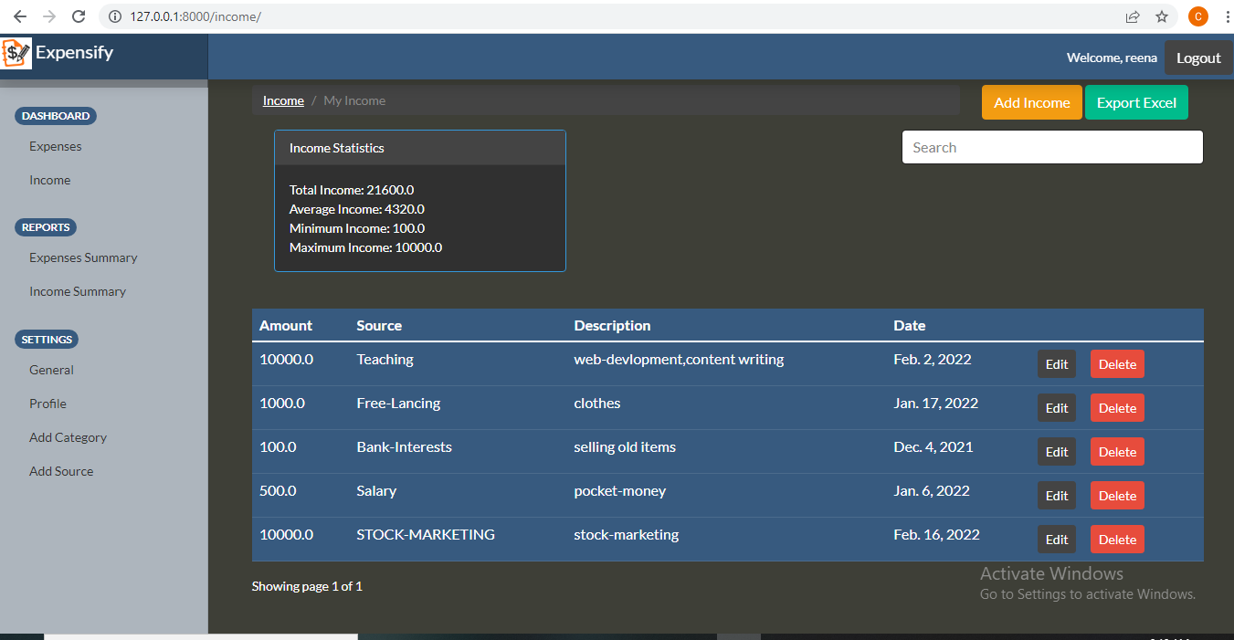

* **Expenses and Income Report** Category wise and Filter it with month and One Category **:**

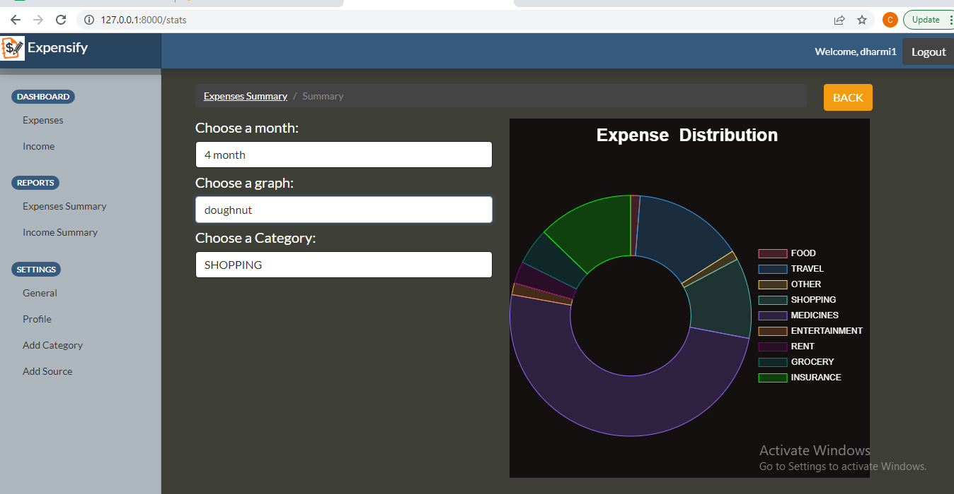

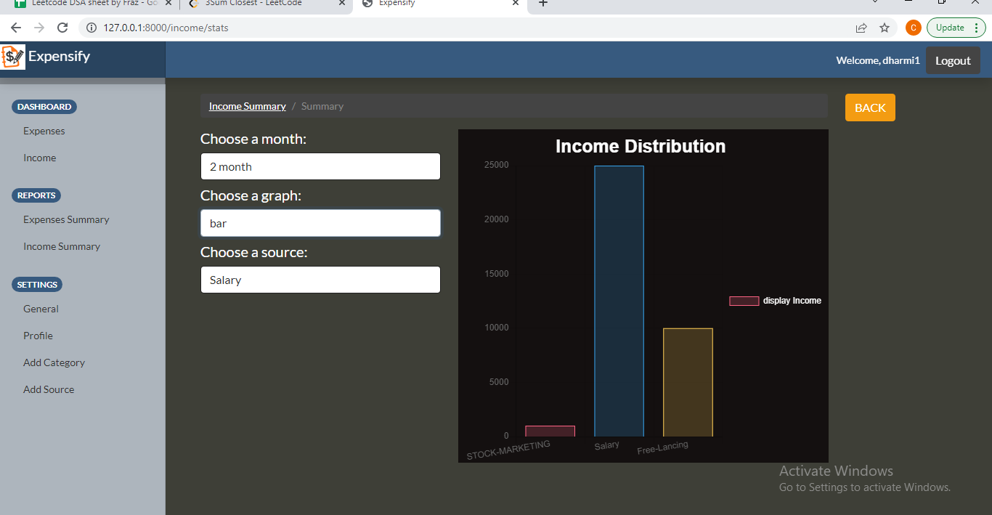

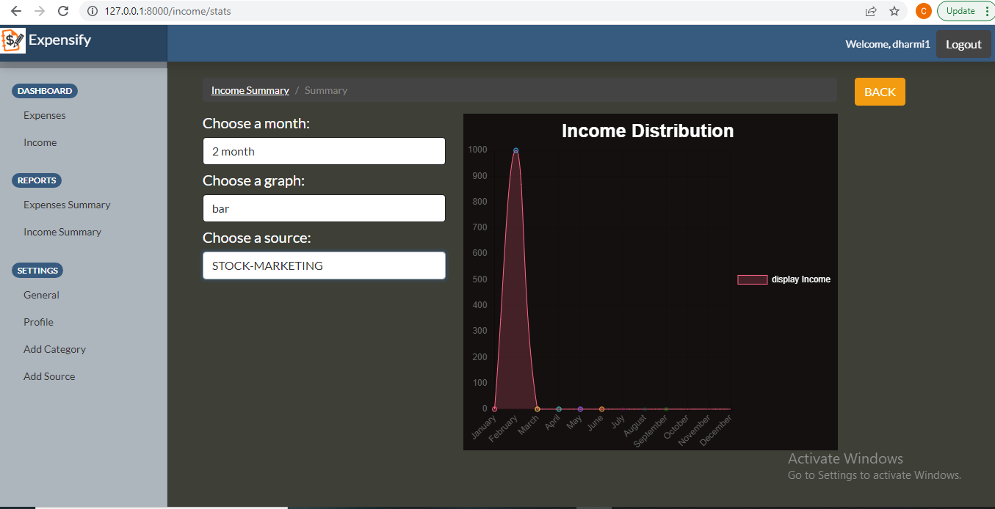

# 8)Conclusion

The functionalities that are implemented in the system are prepared after

understanding all functionalities according to software requirements

specifications (SRS). Functionalities that are successfully implemented in

the system are as follows:

* Login
* Registration
* User authentication
* Logout
* Add Expense/Income record
* Edit Expense/Income record
* Delete Expense/Income record
* Search Expense/Income record
* View Statistic Expense/Income record
* Export Excel Expense/Income record file
* Expense/Income Report
* Add Source/Category
* Edit profile

After implementing all these functionalities, comprehensive testing was

performed on the system to determine possible errors.

**9)Limitations and future extensions**

**Limitations:**

* This project is suitable for small scale organization
* When type of category/source is very high then using graphs see the summary is Difficult.

**Future extensions:**

* We implement Functionality that convert rupees to other currency so is it use for any user.

# 10)Bibliography

Following links and websites were referred during the development of this project:

* [www.docs.djangoproject.com](http://www.docs.djangoproject.com)
* <https://www.chartjs.org/>
* <https://github.com/>
* <https://stackoverflow.com/>
* https://www.w3schools.com/
* <https://getbootstrap.com/docs/4.0>
* <http://www.umletino.com/>
* <https://www.python.org/doc/>