GLOBAL SECTORAL GREENHOUSE GAS EMISSIONS
From emissions trends to an investment decision (1990–2030)
Applied Python Project Report — including the Carbon Strategy & Investment Optimizer
Course: Introduction to Python (Applied Python Project)
Team members / Roll numbers: [Name 1 – Roll no.] [Name 2 – Roll no.]
Faculty: [Instructor name]
Submission date: [dd Month 2026]
Notebook: IPP_PROJECT (Google Colab) — Part A: Cells 1–10, Part B: Cells 11–23
Data: EDGAR Community GHG Database (EDGAR_2026_GHG), European Commission Joint Research Centre, plus World Bank, IEA, IRENA, Ember/Our World in Data and IPCC sources listed in Section 12. All emissions are in million tonnes of CO₂-equivalent (Mt CO₂e).

Contents
Executive Summary
1. Background, Business Problem and Decision-Maker
2. Objectives
3. Data Sources and Variables
4. Methodology and System Design
5. Part A — Exploratory Analysis (Cells 1–10)
6. Part B — Carbon Strategy & Investment Optimizer (Cells 11–23)
7. Consolidated Findings
8. Recommendations to Management
9. Assumptions and Limitations
10. Extra Credit — Live API Integration
11. Conclusion
12. References and Data Sources
Appendix A — Assumption Tables
Appendix B — How to Run the Notebook

Executive Summary
This project turns an exploratory analysis of greenhouse-gas emissions into a decision-support system. Using EDGAR data for 11 countries, 3 sectors (Agriculture, Industrial Combustion, Power Industry) and 36 years (1,188 observations), Part A describes how emissions have changed. Part B — the Carbon Strategy & Investment Optimizer — answers the second half of our approved problem statement, which sectors and countries should be prioritised, as a concrete capital-allocation decision for an illustrative climate investment fund with a US$10 billion budget.
What the data shows. Power Industry is the dominant sector: 11,320 Mt CO₂e in 2025 (59.8% of the sample), up 170.9% since 1990. China's power sector alone emits 6,634 Mt. India's three sectors rank #2–#4 on our priority score and are all at or near their all-time peaks, Indonesia's power emissions are growing 7.7% a year, while UK, German and US power emissions are 39–77% below their peaks. On current trends the sample will be 10,399 Mt CO₂e per year above a 1.5 °C-aligned pathway in 2030 — 6,985 Mt of it in power.
What is at stake financially. Only about US$179 bn a year of carbon cost is priced in these markets today. Applying IEA scenario carbon prices to 2030 emissions raises this to US$1,427 bn (announced pledges) or US$2,379 bn (net zero). The largest repricing risks are China–Power (+US$933 bn), China–Industrial Combustion, India–Power and US–Power — the last two currently have no national carbon price at all.
Recommended plan. Under the central scenario (IEA announced pledges), the optimizer recommends investing US$10.0 bn across 10 countries in four project types — rice-paddy water management (10.0 Mt/yr), industrial energy efficiency (6.7), precision fertiliser management (5.0) and onshore wind (3.3). The plan avoids 25.0 Mt CO₂e per year (333 Mt over project lives), meets the 25 Mt target, and has an NPV of US$16.6 bn (ROI 166%, payback 3.9 years). It avoids 1.5× the emissions of an equal split of the same budget, and gives up only 0.9 Mt/yr versus a pure impact plan while adding US$14.2 bn of value.
Key risks and what management should do. The plan's value depends on carbon policy: at today's carbon prices its NPV falls to US$0.3 bn. Return-seeking capital also bypasses the markets that matter most — only 13% of the budget reaches India, Indonesia, Brazil and South Africa. Cheaper finance alone does not change this; giving those projects full carbon value (e.g. international credits under Article 6) lifts it to 58%, and both levers together to 61%. Management should (1) approve the plan in tranches, starting with "no-regret" negative-cost projects; (2) pair emerging-market investments with development-bank guarantees and international carbon-credit buyers; (3) set carbon-policy triggers for later tranches; and (4) replace our planning cost assumptions with project quotes before investment committee.
Important distinction
Our data measures national sector emissions (e.g. all power plants in India), not any company's emissions. We use it to size markets, forecast where they are heading and estimate national carbon-cost pools — never as a company's carbon footprint. Section 6.12 shows how a company should use the results correctly.

1. Background, Business Problem and Decision-Maker
Greenhouse-gas emissions are a strategic concern for governments, utilities, manufacturers, agribusinesses and investors. Carbon pricing now covers about 29% of global emissions (World Bank, 2026) and is expanding into new economies such as India, Japan and Brazil. For capital providers, this creates both transition risk (assets whose emissions become expensive) and opportunity (projects that cut emissions cheaply).
Approved problem statement: How have emissions changed across Agriculture, Industrial Combustion and Power Industry in a selected sample of countries from 1990 to 2025, and which sectors and countries should be prioritised for decarbonisation?
In the first phase of the project the second half of this question was answered only descriptively. Phase 2 sharpens it into an operational decision without changing the approved statement:
Business decision (Phase 2): Across the 33 country–sector markets in the data, which decarbonisation projects should a climate investment fund finance — and how much in each — to meet an emissions-reduction target while maximising financial value, given a fixed budget, risk limits and uncertain future carbon prices?

1.1 Why a climate investment fund?
We evaluated several possible decision-makers before choosing one:
Candidate decision-maker | Fit with national country × sector data | Verdict
A single company reducing its own emissions | Poor — needs the firm's own inventory; national totals are not company emissions | Rejected (used only as a 'company lens', Cell 22)
Renewable-energy developer choosing countries | Partial — uses only the Power sector (one-third of the data) | Rejected
Low-carbon supplier sourcing tool | Poor — needs supplier-level data we do not have | Rejected
Climate investment fund allocating capital across markets | Strong — every country–sector pair becomes an investable market whose size, growth and carbon exposure come directly from our data | Selected

National data is the right input for this fund because it determines (a) how large each market is and therefore how much the fund can deploy there, (b) whether the market is growing or shrinking, and (c) how much carbon cost is at stake. The fund's own projects are then evaluated with project-level cost assumptions.

2. Objectives

Part A — Exploratory analysis (what happened?)
- Load, validate and clean the EDGAR dataset (missing values, duplicates, data types).
- Compare sectors and countries in 2025, show composition (treemap) and ranking changes (1990, 2010, 2025).
- Measure long-run change (1990–2025) and visualise trends and the power-sector 'race'.

Part B — Decision support (what should we do?)
- Profile all 33 markets with an object-oriented MarketProfile class and rank them with a transparent priority score.
- Add live economic context (GDP, population) through the World Bank API to measure emissions intensity.
- Forecast 2030 emissions and quantify the gap to a 1.5 °C-aligned pathway.
- Estimate each market's carbon-cost exposure under three carbon-price scenarios.
- Build a catalogue of eight decarbonisation projects, a marginal abatement cost curve (MACC) and an optimization engine that allocates the budget.
- Prove the value of optimisation against simple rules, stress-test the plan, and export a management-ready Excel workbook and executive summary.

3. Data Sources and Variables

3.1 Core dataset — EDGAR
The project CSV is derived from the EDGAR Community GHG Database (EDGAR_2026_GHG) published by the European Commission's Joint Research Centre with the report GHG emissions of all world countries – 2026 (time series to 2025). EDGAR reports emissions in Mt CO₂-equivalent; its sectors follow IPCC codes — Power Industry (1A1), Industrial Combustion (1A2) and Agriculture (IPCC 2006 3A, 3C, 5A). The notebook output shows 1,188 rows: 11 countries × 3 sectors × 36 years (1990–2025), a balanced panel with no duplicates or missing emissions values.
Variable | Role in the analysis
Country / EDGAR Country Code | Market identifier; the ISO-3 code is also used to query the World Bank API
Sector | Agriculture, Industrial Combustion or Power Industry
Year | 1990–2025
Emissions_Mt_CO2eq | Annual emissions (Mt CO₂e) — the core measure
Previous_Year_Emissions, Year_on_Year_Change(_Pct) | Annual change measures (used for checks; volatility is recomputed with NumPy)

Countries: Australia, Brazil, Canada, China, Germany, India, Indonesia, Japan, South Africa, United Kingdom, United States. Results are therefore described as 'within the sample', not global.

3.2 External data used in Part B
Item | Source | How it is used
GDP and population | World Bank Open Data API (live); fallback: World Bank 2023 GDP, UN WPP population via Our World in Data | Emissions per person and per US$ of GDP (Cell 13)
Current carbon prices (2026) | World Bank State & Trends of Carbon Pricing 2026; IEA GEC Model documentation 2025 (current-policy prices); UK ETS and ACCU market reports | Today's carbon cost and the downside scenario
Scenario carbon prices | IEA Global Energy & Climate Model documentation 2025, Table 2.4 (2035, US$2024) | Announced-pledges and net-zero scenarios
Solar and wind costs | IRENA, Renewable Power Generation Costs in 2024: solar US$691/kW (CF 17%), onshore wind US$1,041/kW (CF 34%) | Capital cost and output of power projects
Grid carbon intensity | Ember data via Our World in Data (2025; Indonesia 2024) | CO₂ avoided per MWh of new renewable power
Cost of capital | IEA Cost of Capital Observatory (financing costs in emerging economies at least 2× advanced) | Country discount rates
Abatement cost bands | IPCC AR6 WGIII Summary for Policymakers, Fig. SPM.7 | Calibration of non-power project costs
1.5 °C benchmark | IPCC AR6 Synthesis Report (−43% GHG by 2030 vs 2019) | 2030 pathway in Cell 15

4. Methodology and System Design
The notebook is organised as a pipeline. Each stage produces a table that feeds the next, so a manager can change one input on the control panel and re-run the whole analysis.
Stage | Cells | Output
Data pipeline | 1–3 | Clean, validated dataset (df_clean)
Exploratory analysis | 4–10 | Sector, country, ranking and trend visuals
Control panel | 11 | Budget, target, scenario, objective, risk limits, all assumptions and sources
Market intelligence | 12–14 | 33 MarketProfile objects, World Bank intensity data, priority scorecard and matrix
Outlook & exposure | 15–16 | 2030 forecast vs 1.5 °C path; carbon-cost exposure by scenario
Project universe | 17 | 80 investable projects (market × technology) and the MACC
Optimization engine | 18 | Recommended allocation (linear programming)
Validation & risk | 19–20 | Strategy comparison, budget frontier, carbon-price and financing stress tests
Decision output | 21–23 | Dashboard, auto-written recommendations, company lens, Excel + text exports

4.1 Python concepts and where they are used
Concept (syllabus) | Where it appears in the notebook
Variables & constants | Control panel (Cell 11) — BUDGET_USD_M, TARGET_MT_PER_YEAR, BASE_YEAR, FORECAST_YEAR
Lists | selected_years, DATA_SOURCES, attempts (optimizer fallback), recommendations
Tuples | SCENARIO_PRICES (advanced, emerging) unpacked in get_carbon_price; FALLBACK_ECON; (country, sector) dictionary keys
Dictionaries | COUNTRY_INFO, INTERVENTIONS, WEIGHTS, ACTIONS, profiles {(country, sector): MarketProfile}
Sets | REQUIRED_COLUMNS − set(df.columns) (Cell 1); rice-growing countries; missing API codes
Decisions (if/elif/else) | classify_market, momentum, get_carbon_price, rule-based recommendations
Loops & comprehensions | Building profiles and 80 projects; budget frontier; scenario re-valuation; lever tests
Functions | cagr, annuity_factor, get_carbon_price, carbon_exposure, build_projects, optimise_portfolio, portfolio_metrics, equal_split, respects_limits …
Object-oriented programming | MarketProfile class with 8 methods (latest, cagr_recent, forecast, momentum, to_dict, __repr__ …); custom OptimisationError exception class
Exception handling | File upload/read errors; ValueError for short series; API failure fallback; infeasible-optimisation fallback chain; file-write errors; ImportError outside Colab
NumPy | np.polyfit (trend forecast), np.diff/np.std (volatility), np.linspace, np.divide, vectorised optimizer matrices
Pandas | groupby, pivot, merge, rank(pct=True), transform, ExcelWriter
File handling | Read CSV; write 9-sheet Excel workbook; write and read back executive_summary.txt
Visualisation | Matplotlib, Seaborn heatmap, Plotly scatter, treemap, sunburst and animation
API integration | requests.get to the World Bank API with timeout and status checks
Optimisation | scipy.optimize.linprog (HiGHS solver)

4.2 How the optimization engine works
For every investable project i the code calculates three numbers per US$ invested: tonnes avoided per year, net present value (NPV), and yearly cash flow. The decision variable xᵢ is the amount invested in project i. In plain language:
Optimisation problem (Cell 18)
Choose xᵢ ≥ 0 for every project to maximise total NPV (return mode) or total tonnes avoided (impact mode),
subject to: Σ xᵢ ≤ budget • each country ≤ 30% of budget • each project type ≤ 30% • each sector ≥ 20% • each xᵢ ≤ its market capacity • (return mode) tonnes avoided ≥ 25 Mt/yr.
Market capacity = reach share × the market's own 2030 forecast emissions — this is where the national data drives the decision.

Project economics use standard finance formulas: the annuity factor (1 − (1 + r)⁻ⁿ)/r converts a yearly cash flow into today's money; NPV per US$ = (operating benefit + carbon value) × annuity factor ÷ capital per tonne − 1; the levelised abatement cost = capital per tonne ÷ annuity factor − operating benefit. If the settings are impossible (for example a target larger than the budget can buy) the code relaxes constraints step by step and explains what it changed, instead of crashing.

5. Part A — Exploratory Analysis (Cells 1–10)

5.1 Data loading and quality (Cells 1–3)
The CSV is uploaded through Colab and read with pd.read_csv inside a try/except block; a set difference confirms that every required column exists. Cleaning converts types, removes rows missing key fields, drops duplicate country–sector–year records and sorts the panel. The quality table reports 1,188 observations, 11 countries, 3 sectors, years 1990–2025, zero duplicates and zero missing emissions values.
Business value: a repeatable, validated pipeline means every later number can be traced back and re-run when EDGAR releases new data.

5.2 Sector dashboard, 2025 (Cell 4)
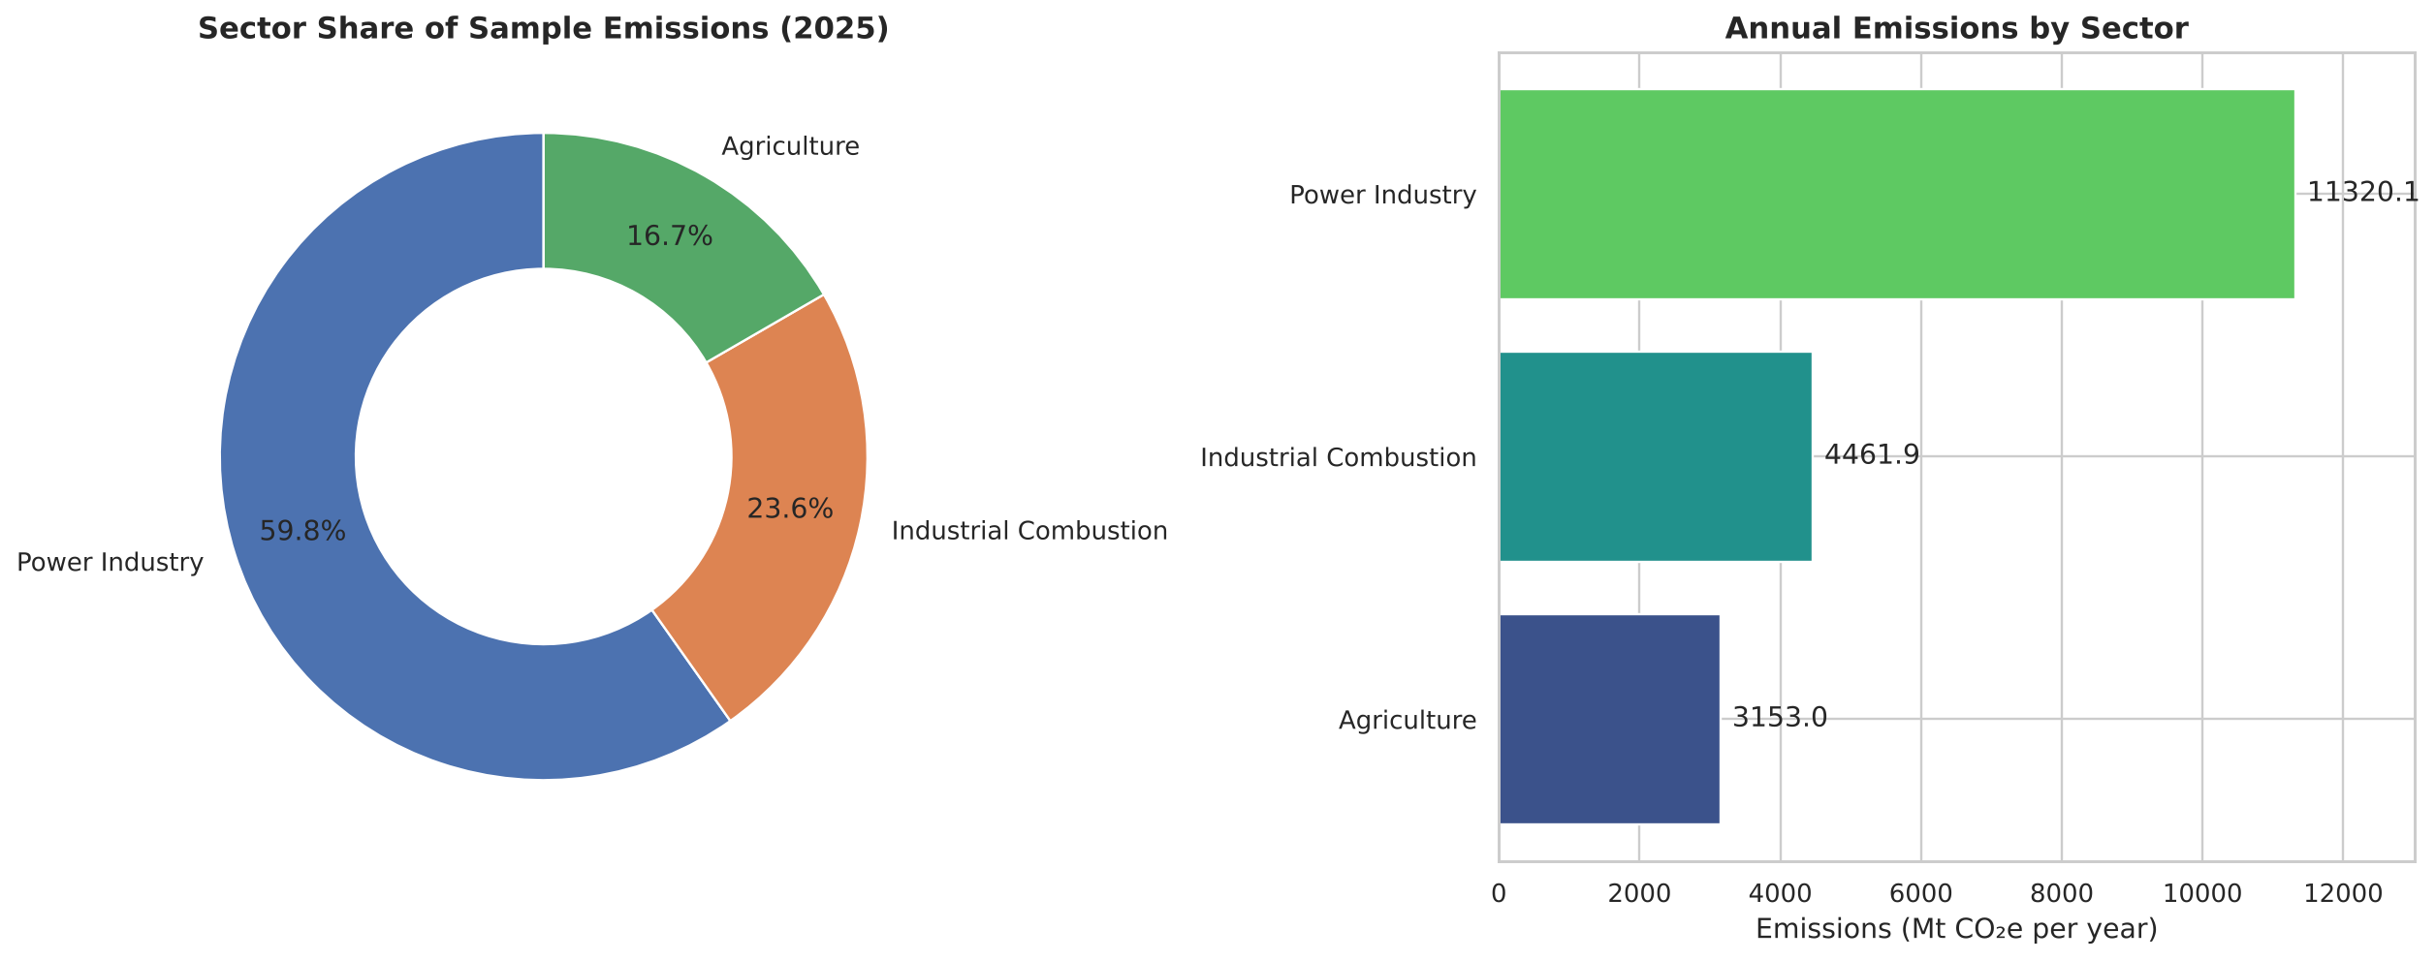
Figure 1. Sector share and annual emissions, 2025 (Mt CO₂e).
Power Industry emits 11,320.1 Mt CO₂e (59.8%), Industrial Combustion 4,461.9 Mt (23.6%) and Agriculture 3,153.0 Mt (16.7%). Power is about 2.5× Industrial Combustion and 3.6× Agriculture, making it the first place to look for large-scale reductions — but not the only one, as Part B shows.

5.3 Country comparison and composition (Cells 5–6)
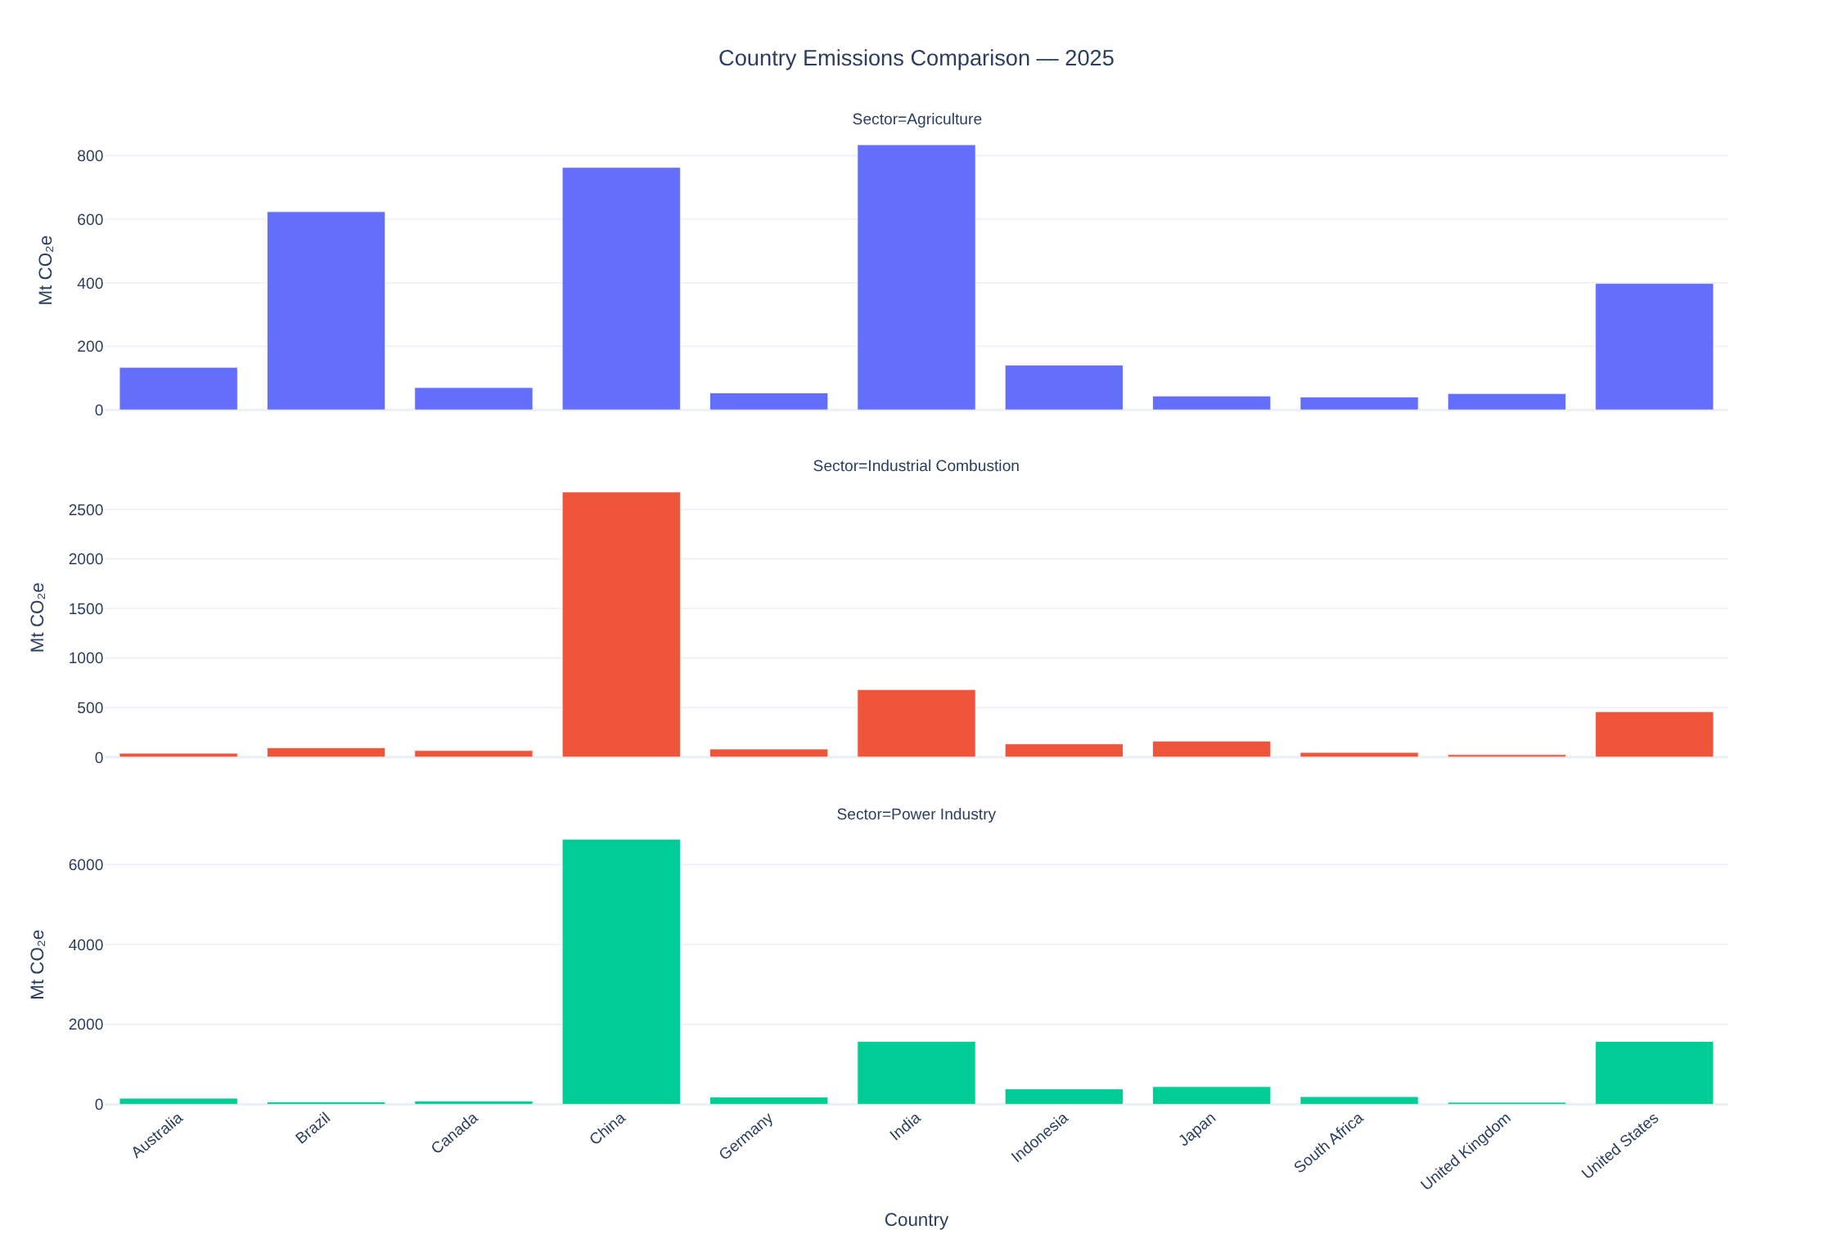
Figure 2. Country emissions by sector, 2025 (interactive in the notebook).
China is the largest emitter in Industrial Combustion and Power Industry; India leads Agriculture, followed by China and Brazil. In Power Industry China is far ahead, with the United States and India next. Absolute size reflects population, economic scale and industrial structure, so it is complemented with intensity measures in Cell 13.
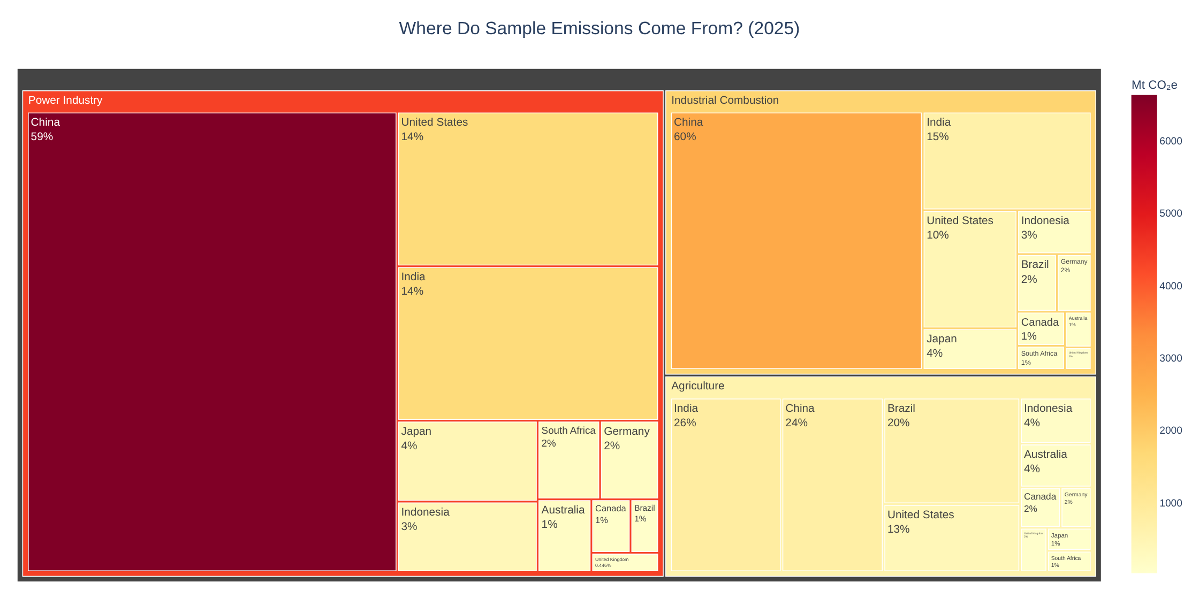
Figure 3. Treemap: where sample emissions come from in 2025 (sector → country).
The treemap confirms the concentration: China accounts for 59% of the Power Industry block and 60% of Industrial Combustion, while Agriculture is more evenly spread (India 26%, China 24%, Brazil 20%).

5.4 Ranking changes (Cell 7)
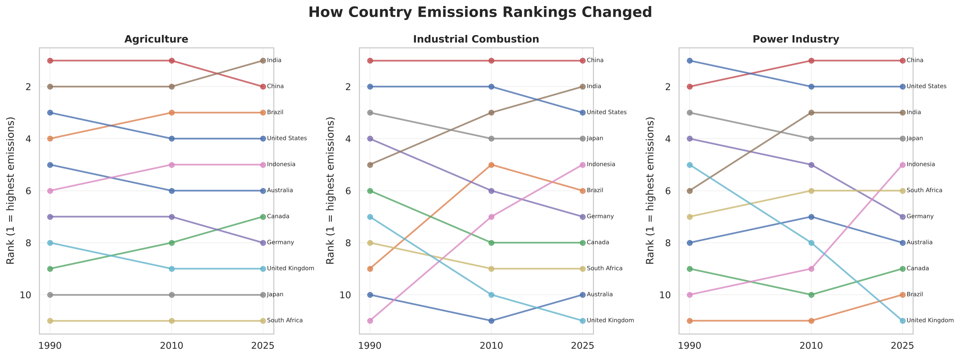
Figure 4. Country rankings by sector in 1990, 2010 and 2025 (1 = highest emissions).
In Power Industry China moves from 2nd (1990) to 1st (2010 onwards) and India from about 6th to 3rd, while the United States drops from 1st to 2nd. India becomes the largest agricultural emitter by 2025. Rankings show relative movement; they do not separate a country's own growth from others' decline.

5.5 Change in power-sector emissions, 1990–2025 (Cell 8)
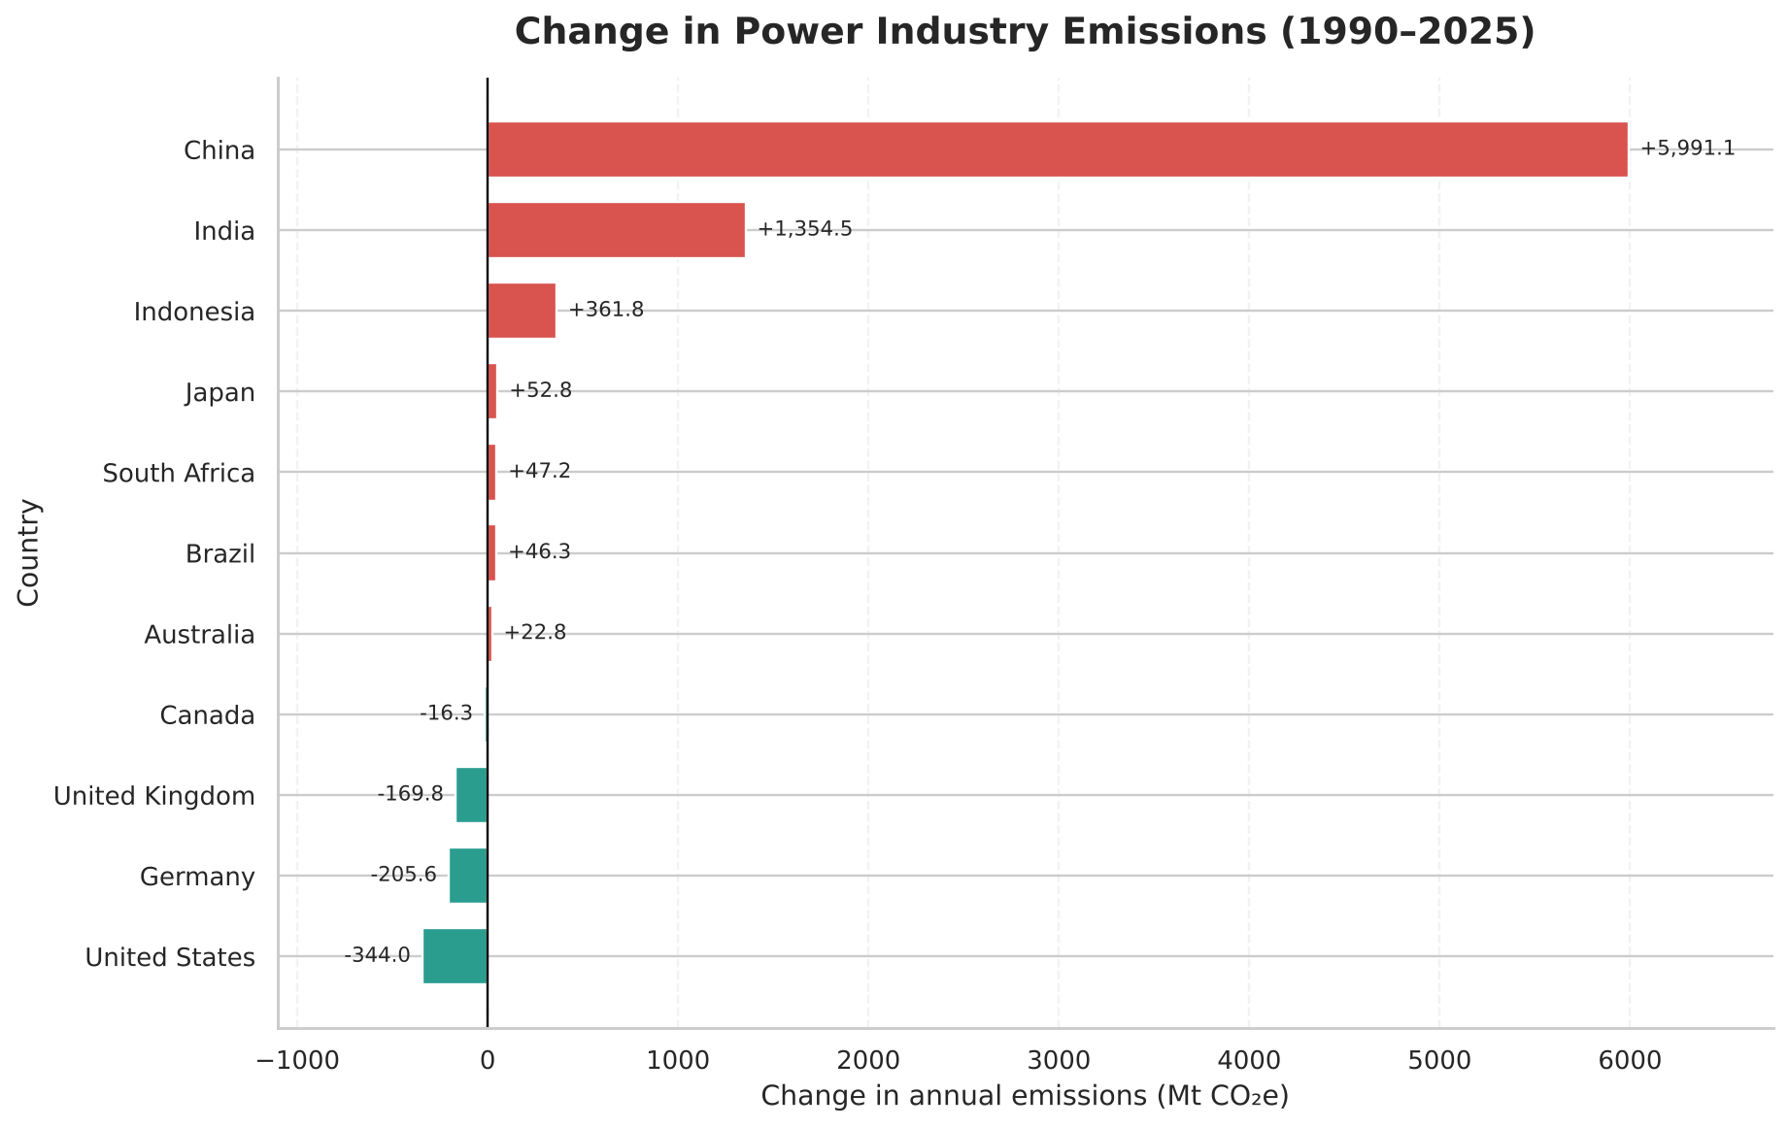
Figure 5. Absolute change in Power Industry emissions, 1990–2025 (Mt CO₂e).
China (+5,991 Mt) and India (+1,355 Mt) dominate the increase, followed by Indonesia (+362 Mt). The United States (−244 Mt), Germany (−206 Mt) and the United Kingdom (−170 Mt) declined. The chart shows that decarbonisation is possible but does not, on its own, explain why.

5.6 Long-term sector trends and the power 'race' (Cells 9–10)
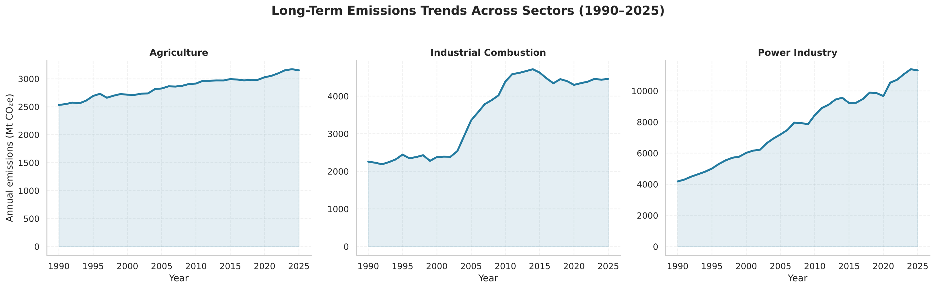
Figure 6. Sample totals by sector, 1990–2025 (Mt CO₂e).
Power Industry rises 170.9% (4,179 → 11,320 Mt), Industrial Combustion 97.8% with a sharp step-up in the 2000s and a plateau after its 2014 peak, and Agriculture a steadier 24.5%. Cell 10 animates the country ranking year by year (interactive; not reproducible on paper), making China's overtaking of the United States in 2006 visible to a non-technical audience.
Bridge to Part B
Part A tells us where emissions are and how they changed. It cannot tell a decision-maker what to do with a budget. Part B converts these patterns into market metrics, money at risk and an optimised investment plan.

6. Part B — Carbon Strategy & Investment Optimizer (Cells 11–23)

6.1 Control panel (Cell 11)
All decision settings sit in one cell that Colab renders as a form (text boxes, dropdowns and sliders). Default settings: budget US$10 bn; target 25 Mt CO₂e avoided per year; scenario = IEA Announced Pledges; objective = maximise NPV subject to the target; max 30% per country; max 30% per project type; min 20% per sector. The same cell stores every assumption in dictionaries (COUNTRY_INFO, INTERVENTIONS, SCENARIO_PRICES) and the full list of data sources, which are exported with the results.

6.2 MarketProfile class (Cell 12)
Each of the 33 markets becomes an object of the MarketProfile class. Its methods calculate the 2025 level, the 10-year compound growth rate, peak year, distance below peak, volatility (standard deviation of yearly % changes with NumPy), a 2030 trend forecast (np.polyfit on 2015–2025) and a momentum label. For example, India–Power Industry: 1,572 Mt in 2025, growing 3.7% a year, forecast 1,833 Mt in 2030. Objects that fail validation raise a ValueError that is caught and logged, so one bad series cannot stop the analysis.

6.3 Fair comparison with World Bank data (Cell 13 — API)
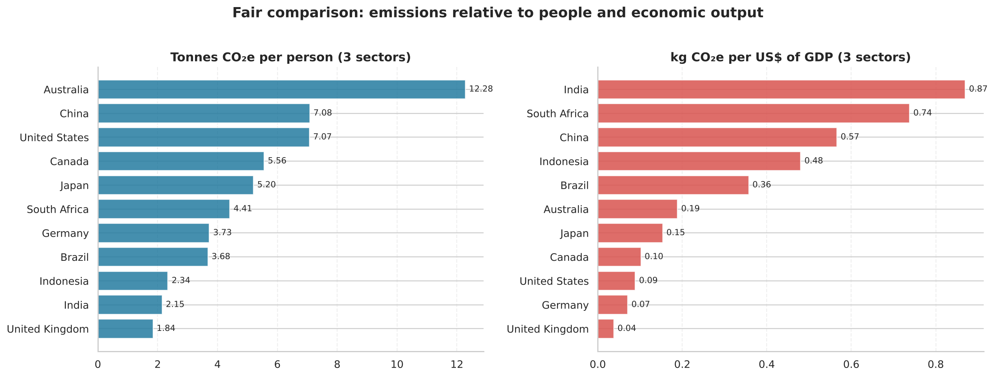
Figure 7. Emissions per person and per US$ of GDP (three sectors combined, 2025 emissions).
Intensity changes the picture. Australia has the highest emissions per person (12.3 t) — more than China or the United States (≈7.1 t) — while India is among the lowest (2.2 t). Per dollar of GDP, India (0.87 kg/US$), South Africa (0.74) and China (0.57) are the most carbon-intensive economies, the UK (0.04) and Germany (0.07) the least. Business meaning: carbon-intensive economies face the largest cost shock if carbon is priced, and offer the most tonnes per dollar for clean investment.

6.4 Market scorecard and priority matrix (Cell 14)
A transparent priority score (0–100) combines four percentile-ranked signals: size (40%), 10-year growth (30%), closeness to peak (15%) and the country's emissions per US$ GDP (15%). Each market is also placed in one of four strategic quadrants with a recommended stance.
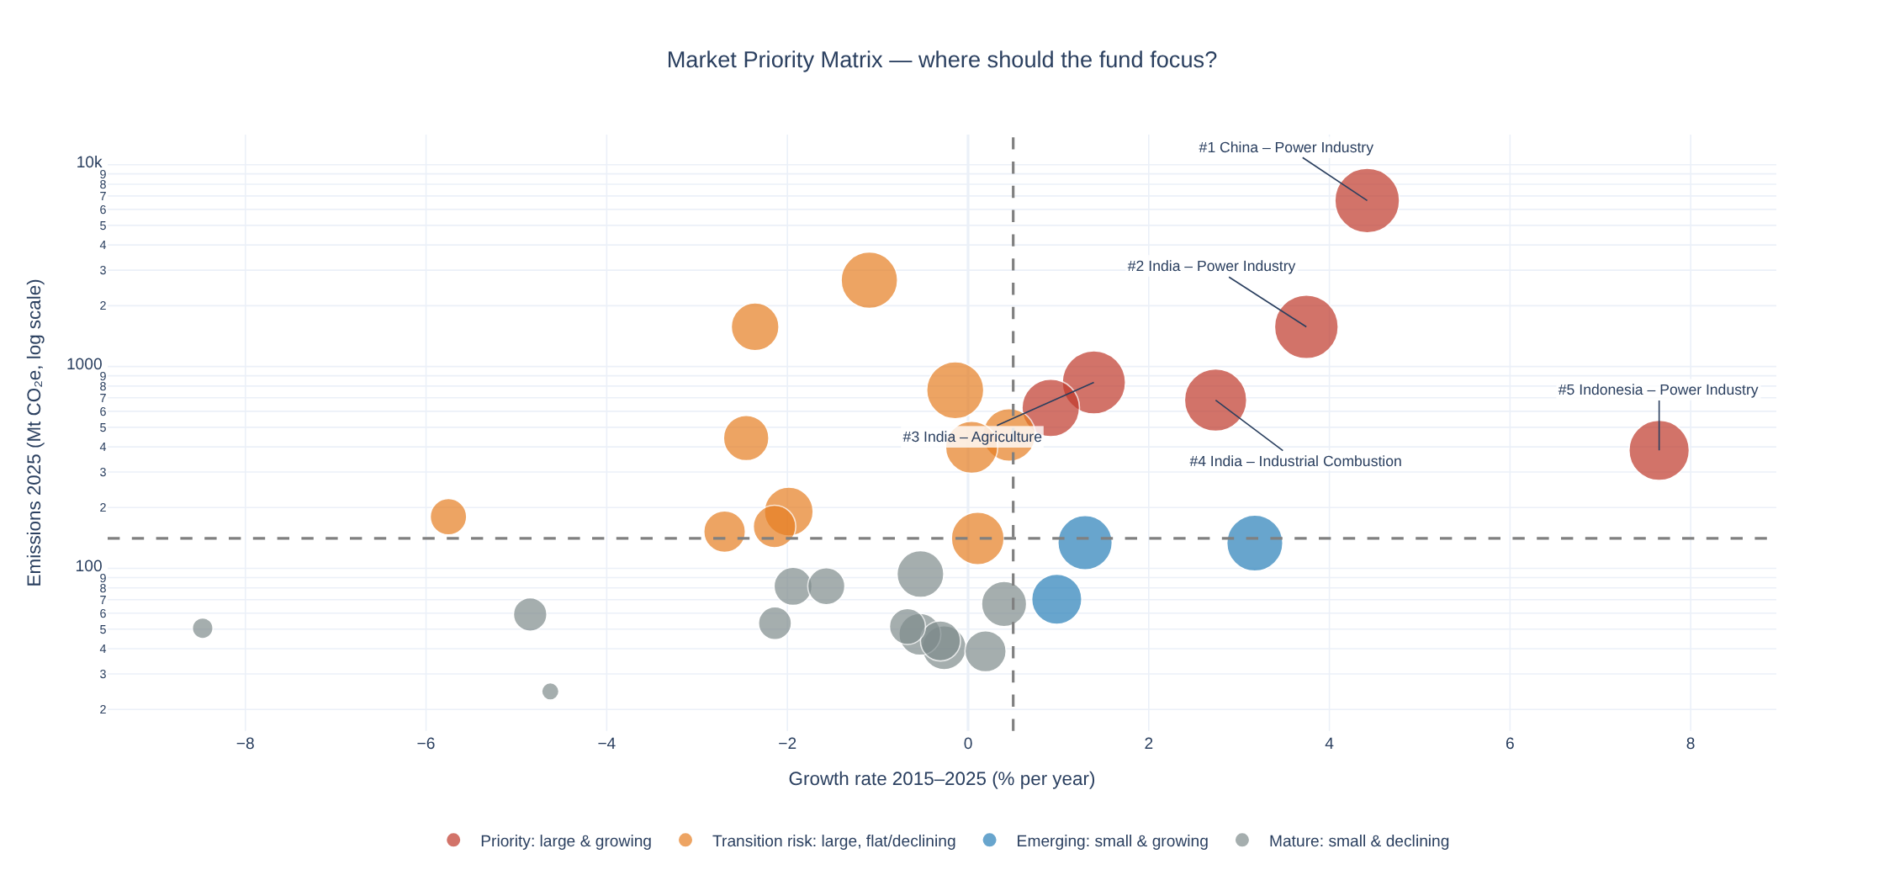
Figure 8. Market priority matrix: growth vs size (log scale); bubble size = priority score.
Rank | Market | 2025 Mt | Growth %/yr | Peak year | Score | Quadrant
1 | China – Power Industry | 6,634 | 4.4 | 2024 | 93 | Priority
2 | India – Power Industry | 1,572 | 3.7 | 2024 | 91 | Priority
3 | India – Agriculture | 834 | 1.4 | 2025 | 89 | Priority
4 | India – Industrial Combustion | 682 | 2.7 | 2024 | 86 | Priority
5 | Indonesia – Power Industry | 384 | 7.7 | 2025 | 81 | Priority
6 | Brazil – Agriculture | 624 | 0.9 | 2024 | 74 | Priority

Six markets are 'large & growing' — all in China, India, Indonesia and Brazil — while 11 are large but flat or declining (e.g. China–Industrial Combustion, which peaked in 2014, and the US and Japanese power sectors). India appears three times in the top four: its power, agriculture and industrial sectors are all growing and at or near their peaks.

6.5 The 2030 emissions gap (Cell 15)
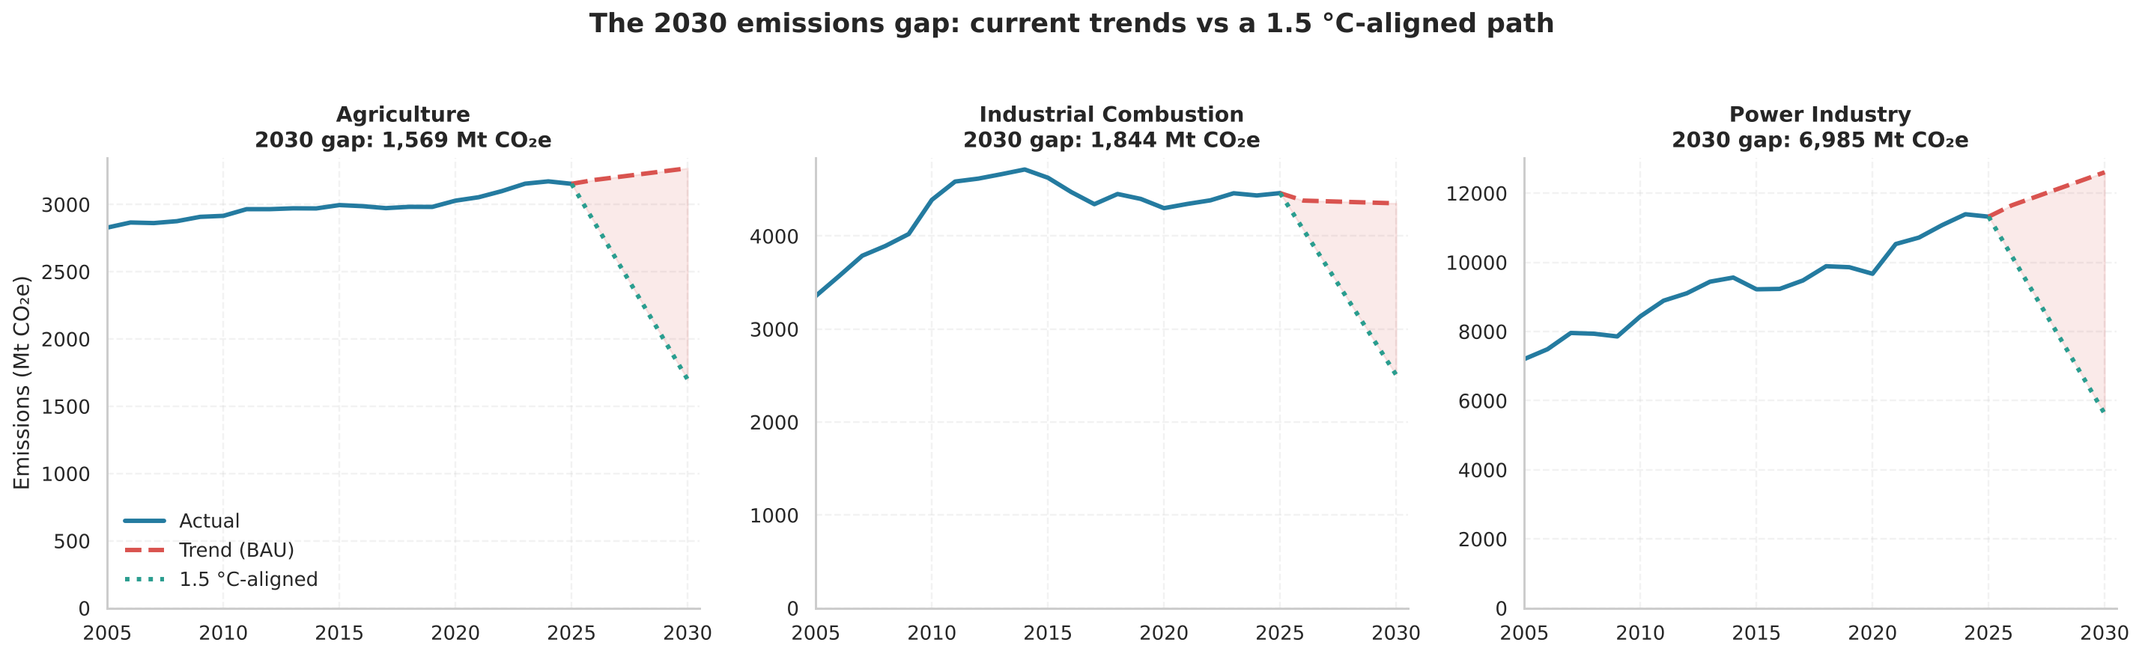
Figure 9. Business-as-usual trend vs a 1.5 °C-aligned path (−43% vs 2019 by 2030).
Sector | 2019 | 2025 | 2030 trend | 2030 1.5 °C path | Gap
Agriculture | 2,981 | 3,153 | 3,269 | 1,699 | 1,569
Industrial Combustion | 4,399 | 4,462 | 4,352 | 2,508 | 1,844
Power Industry | 9,858 | 11,320 | 12,604 | 5,619 | 6,985

The total gap is 10,399 Mt CO₂e a year, two-thirds of it in power. The fund's 25 Mt target is about 0.2% of the gap — no single investor can close it, so the question is where each dollar does the most. The trend lines are simple linear extrapolations and are not predictions of policy outcomes.

6.6 Carbon exposure calculator (Cell 16)
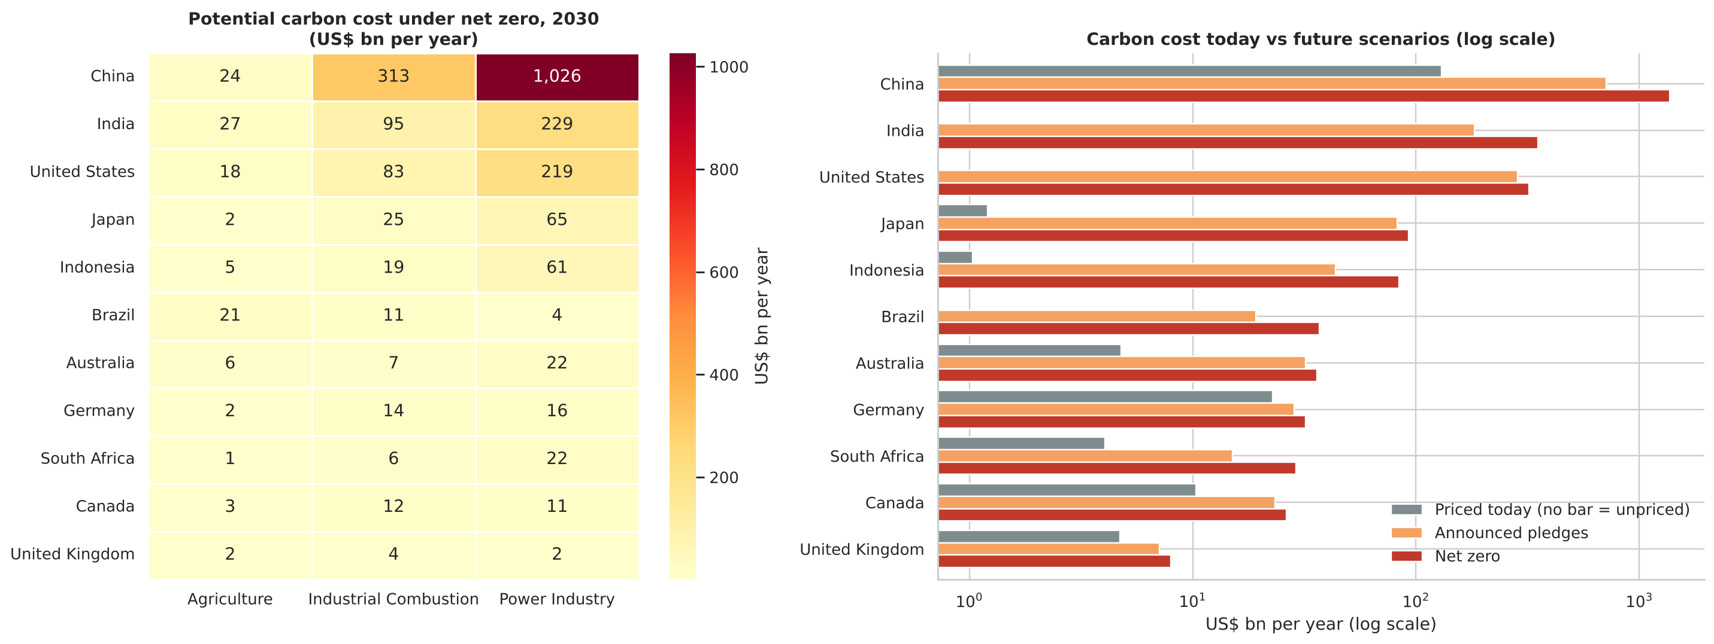
Figure 10. Potential carbon cost by market under net-zero prices (left) and by country across scenarios (right, log scale).
Exposure = emissions × carbon price. Today roughly US$179 bn a year is priced in these markets (mostly China's ETS, the EU and Canada). Under IEA announced-pledge prices it would be US$1,427 bn and under net-zero prices US$2,379 bn. The largest repricing gaps are:
Market | Priced today (US$ bn/yr) | Net zero 2030 (US$ bn/yr) | Repricing gap
China – Power Industry | 92.9 | 1,025.7 | 932.8
China – Industrial Combustion | 37.5 | 313.0 | 275.5
India – Power Industry | 0.0 | 229.2 | 229.2
United States – Power Industry | 0.0 | 219.2 | 219.2
India – Industrial Combustion | 0.0 | 94.8 | 94.8

Business meaning: these are national cost pools, not any firm's bill, but they show where policy change would move the most money — the markets where lenders, investors and suppliers face the greatest transition risk, and where clean projects gain the most value if carbon is priced.

6.7 Project universe and marginal abatement cost curve (Cell 17)
Combining every market with every technology that fits its sector gives 80 investable projects with a combined capacity of 909 Mt/yr (≈US$693 bn of capital). Power projects are calculated from IRENA costs and each country's grid carbon intensity — a wind farm in coal-heavy India or South Africa avoids about six times more CO₂ than one in hydro-based Brazil.
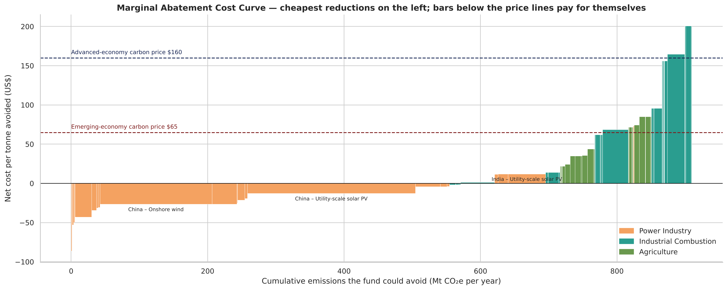
Figure 11. Marginal abatement cost curve (bar width = Mt/yr the fund could avoid; height = net cost per tonne before carbon revenue).
About 570 Mt/yr of the potential — mostly onshore wind and solar in high-carbon grids and industrial energy efficiency — has a negative net cost: it pays for itself from electricity sales or fuel savings even with no carbon price ("no-regret" investments). Agricultural measures cost roughly US$22–85/t and clean fuel switching in industry US$156–201/t, so they need carbon revenue.

6.8 Optimization engine — the recommended allocation (Cell 18)
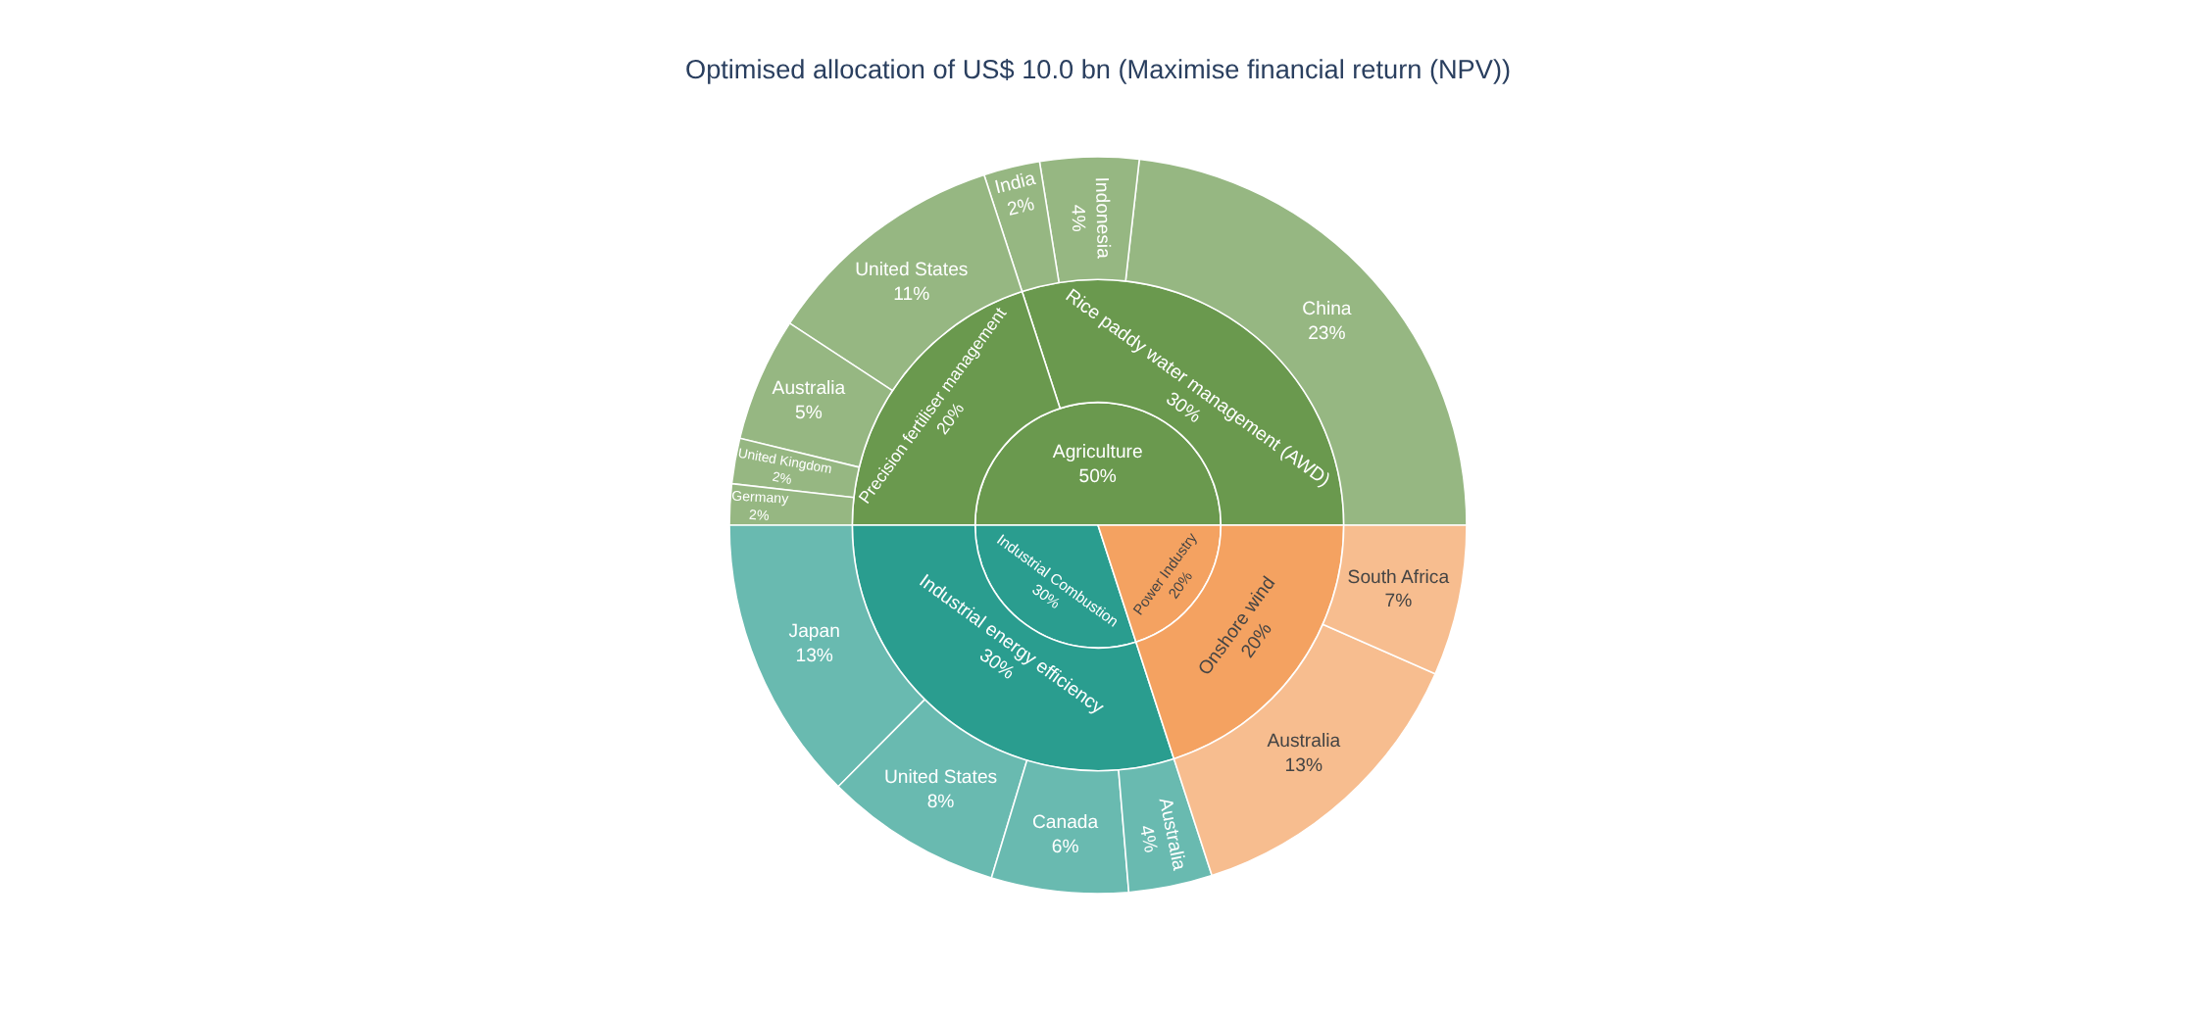
Figure 12. Optimised allocation of US$10 bn (sector → project type → country).
KPI | Value
Capital invested | US$ 10.0 bn
Emissions avoided | 25.0 Mt CO₂e per year (target 25 — met)
Emissions avoided over project lives | 333 Mt CO₂e
Net present value / ROI | US$ 16.6 bn / 166%
Simple payback | 3.9 years
Capital per tonne avoided per year | US$ 400

By sector the plan puts US$5.0 bn into Agriculture, US$3.0 bn into Industrial Combustion and US$2.0 bn into Power. Three limits bind: rice-paddy water management and industrial efficiency each hit the 30% technology cap, and power sits at its 20% minimum. Rice-paddy projects have a slightly negative NPV on their own — the optimizer buys them for their cheap tonnes, which is the cheapest way to meet the 25 Mt target while the profitable projects pay for it.

6.9 Does optimisation add value? (Cell 19)
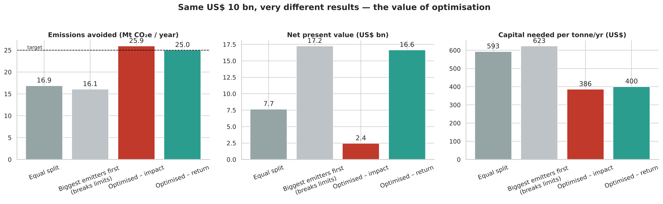
Figure 13. Four strategies with the same US$10 bn budget.
Strategy | Mt/yr | NPV (US$ bn) | ROI | Payback (yrs) | Within risk limits
Equal split | 16.9 | 7.7 | 77% | 6.1 | Yes
Biggest emitters first | 16.1 | 17.2 | 173% | 4.5 | No
Optimised – impact | 25.9 | 2.4 | 24% | 6.7 | Yes
Optimised – return | 25.0 | 16.6 | 166% | 3.9 | Yes

The optimised plans avoid about 1.5× the emissions of an equal split. "Biggest emitters first" achieves a similar NPV but avoids 8.9 Mt/yr less, misses the target and puts 90% of capital into power and none into industry, breaking the fund's diversification rules. Comparing the two optimised plans shows the impact–return trade-off: the return plan gives up only 0.9 Mt/yr but creates US$14.2 bn more value — mainly by shifting capital to advanced economies with cheaper finance and higher carbon prices.

6.10 Stress tests (Cell 20)
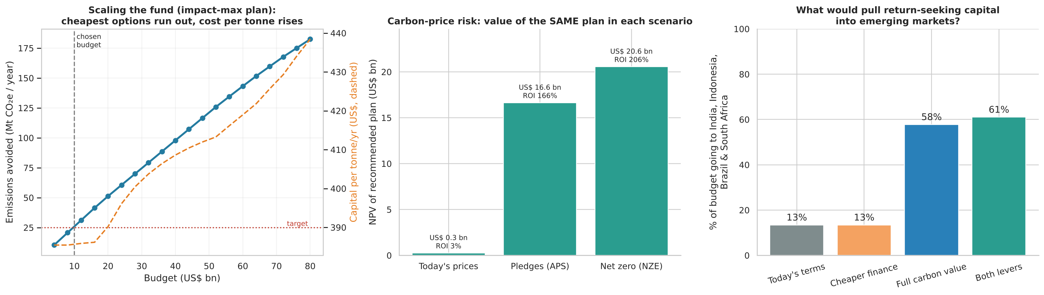
Figure 14. Budget frontier (left), carbon-price risk (centre) and the levers that move capital to emerging markets (right).
- Scale: emissions avoided rise almost in line with budget, while capital per tonne creeps up from US$385 to US$438 as the cheapest options are used up (US$4–80 bn).
- Carbon-price risk: the same plan is worth US$20.6 bn under net-zero prices, US$16.6 bn under announced pledges, but only US$0.3 bn (ROI 3%, payback 10.0 years) if carbon prices stay at today's levels. Most of the upside is a bet on carbon policy.
- Financing levers: at today's terms only 13% of the budget reaches India, Indonesia, Brazil and South Africa. Lowering their cost of capital from 10% to 6% alone changes nothing (13%), because their carbon value (US$65/t) is far below advanced economies' (US$160/t). Giving those projects full carbon value raises the share to 58% and both levers to 61% — with the same 25 Mt target met.

6.11 Recommended business action — dashboard (Cell 21)
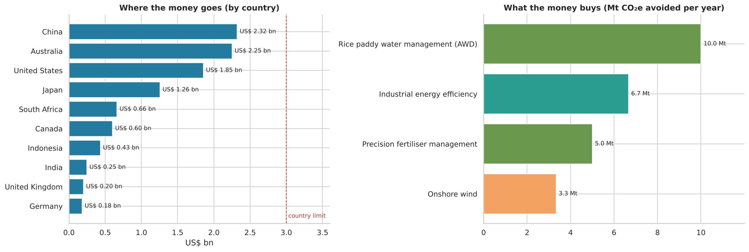
Figure 15. Where the money goes (by country) and what it buys (Mt CO₂e avoided per year).
Cell 21 shows KPI cards and writes the recommendations automatically using if/elif rules, so they update when settings change. With the default settings it produces:
- Commit US$ 10.0 bn across 10 countries and 4 project types, led by China (US$ 2.3 bn).
- The single biggest lever is 'Rice paddy water management (AWD)' (10.0 Mt/yr avoided).
- The 25 Mt/yr target is achievable within budget (25.0 Mt/yr).
- The plan stays profitable at today's carbon prices but loses most of its upside – stage investments and track carbon-price policy closely.
- Only 13% of the budget reaches India, Indonesia, Brazil and South Africa, although they hold top-priority markets (India – Power Industry, India – Agriculture, India – Industrial Combustion). 'Both levers' would raise this to 61% – partner with development banks and secure international carbon-credit buyers for these markets.

6.12 Company lens — using national data correctly (Cell 22)
A company should use the national results as context, never as its own footprint. Cell 22 takes the firm's own emissions from its inventory. Example: an illustrative Indian manufacturer emitting 2.0 Mt CO₂e/yr in industrial combustion. Its national sector emits 682 Mt and is growing 2.7% a year; a 30% cut by 2030 requires -6.9% a year — about 9.6 percentage points a year better than its sector. Its potential carbon bill would be US$0 today, US$130 m/yr under announced pledges and US$250 m/yr under net zero. Its cheapest option is industrial energy efficiency (≈US$14/t), far below heat pumps (≈US$96/t) or clean fuels (≈US$201/t).

6.13 Exports (Cell 23)
The notebook writes carbon_investment_plan.xlsx (nine sheets: recommended portfolio, strategy comparison, market scorecard, carbon exposure, all projects, stress test, project and country assumptions, data sources) and executive_summary.txt, which is read back to confirm it was written correctly and downloaded automatically in Colab. All file operations are wrapped in exception handling.

7. Consolidated Findings
- Power dominates, but is not the whole answer. Power Industry is 59.8% of 2025 sample emissions and grew 170.9% since 1990, yet the cheapest tonnes for a capital-constrained fund are in industrial efficiency and agriculture.
- India is the most important market to watch. Its three sectors rank #2–#4 on priority, are at or near their peaks, and have the highest emissions per dollar of GDP in the sample.
- China's industrial combustion has turned. It peaked in 2014 and has fallen about 1.1% a year since 2015 — invisible in the 35-year view.
- The 2030 gap is huge. Current trends leave the sample 10,399 Mt/yr above a 1.5 °C-aligned path.
- Carbon cost is mostly unpriced today. Exposure could rise from about US$179 bn to US$1,427–2,379 bn a year; China, India and US power carry the largest repricing risk.
- About 570 Mt/yr of the abatement available to the fund pays for itself even without a carbon price (wind, solar in high-carbon grids, industrial efficiency).
- Optimisation matters: 1.5× the tonnes of an equal split, with diversification limits respected.
- The plan's value is a carbon-policy bet: NPV falls from US$16.6 bn to US$0.3 bn at today's prices.
- Return-seeking capital avoids emerging markets (13% share). Carbon value, more than cheaper finance, is the lever that brings it back (58–61%).

8. Recommendations to Management
- Approve the target-constrained return plan as the central case. Invest US$10 bn to avoid 25.0 Mt/yr with an expected NPV of US$16.6 bn under announced-pledge prices.
- Deploy in tranches, starting with no-regret projects. Tranche 1: onshore wind and industrial energy efficiency, which have negative net abatement cost and remain viable at today's carbon prices. Release the agricultural tranches as carbon-credit buyers and monitoring systems are secured.
- Set carbon-policy triggers. Link later tranches to observable milestones — e.g. India's Carbon Credit Trading Scheme prices, Brazil's ETS start, Japan's GX-ETS auctions — and re-run the optimizer when they change.
- Build an emerging-market window with partners. Use development-bank guarantees and long-term international carbon-credit offtake (Article 6) so that India, Indonesia, Brazil and South Africa — where emissions are growing fastest — receive a larger share without destroying value.
- Use the exposure map for transition-risk screening. Apply the Cell 16 heatmap to the fund's wider holdings: China–Power, China–Industrial Combustion, India–Power and US–Power are the largest repricing risks.
- Keep the diversification limits. Two technology caps bind (rice-paddy management, industrial efficiency). Pilot rice-paddy projects first, because measuring methane reductions in smallholder farms is difficult.
- Replace planning assumptions before investment committee. Swap the illustrative non-power cost figures for project quotes; the notebook re-runs in seconds.
- Offer the company lens to portfolio companies. Help firms benchmark their own reduction pathway against their national sector — the Indian manufacturer example must cut 6.9% a year while its sector grows 2.7%.

9. Assumptions and Limitations
- National ≠ company emissions. EDGAR sector totals size markets and cost pools; they are not any firm's footprint or carbon bill.
- Sample scope. 11 countries and 3 sectors only; totals are 'sample', not global. Transport, buildings, industrial processes and waste are excluded.
- Illustrative project costs. Power costs come from IRENA; non-power costs are planning values calibrated to IPCC AR6 cost bands. 'Reach' shares (1–3% of a market) are judgement-based capacity limits.
- Carbon value assumptions. Scenario prices are IEA 2035 values applied as a constant price over project life; agricultural reductions are assumed to earn 25% of the scenario price through credits; current prices are approximate 2026 values (headline rates, not effective rates after free allowances).
- Simplified power economics. Renewables earn an assumed US$50/MWh and displace the average grid mix; real projects face curtailment, marginal (not average) displacement and site-specific costs. Heat pumps' extra electricity emissions are not netted off.
- Linear forecasts. 2030 trends use a straight line through 2015–2025; they are not policy projections.
- Linear optimisation. Returns are assumed to scale proportionally with investment within each project's capacity; there are no fixed costs, minimum ticket sizes or project lead times.
- Descriptive, not causal. The analysis does not explain why emissions changed or prove the effect of any policy.
- 2025 data. The latest EDGAR year may be revised in future releases.

10. Extra Credit — Live API Integration
The guidelines list external APIs as an optional, advanced component. Cell 13 integrates the World Bank Open Data API to pull each country's latest population (SP.POP.TOTL) and GDP in current US$ (NY.GDP.MKTP.CD).
- Request: one call per indicator for all 11 ISO-3 codes taken directly from the dataset's 'EDGAR Country Code' column (https://api.worldbank.org/v2/country/{codes}/indicator/{indicator}?format=json&mrv=1).
- Robustness: a 15-second timeout, raise_for_status() for HTTP errors, a check that every country returned data (set difference), and an except block covering network, JSON and key errors.
- Fallback: if the API is unreachable, stored values (World Bank 2023 GDP, UN WPP population) are used and the notebook prints which source was used — the demo never breaks.
- Business value: converts absolute emissions into per-person and per-GDP intensity, which feeds the priority score and corrects the bias towards large countries noted in Part A's limitations.

11. Conclusion
Part A showed that, within the sample, power-sector emissions dominate and have grown fastest, led by China and increasingly India, while the United States, Germany and the United Kingdom have reduced theirs. Part B turned these patterns into a decision. By treating each country–sector pair as an investable market, combining our data with published carbon prices and technology costs, and optimising under realistic risk limits, the notebook recommends a specific US$10 bn plan that meets a 25 Mt/yr target with strong expected value.
The most important managerial insights are not the headline numbers but the trade-offs the system exposes: impact versus return, carbon-policy risk, and the fact that return-seeking capital bypasses the fastest-growing emitters unless their projects can earn full carbon value. Because every assumption sits on one control panel, management can test its own views in seconds — which is what turns a visualisation project into a decision-support tool.

12. References and Data Sources
- European Commission, Joint Research Centre (2026). EDGAR Community GHG Database, EDGAR_2026_GHG, and 'GHG emissions of all world countries – 2026 Report'. https://edgar.jrc.ec.europa.eu/report_2026
- JRC Publications Repository — GHG emissions of all world countries, 2026 (JRC147815). https://publications.jrc.ec.europa.eu/repository/handle/JRC147815
- EDGAR_2025_GHG dataset page (sector definitions, IPCC codes, licence). https://edgar.jrc.ec.europa.eu/dataset_ghg2025
- World Bank (2026). State and Trends of Carbon Pricing 2026. https://documents1.worldbank.org/curated/en/099051826185087983/pdf/P502283-3ee8b1dc-6f1a-46dd-8141-e6534fd34af9.pdf
- IEA (2025). Global Energy and Climate Model Documentation 2025, Table 2.4 (CO₂ prices by scenario). https://iea.blob.core.windows.net/assets/bccc3753-6330-444e-bc62-356f104ed251/GlobalEnergyandClimateModelDocumentation2025.pdf
- IRENA (2025). Renewable Power Generation Costs in 2024 — Summary. https://www.irena.org/-/media/Files/IRENA/Agency/Publication/2025/Jul/IRENA_TEC_RPGC_in_2024_Summary_2025.pdf
- IEA. Cost of capital survey — financing costs in emerging and developing economies. https://www.iea.org/commentaries/cost-of-capital-survey-shows-investments-in-solar-pv-can-be-less-risky-than-gas-power-in-emerging-and-developing-economies-though-values-remain-high
- Ember / Our World in Data. Energy dataset (carbon intensity of electricity, population). https://github.com/owid/energy-data
- IPCC (2022). AR6 Working Group III, Summary for Policymakers (Figure SPM.7). https://www.ipcc.ch/report/ar6/wg3/
- IPCC (2023). AR6 Synthesis Report. https://www.ipcc.ch/report/ar6/syr/
- World Bank Open Data API (indicators SP.POP.TOTL, NY.GDP.MKTP.CD). https://api.worldbank.org/v2/
- UK ETS prices 2026 (£40–55/t range) — Resilient Sustainance. https://rsustain.co.uk/uk-carbon-markets-2026-landscape/
- ACCU spot price, July 2026 (~A$38/t) — Core Markets. https://coremarkets.co/insights/accu-market-monthly-update-july-2026
- IISD (2026). Carbon pricing in Southeast Asia (Indonesia carbon tax IDR 30,000/t). https://www.iisd.org/system/files/2026-03/carbon-pricing-southeast-asia.pdf
- Python libraries: pandas, NumPy, Matplotlib, Seaborn, Plotly, SciPy (optimize.linprog), requests. https://docs.scipy.org/doc/scipy/reference/generated/scipy.optimize.linprog.html
All web sources accessed 2 November 2026. Carbon-price and cost values are rounded planning inputs; see Appendix A.

Appendix A — Assumption Tables

A1. Country assumptions
Country | IEA group | Carbon price today (US$/t) | Discount rate | Grid intensity (t/MWh)
Australia | Advanced | 25 | 5% | 0.525
Brazil | Emerging | 0 | 10% | 0.110
Canada | Advanced | 70 | 5% | 0.191
China | Emerging | 14 | 6% | 0.525
Germany | Advanced | 87 | 5% | 0.330
India | Emerging | 0 | 10% | 0.670
Indonesia | Emerging | 2 | 10% | 0.680
Japan | Advanced | 2 | 5% | 0.477
South Africa | Emerging | 17 | 10% | 0.699
United Kingdom | Advanced | 63 | 5% | 0.217
United States | Advanced | 0 | 5% | 0.384
Today's prices: EU (Germany), Canada, China, Japan from IEA current-policy values; UK ≈ £47.5/t; Australia ≈ A$38/t (ACCU); South Africa headline tax ZAR 308/t; Indonesia legislated tax IDR 30,000/t; US = no federal price (state schemes excluded); India and Brazil schemes not yet priced. Scenario prices (2035): Announced pledges US$160 (advanced) / US$65 (emerging); Net zero US$180 / US$125.

A2. Project catalogue
Project | Sector | Capital cost | Yearly benefit (US$/t) | Life (yrs) | Reach
Utility-scale solar PV | Power | US$691/kW, CF 17% | Power sales at US$50/MWh less 1.5% O&M | 25 | 3%
Onshore wind | Power | US$1,041/kW, CF 34% | Power sales at US$50/MWh less 2.5% O&M | 25 | 2%
Industrial energy efficiency | Industrial | US$450 per t/yr | +45 (fuel saved) | 15 | 2%
Electrified process heat | Industrial | US$900 per t/yr | +10 | 20 | 1.5%
Clean fuel switch (biomass/H₂) | Industrial | US$1,200 per t/yr | −60 (fuel premium) | 20 | 1%
Precision fertiliser management | Agriculture | US$400 per t/yr | +30 (fertiliser saved) | 10 | 1%
Livestock methane feed additives | Agriculture | US$400 per t/yr | −20 (additive cost) | 10 | 1%
Rice paddy water management (AWD) | Agriculture | US$300 per t/yr | +5 | 10 | 1% (China, India, Indonesia)
'Reach' = share of a market's 2030 forecast emissions that one fund could realistically finance. Agricultural reductions earn 25% of the scenario carbon price (US$5/t voluntary credits under current policies).

Appendix B — How to Run the Notebook
- Open IPP_PROJECT_complete.ipynb in Google Colab (File → Upload notebook).
- Runtime → Run all. When Cell 1 asks, upload EDGAR_sector_emissions_project_dataset.csv.
- To test a decision, change values in the Cell 11 form (budget, target, scenario, objective, limits) and Run all again; for the company lens, edit the Cell 22 form.
- Cell 23 downloads carbon_investment_plan.xlsx and executive_summary.txt to your computer.
- If the World Bank API is unreachable, Cell 13 prints a warning and continues with stored values.

