A PROJECT REPORT ON
BAKERY SHOP

SUBMITTED TO
SAURASHTRA UNIVERSITY, RAJKOT

COLLEGE NAME
BHAVAN’S SHREE H.J. DOSHI I.T. INSTITUTE, JAMNAGAR

ACADAMIC YEAR 2024-2025
B.C.A SEM 6th

SUBMITTED BY
DHARMIK SIDDHPURA
NIDHI KUNDALIA

UNDER GUIDENCE OF
Prof. HIRAL PANDYA
INDEX

No. | Title | Page
1 | Certificate | 2
2 | Introduction | 4
3 | Scope | 5
4 | Tools Used | 7
5 | Data Dictionary | 8
6 | Context Diagram | 12
7 | Data Flow Diagram | 13
8 | E R Diagram | 16
9 | Form Layouts | 17
10 | Limitations | 30
11 | Future Enhancement | 31
12 | Bibliography | 32




INTRODUCTION

This project is an online platform created for a bakery shop, designed to make ordering and managing products easy and efficient. Customers can browse a wide range of bakery items, view details like prices, and place their orders conveniently from anywhere. The platform is user-friendly, ensuring a smooth and hassle-free shopping experience.
For the bakery owner or admin, the system includes an admin panel to manage the shop effectively. Admins can add, update, or remove products, track inventory levels, and monitor customer orders in real-time. This helps keep the shop organized and ensures that the bakery can meet customer demands without delays.
The project demonstrates the practical use of web development technologies to solve everyday business problems.
By integrating customer convenience with administrative efficiency, the platform not only improves operations for the bakery but also enhances customer satisfaction. It is a great example of how technology can be used to support small businesses and make them more accessible and competitive in the digital era.
SCOPE

1. Customer Management: The platform will include a robust customer management system to streamline interactions and improve user experience. Customers will be able to create and manage their accounts, view their order history, and save preferences for future orders. The system will also support personalized engagement through targeted promotions and loyalty rewards to foster long-term customer relationships.

2. Order Management: A comprehensive order management feature will ensure seamless handling of customer purchases. From order placement to fulfillment, the system will track all stages, including payment confirmation, preparation, and delivery.

3. Product Management: Every bakery has a variety of products like cakes, cookies, bread, and pastries. The admin panel will provide options to add new products, update details like pricing and descriptions, and manage stock levels. This will ensure that customers always have accurate information about product availability and offerings.

4. Category Management: Organizing products into proper categories enhances the shopping experience for customers. The system categorizes bakery items into different sections such as cakes, pastries, cookies, bread, and beverages. This makes it easier for both customers and staff to find products quickly.

Conclusion: A Bakery Shop Management System plays a crucial role in ensuring smooth and efficient bakery operations. By managing customers, orders, products, and categories, it enhances overall productivity and customer satisfaction. The system minimizes errors, speeds up service, and ensures that the bakery always has fresh products available. With automated processes, bakery owners can focus more on growing their business while providing a seamless shopping experience to customers.

TOOLS USED

Project Frontend
- ASP.NET (2012)

Project Backend (DATA BASE)
- SQL Server (2012)

Duration
- 3 Months

Software Requirement
1. SQL server
2. Visual studio

Hardware Requirement
        - 2gb ram
        - 80gb hard disk

DATA DICTIONARY

Tbl_AdminMaster

Field Name | Type | Size | Value
AdminId | numeric(18, 0) | 18 | Primary key
FName | varchar(50) | 50 | None
LName | varchar(50) | 50 | None
EmailId | varchar(50) | 50 | None
Password | varchar(50) | 50 | None
Admin_Isact | bit | 1 | None

Tbl_Cart

Field Name | Type | Size | Value
Cart_Id | integer | 10 | None
ClientId | integer | 10 | None
Prdocut_id | integer | 10 | None
Qty | integer | 10 | None
Cart_Isact | bit | 1 | None

Tbl_CategoryMaster

Field Name | Type | Size | Value
Cat_Id | integer | 10 | Primary key
Category_Name | varchar(50) | 50 | None
Cat_Isact | Bit | 1 | None

Tbl_ClientMaster

Field Name | Type | Size | Value
ClientId | numeric(18, 0) | 18 | Primary key
FName | varchar(50) | 50 | None
LName | varchar(50) | 50 | None
Address | varchar(MAX) | 255 | None
MobileNo | nchar(10) | 10 | None
EmailId | varchar(50) | 50 | None
Password | varchar(50) | 50 | None
Client_Isact | Bit | 1 | None

Tbl_Order

Field Name | Type | Size | Value
Date | varchar(50) | 50 | None
Order_Id | integer | 10 | None
Client_Id | integer | 10 | None
Product_Name | varchar(50) | 50 | None
Qty | integer | 10 | None
Price | numeric(18, 2) | 18 | None
TotalAmount | numeric(18, 2) | 18 | None
Order_Isact | bit | 1 | None

Tbl_Product_Master

Field Name | Type | Size | Value
Product_Id | integer | 10 | Primary key
Product_Name | varchar(50) | 50 | None
Category_Name | varchar(50) | 50 | None
Product_Price | varchar(50) | 50 | None
Product_Discription | varchar(MAX) | 255 | None
Product_ImgUrl | varchar(MAX) | 255 | None
Product_Isact | Bit | 1 | None

CONTEXT DIAGRAM

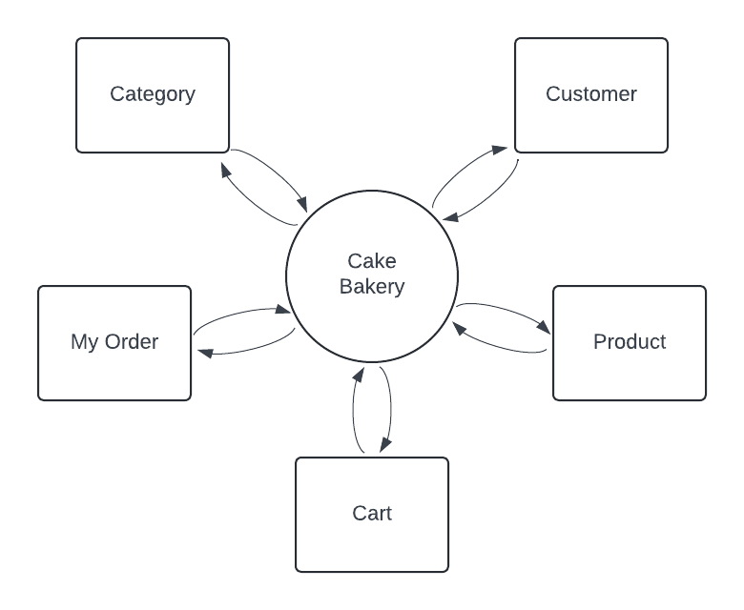

DATA FLOW DIAGRAM

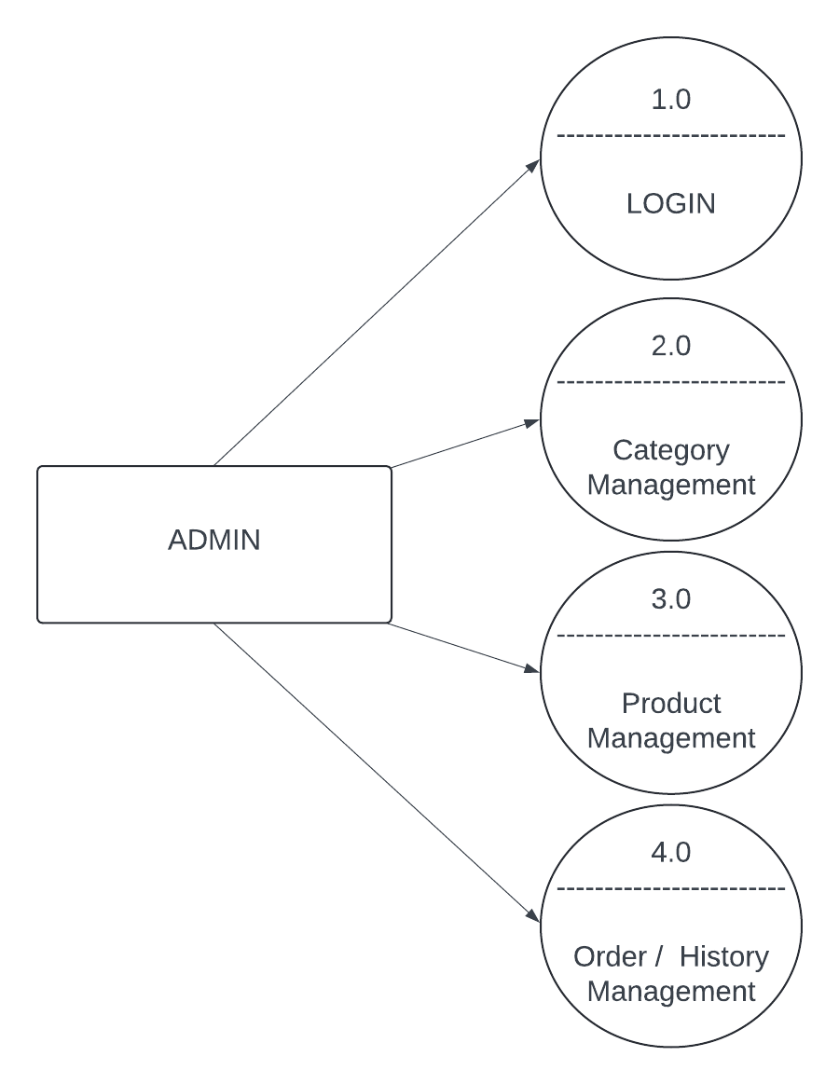

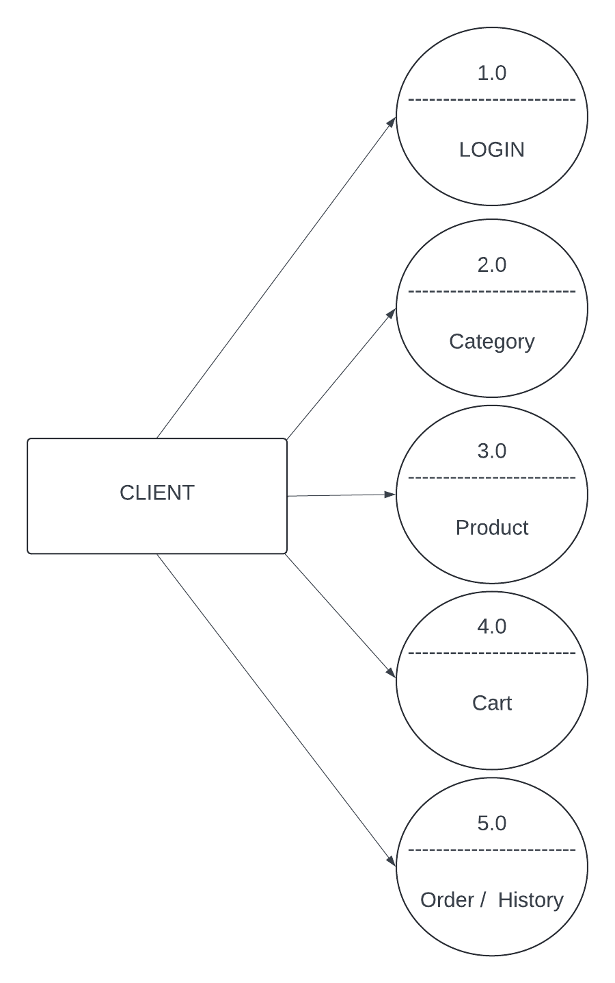
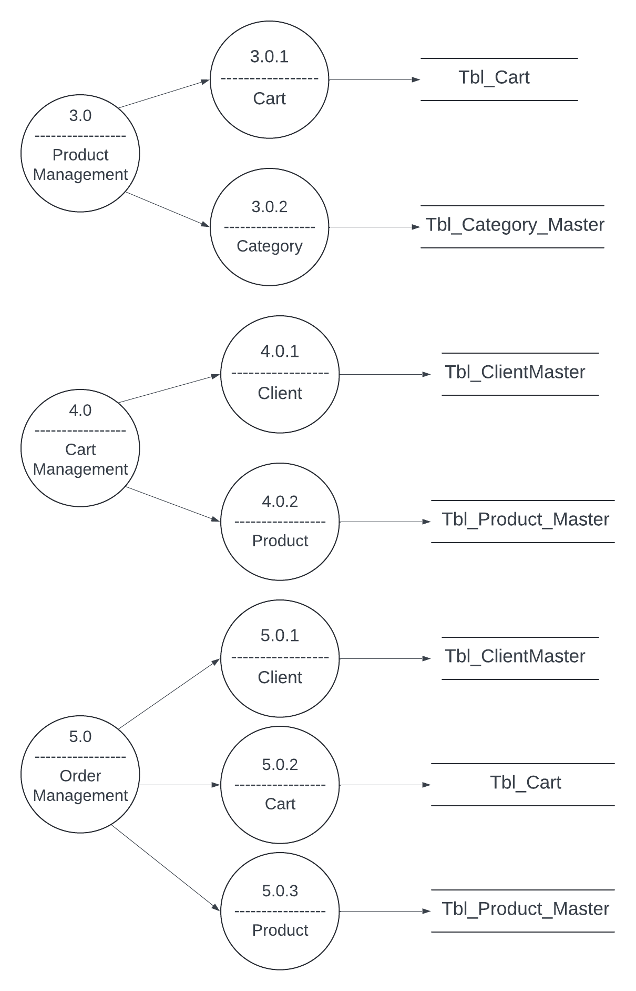
E-R DIAGRAM

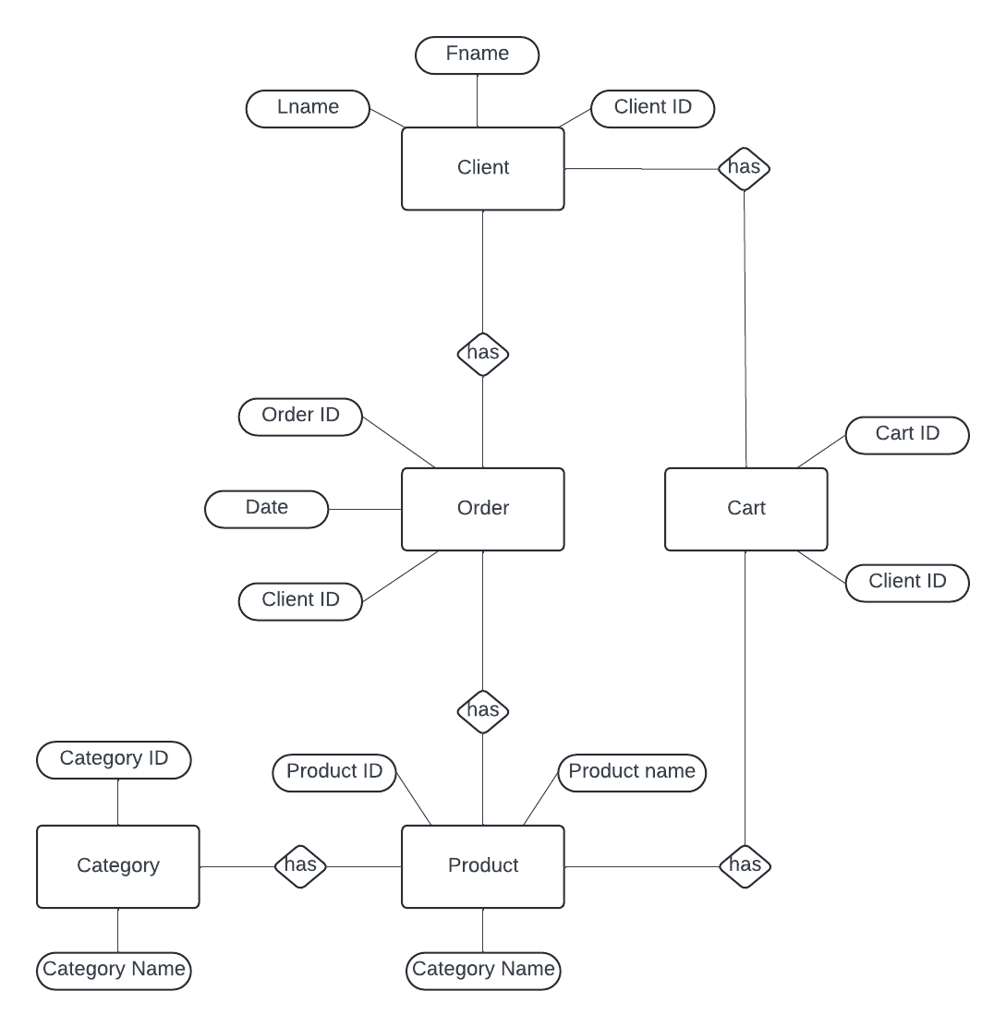

FORMS LAYOUT

- Admin Side

- Home Page
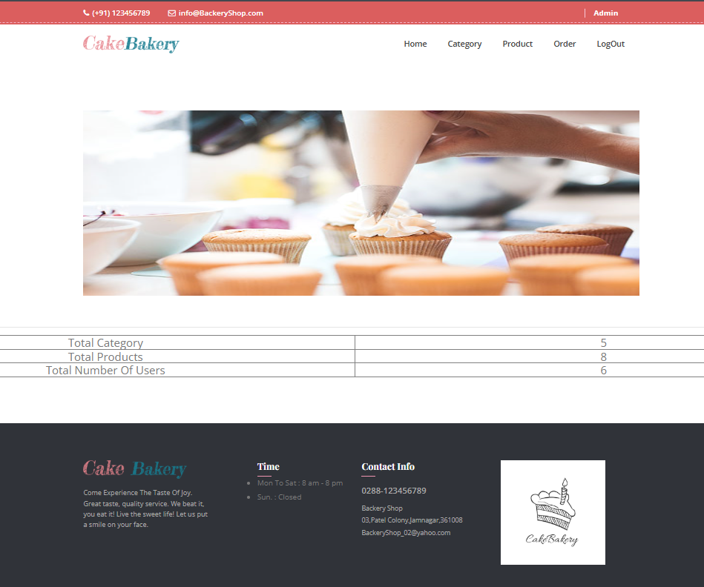

- Category Page

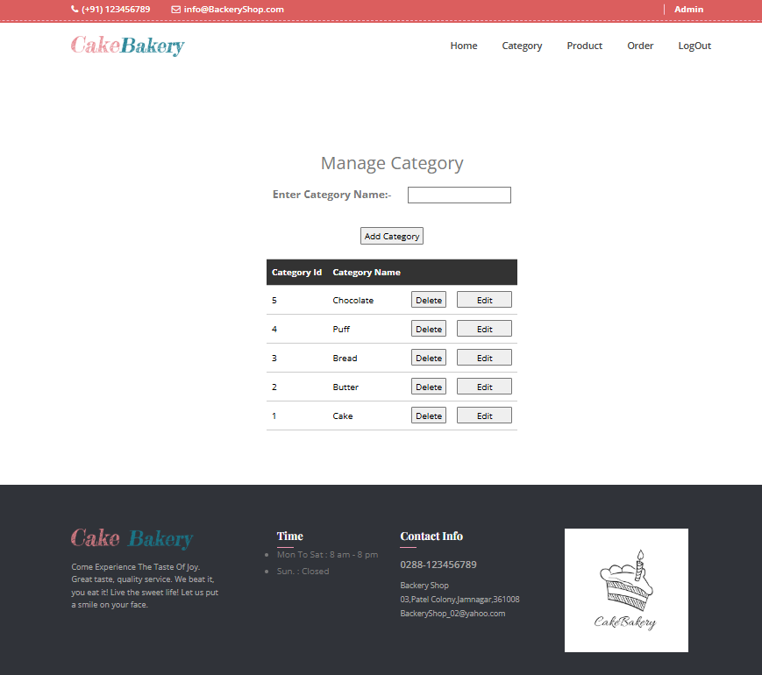

- Product Manage

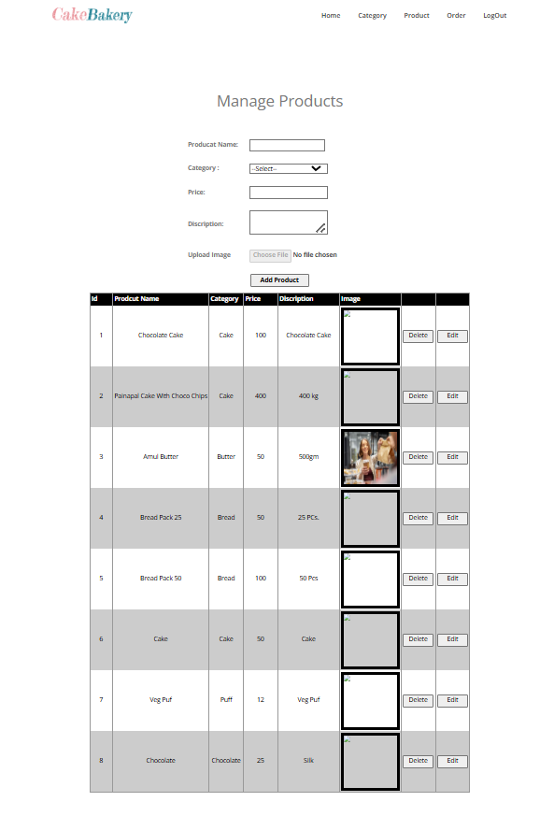
- Orders

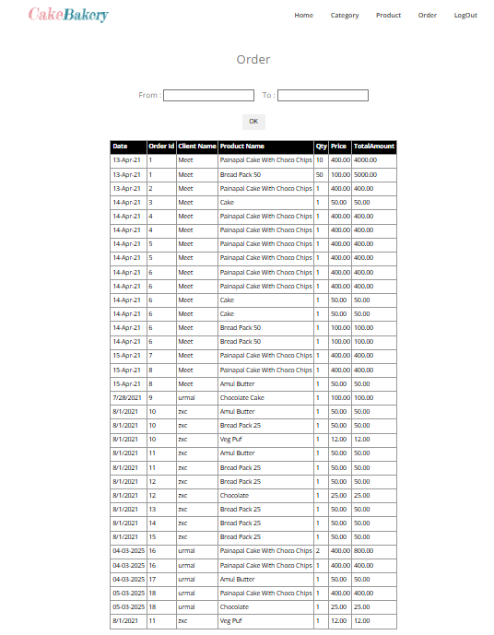
- Client Side

- Home Page

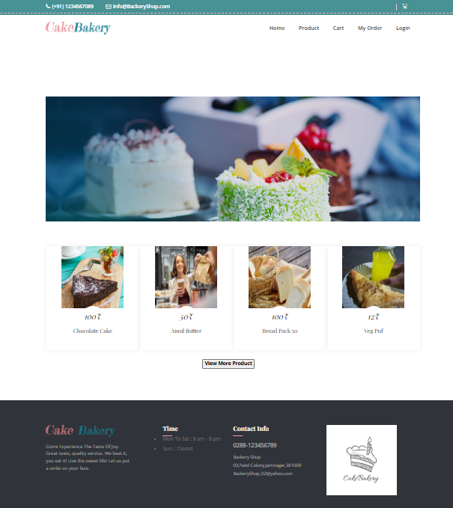

- Login Page

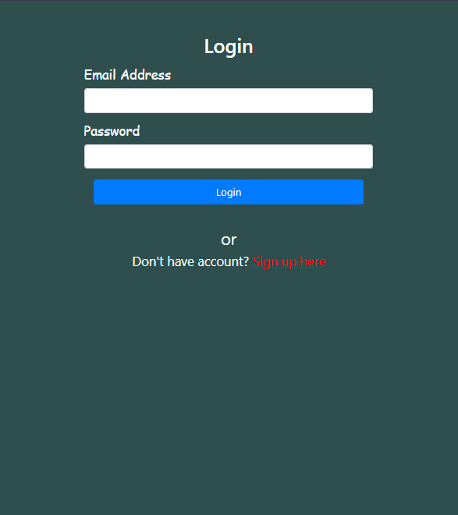

- Sign-Up

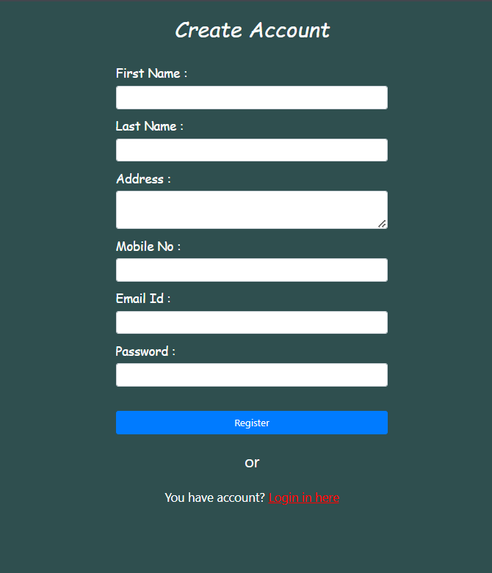

- Product Page

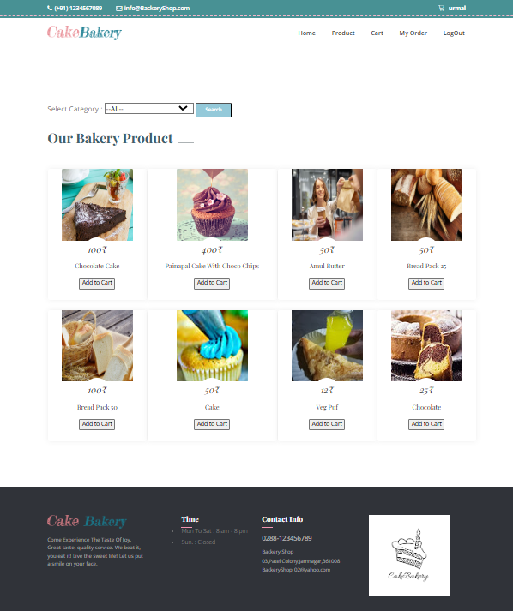

- Cart

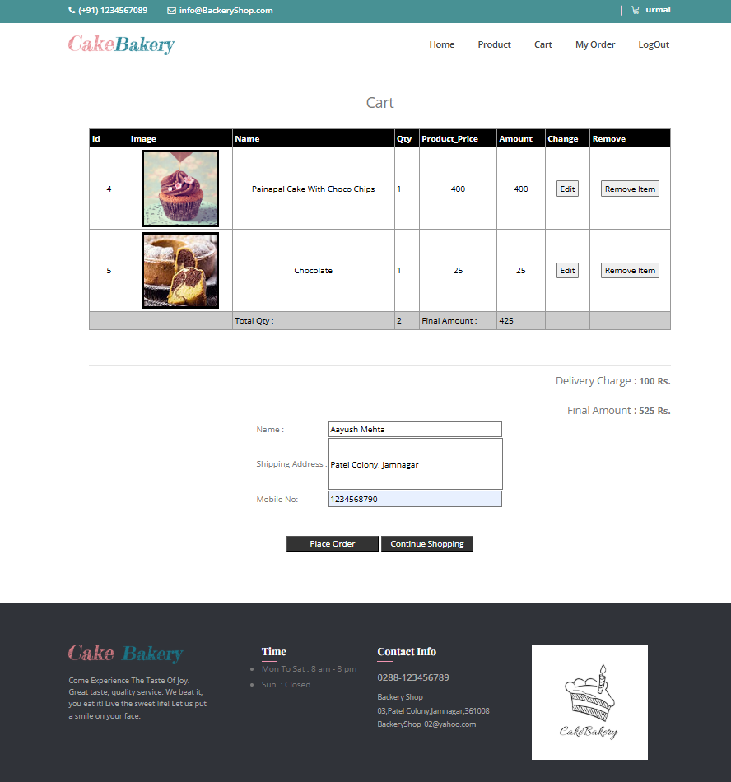

- My Orders

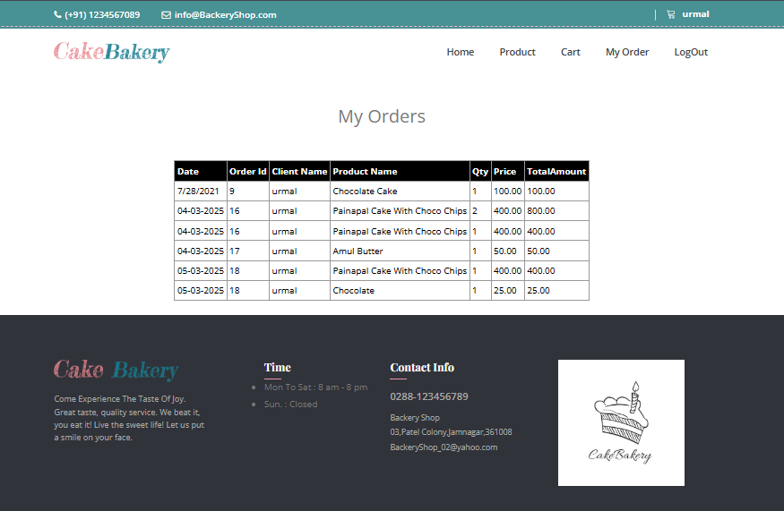

LIMITATIONS

Inventory Management: Maintaining accurate real-time inventory can be challenging. If items are out of stock after an order is placed, it could lead to customer dissatisfaction.

Delivery Logistics: Lack of tracking means customers won't have visibility on their order status. This could result in increased customer inquiries and decreased trust in the delivery process.

Fraud Prevention: Handling cash on delivery increases the risk of fraud. Implementing measures to verify customer information is crucial.

Scalability: As the platform grows, managing more orders and deliveries without tracking will become increasingly complex.

FUTURE ENHANCEMENT

Online Payment Integration: Add various online payment methods, like credit/debit cards, e-wallets, and UPI, to offer more convenience and reduce order cancellations.

Order Tracking: Implement a tracking system so customers can follow their orders in real-time, increasing trust and transparency.

Customer Reviews and Ratings: Allow customers to leave reviews and ratings for products. This feedback can help build trust and guide potential customers.

Personalization: Implement personalization features that recommend products based on customer preferences and previous orders.

Custom Orders: Allow customers to place custom orders for special occasions like birthdays, weddings, or corporate events.

BIBLIOGRAPHY

Youtube Reference:

Net Ninja, Traversy Media
Academind, IAmTimCorey
Codecourse, freeCodeCamp

Website Reference:
logo.com
Lucid Charts

Book Reference:

1. ASP.NET - Unleashed
2. ASP.NET – Wrox Publication
3. Pro ASP.NET Core MVC 2 Book by Adam Freeman

