* **Module 1: Introduction to Mobile Development and Flutter**

**Theory Assignments:**

1. **Explain the benefits of using Flutter over other cross-platform frameworks.**

1. Single Codebase for Multiple Platforms

* Write once, run on Android, iOS, Web, Windows, macOS, and Linux.
* Fewer platform-specific quirks compared to React Native or Xamarin.

2. Native-Like Performance

* Flutter compiles to native ARM code using Dart and avoids the JavaScript bridge bottleneck common in other frameworks.
* This makes animations, gestures, and transitions smooth and snappy.

3. Rich UI with Customization

* Offers a wide range of widgets that follow Material and Cupertino designs.
* Easily customize widgets or build entirely new ones—ideal for your interest in ripple effects, sticky nav bars, and custom layouts.

4. Hot Reload for Faster Development

* Instantly see changes in your code without restarting the app.
* Great for experimenting with design tweaks and fixing bugs quickly.

5. Strong Community and Ecosystem

* Backed by Google, with a rapidly growing package ecosystem.
* Tons of tutorials, plugins, and open-source projects to accelerate development.

6. Consistent UI Across Devices

* Doesn’t rely on native components, so your app looks the same across platforms.
* Useful when you're building personalized or branded experiences.

7. Integrated Testing and Dev Tools

* Built-in support for unit, widget, and integration testing.
* Clean IDE integration with VS Code and Android Studio, which streamlines your debugging and Gradle error resolution work.

8. Growing Support for Embedded & Web

* Flutter’s push into web and embedded devices opens up cool possibilities—like building apps for kiosks, dashboards, or even smart sensors.

1. **Describe the role of Dart in Flutter. What are its advantages for mobile development?**

**Dart plays the starring role in Flutter’s performance—it’s not just the language Flutter uses, it’s a big reason why Flutter runs so smoothly across platforms. Here's what makes Dart so well-suited for mobile development, especially when paired with Flutter:**

* Primary Language: Dart is the core programming language behind Flutter. All UI components, business logic, and interactions in Flutter apps are written in Dart.
* Unified Development: Unlike JavaScript-based frameworks, Dart lets you write both frontend UI and backend logic in the same language, streamlining the development process.
* Widget-Centric: Dart works seamlessly with Flutter’s widget-based architecture, making it easy to create dynamic, responsive UIs from the ground up.
* Advantages of Dart for Mobile Development

1. Ahead-of-Time (AOT) Compilation

* Dart compiles to native ARM machine code before runtime.
* Boosts startup time and overall performance—essential for delivering snappy mobile experiences.

2. Hot Reload

* Allows instant UI updates without restarting the app.
* Lets you tweak design, fix bugs, and test interactions rapidly—great for your work on animations and layout design.

3. Object-Oriented and Familiar Syntax

* Dart’s syntax resembles other popular languages like Java, C#, and JavaScript.
* Easy for developers with OOP backgrounds to pick up—ideal for structuring scalable apps with reusable components.

4. Rich Standard Library

* Offers utilities for async programming, collections, math, and more.
* Helps manage state, perform network calls, and handle user input with minimal boilerplate.

5. Strong Support for Asynchronous Code

* Uses Future, async, and await for async operations.
* Perfect for mobile apps that rely on API calls, database interactions, and smooth UI responsiveness.

6. Platform Independence

* Since Dart compiles to native code, it avoids the need for a JavaScript bridge.
* Results in consistent performance across Android, iOS, and beyond.

1. **Outline the steps to set up a Flutter development environment.**

**Setting up your Flutter development environment is a straightforward process, especially on Windows. Since you’ve already got a solid Dart and Flutter foundation, this will feel like extending your toolbelt. Here's how to get rolling:**

🛠️ Steps to Set Up a Flutter Environment on Windows

1. Download Flutter SDK

* Head to [flutter.dev](https://flutter.dev/docs/get-started/install/windows) and download the latest stable Flutter SDK.
* Unzip it to a path like C:\src\flutter (avoid installing it in a directory that requires admin privileges).

2. Update Environment Variables

* **Add Flutter to the system path:**
* Open *System Properties → Environment Variables*.
* In *System Variables*, find Path, click *Edit*, then *New*.
* Add the path to flutter\bin.

3. Install Git

* Flutter uses Git for version control and fetching packages.
* Install Git for Windows from [git-scm.com](https://git-scm.com/), and make sure Git is added to your path.

4. Run flutter doctor

* Open Command Prompt or PowerShell.
* Type flutter doctor to identify any missing dependencies.
* It checks for Android Studio, Dart SDK, connected devices, and more.

5. Install Android Studio

* **Download Android Studio, then:**
* Install Flutter and Dart plugins from the plugin marketplace.
* Set up the Android SDK via *SDK Manager*.
* Configure an emulator if you don’t have a physical device.

6. Configure an Editor (Optional but Recommended)

* **Choose your IDE:**
  + VS Code: Lightweight and fast with great Flutter support.
  + Android Studio: Feature-rich with layout inspector and profiler.
* Install Flutter and Dart extensions in your preferred editor.

7. Create and Run Your First App

flutter create my_first_app

cd my_first_app

flutter run

1. **Describe the basic Flutter app structure, explaining main.dart, the main function, and the widget tree.**

1. main.dart — The Entry Point

* This is the default starting file for any Flutter app.
* It contains the main() function, which triggers your app’s execution.
* Think of it as the app's front gate — everything passes through here first.

2. The main() Function

void main() {

runApp(MyApp());

}

* runApp() is a built-in Flutter function that inflates the widget tree and attaches it to the screen.
* MyApp is your custom widget, usually a StatelessWidget or StatefulWidget.

3. Widget Tree — The Backbone of the UI

* Flutter’s UI is built as a hierarchical structure called the widget tree.
* Every visual component (like buttons, containers, sliders) is a widget.
* Your widget tree starts with a root widget, usually MaterialApp or CupertinoApp, followed by child widgets.

class MyApp extends StatelessWidget {

@override

Widget build(BuildContext context) {

return MaterialApp(

title: 'Demo App',

home: Scaffold(

appBar: AppBar(title: Text('Home')),

body: Center(

child: Text('Hello, Flutter!'),

),

),

);

}

}

**Key Widget Layers:**

|  |  |
| --- | --- |
| Widget | Purpose |
| MaterialApp | Provides app-level configurations |
| Scaffold | Basic layout structure — includes AppBar etc. |
| AppBar | Top navigation/header |
| Body | Main content area |
| Center | Centers its child widget |
| Text | Displays a string |

**Practical Assignment :**

1. **Setup the Flutter development environment on your system and verify installation with flutter doctor.**

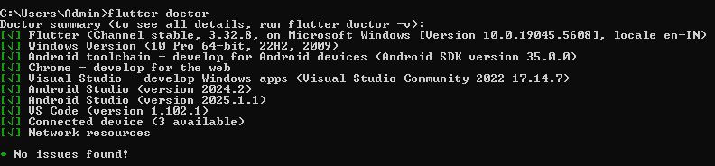

1. **Create a new Flutter project and customize it to display a personalized “Hello, World!” message with your name.**

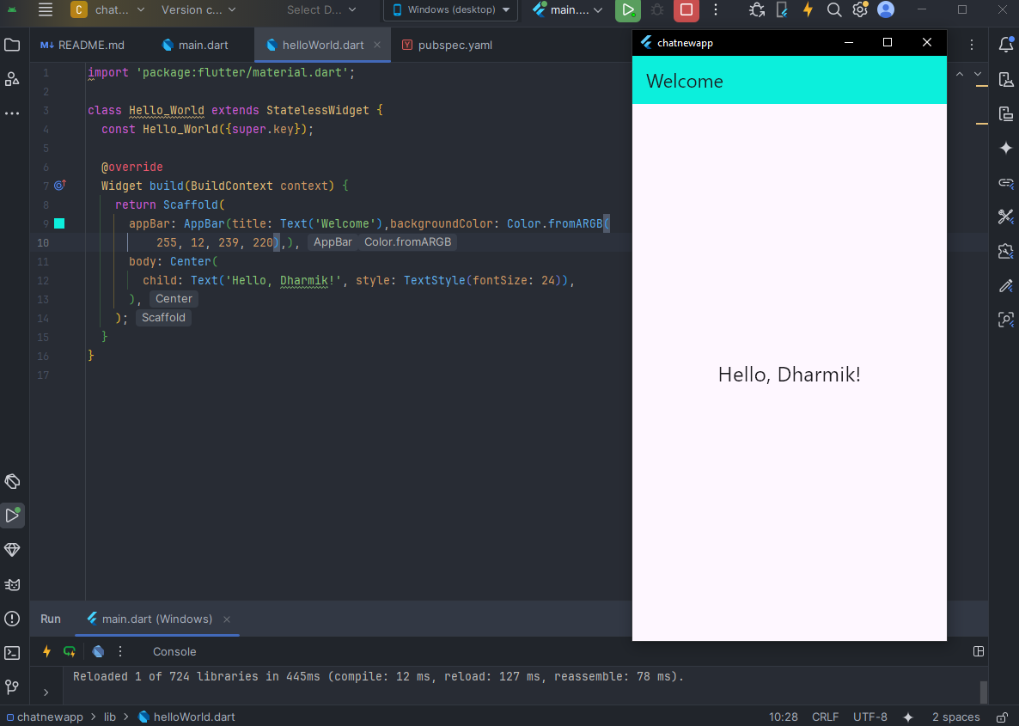

**import 'package:flutter/material.dart';**

**void main() {**

**runApp(MyApp());**

**}**

**class MyApp extends StatelessWidget {**

**@override**

**Widget build(BuildContext context) {**

**return MaterialApp(**

**title: 'Hello App',**

**home: Scaffold(**

**appBar: AppBar(**

**title: Text('Welcome'),**

**),**

**body: Center(**

**child: Text(**

**'Hello, YourName!',**

**style: TextStyle(fontSize: 24),**

**),**

**),**

**),**

**);**

**}**

**}**

1. **Customize the app by adding a background color and using different text styles (font, size, color) for the welcome message.**

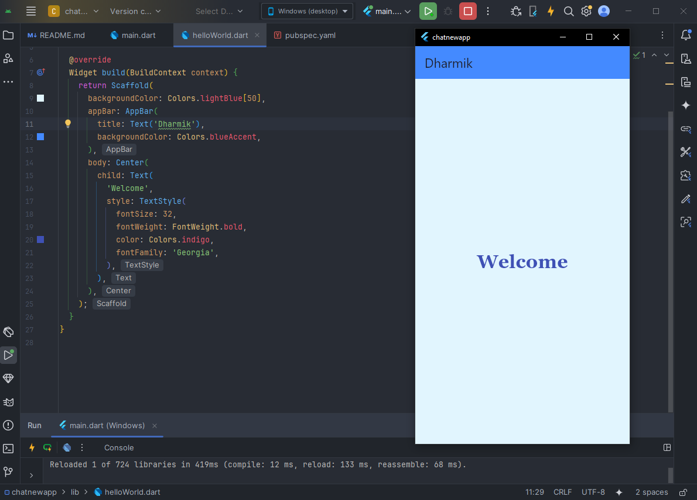

**Code :**

**import 'package:flutter/material.dart';**

**void main() {**

**runApp(MyApp());**

**}**

**class MyApp extends StatelessWidget {**

**@override**

**Widget build(BuildContext context) {**

**return MaterialApp(**

**title: 'Styled Hello App',**

**home: Scaffold(**

**backgroundColor: Colors.lightBlue[50],**

**appBar: AppBar(**

**title: Text('Dharmik'),**

**backgroundColor: Colors.blueAccent,**

**),**

**body: Center(**

**child: Text(**

**‘Welcome',**

**style: TextStyle(**

**fontSize: 32,**

**fontWeight: FontWeight.bold**

**color: Colors.indigo,**

**fontFamily: 'Georgia',**

**),**

**),**

**),**

**),**

**);**

**}**

**}**