- Explain what state management is and why it’s important in Flutter applications.
🧠 What Is State?
In Flutter, state refers to any data that can change during the lifetime of an app:
- A counter value
- A user’s login status
- A list of products in a cart
- A form’s input fields
🚀 Why Is State Management Important?
Without proper state management, your app can become:
- Buggy: UI doesn’t reflect the latest data
- Hard to maintain: Logic is scattered across widgets
- Slow: Unnecessary rebuilds and poor performance
With good state management:
- You centralize logic and make it reusable
- You decouple UI from business logic
- You improve performance by rebuilding only what’s needed
🔧 Common State Management Approaches in Flutter

setState
This is the most fundamental, built-in approach for managing state that is local to a single widget.
- How it Works: You use setState inside a StatefulWidget. Calling it tells Flutter that some internal state of that widget has changed, and Flutter should re-run the build method to reflect the change in the UI.
- Best For: Simple, UI-specific state that doesn't need to be shared, like a checkbox's status or a counter's current value.
- Pros: No external libraries needed; it's easy to understand for beginners.
- Cons: It rebuilds the entire widget subtree, which can be inefficient. It's not suitable for sharing state across different screens or complex widgets.

Provider
Provider is a wrapper around InheritedWidget that makes it easier to use and more reusable. It's one of the first state management solutions recommended by the Flutter team.
- How it Works: It "provides" a piece of state down the widget tree. Any widget below it in the tree can "listen" for changes to that state and rebuild itself when the state updates, without affecting other widgets.
- Best For: Sharing application-wide state, like user authentication status or theme settings. It's a great starting point for apps that outgrow setState.
- Pros: Simple, clean, and reduces boilerplate compared to using InheritedWidget directly.
- Cons: It's tied to the widget tree (relies on BuildContext), which can lead to runtime errors if you try to access a provider from the wrong context.

Riverpod
Created by the author of Provider, Riverpod is a complete rewrite that aims to solve Provider's main drawbacks. It's often considered a more modern and robust solution.
- How it Works: Riverpod decouples state from the widget tree. You declare "providers" globally, which can then be accessed from anywhere in your app without needing BuildContext. This makes state management more flexible and testable.
- Best For: Any project, from small to large-scale enterprise apps. It's particularly powerful for fetching data from an API or managing complex dependencies.
- Pros: Compile-safe (catches errors at compile-time, not runtime), independent of the widget tree, and very flexible.
- Cons: The learning curve is slightly steeper than Provider.

BLoC (Business Logic Component) / Cubit
BLoC is an architectural pattern that separates an app's business logic from its UI. It's a powerful and highly structured approach. Cubit is a simpler, less boilerplate-heavy subset of the BLoC pattern.
- How it Works:
  - BLoC: UI components dispatch Events to the BLoC. The BLoC processes these events, manages the logic, and emits States. The UI then rebuilds based on these new states.
  - Cubit: It's simpler. You call functions on the Cubit, and it emits new states. There are no "Events."
- Best For: Complex applications where you need a clear separation between UI and logic, such as e-commerce apps or social media platforms. It's also excellent for testability.
- Pros: Highly testable and scalable, enforces a strict and predictable architecture.
- Cons: Can be verbose and introduce significant boilerplate, especially with the full BLoC pattern.

GetX
GetX is more than just a state management library; it's a micro-framework that also handles routing, dependency injection, and more. It's known for its simplicity and performance.
- How it Works: GetX uses a reactive approach. You wrap your variables in .obs (making them "observable"), and widgets automatically update when their value changes.
- Best For: Developers who want to build apps quickly with minimal code. It's popular for rapid prototyping and smaller projects.
- Pros: Extremely concise syntax (very little boilerplate), high performance, and an all-in-one solution.
- Cons: Its "magic" can sometimes make the code harder to debug. It deviates from the idiomatic Flutter way of doing things, which might be a concern for some teams.

- Comparethe different types of state management solutions in Flutter, like Provider, Riverpod, and Bloc.

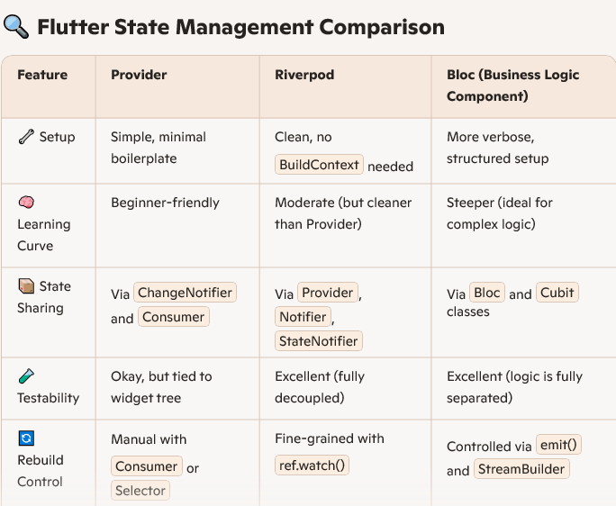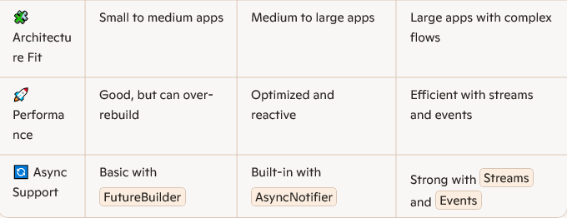
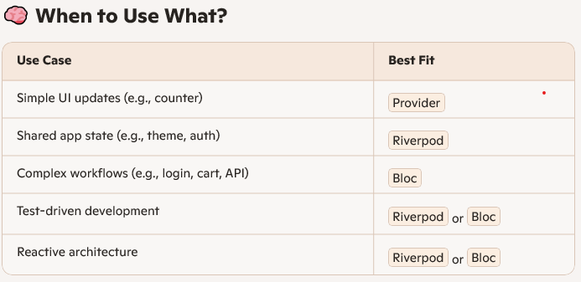

- Describe the Provider package and how it differs from basic setState usage.
🧩 What Is the Provider Package?
Provider is a state management solution in Flutter that allows you to:
- Share data across multiple widgets
- Reactively update the UI when data changes
- Keep business logic separate from UI code
It’s built on top of InheritedWidget, but simplifies the syntax and improves performance.
🔄 How Does It Work?
You wrap your app (or part of it) in a ChangeNotifierProvider, then use Consumer, Provider.of, or context.watch() to access and react to changes.
ChangeNotifierProvider(
create: (_) => CounterModel(),
child: MyApp(),
)
Inside widgets:
Consumer<CounterModel>(
builder: (context, model, child) => Text('${model.count}'),
)
🔧 How Is It Different from setState()?
 | setState() | Provider
🧪 Example: Counter App Comparison
Using setState():
int count = 0;

void increment() {
setState(() {
count++;
});
}

Using Provider:
class CounterModel extends ChangeNotifier {
int count = 0;
void increment() {
count++;
notifyListeners();
}
}
Then use Consumer to rebuild only the widget that displays the count.

