PRACTICAL - 12
Part A — Practice Programs (Hour 1)

PROBLEM1 | 1. Word frequency: split a paragraph into words, count each in a HashMap, and print the words sorted by frequency (highest first) using a Comparator.
CODE | import java.util.*;  public class WordFrequency {  public static void main(String[] args) {  String paragraph = "java is easy and java is powerful and java is popular";  HashMap<String, Integer> map = new HashMap<>();  String[] words = paragraph.toLowerCase().split("\\s+");  // Count frequency  for (String word : words) {  map.put(word, map.getOrDefault(word, 0) + 1);  }  // Sort by frequency (highest first)  List<Map.Entry<String, Integer>> list =  new ArrayList<>(map.entrySet());  list.sort((a, b) -> b.getValue().compareTo(a.getValue()));  // Print result  System.out.println("Words sorted by frequency:");  for (Map.Entry<String, Integer> entry : list) {  System.out.println(entry.getKey() + " : " + entry.getValue());  }  }  }
OUTPUT | 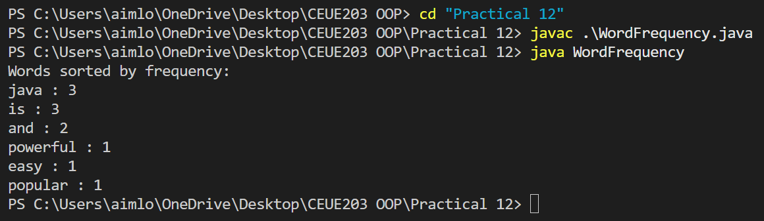
PROBLEM2 | 2. Unique visitors: from a list of login names with repeats, use a HashSet to count unique users and a LinkedHashSet to keep first-seen order; print the unique count and the first three distinct names.
CODE | import java.util.*;  public class UniqueVisitors {  public static void main(String[] args) {  List<String> logins = Arrays.asList(  "Dharmik", "Rahul", "Amit", "Dharmik",  "Priya", "Rahul", "Neha", "Amit"  );  // HashSet for unique count  HashSet<String> uniqueUsers = new HashSet<>(logins);  // LinkedHashSet for first-seen order  LinkedHashSet<String> orderedUsers = new LinkedHashSet<>(logins);  System.out.println("Unique users: " + uniqueUsers.size());  System.out.println("First three distinct users:");  int count = 0;  for (String user : orderedUsers) {  System.out.println(user);  count++;  if (count == 3)  break;  }  }  }
OUTPUT | 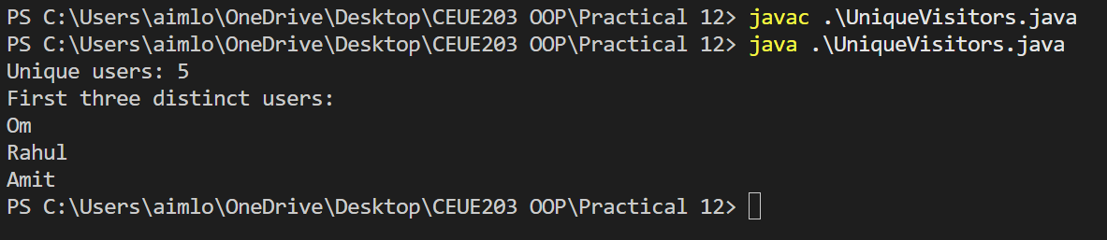
PROBLEM3 | 3. (For Advanced Learners – home) Build a leaderboard from player scores held in a Map and print the top-N sorted by score (ties broken by name); choose the data and sorting details.
CODE | import java.util.*;  public class Leaderboard {  public static void main(String[] args) {  Map<String, Integer> scores = new HashMap<>();  scores.put("Om", 950);  scores.put("Rahul", 870);  scores.put("Nishant", 950);  scores.put("Kushagra", 920);  scores.put("Neha", 870);  // Convert Map entries to List  List<Map.Entry<String, Integer>> players =  new ArrayList<>(scores.entrySet());  // Sort by score descending  // If scores are equal, sort by name  players.sort((a, b) -> {  int scoreCompare = b.getValue().compareTo(a.getValue());  if (scoreCompare != 0)  return scoreCompare;  return a.getKey().compareTo(b.getKey());  });  int N = 3;  System.out.println("Top " + N + " Players:");  for (int i = 0; i < N && i < players.size(); i++) {  Map.Entry<String, Integer> player = players.get(i);  System.out.println(  (i + 1) + ". " +  player.getKey() + " - " +  player.getValue()  );  }  }  }
OUTPUT | 