PRACTICAL - 13
Part A — Practice Programs (Hour 1)

PROBLEM1 | 1. Generic containers: a generic Box with get/set and a Pair; use them with different types to show type safety without casts, and write a generic method that returns the first element of any array.
CODE | class Box<T> {  private T value;  public void set(T value) {  this.value = value;  }  public T get() {  return value;  }  }  class Pair<A, B> {  private A first;  private B second;  public Pair(A first, B second) {  this.first = first;  this.second = second;  }  public A getFirst() {  return first;  }  public B getSecond() {  return second;  }  }  public class GenericDemo {  // Generic method  public static <T> T firstElement(T[] array) {  return array[0];  }  public static void main(String[] args) {  // Box with Integer  Box<Integer> intBox = new Box<>();  intBox.set(100);  // Box with String  Box<String> stringBox = new Box<>();  stringBox.set("Hello");  System.out.println("Integer Box: " + intBox.get());  System.out.println("String Box: " + stringBox.get());  // Pair with different types  Pair<String, Integer> student =  new Pair<>("Om", 21);  System.out.println("Name: " + student.getFirst());  System.out.println("Age: " + student.getSecond());  // Generic method  String[] names = {"Dharmik", "Rahul", "Amit"};  Integer[] numbers = {10, 20, 30};  System.out.println("First name: " + firstElement(names));  System.out.println("First number: " + firstElement(numbers));  }  }
OUTPUT | 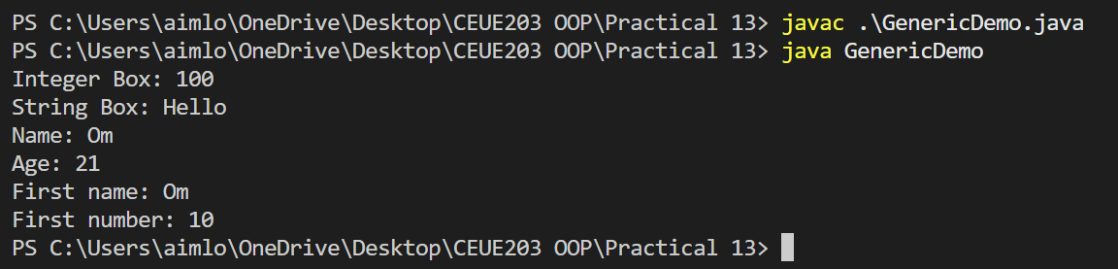
PROBLEM2 | 2. Bounded stats: a generic method double average(N[] values) that works for Integer[], Double[] and Long[]; note why it refuses non-Number types.
CODE | public class BoundedStats {  public static <N extends Number> double average(N[] values) {  double sum = 0;  for (N value : values) {  sum += value.doubleValue();  }  return sum / values.length;  }  public static void main(String[] args) {  Integer[] integers = {10, 20, 30, 40};  Double[] doubles = {10.5, 20.5, 30.5};  Long[] longs = {100L, 200L, 300L};  System.out.println("Integer average: " + average(integers));  System.out.println("Double average: " + average(doubles));  System.out.println("Long average: " + average(longs));  }  }
OUTPUT | 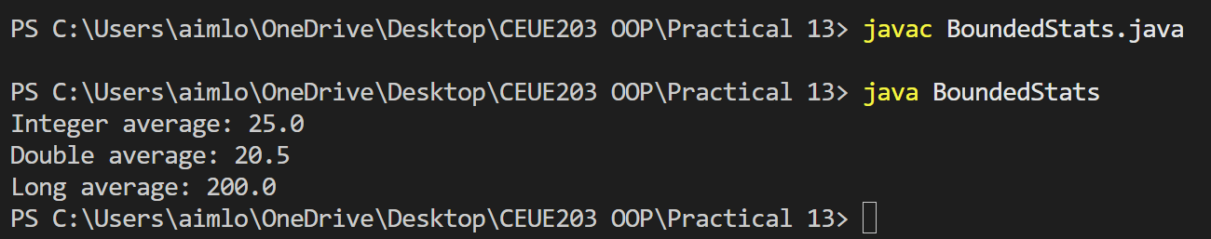
PROBLEM3 | 3. (For Advanced Learners – home) Implement a small generic container of your choice (e.g. a stack) backed by an array, reuse it for two different types, and handle the empty case sensibly.
CODE | class MyStack<T> {  private T[] stack;  private int top;  @SuppressWarnings("unchecked")  public MyStack(int size) {  stack = (T[]) new Object[size];  top = -1;  }  public void push(T value) {  if (top == stack.length - 1) {  System.out.println("Stack is full!");  return;  }  stack[++top] = value;  }  public T pop() {  if (top == -1) {  System.out.println("Stack is empty!");  return null;  }  return stack[top--];  }  public T peek() {  if (top == -1) {  System.out.println("Stack is empty!");  return null;  }  return stack[top];  }  public boolean isEmpty() {  return top == -1;  }  }  public class GenericStackDemo {  public static void main(String[] args) {  // Integer stack  MyStack<Integer> intStack = new MyStack<>(5);  intStack.push(10);  intStack.push(20);  intStack.push(30);  System.out.println("Integer stack pop: "  + intStack.pop());  System.out.println("Integer stack peek: "  + intStack.peek());  // String stack  MyStack<String> stringStack = new MyStack<>(5);  stringStack.push("Java");  stringStack.push("Python");  stringStack.push("C++");  System.out.println("String stack pop: "  + stringStack.pop());  System.out.println("String stack peek: "  + stringStack.peek());  // Empty case  while (!stringStack.isEmpty()) {  stringStack.pop();  }  System.out.println("Trying to pop from empty stack:");  stringStack.pop();  }  }
OUTPUT | 