PRACTICAL - 09
Part A — Practice Programs (Hour 1)

PROBLEM1 | 1. Counter race: several threads each increment a shared counter many times. Run it  without synchronization to watch the total come out too low, then make the increment  synchronized and confirm it is exactly right every run.
CODE | class Counter {  int count = 0;  void increment() {  count++;  }  }  class CounterThread extends Thread {  Counter counter;  int times;  CounterThread(Counter counter, int times) {  this.counter = counter;  this.times = times;  }  public void run() {  for (int i = 0; i < times; i++) {  counter.increment();  }  }  }  public class CounterRace {  public static void main(String[] args) throws Exception {  int threadCount = 10;  int times = 100000;  // Without synchronization  Counter counter = new Counter();  Thread[] threads = new Thread[threadCount];  for (int i = 0; i < threadCount; i++) {  threads[i] = new CounterThread(counter, times);  threads[i].start();  }  for (Thread thread : threads) {  thread.join();  }  System.out.println("Without synchronization: " + counter.count);  System.out.println("Expected: " + (threadCount * times));  // With synchronization  Counter counter2 = new Counter();  Thread[] threads2 = new Thread[threadCount];  for (int i = 0; i < threadCount; i++) {  threads2[i] = new Thread(() -> {  for (int j = 0; j < times; j++) {  synchronized (counter2) {  counter2.count++;  }  }  });  threads2[i].start();  }  for (Thread thread : threads2) {  thread.join();  }  System.out.println("With synchronization: " + counter2.count);  System.out.println("Expected: " + (threadCount * times));  }  }
OUTPUT | 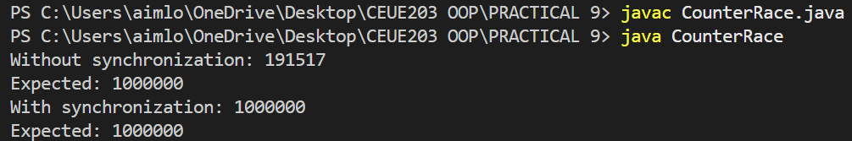
PROBLEM2 | 2. Seat booking race: a shared seatsLeft of 5 with about 10 threads each trying to book one  seat. Without synchronization show that more than 5 can succeed (oversell); with a  synchronized book() exactly 5 do.
CODE | class SeatBooking {  int seatsLeft = 5;  void book() {  if (seatsLeft > 0) {  try {  Thread.sleep(10);  } catch (InterruptedException e) {  e.printStackTrace();  }  seatsLeft--;  System.out.println(Thread.currentThread().getName()  + " booked a seat.");  } else {  System.out.println(Thread.currentThread().getName()  + " failed - No seats left.");  }  }  synchronized void bookSynchronized() {  if (seatsLeft > 0) {  try {  Thread.sleep(10);  } catch (InterruptedException e) {  e.printStackTrace();  }  seatsLeft--;  System.out.println(Thread.currentThread().getName()  + " booked a seat.");  } else {  System.out.println(Thread.currentThread().getName()  + " failed - No seats left.");  }  }  }  public class SeatBookingRace {  public static void main(String[] args) throws Exception {  // Without synchronization  SeatBooking booking = new SeatBooking();  Thread[] threads = new Thread[10];  System.out.println("WITHOUT SYNCHRONIZATION:");  for (int i = 0; i < 10; i++) {  threads[i] = new Thread(  () -> booking.book(),  "Thread-" + (i + 1)  );  threads[i].start();  }  for (Thread thread : threads) {  thread.join();  }  System.out.println("Seats left: " + booking.seatsLeft);  // With synchronization  SeatBooking booking2 = new SeatBooking();  Thread[] threads2 = new Thread[10];  System.out.println("\nWITH SYNCHRONIZATION:");  for (int i = 0; i < 10; i++) {  threads2[i] = new Thread(  () -> booking2.bookSynchronized(),  "Thread-" + (i + 1)  );  threads2[i].start();  }  for (Thread thread : threads2) {  thread.join();  }  System.out.println("Seats left: " + booking2.seatsLeft);  }  }
OUTPUT | 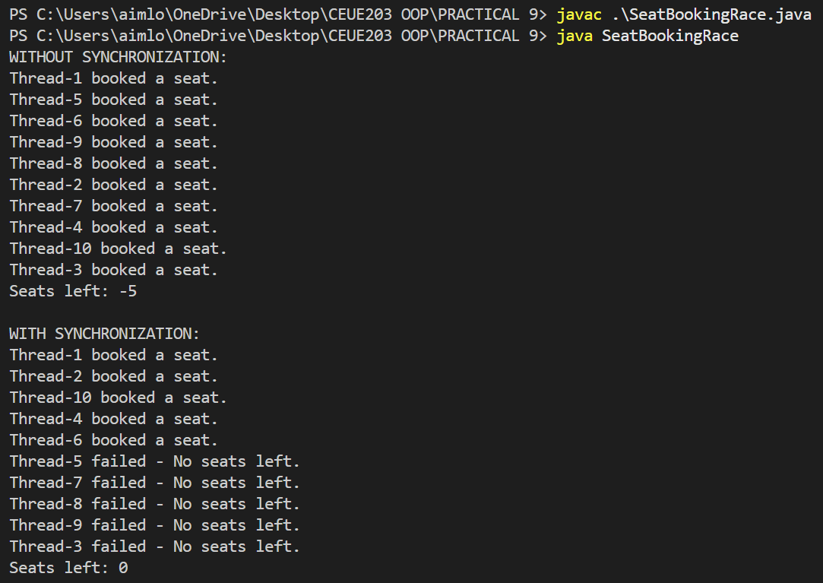
PROBLEM3 | 3. (For Advanced Learners – home) Split a large array of numbers across several threads  that add into one shared total, show the wrong result, then fix it two ways and compare;  decide how to measure the difference.
CODE | import java.util.concurrent.atomic.AtomicLong;  class SharedTotal {  long total = 0;  void add(long value) {  total += value;  }  synchronized void addSynchronized(long value) {  total += value;  }  }  public class ArraySumRace {  static int[] arr = new int[1_000_000];  static int threadCount = 10;  public static void main(String[] args) throws Exception {  // Fill array with 1  for (int i = 0; i < arr.length; i++) {  arr[i] = 1;  }  System.out.println("Expected Total: " + arr.length);  // 1. Without Synchronization  SharedTotal total1 = new SharedTotal();  long start1 = System.nanoTime();  runThreads((start, end) -> {  for (int i = start; i < end; i++) {  total1.add(arr[i]);  }  });  long end1 = System.nanoTime();  System.out.println("\nWithout Synchronization:");  System.out.println("Total = " + total1.total);  System.out.println("Time = " + (end1 - start1) / 1_000_000.0 + " ms");  // 2. With Synchronization  SharedTotal total2 = new SharedTotal();  long start2 = System.nanoTime();  runThreads((start, end) -> {  for (int i = start; i < end; i++) {  total2.addSynchronized(arr[i]);  }  });  long end2 = System.nanoTime();  System.out.println("\nWith Synchronization:");  System.out.println("Total = " + total2.total);  System.out.println("Time = " + (end2 - start2) / 1_000_000.0 + " ms");  // 3. Using AtomicLong  AtomicLong total3 = new AtomicLong(0);  long start3 = System.nanoTime();  runThreads((start, end) -> {  for (int i = start; i < end; i++) {  total3.addAndGet(arr[i]);  }  });  long end3 = System.nanoTime();  System.out.println("\nUsing AtomicLong:");  System.out.println("Total = " + total3.get());  System.out.println("Time = " + (end3 - start3) / 1_000_000.0 + " ms");  }  interface Task {  void execute(int start, int end);  }  static void runThreads(Task task) throws Exception {  Thread[] threads = new Thread[threadCount];  int partSize = arr.length / threadCount;  for (int i = 0; i < threadCount; i++) {  int start = i * partSize;  int end = (i == threadCount - 1)  ? arr.length  : start + partSize;  threads[i] = new Thread(() -> task.execute(start, end));  threads[i].start();  }  for (Thread thread : threads) {  thread.join();  }  }  }
OUTPUT | 