PulseSplit: recorded dataset experiment
Evaluated data label (user supplied): UCI HLS-CMDS
Evaluation completed (UTC): 2026-10-19T11:41:28.505738+00:00
Held-out test recordings: 22. Checkpoint and split hashes, test IDs, and aggregate statistics were cross-checked against saved artifacts.

Held-out SI-SDR results
All scores and gains are in dB. Gain is separated-estimate SI-SDR minus the unprocessed-mixture baseline for the same recording and source. Positive gain means an improvement; negative gain means the estimate scores below the mixture. SI-SDR is not percentage accuracy.
The 95% intervals below are descriptive per-recording bootstrap intervals. Shared-source dependence is not modeled; these are not calibrated intervals over independent source components.
Source / measurement | Valid n | Undefined | Mean (dB) | Median (dB) | SD (dB) | Mean 95% CI (dB)
Heart: mixture baseline | 22 | 0 | -28.201 | -33.632 | 20.051 | [-36.245, -19.863]
Heart: separated estimate | 22 | 0 | -25.010 | -32.269 | 15.768 | [-31.370, -18.417]
Heart: gain over mixture | 22 | 0 | 3.191 | 2.216 | 7.771 | [-0.034, 6.504]
Lung: mixture baseline | 22 | 0 | -27.069 | -34.814 | 23.157 | [-36.476, -17.592]
Lung: separated estimate | 22 | 0 | -26.909 | -36.335 | 21.779 | [-35.558, -17.625]
Lung: gain over mixture | 22 | 0 | 0.160 | -0.453 | 4.791 | [-1.268, 2.424]
Statistics are calculated over complete held-out recordings, not training windows. The intervals use a percentile bootstrap of recording means (2,000 resamples; seed 42). Undefined scores are excluded and counted; intervals are unavailable with fewer than two valid recordings. Rounded report values are backed by full-precision JSON and CSV outputs.
These intervals assume independent recordings. Repeated manikin playback patterns may violate that assumption; the interval does not capture retraining variability or clinical generalization.

Training and experiment configuration
Setting | Recorded value
Training data label (user supplied) | UCI HLS-CMDS
Recordings | 145
Train / validation / test recording counts | 101 / 22 / 22
Split strategy | exact-source-connected-components
Completed epochs | 10
Selected checkpoint epoch | 3
Selected checkpoint training log-magnitude MAE | 0.09426313062241931
Selected checkpoint validation log-magnitude MAE | 0.07992566674463934
Exact-source connected components | 28
Train / validation / test component counts | 14 / 5 / 9
Distinct byte hashes (mixture / heart / lung) | 144 / 89 / 74
Batch size | 8
U-Net base channels | 16
Training segment length (seconds) | 2.0
Model parameters | 488434
Seed | 42
Training device | cpu
Training runtime (seconds) | 428.0974077999708
Training completed (UTC) | 2026-10-19T11:41:24.809017+00:00
Python | 3.14.2
Platform | Windows-11-10.0.26200-SP0
PyTorch | 2.14.1+cpu
NumPy | 2.5.4
Checkpoint selection uses validation loss with a minimum improvement of 0.00001. The selected checkpoint epoch can precede the final completed epoch. The training objective is log-magnitude spectral mean absolute error; it is different from the SI-SDR evaluation metric.

Completed training history
Epoch | Training log-magnitude MAE | Validation log-magnitude MAE
1 | 0.09483767002610202 | 0.08117930325014251
2 | 0.09456351774585298 | 0.08007285206929429
3 | 0.09426313062241931 | 0.07992566674463934
4 | 0.09382357700204917 | 0.08007866790058552
5 | 0.09423604020598586 | 0.08010517873547295
6 | 0.09403779121613738 | 0.07992941228213249
7 | 0.09380025537803116 | 0.08105962568676317
8 | 0.09367490125638255 | 0.08024208412154929
9 | 0.09333306552033445 | 0.08050352804266013
10 | 0.09351550610643802 | 0.08016256750984625

Native audio audit
Native audio measurement | Audited value
Matched WAV files | 435
Native sample rate(s), Hz | 4,000
Channel count(s) | 1
File duration range, seconds | 15.0 to 15.0
Total mixture duration, seconds | 2175.0
Audit status | warnings
The measured native rate(s), 4,000 Hz, differ from the 22,050 Hz stated in the [official UCI description](https://archive.ics.uci.edu/dataset/1202/hls-cmds). Report the measured file properties for this downloaded release rather than substituting the catalogue rate.
The model pipeline resamples to 8,000 Hz. Upsampling lower-rate source audio does not restore frequencies absent from the original recording.
Audit issue counts: possible_clipping = 36. The possible_clipping flag marks near-full-scale samples under the recorded threshold; it is a screening warning, not proof of signal distortion.

Dataset provenance and interpretation limits
UCI describes HLS-CMDS as digital-stethoscope recordings from a clinical manikin, including mixed recordings and corresponding source recordings. These are manikin recordings, not a patient cohort. [Official UCI dataset description](https://archive.ics.uci.edu/dataset/1202/hls-cmds).
The data labels in run_metadata.json and summary.json are supplied by the experiment runner. The report verifies consistency of the saved experiment files; it does not independently authenticate the downloaded archive or assign a clinical meaning to the scores. Retain the download URL, archive SHA-256, audit outputs, and original dataset metadata with the submission.
Corresponding IDs do not by themselves prove sample-level synchronization or that the mixture is exactly the sum of the two reference recordings. When source components are recorded in separate acquisition phases, time/phase differences can strongly affect waveform SI-SDR. The current pipeline resamples audio, trims to a shared length, and uses shared amplitude scaling; it does not perform lag or phase correction. Treat scores under this protocol as an initial benchmark, and inspect acquisition/alignment evidence before drawing source-fidelity conclusions.
Partitions are assigned before segmentation. Recorded split strategy: exact-source-connected-components. Recording IDs connected through byte-identical mixed, heart, or lung files are held in the same partition. This limits exact-source reuse across partitions. It is not a holdout of all simulator sound types or acoustic patterns. Shared sources within a partition also mean recording-bootstrap intervals need not have calibrated coverage for independent sources. Repeated sound types, simulator playback patterns, and anatomical locations can still span partitions. A stricter grouping study and independent patient recordings are required for broader claims. No diagnosis, treatment, or clinical validation is established by this experiment. The pretraining protocol records a revision after duplicate-source inspection and before training/test evaluation; see results/PRETRAINING_PROTOCOL.md for the fixed procedure.
Dataset attribution: Yasaman Torabi, Shahram Shirani, and James P. Reilly (2025), HLS-CMDS; CC BY 4.0. [UCI attribution and license](https://archive.ics.uci.edu/dataset/1202/hls-cmds).

Recorded archive provenance
Dataset source: https://archive.ics.uci.edu/static/public/1202/hls-cmds%3A%2Bheart%2Band%2Blung%2Bsounds%2Bdataset%2Brecorded%2Bfrom%2Ba%2Bclinical%2Bmanikin%2Busing%2Bdigital%2Bstethoscope.zip
Original archive SHA-256: 183ddb847c70dc394120284c2c3cb79c717fc37ac7f81bd29f3d5e5b572d4804
This archive hash is preserved from the download workflow. Raw audio is not required to regenerate this report; the report does not re-download or re-authenticate it.

Held-out recording IDs
0007, 0008, 0011, 0027, 0035, 0039, 0048, 0061, 0064, 0065, 0072, 0074, 0089, 0092, 0095, 0114, 0117, 0119, 0129, 0138, 0139, 0141
Full per-recording results: results/test_per_recording.csv. Full summary and intervals: results/summary.json. Training curve: artifacts/training_history.png. Evaluation chart: results/test_comparison.png.

Exact source artifacts
SHA-256 hashes identify the inputs used for this report. They do not certify experimental quality.
Source artifact | SHA-256
artifacts/best.pt | 8f7d663dcf0b582291c535c2e2935afb5c2f348ed67c18e6fe78f9f5f9f8bce9
artifacts/run_metadata.json | b8741ede424311c6a6b755f9eba0e207ed3476136d370c0d650c35b4f0f3055c
artifacts/history.json | bc7fb5c545f35c83c88018603e110fb3803a98191b8e8b91884b5a0c97a2e7b1
artifacts/split.json | a03c65a388c4033311a4fcfda76b95b4ac3c091cb17953ca02a3980d80bf7bb1
results/summary.json | fffcf839198c9bd7d1d88f7a6af5dcb53d1ff87bc01feaa90885900f5f7d9170
results/test_per_recording.csv | a7c673536c2376f2573e6126179a524e848bd203a6c793fcada2501520921269
results/dataset_provenance.json | 9e40d3e2851af1317cfa9754ba4ba12f772bd0913b54265d0f12c1519f3e96f9
results/audio_sha256.json | 24db74754b7c46081d652e2785b0c764296a3c9d07d9130cb75180be27b96629
results/audit/dataset_audit.json | 35702c4a742bd8d513f96645314d3fac776c47a19ee8d1dacf2d2d40ef6f3dad
results/PRETRAINING_PROTOCOL.md | fd08548e51fdbc6f1eef21f6eae1ea5fbc0a7a510a61ee2e9e7c51b081bad03b

Regenerate this appendix
python docs/build_experiment_report.py --artifacts artifacts --results results --output results/actual_experiment_report
The Word appendix remains editable. Existing working-draft reports are not overwritten.

Experiment figures
Recorded training history
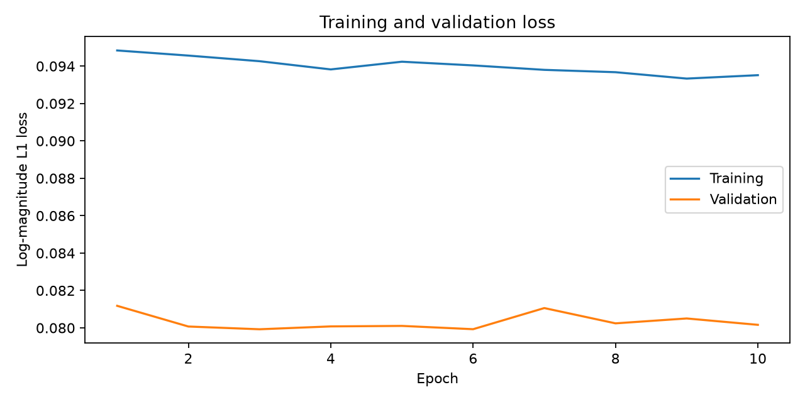
Held-out source and mixture comparison
