Experiment 4

AIM: Use npm / yarn / pip to install and manage packages

Step 1: Check Installation C:\Users\student\Desktop>npm -v 10.9.0
C:\Users\student\Desktop>node -v v23.3.0

Step 2: Create New npm Project
C:\>cd Users

C:\Users>cd student

C:\Users\student>cd Desktop

C:\Users\student\Desktop>mkdir npm-lab

C:\Users\student\Desktop>cd npm-lab

C:\Users\student\Desktop\npm-lab>npm init -y
(node:11488) ExperimentalWarning: CommonJS module C:\Program Files\nodejs\node_modules\npm\node_modules\debug\src\node.js is loading ES Module C:\Program Files\nodejs\node_modules\npm\node_modules\supports-color\index.js using require().
Support for loading ES Module in require() is an experimental feature and might change at any time (Use `node --trace-warnings ...` to show where the warning was created)

Wrote to C:\Users\student\Desktop\npm-lab\package.json:
{
"name": "npm-lab",
"version": "1.0.0",
"main": "index.js", "scripts": {
"test": "echo \"Error: no test specified\" && exit 1"
},
"keywords": [],
"author": "",
"license": "ISC",
"description": ""
}

Step 3: Install Required Packages
C:\Users\student\Desktop\npm-lab>npm install express (node:8820) ExperimentalWarning: CommonJS module C:\Program
Files\nodejs\node_modules\npm\node_modules\debug\src\node.js is loading ES Module C:\Program Files\nodejs\node_modules\npm\node_modules\supports-color\index.js using require().
Support for loading ES Module in require() is an experimental feature and might change at any time (Use `node --trace-warnings ...` to show where the warning was created)

added 65 packages, and audited 66 packages in 4s

22 packages are looking for funding run `npm fund` for details
found 0 vulnerabilities

C:\Users\student\Desktop\npm-lab>npm install axios (node:9940) ExperimentalWarning: CommonJS module C:\Program
Files\nodejs\node_modules\npm\node_modules\debug\src\node.js is loading ES Module C:\Program Files\nodejs\node_modules\npm\node_modules\supports-color\index.js using require().
Support for loading ES Module in require() is an experimental feature and might change at any time (Use `node --trace-warnings ...` to show where the warning was created)

added 11 packages, and audited 77 packages in 2s

24 packages are looking for funding run `npm fund` for details

found 0 vulnerabilities

C:\Users\student\Desktop\npm-lab>npm install nodemon --save.dev (node:9224) ExperimentalWarning: CommonJS module C:\Program
Files\nodejs\node_modules\npm\node_modules\debug\src\node.js is loading ES Module C:\Program Files\nodejs\node_modules\npm\node_modules\supports-color\index.js using require().
Support for loading ES Module in require() is an experimental feature and might change at any time (Use `node --trace-warnings ...` to show where the warning was created)

added 27 packages, and audited 104 packages in 3s

28 packages are looking for funding run `npm fund` for details

found 0 vulnerabilities

C:\Users\student\Desktop\npm-lab>npm list
(node:13052) ExperimentalWarning: CommonJS module C:\Program Files\nodejs\node_modules\npm\node_modules\debug\src\node.js is loading ES Module C:\Program Files\nodejs\node_modules\npm\node_modules\supports-color\index.js using require().
Support for loading ES Module in require() is an experimental feature and might change at any time (Use `node --trace-warnings ...` to show where the warning was created)
npm-lab@1.0.0 C:\Users\student\Desktop\npm-lab
+-- axios@1.13.5
+-- express@5.2.1
`-- nodemon@3.1.11
C:\Users\student\Desktop\npm-lab>notepad index.js

Step 4: Create Web Server
Create a file named index.js and Add below content : const express = require("express");
const axios = require("axios"); const app = express();

app.get("/", (req, res) => { res.send("Hello Open Source Lab");
});

// JSON Route app.get("/api/info", (req, res) => {
res.json({

name: "NPM Lab",
subject: "Open Source Technology", semester: "BE 6th Sem"
});
});

// Axios Demo Route app.get("/api/user", async (req, res) => {
const response = await axios.get("https://jsonplaceholder.typicode.com/users/1"); res.json(response.data);
});

app.listen(3000, () => {
console.log("Server running at http://localhost:3000");
});

Step 5: Run Server (Normal Way) C:\Users\student\Desktop\npm-lab>node index.js Server running at http://localhost:3000

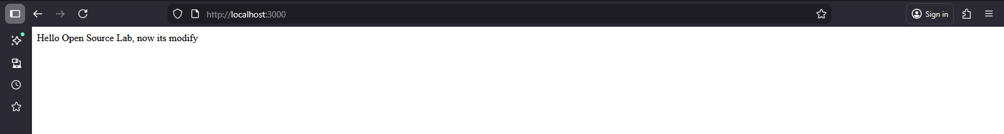

http://localhost:3000/api/info

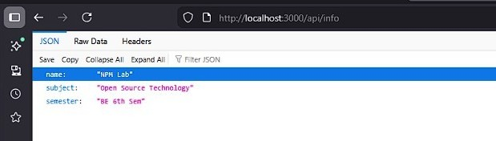

http://localhost:3000/api/user
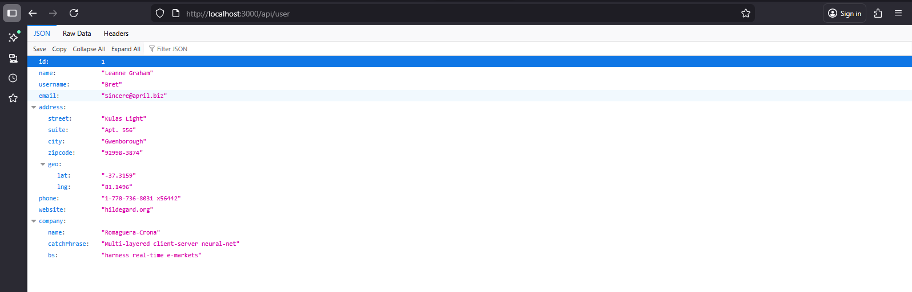

Step 6: Add npm Scripts
Open package.json and modify scripts section:

"scripts": {
"start": "node index.js", "dev": "nodemon index.js"
}

Step 7: Run Using npm Script
- Normal mode:
C:\Users\student\Desktop\npm-lab>npm run start

  - npm-lab@1.0.0 start
  - node index.js

Server running at http://localhost:3000 Terminate batch job (Y/N)? y

Development mode (nodemon):
Now modify index.js text and save → Server automatically restarts (nodemon demo).
C:\Users\student\Desktop\npm-lab>npm run dev

  - npm-lab@1.0.0 dev
  - nodemon index.js

[nodemon] 3.1.11
[nodemon] to restart at any time, enter `rs` [nodemon] watching path(s): *.*
[nodemon] watching extensions: js,mjs,cjs,json [nodemon] starting `node index.js`
Server running at http://localhost:3000 [nodemon] restarting due to changes... [nodemon] starting `node index.js` Server running at http://localhost:3000 Terminate batch job (Y/N)? y

Step 8: Delete node_modules and Reinstall
Delete manually

Now reinstall:
C:\Users\student\Desktop\npm-lab>npm install
(node:12492) ExperimentalWarning: CommonJS module C:\Program Files\nodejs\node_modules\npm\node_modules\debug\src\node.js is loading ES Module C:\Program Files\nodejs\node_modules\npm\node_modules\supports-color\index.js using require().
Support for loading ES Module in require() is an experimental feature and might change at any time (Use `node --trace-warnings ...` to show where the warning was created)
added 103 packages, and audited 104 packages in 1s 28 packages are looking for funding
run `npm fund` for details found 0 vulnerabilities

Step 9: Add .gitignore File
Create file: .gitignore Add:
node_modules/

Step 10: Upload Project to Git (Without node_modules)
C:\Users\student\Desktop\npm-lab>git config user.name "dharmiktrada"

C:\Users\student\Desktop\npm-lab>git config user.email "dharmik.trada132980@marwadiuniversity.ac.in"

C:\Users\student\Desktop\npm-lab>git init
Initialized empty Git repository in C:/Users/student/Desktop/npm-lab/.git/

C:\Users\student\Desktop\npm-lab>git add .
warning: in the working copy of 'package-lock.json', LF will be replaced by CRLF the next time Git touches it
warning: in the working copy of 'package.json', LF will be replaced by CRLF the next time Git touches it

C:\Users\student\Desktop\npm-lab>git remote add origin "https://github.com/dharmiktrada"

C:\Users\student\Desktop\npm-lab>git branch -m main

C:\Users\student\Desktop\npm-lab>git push -u origin main error: src refspec main does not match any
error: failed to push some refs to “https://github.com/dharmiktrada”

C:\Users\student\Desktop\npm-lab>dir Volume in drive C has no label.
Volume Serial Number is C2A1-ABB5

Directory of C:\Users\student\Desktop\npm-lab

18-02-2026 | 08:47 | <DIR> | .
18-02-2026 | 08:47 | <DIR> | ..
18-02-2026 | 08:41 | 13 .gitignore
18-02-2026 | 08:35 | 610 index.js
18-02-2026 | 08:38 | <DIR> node_modules
18-02-2026 | 08:38 | 45,150 package-lock.json
18-02-2026 | 08:12 | 310 package.json
4 File(s) 46,083 bytes
3 Dir(s) 71,987,359,744 bytes free C:\Users\student\Desktop\npm-lab>git add . C:\Users\student\Desktop\npm-lab>git branch -M main
C:\Users\student\Desktop\npm-lab>git pull origin main --allow-unrelated-histories remote: Enumerating objects: 16, done.
remote: Counting objects: 100% (16/16), done. remote: Compressing objects: 100% (13/13), done.
remote: Total 16 (delta 4), reused 3 (delta 1), pack-reused 0 (from 0) Unpacking objects: 100% (16/16), 253.34 KiB | 560.00 KiB/s, done. From https://github.com/dharmiktrada
- branch main -> FETCH_HEAD
- [new branch] main -> origin/main

C:\Users\student\Desktop\npm-lab>git push -u origin main branch 'main' set up to track 'origin/main'.
Everything up-to-date

C:\Users\student\Desktop\npm-lab>git status On branch main
Your branch is up to date with 'origin/main'.

Changes to be committed:
(use "git restore --staged <file>..." to unstage) new file: .gitignore
new file: index.js
new file: package-lock.json new file: package.json

C:\Users\student\Desktop\npm-lab>git commit -m "Initial commit" [main dc97862] Initial commit
Committer: Students <student@mefgi.com>
Your name and email address were configured automatically based on your username and hostname. Please check that they are accurate. You can suppress this message by setting them explicitly. Run the following command and follow the instructions in your editor to edit your configuration file:

git config --global --edit

After doing this, you may fix the identity used for this commit with: git commit --amend --reset-author
4 files changed, 1325 insertions(+) create mode 100644 .gitignore create mode 100644 index.js
create mode 100644 package-lock.json create mode 100644 package.json

C:\Users\student\Desktop\npm-lab>git push origin main Enumerating objects: 7, done.
Counting objects: 100% (7/7), done. Delta compression using up to 6 threads Compressing objects: 100% (5/5), done.
Writing objects: 100% (6/6), 12.30 KiB | 6.15 MiB/s, done. Total 6 (delta 1), reused 0 (delta 0), pack-reused 0 (from 0)
remote: Resolving deltas: 100% (1/1), completed with 1 local object. To “https://github.com/dharmiktrada”

dd2ae09..dc97862 main -> main
