HCAHPS Patient Experience Analytics
Deliverable 9: Power BI Dashboard Development
This document summarizes the 5 dashboard pages developed in Power BI (4 consolidated pages plus a supplementary Root Cause Analysis page), including the visuals used on each and a screenshot of the final result.

Page 1: Executive Overview
Audience: CEO & Executive Committee
- KPI Cards: National Top-box %, Survey Response Rate, Number of Participating States, Number of Quality Measures
- Clustered Bar Chart: Top-box % by Region
- Line Chart: National Top-box % trend by Release Period (2015-2023)
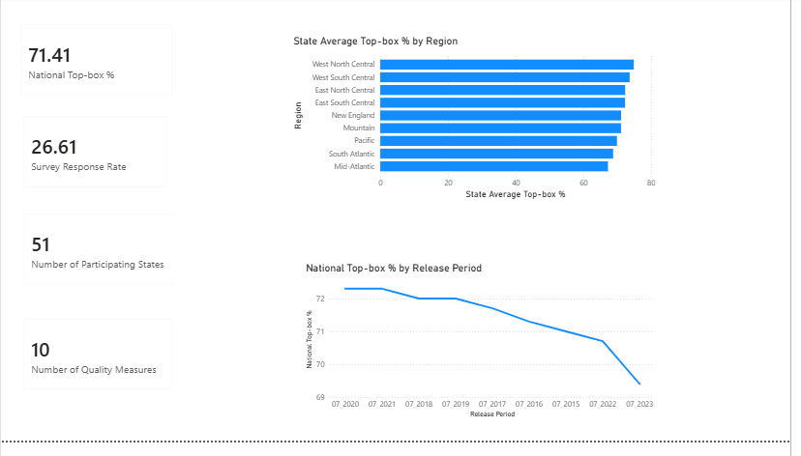

Page 2: State Performance & Benchmark
Audience: State Health Administrators, Hospital Accreditation Team
- Filled Map: State-wise Top-box % (color gradient)
- Matrix Table: State Name, State Ranking (with data bars), State Average Top-box % (with conditional formatting icons)
- Bar Chart: State Average Top-box % ranked, all 51 states
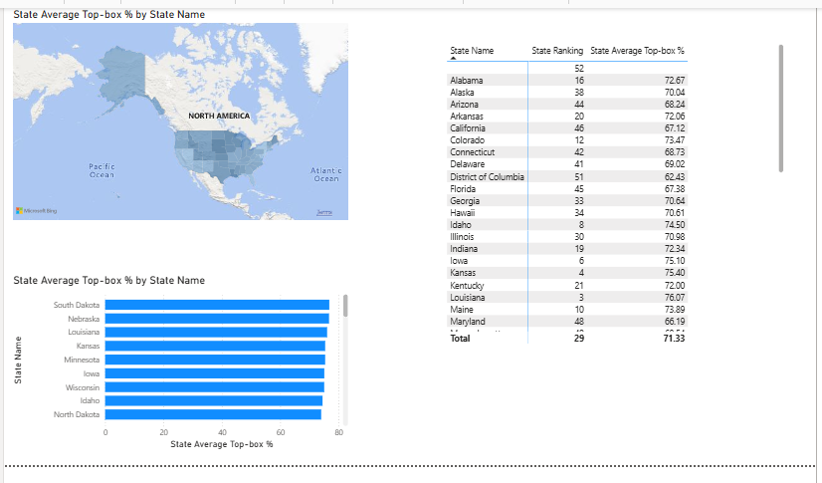

Page 3: Patient Experience Measures
Audience: Chief Quality Officer
- Bar Chart: National Top-box % ranked by Measure
- KPI Cards: Highest Performing Measure, Lowest Performing Measure
- Table: Measure-wise National Top-box %, Average Middle-box %, Average Bottom-box %
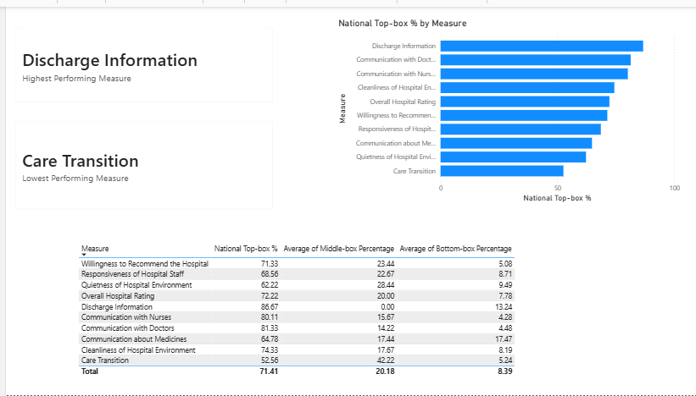

Page 4: Regional & Trend Analysis
Audience: Policy Makers, Regional Managers
- Bar Chart: Regional Ranking by Region
- Line Chart: State Average Top-box % by Release Period and Region (9 regions)
- KPI Card: Year-over-Year Satisfaction Change
- Navigation Button (bookmark-linked back to Executive Overview)
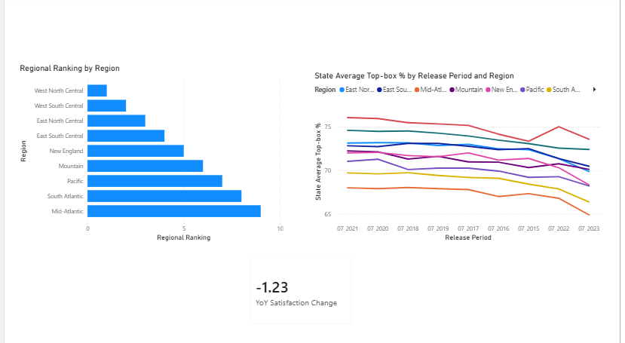

Page 5: Root Cause Analysis (Supplementary)
Audience: Chief Quality Officer, Healthcare Analytics Team
- Decomposition Tree: National Top-box % broken down interactively by Measure and then by State, supporting root-cause exploration of performance drivers
