Internship Project ON:
Dual-Level IoT Smart Home Automation:
Integrating Human-Centric Access and Rain-Responsive Asset Protection.
Diploma in Computer Science &
Technology
By
Rashmi Singh
D232431085
Dharmistha Ghosh
D232431106
Akshaj Hui
D232411087
Sohan Dey
D2322431119
Soumili Bandhapayay
D242506910
Under the guidance of
Subhajit Bhowmick
Rajdeep Ghatak

Techno India, Salt Lake
EM 4/ Salt lake City, Sector V
KOLKATA – 700091

WEST BENGAL STATE COUNCIL OF TECHNICAL EDUCATION
Certificate of Approval
The foregoing project is hereby approved as a creditable study of Diploma in Computer Science & Technology and presented in a manner satisfactory to warrant its acceptance as a pre-requisite to the internship for which it has been submitted. It is understood that by this approval the undersigned do not necessarily endorse any statement made, opinion expressed or conclusion therein but approve this project only for the purpose for which it is submitted.
________________________
________________________
________________________
Signature of the Examiners

Final Examination for
Evaluation of the Project.
Abstract
This report presents a Two-Level IoT Automation System that integrates residential convenience with active asset protection. Utilizing an Arduino Uno, the system employs IR sensors for hands-free door automation and rain-responsive pulley mechanisms to safeguard property from adverse weather. By bridging physical movement with digital data, the model provides a proactive, sensor-driven environment that anticipates user needs and environmental shifts.
Introduction
Modern smart home technology is transitioning from reactive tools to proactive ecosystems. This report details the development of a Two-Level IoT Automation System designed to address common household pain points through intelligent, sensor-driven intervention. While traditional automation often focuses solely on convenience, our system integrates active asset protection with daily accessibility.
The architecture of the system is divided into two primary operational levels:
- Level 1: Access Automation (Automatic Door)
Serving as the foundational entry point, this level focuses on human-centric automation. It utilizes an Infrared (IR) sensor to detect the presence of an individual at the entrance. Upon detection, the sensor sends a signal to an Arduino Uno microcontroller, which processes the data and triggers a DC motor. This automated mechanism facilitates the smooth opening and closing of the door, ensuring seamless, hands-free entry without manual intervention.
- Level 2: Rain-Responsive Asset Protection Addressing environmental risks, this level employs rain sensors paired with a robust pulley-driven mechanism. This subsystem is designed to detect the onset of precipitation and automatically trigger protective measures—such as moving laundry or deploying covers—thereby safeguarding the home’s assets when the owner is away or occupied.
The technical realization of this project involved a multi-disciplinary approach, encompassing hardware integration, precise sensor calibration, and IoT cloud connectivity. By bridging the gap between physical movement and digital data, the system ensures that the home remains one step ahead of both human needs and environmental changes. This dual-layer approach demonstrates a scalable model for future smart environments where convenience and security are inextricably linked.

Methodology
Automatic Door
The proposed system is designed to automatically open and close a door using an IR sensor, Arduino Uno, L293D motor driver, and a DC motor. The working methodology is divided into the following steps:

1. Sensing the Presence
An IR (Infrared) sensor is placed near the door to detect the presence of a person.
When an individual comes in front of the door, the IR sensor detects the object by receiving reflected infrared light and generates a digital signal.

2. Signal Processing by Arduino Uno
The output signal from the IR sensor is sent to the Arduino Uno microcontroller.
The Arduino continuously monitors the sensor input.
• If the signal indicates the presence of a person (logic HIGH), the Arduino processes this condition.
• If no object is detected (logic LOW), the Arduino remains in the idle state.

3. Motor Control Using L293D
After detecting a valid signal, the Arduino sends control signals to the L293D motor driver module.
The L293D acts as an interface between the low-power Arduino and the high-power DC motor. It amplifies the control signals so that the motor can rotate safely in the required direction.

4. Door Operation
The DC motor connected to the L293D rotates according to the command:
• When a person is detected, the motor rotates in the forward direction to open the door.
• After a predefined delay (or when no object is detected), the motor rotates in the opposite direction to close the door.
5. Automation and Safety
The system operates automatically without human intervention.
The door only opens when a person is detected, improving convenience and energy efficiency.
The use of the motor driver ensures electrical isolation and protects the Arduino from high current loads. This is only for the door.
Block Diagram
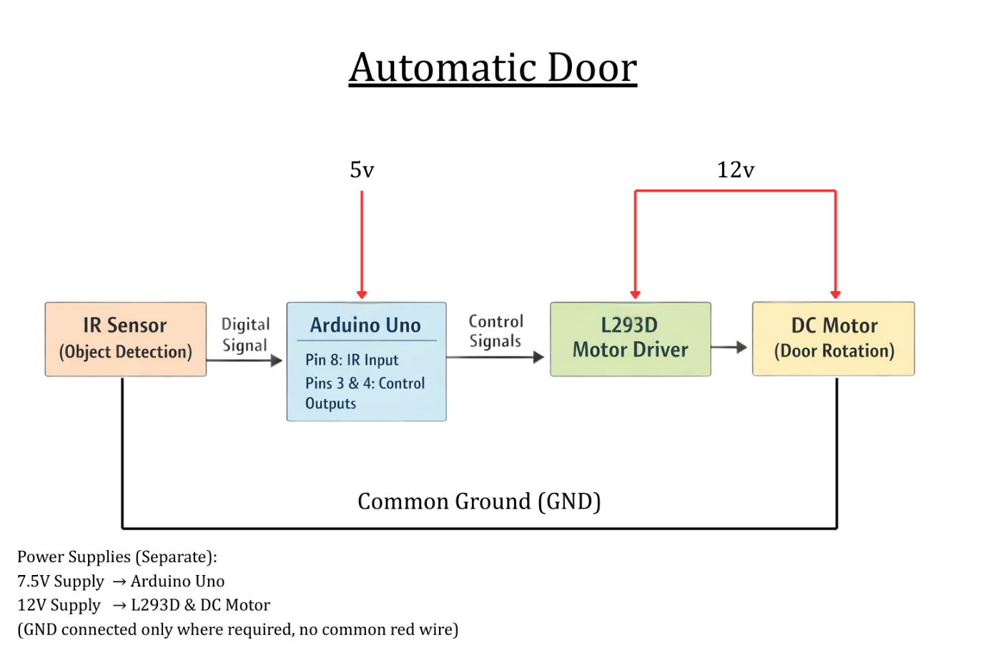
Circuit Diagram
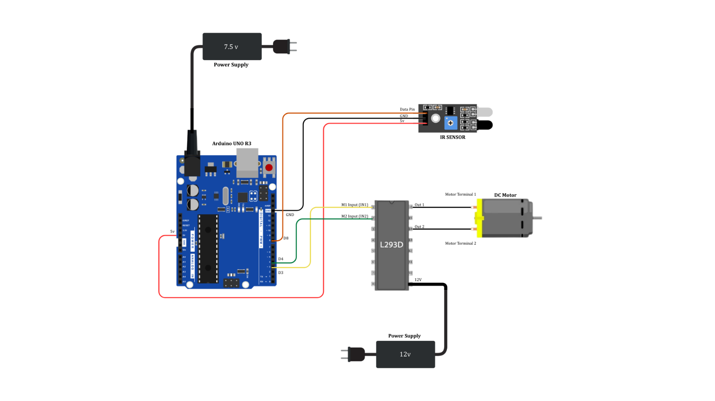

PSUEDO CODE

START
Initialize IR sensor pin as INPUT
Initialize motor control pins as OUTPUT

LOOP forever:
Read IR_sensor_value

IF IR_sensor_value == HIGH then
// Person detected
Rotate motor forward (open door)
Wait for predefined time (e.g., 3 seconds)
ELSE
// No person detected
Rotate motor backward (close door)
END IF

END LOOP

Rain sensor:-
The rain detection module is designed to automatically respond to rainfall using a rain sensor, Arduino board, and an MG996R servo motor connected to a pulley mechanism. This system helps in protecting household items such as windows, clothes, or rooftops by performing automatic actions during rain. The working methodology is explained in the following steps:

- Rain Detection
A rain sensor module is placed in an open area where it can directly sense rainfall.
When raindrops fall on the sensor plate, the water changes the resistance of the sensor, generating an electrical signal proportional to the amount of rain detected.

2. Signal Processing by Arduino
The output from the rain sensor is sent to the Arduino board.
The Arduino continuously reads the sensor value and compares it with a predefined threshold:
• If the sensor value indicates no rain, the system remains in the default state.
• If the sensor value crosses the threshold, indicating rainfall, the Arduino triggers the control action.

3. Servo Motor Control
Upon detecting rain, the Arduino sends control signals to the MG996R servo motor.
The servo motor is programmed to rotate to a specific angle based on the detected condition:
• When rain is detected, the servo rotates in a predefined direction.
• When rain stops, the servo returns to its original position.

4. Pulley Mechanism Operation
The pulley mechanism is mechanically connected to the MG996R servo motor.
As the servo rotates:
• It pulls or releases the pulley system to close a window, move a cover, or retract clothes to protect them from rain.
• When rainfall ends, the pulley returns to its initial position, restoring the system to its normal state.
5. Automation and Reliability
The entire process is fully automated and does not require human intervention.
This system ensures quick response to environmental changes, minimizes water damage, and improves convenience.
The use of a servo motor provides precise angular control, ensuring smooth and accurate mechanical movement.
Block Diagram
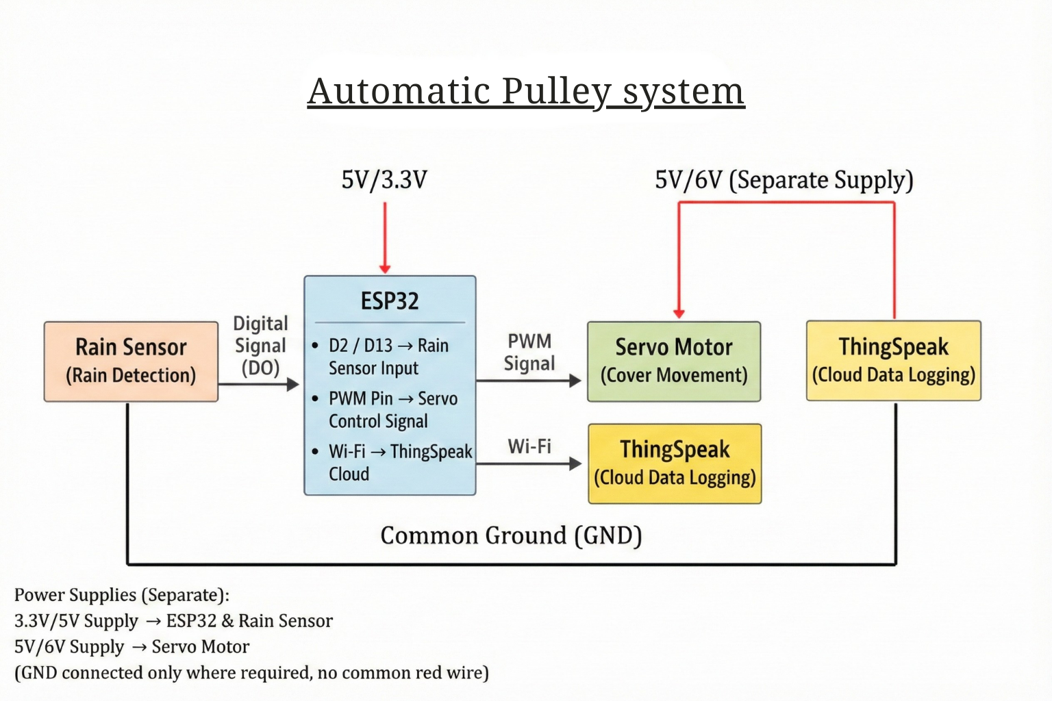
Circuit Diagram
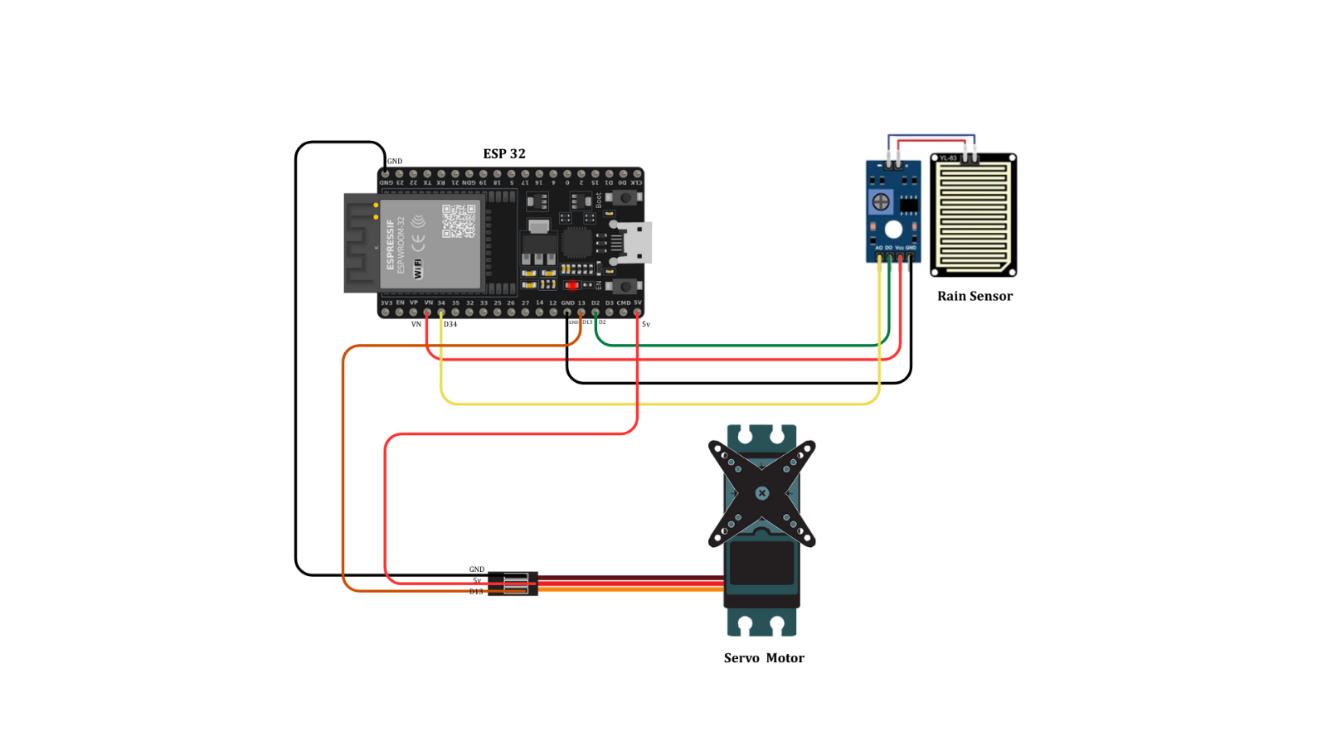
PSUEDO CODE

START

Initialize rain sensor pin as INPUT
Initialize servo motor
Set servo to initial position

LOOP forever:
Read rain_sensor_value
IF rain_sensor_value > threshold then
// Rain detected
Move servo to protection angle
ELSE
// No rain
Move servo back to initial position
END IF

END LOOP

System Implementation Results
- Automatic Door System
  - The IR sensor successfully detected the presence of a person in front of the door.
  - The Arduino processed the sensor signal correctly and sent control signals to the L293D motor driver.
  - The DC motor rotated smoothly to open the door when a person was detected.
  - After a short delay or when no object was present, the motor rotated in the opposite direction and the door closed automatically.
  - The system operated reliably without any manual intervention.

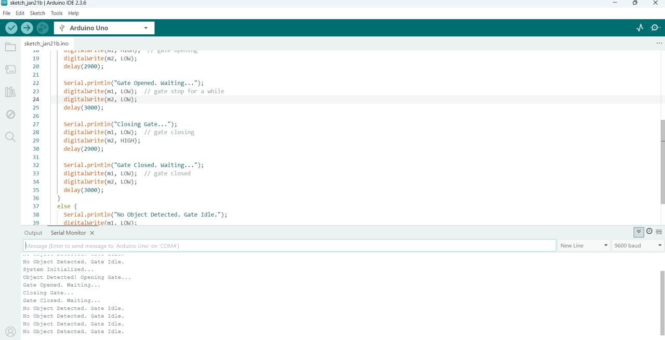
Fig - Arduino Serial Monitor Output for Object Detection and Door Control

- Rain Detection System
  - The rain sensor accurately detected water droplets when rainfall occurred.
  - The Arduino correctly compared the sensor value with the preset threshold.
  - On detecting rain, the MG996R servo motor rotated to the programmed angle.
  - The pulley mechanism was activated successfully to close/protect the target structure (window, cover, or clothes).
  - When rain stopped, the servo returned to its initial position, restoring normal condition.
  - The system responded quickly and worked automatically.

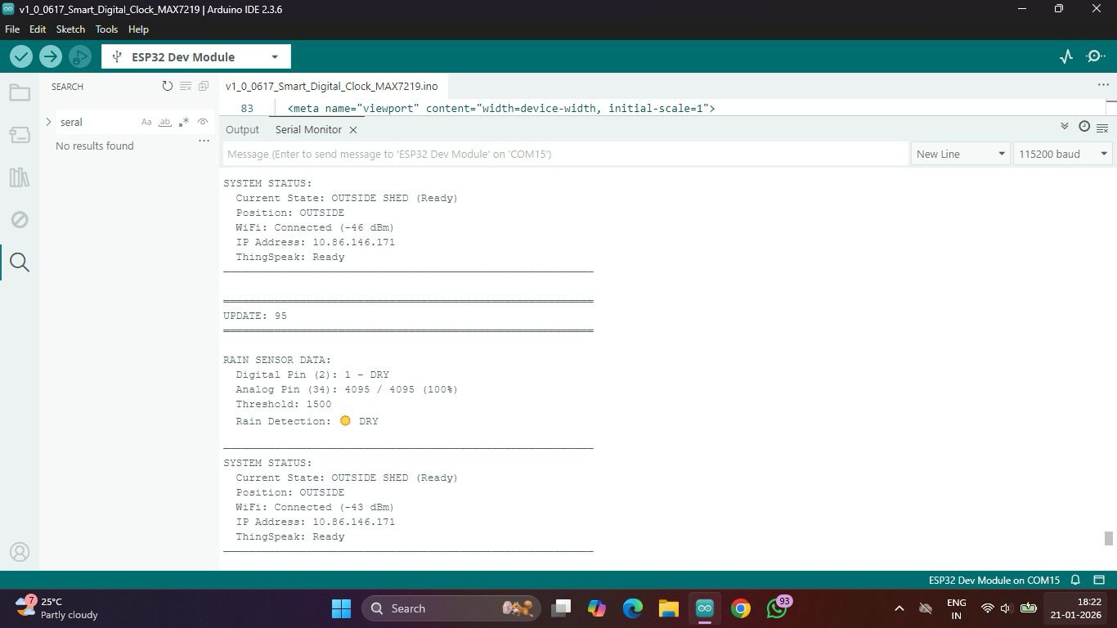
Fig - Serial Monitor Output Showing Automatic Pulley System in Dry Condition

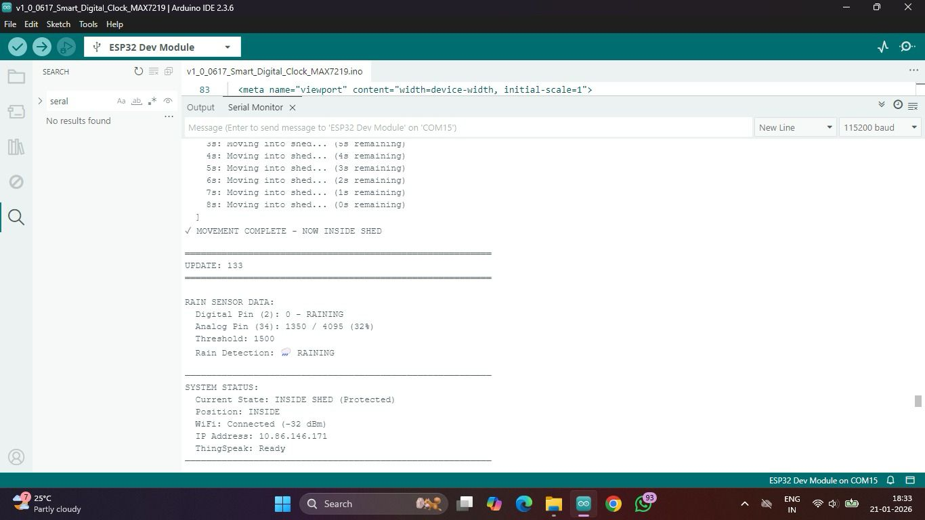
Fig - Serial Monitor Output Showing Automatic Pulley System in Wet Condition
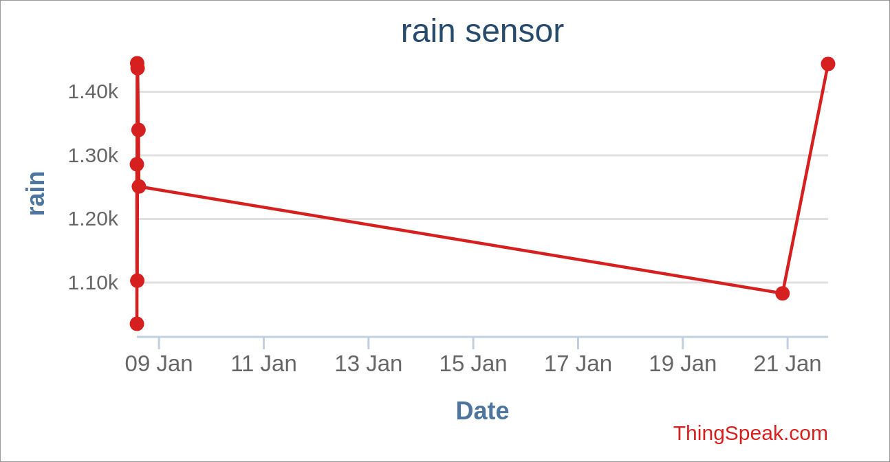
Fig - Cloud-Based Visualization of Rain Sensor Readings Over Time

Discussion

Automatic Door System
The automatic door system demonstrated reliable detection and control using an IR sensor, Arduino Uno, L293D motor driver, and DC motor. The IR sensor effectively identified the presence of a person and provided timely input to the Arduino. The L293D module ensured proper current handling and protected the microcontroller while driving the motor.
However, the system may occasionally be affected by ambient light or reflective surfaces, which can cause false detection. The door operation also depends on proper motor speed and timing; incorrect delay values may lead to incomplete opening or closing. Overall, the system proves to be cost-effective, simple to implement, and suitable for basic smart home automation applications.

Rain Detection System
The rain detection module responded accurately to rainfall using the rain sensor, Arduino, and MG996R servo motor with a pulley mechanism. The sensor successfully detected water droplets and triggered the servo to move the protective mechanism. The servo motor provided precise angular control, enabling smooth and reliable mechanical movement.
However, environmental factors such as dust accumulation on the sensor plate or very light rain may affect sensitivity. Periodic cleaning and proper threshold calibration are necessary for consistent performance. Despite these limitations, the system offers an efficient, automated solution for protecting windows, clothes, or covers from rain and demonstrates the practical use of IoT-based environmental monitoring.

Conclusion:

The IoT-based smart home automation system successfully integrates an automatic door and a rain detection module using Arduino and sensor-based control. The automatic door efficiently detects human presence through an IR sensor and operates a DC motor via the L293D driver to provide smooth, hands-free access, improving convenience and accessibility. The rain detection system accurately senses rainfall and activates the MG996R servo motor with a pulley mechanism to protect household structures from weather damage. Together, both subsystems demonstrate reliable sensing, real-time processing, and automated actuation, proving that low-cost microcontrollers and sensors can be effectively used to enhance safety, comfort, and efficiency in smart home environments, with strong potential for future expansion through wireless connectivity and advanced control features.
References:
1. Arduino, Arduino Uno Documentation, Arduino.cc, 2024.
2.ESP32 Technical Reference Manual, Espressif Systems, 2024.
3.Muhammad Ali Mazidi et al., Arduino Programming and Interfacing, Pearson Education, 2018.
4.IEEE, Research Papers on IoT-Based Home Automation Systems, IEEE Xplore Digital Library.
5.Sensors Online, IR Sensor and Rain Sensor Working Principles, [Online].
6.L293D Motor Driver Datasheet, Texas Instruments, 2023.
7.IoT Analytics, Smart Home Automation Using IoT, [Online].
8.Stack Overflow, Embedded Systems and IoT Development Discussions, [Online].

