CS683 Project Assignment   
BMI Calculator  
Dharmendra Thotakura

1. Overview 2

2. Related Work 2

3. Proposed High level Requirements 2

4. Testing Requirements 2

5. UI description with screen shots 2

6. Project Structure 6

7. Android Components and Features to Be Used 7

8. Future Work 7

9. Project Links 8

# 

# Overview

Motivation: Me and my friends are always looking for simple Application that calculates the BMI by taking only required inputs like height and weight and do not ask for any personal data and show the BMI output without showing any advertisements.

Purpose –

A simple BMI calculator, targeted for all users, that does the BMI calculation and flags limit range and records all the previous BMI values in the data base.

Time-Graph of the BMI trending is a stretch goal.

# Related Work

Lot of BMI calculators in the market. May be ours is the one of the few that will also have time graph for BMI changes for multiple users.

# Proposed High level Requirements

* 1. Essential Features:   
     Take Height and weight has input and calculate BMI.

If save is selected –

1. Show the existing users in the system and add BMI with timestamp as new row for the selected user.
2. For a new user take input in String and add BMI and timestamp in a new row
   1. Desirable Features:

Translate BMI Value to BMI Category

Show the data in metric system and US units

* 1. Optional Features:

1) Render the time graph with BMI for the selected user.

2) Give ability to export the data in CSV format for mailing or sharing.

# Testing Requirements

1. Assert that inputs of height and weight are given in integers/decimals
2. Assert that inputs are smaller than max human height and weight
3. Assert that BMI calculator formula does not end up doing divide by zero
4. Assert the outputs are correct for metric and non-metric units
5. Assert that BMI categories are correctly mapped
6. Assert that Username is alphabets only

# UI description with screen shots

Below is the proposed UI for the BMI calculator.

1. If the height and weight are given it calculates the BMI and classifies which BMI category that users fall in to.
2. If Metric Units switch is toggled, it changes to CMs for height and Kgs for weight.
3. Save button saves the username, BMI value and time stamp to SQLite data base.
4. Share button initiates new ACTION_SEND intent to transfer BMI details to any

Application that supports Text/Plain type.

US units view

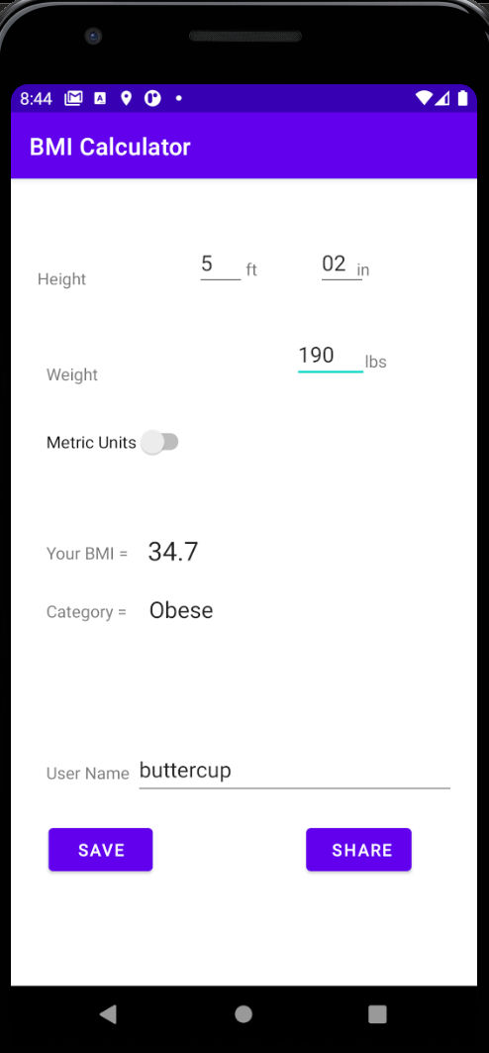

Metric Untis view with the data saved toast notfication

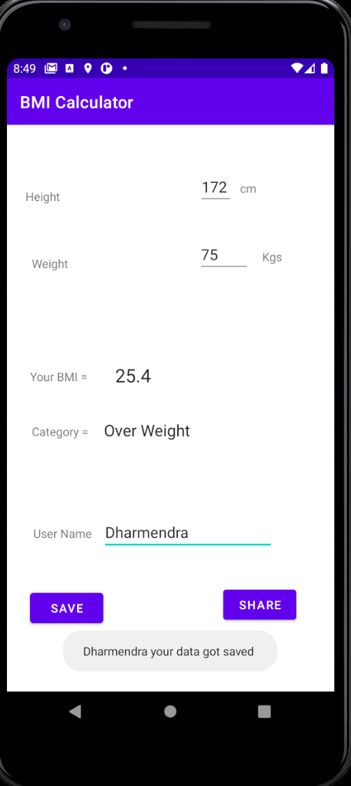

Share Button sending the BMI details to mail App.

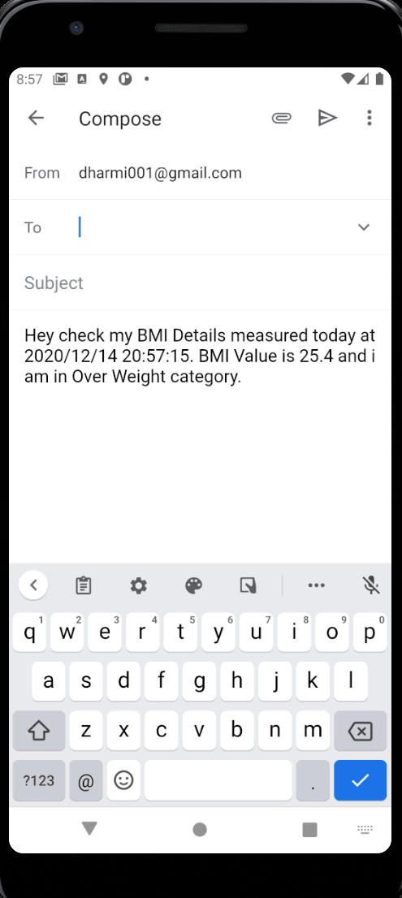

# Project Structure

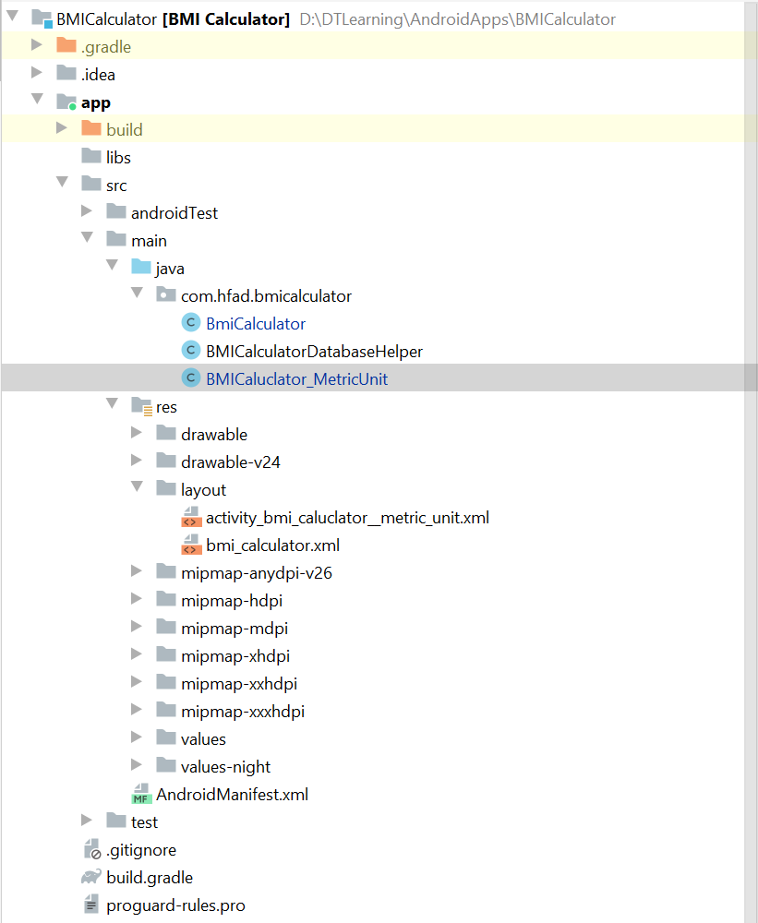

Compared to previous iteration following things are new

1. SQLite Database helper class is new and saving to db is new.
2. Layout got changed to accommodate Save and Share buttons.
3. shareBMI method that uses implicit intent to transfer text/plain message is new
4. Toast message validations are new.

# Android Components and Features to Be Used

Here is a list of components/features that are used:

Activities, Views, Layouts, Intents, Resources, Manifest and Database.

Timeline

(Please provide a detailed plan to specify when the above requirements and android features will be implemented)

|  |  |  |
| --- | --- | --- |
| Iteration | Application Requirements(E/D/O) | Android Components and Features |
| 1 | 11/8 | Project Proposal |
| 2 | 11/15 | Main Activity and its Layout |
| 3 | 11/22 | Secondary Activity and its Layout |
| 4 | 1129 | BMI Value Calculation and Categorization methods |
| 5 | 12/14 | SQLite Database Implementation, Share Intent implementation, and Validation through Toast messages |

# 

# Future Work

Things that I did not get to do but if done elevates the value proposition of the application.

1. Move the metric toggle to the top of the layout
2. Should have created a new button for BMI calculation
3. Populate existing usernames by reading the SQLite DB
4. Create a user specific time graph for BMI value trend
5. Give option to user to export all his records to csv and share to application that handle CSVs

# Project Links

PPT –



Source Code - [cs683f20project-dharmt001/cs683f20project-dharmt001-master (3).zip at master · CS683/cs683f20project-dharmt001 (github.com)](https://github.com/CS683/cs683f20project-dharmt001/blob/master/cs683f20project-dharmt001-master%20(3).zip)

Kaltura presentation

<iframe id="kaltura_player" src="https://cdnapisec.kaltura.com/p/2159741/sp/215974100/embedIframeJs/uiconf_id/45028821/partner_id/2159741?iframeembed=true&playerId=kaltura_player&entry_id=1_vpk48vow&flashvars[streamerType]=auto&amp;flashvars[localizationCode]=en&amp;flashvars[leadWithHTML5]=true&amp;flashvars[sideBarContainer.plugin]=true&amp;flashvars[sideBarContainer.position]=left&amp;flashvars[sideBarContainer.clickToClose]=true&amp;flashvars[chapters.plugin]=true&amp;flashvars[chapters.layout]=vertical&amp;flashvars[chapters.thumbnailRotator]=false&amp;flashvars[streamSelector.plugin]=true&amp;flashvars[EmbedPlayer.SpinnerTarget]=videoHolder&amp;flashvars[dualScreen.plugin]=true&amp;flashvars[hotspots.plugin]=1&amp;flashvars[Kaltura.addCrossoriginToIframe]=true&amp;&wid=1_dz647edk" width="400" height="285" allowfullscreen webkitallowfullscreen mozAllowFullScreen allow="autoplay *; fullscreen *; encrypted-media *" sandbox="allow-forms allow-same-origin allow-scripts allow-top-navigation allow-pointer-lock allow-popups allow-modals allow-orientation-lock allow-popups-to-escape-sandbox allow-presentation allow-top-navigation-by-user-activation" frameborder="0" title="Kaltura Player"></iframe>