DATA CLEANING AND PRELIMINARY ANALYSIS WITH R

Week 1 — Data Analyst Internship
Dataset: Titanic — Machine Learning from Disaster
Tools Used:
R Programming
RStudio
Microsoft Word
Submitted By:
Dharaneesh A
Internship:
YuvaIntern — Data Analyst Internship
Date:
September 2026

- Introduction
- Data cleaning and preliminary analysis are important steps in the data analysis process. Raw datasets often contain missing values, inconsistent data types, categorical variables, and unusual observations that can affect the quality of analysis. This project focuses on cleaning and exploring the Titanic passenger dataset using the R programming language.
- The main objective of this analysis is to understand the structure and quality of the dataset, identify and handle missing values, detect potential outliers, encode categorical variables, normalize numerical variables, and perform preliminary exploratory analysis. RStudio was used to implement the data cleaning and analysis procedures.
- The Titanic dataset contains information about passengers, including passenger class, survival status, name, gender, age, number of siblings or spouses aboard, number of parents or children aboard, ticket information, fare, cabin information, and port of embarkation.
- The cleaned dataset was then used to generate descriptive statistics, visualizations, and correlation analysis. These preliminary findings help identify patterns and relationships within the data and demonstrate the importance of data preprocessing before performing further statistical or machine-learning analysis.
2. Dataset Overview
The dataset used for this project is the Titanic passenger dataset obtained from the Kaggle “Titanic – Machine Learning from Disaster” competition. The dataset was selected because it contains both numerical and categorical variables and includes missing values, making it suitable for practicing data cleaning and preliminary analysis.
The original training dataset contains 891 passenger records and 12 variables. The target variable is Survived, where 0 represents passengers who did not survive and 1 represents passengers who survived.
The dataset includes demographic information, passenger class, family-related information, ticket and fare information, cabin information, and embarkation details.
2.1 Dataset Characteristics
The dataset contains a mixture of numerical, categorical, and text-based variables. The presence of missing values in Age and Cabin provides an opportunity to demonstrate appropriate missing-value treatment. Numerical variables such as Age and Fare can also be examined for potential outliers and normalized for analysis. Categorical variables such as Sex, Embarked, and the derived CabinKnown variable can be converted into factors for analysis.

3. Data Cleaning and Preprocessing
3.1 Identifying Missing Values
Missing values were identified using the is.na() function in R. The colSums() function was then used to calculate the number of missing values in each column. The analysis showed that the Age variable contained 177 missing values, while the Cabin variable contained 687 missing values. The remaining variables did not contain missing values requiring treatment.
3.2 Handling Missing Age Values
The missing values in Age were handled using median imputation. The median was selected because it is less affected by extreme values than the mean. The missing age values were replaced with the median age of the available observations. After imputation, a missing-value check confirmed that the number of missing values in Age was reduced to zero.
# Handle missing Age values
titanic$Age[is.na(titanic$Age)] <-
median(titanic$Age, na.rm = TRUE)

# Check Age missing values
sum(is.na(titanic$Age))

Output:
[1] 0

3.3 Handling Missing Cabin Information
The Cabin variable contained a large number of missing observations. Instead of assigning artificial cabin numbers, a new categorical variable called CabinKnown was created. It records whether cabin information was available. A value of Yes indicates that cabin information was present, while No indicates missing cabin information. The original Cabin column was then removed from the cleaned dataset.
# Create CabinKnown variable
titanic$CabinKnown <- ifelse(
is.na(titanic$Cabin) |
trimws(titanic$Cabin) == "",
"No",
"Yes"
)

# Remove original Cabin column
titanic$Cabin <- NULL

# Check result
table(titanic$CabinKnown)

3.4 Encoding Categorical Variables
The categorical variables Sex, Embarked, and CabinKnown were converted into factor variables using R's as.factor() function. This makes the categorical information suitable for statistical analysis and further data-processing tasks.
Code:
titanic$Sex <- as.factor(titanic$Sex)
titanic$Embarked <- as.factor(titanic$Embarked)
titanic$CabinKnown <- as.factor(titanic$CabinKnown)
4. Outlier Detection
Outlier detection was performed for the numerical variables Age and Fare. Boxplots were used to visually identify unusually high or low observations. The boxplot method in R uses the interquartile range (IQR) to identify observations outside the expected range.
The analysis identified 66 potential outliers in Age and 116 potential outliers in Fare. These observations were not automatically removed because an unusual value does not necessarily indicate an error. In the Titanic dataset, higher fares or unusual ages can represent genuine passenger characteristics. Therefore, the observations were retained for further analysis.
# Age outliers
boxplot(titanic$Age,
main = "Age Outliers",
ylab = "Age")

length(boxplot.stats(titanic$Age)$out)

# Fare outliers
boxplot(titanic$Fare,
main = "Fare Outliers",
ylab = "Fare")

length(boxplot.stats(titanic$Fare)$out)

Variable | Potential Outliers
Age | 66
Fare | 116
- Data Normalization
Min-Max normalization was applied to the numerical variables Age and Fare. This transformation scales the values to a range between 0 and 1. Normalization can be useful when numerical variables have substantially different scales and are later used in analytical or machine-learning procedures.
# Normalize Age
titanic$Age_Normalized <-
(titanic$Age - min(titanic$Age)) /
(max(titanic$Age) - min(titanic$Age))

# Normalize Fare
titanic$Fare_Normalized <-
(titanic$Fare - min(titanic$Fare)) /
(max(titanic$Fare) - min(titanic$Fare))

# Check normalized values
head(titanic[, c("Age_Normalized",
"Fare_Normalized")])
- Exploratory Data Analysis
6.1 Survival Distribution
The survival variable was analyzed to understand the distribution of passengers who survived and those who did not survive. In the dataset, Survived = 0 represents passengers who did not survive, while Survived = 1 represents passengers who survived. A bar chart was generated to visualize the survival distribution.
# Survival count
table(titanic$Survived)

# Survival visualization
barplot(
table(titanic$Survived),
main = "Survival Count",
xlab = "Survived (0 = No, 1 = Yes)",
ylab = "Number of Passengers"
)
6.2 Survival by Gender
Survival was also examined according to gender. A cross-tabulation and grouped bar chart were used to compare survival counts between male and female passengers. This provides an initial understanding of how survival outcomes varied across the gender categories in the dataset.
Code:
# Survival by gender
table(titanic$Sex, titanic$Survived)

# Visualization
barplot(
table(titanic$Sex, titanic$Survived),
beside = TRUE,
main = "Survival by Gender",
xlab = "Gender",
ylab = "Number of Passengers",
legend.text = TRUE
)
6.3 Survival by Passenger Class
Passenger class was examined to identify differences in survival counts across first, second, and third class. A grouped bar chart was created to visually compare the survival outcomes for each passenger class.
Code:
# Survival by passenger class
table(titanic$Pclass, titanic$Survived)

# Visualization
barplot(
table(titanic$Pclass, titanic$Survived),
beside = TRUE,
main = "Survival by Passenger Class",
xlab = "Passenger Class",
ylab = "Number of Passengers",
legend.text = TRUE
)
6.4 Age Distribution
The distribution of passenger ages was examined using a histogram. The histogram provides an overview of the age range and concentration of passengers in the dataset.
Code:
# Age distribution
hist(
titanic$Age,
main = "Age Distribution of Passengers",
xlab = "Age",
ylab = "Number of Passengers"
)
- Correlation Analysis
Correlation analysis was performed to examine the relationships between the main numerical variables in the cleaned Titanic dataset. The variables considered were Survived, Pclass, Age, SibSp, Parch, and Fare.
The Pearson correlation coefficient was calculated using R. Correlation values range from -1 to +1. A positive value indicates that two variables tend to increase together, while a negative value indicates an inverse relationship. Correlation does not by itself establish causation.
7.1 Age and Fare Relationship
A scatter plot was also used to visually examine the relationship between passenger age and fare.
# Age vs Fare
plot(
titanic$Age,
titanic$Fare,
main = "Age vs Fare",
xlab = "Age",
ylab = "Fare",
pch = 19
)
8.Initial Insights
The preliminary exploratory analysis provides several observations about the Titanic dataset. The dataset contains a substantial amount of missing cabin information, while the missing age values were successfully handled using median imputation.
The survival distribution shows that the number of passengers who did not survive was greater than the number who survived. The gender and passenger-class analyses provide useful comparisons of survival outcomes across different passenger groups.
The analysis also identified 66 potential outliers in Age and 116 potential outliers in Fare. These observations were retained because they may represent genuine values rather than data-entry errors.
Min-Max normalization successfully transformed Age and Fare into variables on a 0-to-1 scale. The correlation analysis provides an initial understanding of relationships among the numerical variables and can be used as a starting point for more detailed analysis.
- Conclusion
This project demonstrated the major stages of data cleaning and preliminary analysis using R. The Titanic dataset was loaded and examined using structural information and descriptive statistics. Missing values were identified and handled appropriately, categorical variables were converted into factors, potential outliers were detected, and numerical variables were normalized.
Exploratory analysis was then performed using tables, bar charts, histograms, scatter plots, and correlation analysis. The resulting cleaned dataset provides a more suitable foundation for further statistical analysis or machine-learning tasks.
Overall, the project demonstrates how systematic data preprocessing and exploratory analysis can improve the quality and interpretability of a dataset before advanced analytical techniques are applied.
10.graphs
10.1 Add Survival Count graph

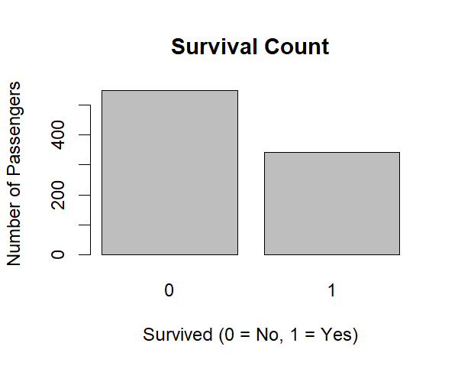
10.2 Add Survival by Gender graph
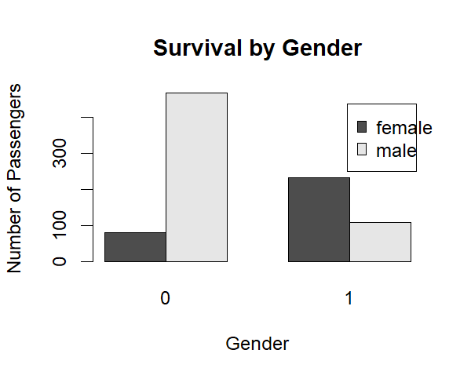

10.3 Add Survival by Passenger Class

10.4 Add Age histogram
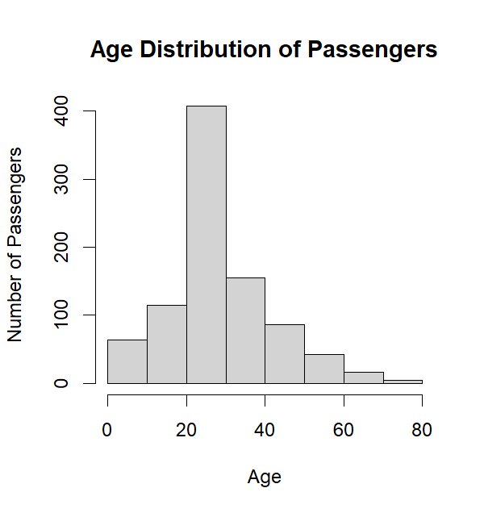

10.5 Add Age vs Fare scatter plot
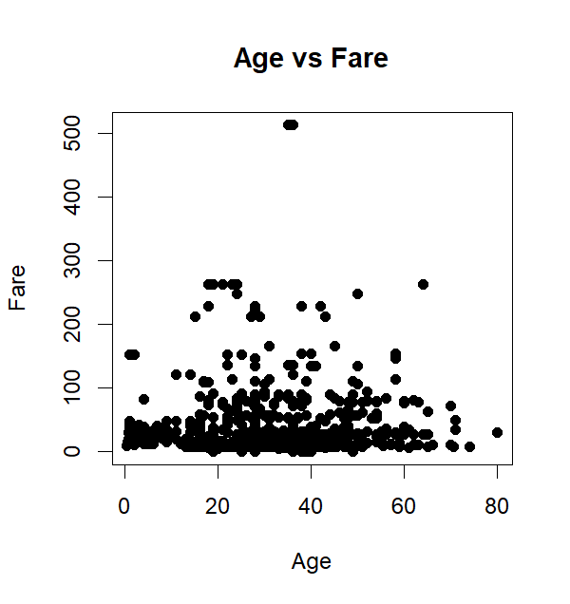

Appendix A — Complete R Code
# Load dataset
titanic <- read.csv(file.choose())

# View first 6 rows
head(titanic)

# Check structure
str(titanic)

# Check dimensions
dim(titanic)

# Summary
summary(titanic)
# Check missing values
colSums(is.na(titanic))
# Handle missing Age values
titanic$Age[is.na(titanic$Age)] <- median(titanic$Age, na.rm = TRUE)
# Check Age missing values again
sum(is.na(titanic$Age))
# Create CabinKnown variable
titanic$CabinKnown <- ifelse(
is.na(titanic$Cabin) | trimws(titanic$Cabin) == "",
"No",
"Yes"
)

# Check CabinKnown
table(titanic$CabinKnown)
# Convert categorical variables to factors
titanic$Sex <- as.factor(titanic$Sex)
titanic$Embarked <- as.factor(titanic$Embarked)
titanic$CabinKnown <- as.factor(titanic$CabinKnown)

# Check categorical variables
str(titanic[, c("Sex", "Embarked", "CabinKnown")])
# Outlier detection using boxplots

boxplot(titanic$Age,
main = "Boxplot of Age",
ylab = "Age")

boxplot(titanic$Fare,
main = "Boxplot of Fare",
ylab = "Fare")
# Calculate Age outliers
Q1_Age <- quantile(titanic$Age, 0.25)
Q3_Age <- quantile(titanic$Age, 0.75)

IQR_Age <- Q3_Age - Q1_Age

lower_Age <- Q1_Age - 1.5 * IQR_Age
upper_Age <- Q3_Age + 1.5 * IQR_Age

# Count Age outliers
age_outliers <- titanic$Age[
titanic$Age < lower_Age | titanic$Age > upper_Age
]

length(age_outliers)
# Check Age outliers
boxplot.stats(titanic$Age)$out
# Count Age outliers
length(boxplot.stats(titanic$Age)$out)
# Check Fare outliers
boxplot.stats(titanic$Fare)$out
# Count Fare outliers
length(boxplot.stats(titanic$Fare)$out)
length(boxplot.stats(titanic$Age)$out)
# Normalize Age
titanic$Age_Normalized <-
(titanic$Age - min(titanic$Age)) /
(max(titanic$Age) - min(titanic$Age))

# Normalize Fare
titanic$Fare_Normalized <-
(titanic$Fare - min(titanic$Fare)) /
(max(titanic$Fare) - min(titanic$Fare))

# Check the new columns
head(titanic[, c("Age_Normalized", "Fare_Normalized")])
# Survival count
table(titanic$Survived)

# Survival visualization
barplot(
table(titanic$Survived),
main = "Survival Count",
xlab = "Survived (0 = No, 1 = Yes)",
ylab = "Number of Passengers"
)
# Survival by gender
table(titanic$Sex, titanic$Survived)

# Visualization
barplot(
table(titanic$Sex, titanic$Survived),
beside = TRUE,
main = "Survival by Gender",
xlab = "Gender",
ylab = "Number of Passengers",
legend.text = TRUE
)
# Survival by passenger class
table(titanic$Pclass, titanic$Survived)

# Visualization
barplot(
table(titanic$Pclass, titanic$Survived),
beside = TRUE,
main = "Survival by Passenger Class",
xlab = "Passenger Class",
ylab = "Number of Passengers",
legend.text = TRUE
)
# Age distribution
hist(
titanic$Age,
main = "Age Distribution of Passengers",
xlab = "Age",
ylab = "Number of Passengers"
)
# Relationship between Age and Fare
plot(
titanic$Age,
titanic$Fare,
main = "Age vs Fare",
xlab = "Age",
ylab = "Fare",
pch = 19
)
# Correlation between Age and Fare
cor(titanic$Age, titanic$Fare)
# Correlation matrix
cor(
titanic[, c("Survived", "Pclass", "Age", "SibSp", "Parch", "Fare")]
)
# Save cleaned Titanic dataset
write.csv(
titanic,
"titanic_cleaned.csv",
row.names = FALSE
)

# Confirm final dataset dimensions
dim(titanic)

# Check remaining missing values
colSums(is.na(titanic))

Final Data Validation


